- docker –version
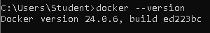

- docker run hello-world
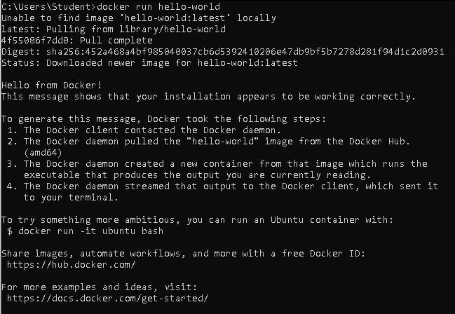

- docker pull nginx
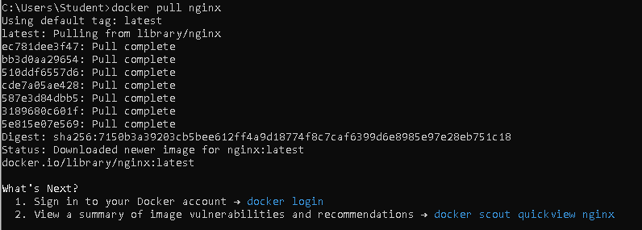

- docker images
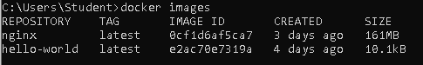

- docker run -d nginx

- docker ps

- docker ps –a

- docker logs <container_id>
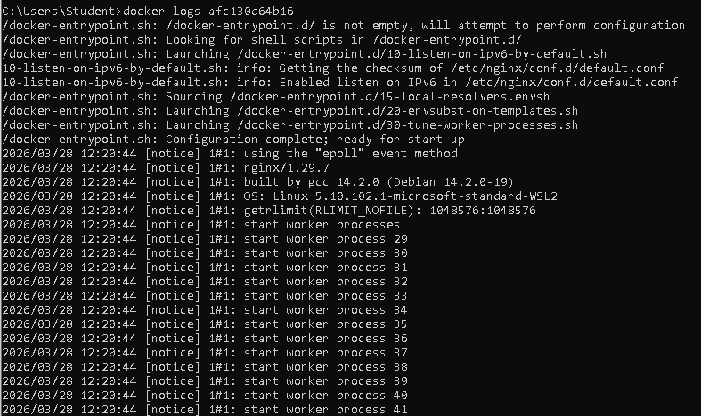

- docker exec -it <container_id> /bin/sh
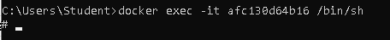
- docker stop <container_id>
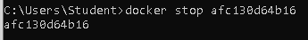

- docker restart <container_id>
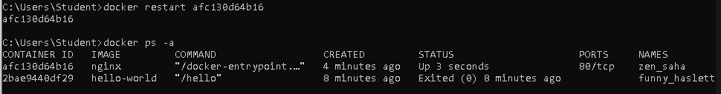

- docker rm <container_id>
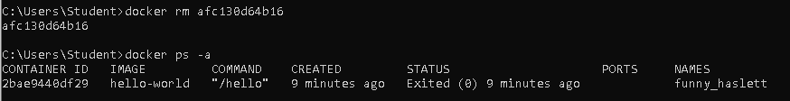

- docker container prune
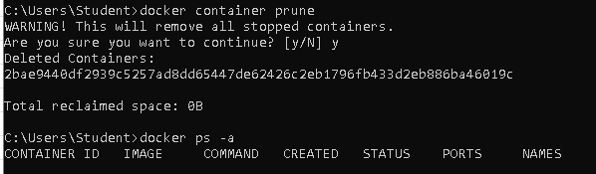

- docker rmi <image_id>
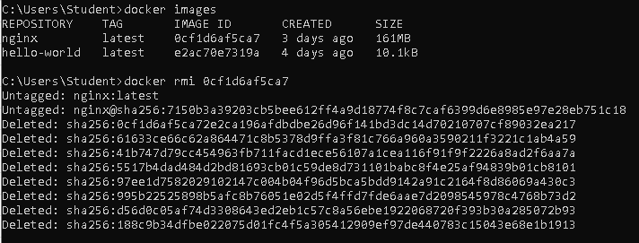

- docker image prune –a
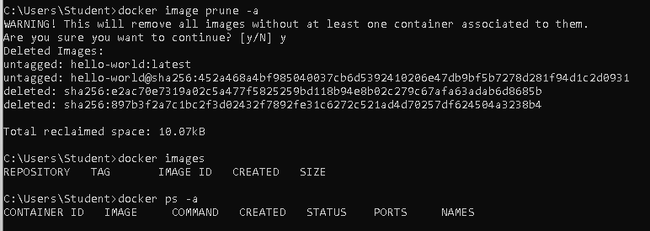

- docker run -d -p 8080:80 nginx
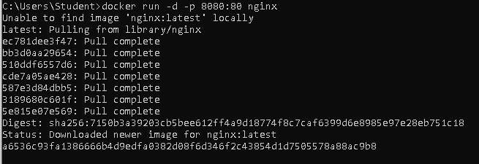

- docker inspect <container_id>
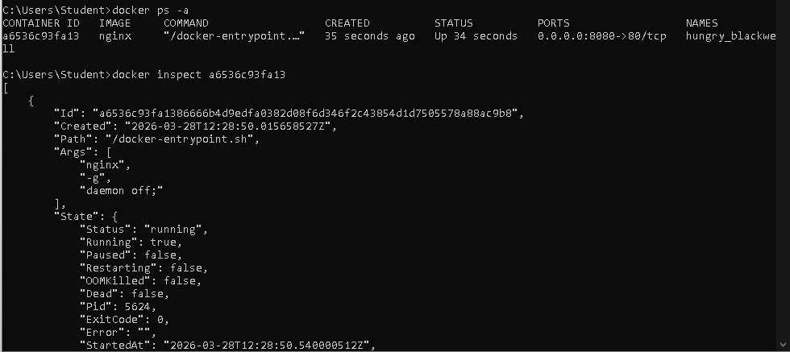

- docker run -d -v mydata:/data nginx

- docker volume ls
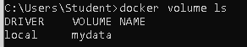

- docker volume prune
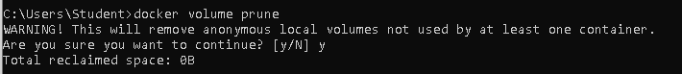

- docker run -d --name my_nginx nginx

- docker stats
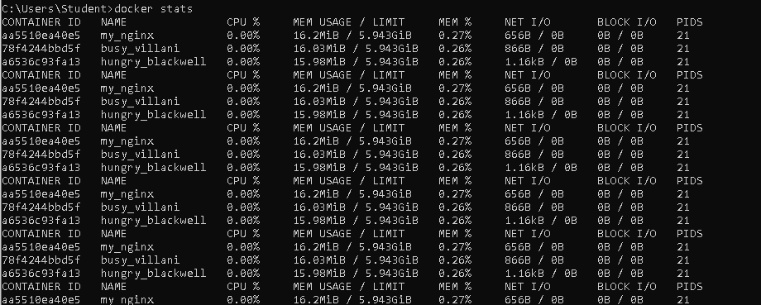

- docker network ls
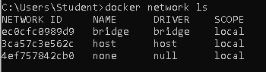

- docker network create my_network
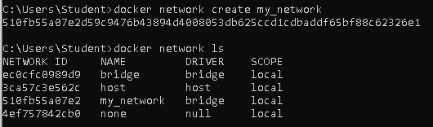

- docker run -d --network my_network --name my_container nginx
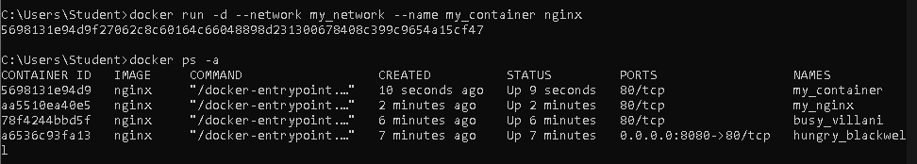

- docker network connect my_network my_nginx

- docker run -d -e MY_ENV=hello_world nginx

- docker logs -f my_nginx
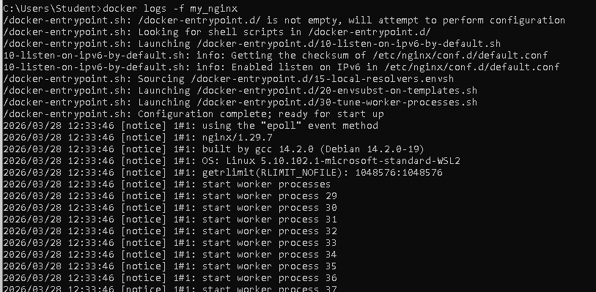

- FROM nginx
COPY index.html /usr/share/nginx/html/index.html
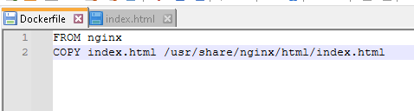
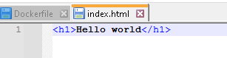

- docker build -t my_nginx_image .
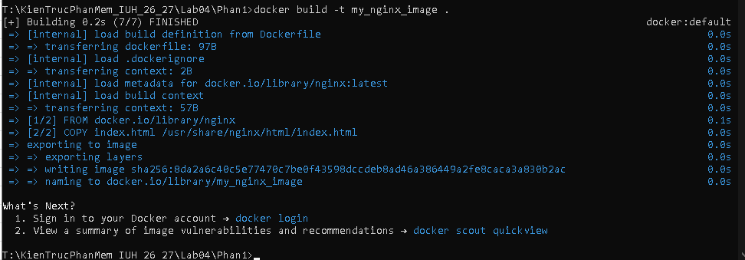

- docker run -d -p 8080:80 my_nginx_image
