CSC358 A3 Report

1. Wentao Zhou 1005308490

All the requirements were completed

1. NUM_NODE: 5 Seed: 2 No link change

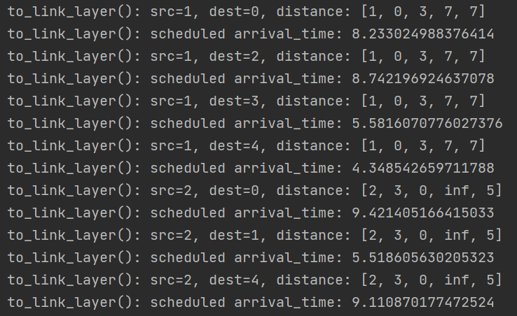

At first, every node will send its DV to all its neighbors. If the link cost is infinite, that means the two nodes are not connected and won’t send their DV to each other.

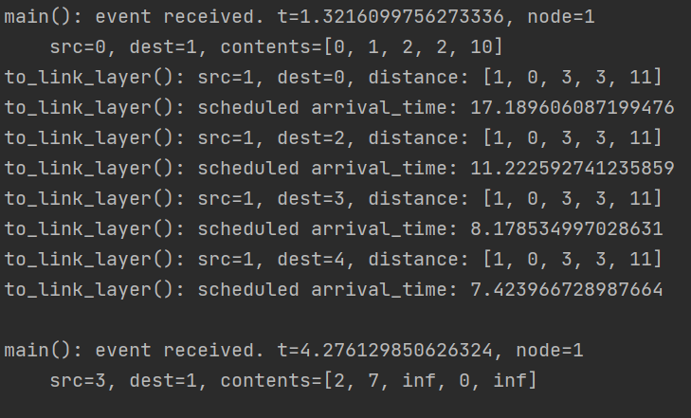

Once a DV was received, the node will compare it to its dist_table and check whether the upcoming DV is a new one. If the upcoming DV is not the same as the one in dist_table, the node will update its own DV with the new one and send its updated DV to all its neighbors. Otherwise, nothing will happen.

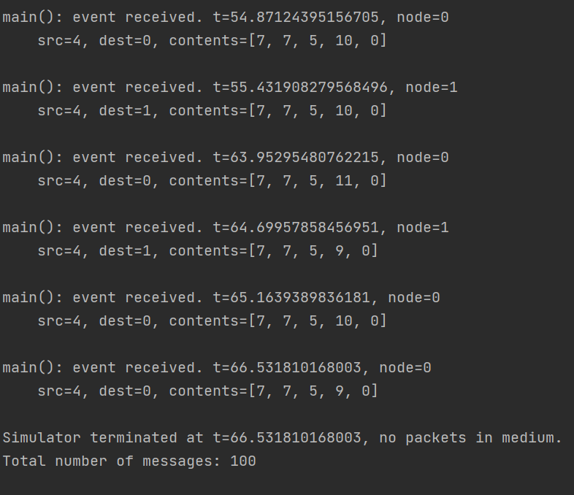

This process will continue until all the nodes have no updates with the new DV and no longer sending their DV to their neighbors. They just store the new DV to their dist_table.

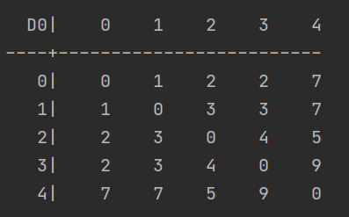

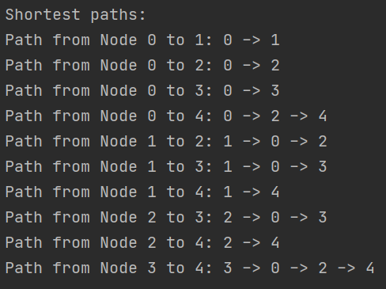

The results are the same as the manual calculations

1. NUM_NODE: 4 Seed: 6 Link change at 1-2 with cost 1

Node 0 and 1 are not connected

The number of messages sent from no link change were 46

Original table and path without link change:

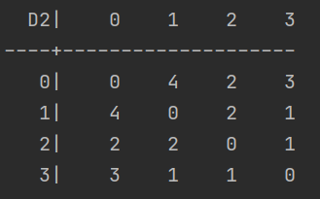

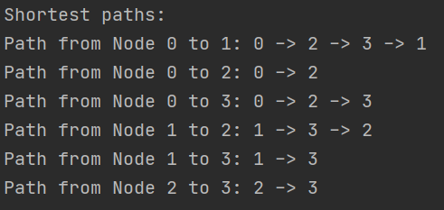

Before link change happens, everything is the same as without link change.

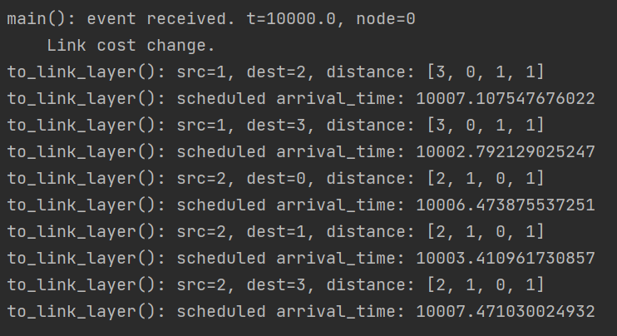

Link change between 1 and 2 will cause them to send their new DV to all its neighbors

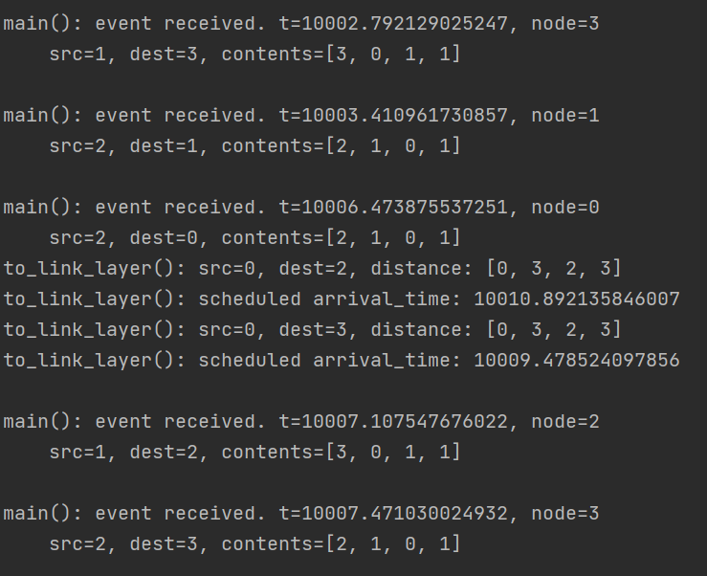

Majority nodes have no updates on their DV since they are not taking the link change path at the first place. Only those who were taking that path will update the DV and send to their neighbors.

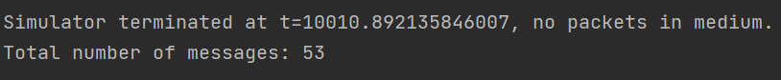

Only a few more messages were sent. Since those affected nodes just update their DV to the new minimum once or few times. That why good news travels fast.

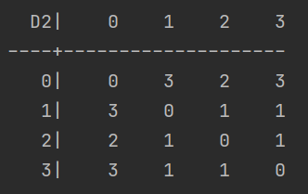

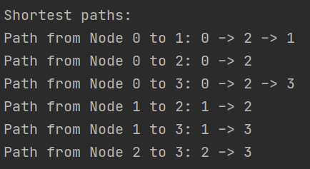

New tables and paths after link change. Same as manual calculation.

1. NUM_NODE: 4 Seed: 6 Link change at 0-2 with cost 60

Node 0 and 1 are not connected

The number of messages sent from no link change were 46

Original table and paths can be found above

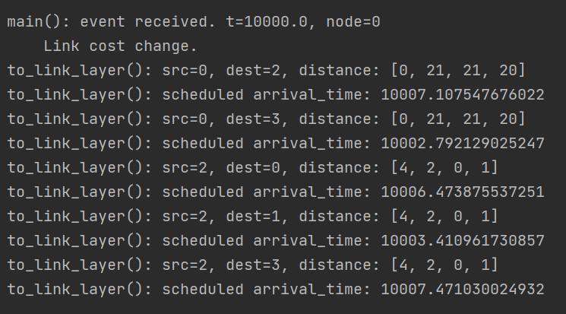

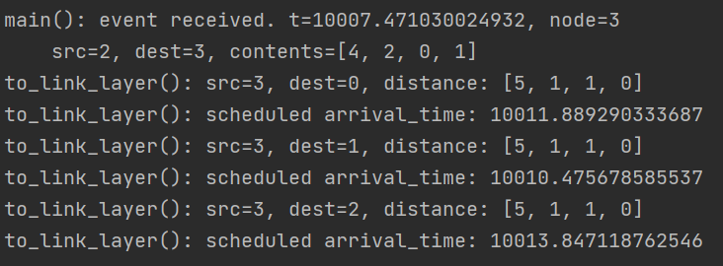

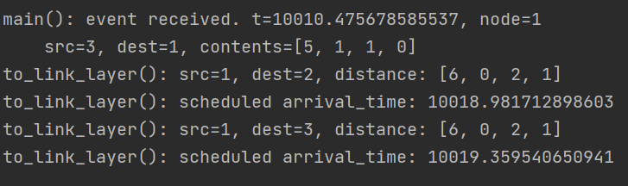

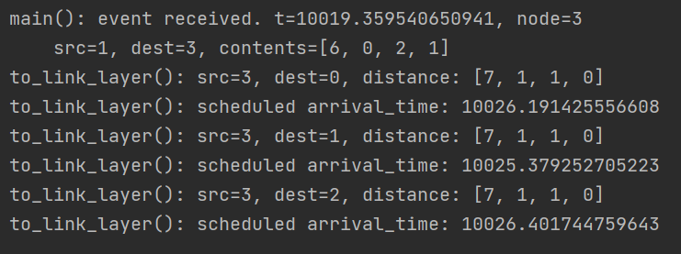  
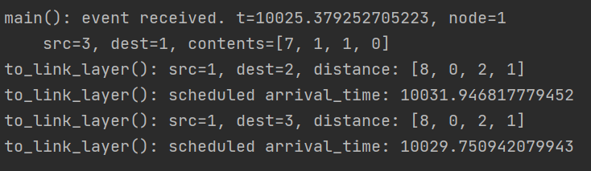

As the screen shots show, the shortest path is slowly increasing.

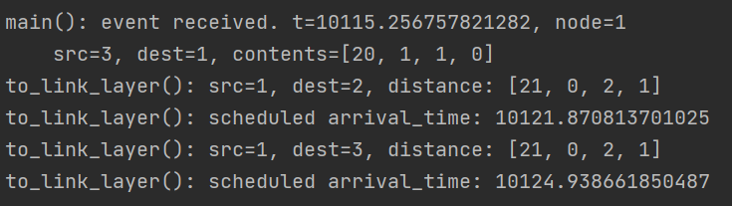

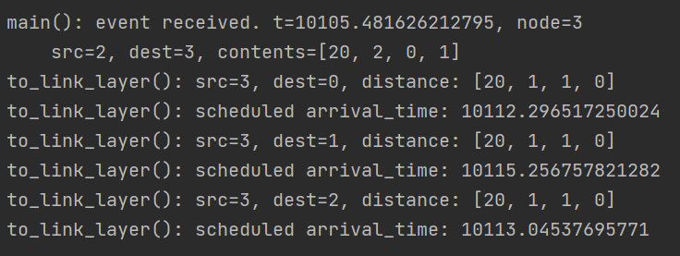

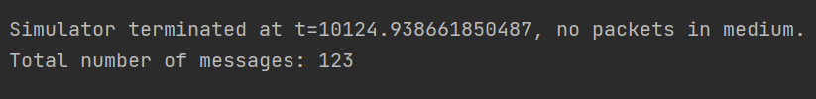

It stops when it reaches the new shortest path. As you can see, there are tons of messages sent in between.

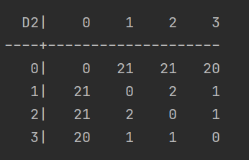

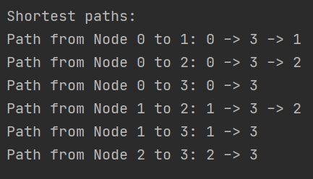

New tables and paths after link change. Same as manual calculation.

1. The running time of update method is O(n^2).

If we keep the same seed. The messages sent for different number of nodes are: 3 nodes 20 messages, 4 nodes 57 messages, 5 nodes 100 messages, 6 nodes 225 messages.