翻译

Q： 什么是翻译？ （**理解+表达**）

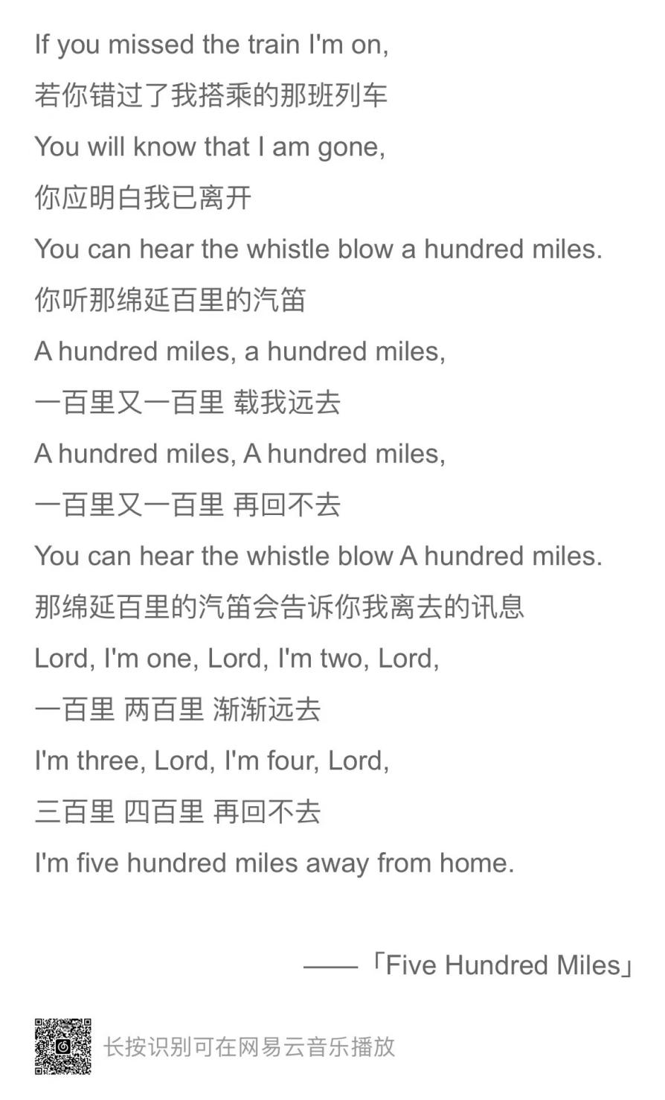

什么是好的翻译？ （**信、达、雅**）

**第一章　考研翻译概况**

**一、考研翻译考查内容和形式**

**（一）英语一& 英语二的大纲要求 （英汉）**

|  |  |  |
| --- | --- | --- |
|  | 英语一 | 英语二 |
| 考试形式 | **5个划线句子（约150词）** | **150词左右篇章** |
| 测试要点 | **理解概念或结构较复杂的英语文字材料** | **理解和表达的准确、完整、通顺** |
| 分数 | **10分** | **15分** |
| 做题时间 | **15-20min** | **20-25min** |

**准确、完整、通顺**

**英语一真题范例：2023年翻译真题**

**Directions:**

*Read the following text carefully and then translate the underlined segments into Chinese. Write your answers on the ANSWER SHEET. (10 points)*

There has been some exploration around the use of artificial intelligence (AI) in digital marketing. For example, AI can be used to analyse what type of advertising content or copy would be appropriate to ‘speak’ to a specific target customer group by revealing information about trends and preferences through the analysis of big data. (46) AI can also be used to identify the lifestyle choices of customers regarding their hobbies, favorite celebrities, and fashions to provide unique content in marketing messages put out through social media. At the same time AI can also be used to generate content for social media posts and chat sites.

The main disadvantage of using AI to respond to customers is that there are concerns about trusting personal interactions to machines, which could lead not only to the subsequent loss of interpersonal connections, but also to a decrease in marketing personnel. (47) Some believe that AI is negatively impacting on the marketer’s role by reducing creativity and removing jobs, but they are aware that it is a way of reducing costs and creating new information.

By allowing AI to develop content some brand marketers may find that they are losing control over the brand narrative.

(48) Algorithms used to stimulate human interactions are creating many of these concerns, especially as no-one is quite sure what the outcomes of using AI to interact with customers will be.

For AI to be successful, data needs to be accessible, but the use of personal data is becoming more regulated and the automated sharing of data is becoming more difficult. (49) If customers are not willing to share data, AI will be starved of essential information and will not be able to function effectively or employ machine learning to improve its marketing content and communication. Therefore, unless customers are prepared to sign release agreements, the use of AI may become somewhat restricted in the future. Not only can AI help to create the marketing content, but it can also provide a non-intrusive way of delivering the content to the target customers. Data can be gathered on where the customer can be engaged, such as location, devices used, website interactions, and sites visited, to display marketing messages in appropriate forms, including emails, social media posts, pop-up advertisements, and banners at an appropriate frequency. (50) The non-intrusive delivery of the marketing messages in a way that is sensitive to the needs of the target customer is one of the critical challenges to the digital marketer.

**英语二真题范例：2023年翻译真题**

**Directions：**

*Translate the following text into Chinese. Write your translation on the ANSWER SHEET. (15 points)*

In the late 18th century, William Wordsworth became famous for his poems about nature. And he was one of the founders of a movement called Romanticism, which celebrated the wonders of the natural world.

Poetry is powerful. Its energy and rhythm can capture a reader, transport them to another world and make them see things differently. Through carefully selected words and phrases, poems can be dramatic, funny, beautiful, moving and inspiring.

No one knows for sure when poetry began but it has been around for thousands of years, even before people could write. It was a way to tell stories and pass down history. It is closely related to song and even when written it is usually created to be performed out loud. Poems really come to life when they are recited. This can also help with understanding them too, because the rhythm and sounds of the words become clearer.

**二、翻译评分标准**

（一）英语一翻译评分标准

要求**译文准确、完整、通顺。**准确是前提，是最基本的翻译标准。

◇所谓准确，指的是译文必须**正确地传达原文的内容。**译者必须把原作的内容完整而准确地表达出来，**不得有任何篡改、歪曲、遗漏或增删的现象。**

◇所谓完整，是考研翻译的一个比较特殊的翻译标准。就是说，翻译出来的每一句话，**应该是一句完整的汉语句子，而不是叙述不清、意义不全的句子。**

◇所谓通顺，指的是译文语言必须明白畅达，符合规范。要做到行文流畅通顺，尤其要注意避免生搬硬套，应该在深刻**领会原文意思的基础上，把原文意思清楚明白地表达出来。**遣词造句力求符合汉语的语言文字规范，不可出现文理不通、结构混乱、逻辑模糊、语言晦涩等现象。

**评分细则：**

①如果译文与原文意思有明显不同，该句得分最多不超过**0.5分。**

②如果考生就一个题目提供了两个或两个以上的译文，并均正确，按正确译文给分；如果其中一个译文有错，按错误译文给分。

③译文中错别字按每题累计扣分。**三个及以上错别字扣0.5分，**否则不扣分。

William Wordsworth 威廉·华兹华斯

Greenberg 格林伯格

（三）翻译评分标准案例分析

**以2007年翻译46题为例**

**找到所有的谓语动词**

* **划分：标点、连词（从属连词/并列连词）、二谓**
* 翻译：找修饰、定主干
* 调整：主干依序翻，定状往前走

Traditionally, legal learning **has been viewed** in such institutions大学/学院 **as** **the special preserve of lawyers,** rather than而不是 a necessary part of the **intellectual equipment**知识储备 of an educated person.

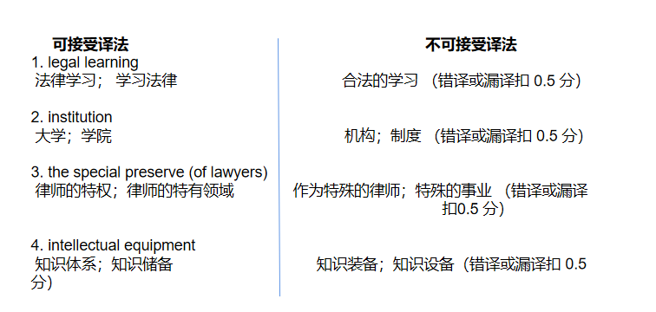

例1. 长久以来，在这类院校中，法律学习被视为律师的专有特权，而不是一个受教育者的知识储备的必要组成部分。

例2. 传统上，法律方面的学习在这些大学中被视为律师的专业课程安排，而不是每一个被教育者的知识储备中必不可少的一部分。

例3. 从传统意义上讲，法律学习在这些学院里一直被看成是只有律师们才应该具有的专业素质，但却不是教育者的智力工具。

例4. 通常讲，作为~~特殊的律师，合法学习~~已经被认为是~~一种制度~~，而不是受教育者的**~~知识设备。~~ 0.5**

例5. 传统教育通常~~反映在一些机构~~如法律中~~指定的~~机构，不是给~~受训者提供一些先进的设备。~~ 0

（二）英语二翻译评分标准

评分标准分为四个分数档：

**第四档（13-15分）：很好地完成了试题规定的任务。理解准确无误；表达通顺清楚；没有错译、漏译。**

第三档（9-12分）：基本完成了试题规定的任务。理解基本准确；表达比较通顺；没有重大错译、漏译。

第二档（5-8分）：未能按要求完成试题规定的任务。理解原文不够准确；表达欠通顺；有明显错译、漏译。

第一档（0-4分）：未完成试题规定的任务。不能理解原文；表达不通顺；**文字支离破碎。**

**以2014年英二翻译真题为例**

**Section III Translation**

**Directions:**

*Translate the following text from English into Chinese. Write your translation on ANSWER SHEET 2. (15 points)*

**Most people would define optimism as endlessly happy, with a glass that’s perpetually half fall.** But that’s exactly the kind of false cheerfulness that positive psychologists wouldn’t recommend. “Healthy optimism means being in touch with reality.” says Tal Ben-Shahar, a Harvard professor, According to Ben- Shalar, realistic optimists are these who make the best of things that happen, but not those who believe everything happens for the best.

Ben-Shalar uses three optimistic exercises. **When he feels down-say, after giving a bad lecture-he grants himself permission to be human.** He reminds himself that **not every lecture can be a Nobel winner;** some will be less effective than others. Next is reconstruction. He analyzes the weak lecture, learning lessons, for the future about what works and what doesn’t. Finally, there is perspective, which involves acknowledging that in the grand scheme of life, one lecture really doesn’t matter.

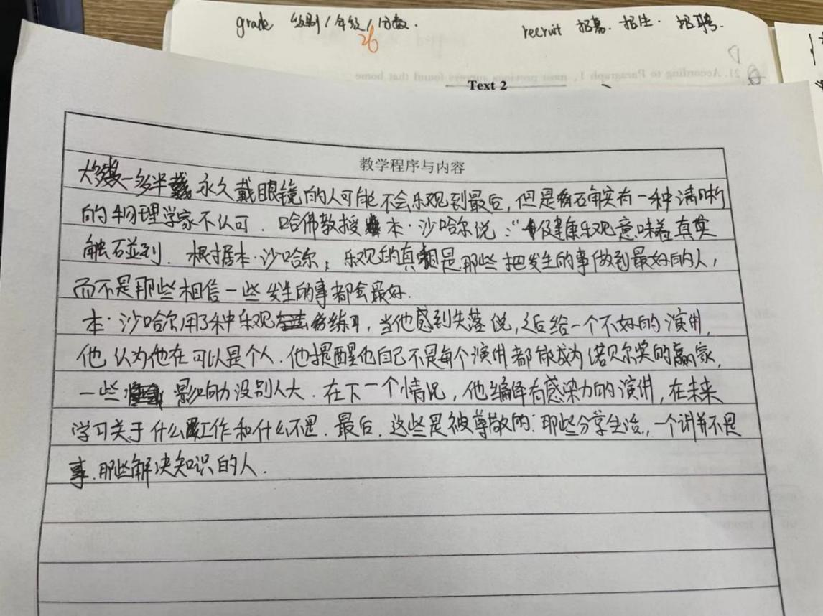

**三、翻译考查要点**

英语一和英语二的考点：

Rate 比率/比例/ 评价

1. 个别**词语在具体语境中的翻译**、固定搭配以及代词的翻译。

2. 谓语动词、非谓语动词。**理清句子结构**

3. 三大从句。（80%必有定从；名词性从句---主、宾、表、同； 副词性从句—状）

4. 被动语态、强调结构、倒装结构、插入结构、比较结构、否定结构（英一考察偏多）、并列结构及省略结构等。

**第二章　翻译方法**

**一、直译**

直译：指在翻译过程中按原文内容逐字逐句一对一的进行翻译，在**译文语言条件许可时，译文尽量保持原文的形式，特别指保持原文的比喻、形象和民族、地方色彩**等。

说出下列词组的意思

例1．detect errors: 察觉错误（2008年, 翻译46题）

例2．moral problems道德问题:（2006年, 翻译46、48题）

例3．factual aspects事实层面:（2006年, 翻译48题）

例4．multi-media groups:多媒体集团（2005年, 翻译47题）

例5．natural selection 自然选择:（2002年, 翻译43题）

**二、意译 free translation**

意译：指译文与原文因表达方式上的差异，不便或无法将原文的思想内容形象、直接表现出来，需要译者抛开原句的句子结构根据原文的意思用自己的话恰如其分地将其译出。

翻译小练习

* Apples and oranges 风马牛不相及
* Teach fish how to swim

班门弄斧/画蛇添足

* Rob Peter to pay Paul 拆东墙补西墙
* Queen's English 标准英语

**诗歌鉴赏**

I love three things in the world.

The sun, the moon, and you.

The sun for morning, moon for night, and you forever.

-------Tagore *Stray Birds*

译文甲：在这个世界我只喜欢三件事，太阳、月亮和你，太阳是为了白天而存在，月亮是为了夜晚，而你对我来说是永恒的。

译文乙：**浮事万千，吾爱有三，日，月，卿。日为朝， 月为暮，卿为朝朝暮暮**。

译文丙：**浮世万千，挚爱有三，喷薄朝阳，皓婉皎月，不及汝尔，沧海桑田。**

1. Let life be beautiful like summer flowers and death like autumn leaves. ----- Tagore

译文： 生如夏花之绚烂， 死如秋叶之静美。---- 郑振铎

1. In me the tiger sniffs the rose.

译文：心有猛虎，细嗅蔷薇。

1. All flowers in late spring have fallen far and wide.

But peach blossoms are full- blown on this mountainside.

1. -----大林寺桃花 白居易

试着翻译以下内容

No one but you.

无人能及你

政治：极个别同志

语文：红尘万千去处，无一不是你

众生皆草木，唯你是青山。

老师：整栋楼就你们班声音最大

经济：也就你来了才有这个价格

弱水三千 只取一瓢

Cream always rises to the top.

是金子总会发光的

I can’t love you in the dark.

------ 歌曲 Adele *love in the dark*

1. 爱你孤身走暗巷
2. 我不接受地下恋。
3. 爱在黎明破晓时
4. 我不能盲目的爱你。
5. 阿珍爱上了阿强，在一个没有星星的夜晚。

例1：When he feels down — say, after giving a bad lecture — **he grants himself permission to be human**.（2014年, 英语二翻译）

**译文：当他感觉到心情低落时——比如说，在搞砸了一场讲座之后，他告诉自己是人都会犯错的。**

**这是人之常情。**

**人非圣贤 孰能无过**

例2：Comment and reaction **from lawyers** may **enhance提升 stories故事/报道**.（2007年, 翻译50题） 虽无其形 但有其意

**译文：来自律师的评论和反映提升了报道的真实性/质量/信度。**

**三、遵循策略**

（一）尽量采用直译

Humans have the ability to modify改造/改变 the environment //**in which they live.**（2003年, 翻译41题）

**译文： 人类有能力改造自己所居住的环境**

（二）不宜直译才意译

Many papers报社 stayed **afloat**维持生计/维持经营 by pushing **journalists** overboard. （2011年, 英语二Text2）

**译文：许多报社通过裁掉记者来维持运营。**

（三）必要时直译意译相结合

You know every twist and turn like the back of your hand.（2015年, 英语二翻译）

**译文：你对每一处的曲曲折折都了如指掌。**

**第三章　词法翻译技巧**

词是构成句子的基本单位，因此词的翻译至关重要，我们可以采用词义选择法、词性转换法、增词法、省略法和代词指代法，其中词义选择法最为重要。

**第一节　词义选择法**

英汉两种语言都有一词多性、一词多义的现象。一词多性是指一个词往往属于几个词性，具有几个不同的意义；一词多义是指同一个词性中，又往往有几种不同的释义。

**一、词性不同、词义不同**

1. 以“**light**”一词为例，指出其词性和词义

(1) This light is too poor to read by. 光线 n.

(2) Aluminum is a light metal. 轻的 n.

(3) Will you light the fire for me? 点燃 v.

Lighten 减轻

Cloud n.云 v.掩盖/遮住/玷污

Cloud the reputation 玷污名誉

Weather n.天气； v.渡过

Dog n.狗； v.跟踪

Doctor n.医生/博士； v. 伪造

Cook evidence捏造证据

manufacture report 编造报告

补充上文：

**In 1881, however, he said: “Now for many years I cannot endure to read a line of poetry. I have also almost lost my taste for pictures or music.”**

2. Darwin was convinced that the loss of these **tastes** 爱好 was not only a loss of happiness, but might possibly be injurious to the intellect, and more probably to the moral character.（2008年, 翻译50题）

* Taste 作为名词还有哪些含义？

1. He has a good **taste品味** in clothes.
2. Don’t be shy, have a **taste尝一下**!
3. The perfume has a unique **taste味道**.

二、词性相同词义不同

An **elegant** lady 优雅的女性

An **elegant** skin 细腻的皮肤

An elegant program 严密的项目

词本无义，义由境生

以“**head**”为例，指出其词义

(1) He was badly wounded in the head.头部

(2) He has a good head for mathematics. 头脑/天赋

(3) He was standing at the head of the staircase.楼梯口

(4) Present at the meeting were the heads of government of the four countries. 首脑

(5) Go and ask the head of our department.领导

**分析下列句中划线单词的意思：**

1. He analyzes the weak**虚弱/糟糕** lecture, learning lessons for the future about what works and what doesn’t.（2014, 英语二翻译）

2. By 1987 there was only one American television maker left, Zenith. (Now there is none: Zenith was bought收购 by South Korea’s LG Electronics in July.)（2000年, Text 1）

兼并：buy/ merge / acquire / incorporate / combine/ consolidate

3. Lots of Americans bought相信/买账 that nonsense, and over three decades, some 10 million smokers went to early graves.（2005年, Text 2）

**第二节　词性转换法**

不同语言互译过程中，**源语言和目标语言的词性难以做到完全对等，**因而要对源语言某些用词的词性进行调整，以符合目标语言的思维方式和表达习惯。

**一、**动/名/形/副实词之间可以相互转化

1. We were caught up in a discussion（**N---V**） about the situation in Afghanistan when the professor walked into the classroom.

英文多静态、汉语多动态

表达动词的时候，英文偏向于**使用名词、动名词、 介词、名词性**的短语；中文大多使用动作本身表示动词

With long hair, bear, scandal and noise.

留着长头发、蓄着胡须、穿着拖鞋、发出噪音

越过山丘、爬上高山、穿过草地、跨过河流**来到**这里。

Beyond the hill, up the mountain, across the grassland and over the river, he came here.

2. He has long been used to last-minute decisionsN--- V. 做决定.

3. The university aims at the first rate of the world.

V--- N 瞄准---- 目标

4. Darwin was convinced that the loss of these tastes was not only a loss of happiness, but might possibly **be injurious to** the intellect, and more probably to the moral character.（2008年, 翻译50题） adj—v

对…有害； 不利于…

  Be injurious to / be harmful to / be unbeneficial for / be poisonous to / be detrimental for / adverse

Exert XXX influence on…

5. No boy //who **went to** a grammar school **could be** ignorant 无知的 that the drama was a form of literature….（2018年, 翻译47题） adj.--- V

  上过文法学校的人都知道：

6. Internally the earth consists of two parts, a core and a mantle.

Adv---- N

**二、**介词可以转化为动词

1. Many laboratories are developing研发 medicines against对抗 AIDS.

2. Millions of people in the mountain areas are finally off 脱离了poverty.

**第三节　增词法**

所谓增词法，就是在翻译时根据意义上或句法上的需要，增加一些词来更加忠实通顺地表达原文的意思。这当然不是无中生有地随意增词，而是**增加原文中虽无其词而有其意的一些词。**

因此，在英译汉过程中，为了使译文更加清楚地表达出原文的意思，为了修辞上的需要，可以根据情况**增加动词、形容词、副词、名词、以及表达时态的词、语气助词、量词等。**

**一、增译虽无其形但有其义的内容**

1. He dismissed解散了 the meeting **without a closing speech.**

**他解散了会议，没有致闭幕词**

  增译动词

2. Flowers bloom all over the yard.

增译量词

Agreement 协议

Agreements 多项协议

3. IQ tests ask you to complete verbal and visual analogies, to envision **paper** after it has been folded and cut, and to deduce numerical sequences, among other similar tasks.（2007年, Text 2） 纸--- 纸的样子

增译了具体内容

4. The second,

by

Joseph Greenberg, takes a more empirical经验主义 approach to universality,

约瑟夫·格林伯格采用了更为经验主义的方式来 XX 普遍性。

诠释/ 验证/ 研究/ 证明

identifying traits (particularly in word order) shared by many languages, which are considered to represent biases that result from cognitive constraints.（2012年, 翻译49题）

**二、增译表示具体内容的词**

to innovate革新   innovation 革新制度/方式

to evolve进化 evolution 进化过程

to solve 解决   solution 解决方案

to derive推导 derivation 推导过程

to persuade说服 persuasion 说服力

to prepare准备 preparation 准备工作

backward落后 backwardness落后状态/面貌

tense紧张 tension 紧张局势

1. He discussed greatness and excellence**的事物/品质/人物.**

**三、增译表示时态的内容**

英语动词的时态变化主要通过下列两种方式：①动词词形的变化 ②加“助动词”；而汉语动词没有形式的变化，表达时态要靠增加汉语特有的“时态助词”或“表示时间的词”。

**完成时往往要增加“曾”、“已经”等词；**

**进行时要用“在”、“正在”等词；**

**将来时要用“将”、“就”、“要”、“会”、“便”等词。**

1. Man **was, is and always will** be trying to improve his living conditions.

  人类过去、现在、将来都会尝试改善居住环境。

2. Before applying for university I told everyone that I would study journalism, because writing was, and still is, one of my favourite activities. （2017年, 英语二翻译）

3. By the date of his birth Europe **was witnessing那时正见证着** the passing of the religious drama….（2018年, 英语一翻译46题）

**第四节　省略法**

省略法是与增译法相对应的一种翻译方法，即删去不符合目标语言思维习惯、语言习惯和表达方式的词，以避免译文累赘。要注意的是，不能随意使用省译法，省去的词在译文中应属于累赘、重复、可有可无的词。

**The Supreme Court’s decisions on physician-assisted suicide carry important implications for** how medicine seeks to relieve dying patients of pain ~~and suffering.~~（2002年, Text 4）

最高法关于医助死亡的裁决对于用药减轻将死之人的痛苦方面有重大意义。

**第五节　代词指代**

（一）总原则：若直接译为代词没有歧义，就直接译为代词；反之，**就要找出具体指代的名词，并将其还原。**

（二）如何查找所指代词，有两大原则：

**1. 往上文查找，距离最近的核心名词**

**2. 根据句意判断具体的指代**

**真题例句：**

1. Television**is** one of the means 0.5分//定从by which these feelings **are created and conveyed** — 0.5分//and perhaps **it has** **served** so much **never** before**to connect different peoples and nations as正如 in the recent events in Europe** 1分.（2005年, 翻译46题）

 【考点分析】被动语态---主动语态

英汉差异： 英文多被动，汉语多主动

be done by 动作的发出者已知，主宾颠倒翻译

be done 动作的发出者未知，增加通用主语

隐含被动： 被表达被创造--- 得以创造和表达

Never 等否定词 置于句首，句子需要部分倒装，翻译时先还原语序再处理。

后置定语过长，按照介词的位置划开，分别翻译后重组； 倒序翻译； 整体后置定语前置翻译

【句子译文】电视是一种创造和表达情绪的方式，也许电视所发挥的作用如此之大前所未有，**正如在欧洲近期的事件中（所发挥的作用）一样，**能够把不同的民族和国家联系起来。

1. [What is **an** intellectual?] (46) I shall **define him as** an individual 0.5分//定从who **has elected the activity** **of thinking in a Socratic way about moral problems as** his primary duty and pleasure in life. 1.5分

（2006年, 翻译46题）

宾语后置现象⬇️

Regard A as B / treat A as B / View A as B

Regard as BA / treat as BA / View as BA

I treat Tom as my best friend.

I treat as my best friend Tom.

  【考点分析】定从/ 后置定语过长/ 宾语后置还原语序后翻译

【句子译文】我将把知识分子定义为一个个体：他把以苏格拉底的方式思考道德问题的活动当作是人生中首要的责任和快乐。

【词汇拓展】intellectual adj.智慧的/ 智力的

n.知识分子

Intelligence n.智力/情报

Intellect 才智

**第四章　句法翻译技巧**

三大从句的翻译（尤其是定语从句）是翻译高频考点，几乎年年考到，是考研复习的重点。

**第一节　被动语态**

1. **被动语态的识别**

结构： Be done by / be done

形态：be动词+及物动词的过去分词

变化：时态变化只改变be动词的形式，过去分词部分不变。

**二、被动语态的本质**

英语的语态共有两种：主动语态和被动语态。主动语态表示主语是动作的执行者，被动语态表示主语是动作的承受者。被动语态是动词的一种特殊形式，一般来说，只有需要动作对象的及物动词才有被动语态。

中文和英文中都有被动语态，但是中文的被动语态使用频率较少，因此需要在翻译时对其处理。

**三、被动语态的翻译技巧**

（一）被动转主动

1. 主宾颠倒

Television is one of the means by which these feelings are created and conveyed …（2005年, 翻译46题）

2. 介词短语（含有动作发出者）置于句首

Only a small portion of solar energy **is now being used by** human beings.

  人类现在使用了一小部分的太阳能。

3. 无动作发出者，增加通用主语“ 人们、我们、大家”

More work should be done to advance the training of highly skilled talent **in advanced manufacturing and modern services industries.**

4. 省去被动不译/ 隐含被动

(1) Not long ago, with the country entering a recession and Japan at its pre-bubble peak, the U.S. workforce **was derided as** poorly educated...（2009年，Text 3）

(2) Fruit flies **can be taught to** fly toward a certain direction.

（二）保留被动，使用“被”的替代词

包括： **把/ 得以/ 受到/ 遭到/ 得到**

He was awarded the second prize.

1. The role of natural selection in evolution **was formulated** only a little more than a hundred years ago, //and **the selective role** of the environment in shaping and maintaining the behavior of the individual **is only beginning to be recognized and studied**. （2002年, 翻译48题）

【句子译文】仅仅在一百多年前，自然选择在进化中的作用得以形成，而且在塑造和维持个体行为方面环境的选择作用才开始受到认可和研究。

2. In Europe, where forestry is ecologically more advanced先进/发达, **the non-commercial tree** species **are recognized as** members of the native forest community, **to be preserved** as such, within reason.（2010年, 英语一翻译49题）

  在欧洲，生态上林业更为先进，非经济树种**属于**当地的森林群落，应该**予以**合理保护。

**第二节　名词性从句**

当英语句子内容的叙述层次与汉语基本一致时，可以按照英语原文的顺序翻译成汉语。英汉句子中主要成分主语、谓语、宾语、表语或同位语的次序基本上是一致的，所以**英语的名词性从句（主语从句、宾语从句和表语从句、同位语从句）一般都采取顺译**。

**一、主语从句翻译技巧**

1. 主从+ 谓+ 宾

主从+ 系 + 表

**按照原文语序译出**

Whatever he saw and heard on his trip gave him a very deep impression.

1. It + 谓+ 宾 + 主从

It + 系+ 表 + 主从

找到真正的主语，放在最前面（还原语序后）进行翻译； 按照原语序译出也可以

(1) But it’s obvious that a majority of the president’s advisers still don’t **take global warming seriously认真对待.**（2005年, Text 2）

(2) It seemed **inconceivable**难以置信的 that the pilot **could竟然** have survived the crash.

  Could/ should 在疑问句中的意思表示“竟然”

(3) It did not matter what was done in the experiment.（2010年, 完形）

**二、宾语从句翻译技巧（常考）**

1. 常规结构： 主+ 谓+ 宾从

按照原文语序顺译

The Greeks **assumed** //宾从that the structure of language **had** some connection with the process of thought, //非限制性定从which **took root in** Europe //时间状语从句long before people **realized** //宾从how diverse languages **could be.**（2004年, 翻译41题）

 希腊人认为语言的结构和思维过程存在某种联系，早在人们意识到语言有多么丰富之前，**这**就已经根植于欧洲人心中了。

2. 主+ 谓+ it + 宾补 + 宾从

Having endured a painful period of unsustainability in his own life made it clear to him //that sustainability-oriented values **must be expressed through everyday action and choice.**（2010年, 英语二翻译）

在人生中经历了一段痛苦的难以持续的恶时间之后， 让他很清楚：以持续性为导向的价值观必须通过每日的行为和选择来表达。

**三、表语从句翻译技巧**

主+ 系+ 表从

翻译时按照原文语序处理

1. The consequence is //表从that you perceive //宾从that the trip has taken less time than it actually has.（2015年, 英语二翻译）

 比较结构： 比较对象、比较内容、比较结果

2. But it’s not //**as if** earlier times didn’t know perpetual连续不断的/永恒的 war, disaster and the massacre 屠杀 of innocents.（2006年, Text 4）

**四、同位语从句翻译技巧（常考）**

（一）同位语从句识别方法

1. 同位语从句只是对主句中的名词作解释说明，因此主句的成分是完整的。（有别于其他名词性从句）

2. 同位语从句的引导词没有指代作用（有别于定语从句），不能替换成所修饰的名词。

**能接同位语从句的名词主要有**：belief（相信），fact（事实），hope（希望），idea（想法，观点），news（新闻，消息），rumor（传闻），conclusion（结论），evidence（证据），suggestion（建议），problem（问题），order（命令），answer（回答），decision（决定），discovery（发现），explanation（解释），information（消息），knowledge（知识），promise（承诺），opinion（意见，观点），truth（真理，事实）等。

（二）翻译技巧

1. 前置法

___________________________________________________________________

But the idea that the journalist must understand the law more profoundly than an ordinary citizen rests on an understanding of the established conventions and special responsibilities of the news media.（2007年, 翻译48题）

2. 后置法

___________________________________________________________________

Allen’s contribution was to take an assumption we all share — that because we are not robots we therefore control our thoughts — and reveal its erroneous nature.（2011年, 英语一翻译46题）

**第三节　定语从句**

在英语中，定语从句的位置一般是在其所修饰的先行词后面。限制性定语从句与非限制性定语从句的区别只在于限制意义的强弱；而汉语中定语作为修饰语通常在其所修饰的词前面，并且没有限制意义的强弱之分，因此，限制与非限制在翻译中并不起十分重要的作用。英语中多用结构复杂的定语从句，而汉语中修饰语则不宜臃肿。所以，在翻译定语从句时，一定要考虑到汉语的表达习惯。如果英语的定语从句太长，无论是限制性的或非限制性的，都不宜译成汉语中的定语，而应通过其他方法处理。以下将介绍定语从句的识别方法以及其常见的翻译方法。

**一、定语从句识别方法**

1. 修饰名词、代词或句子等的从句叫定语从句，被修饰的名词或代词叫**先行词**，定语从句放在先行词的后面。引导定语从句的词有**关系代词**（that，which，who, whom，whose，as）和**关系副词**（when，where，why），其中，**关系副词=介词+which。**在限制性定语从句中，**关系词**指代**先行词**，在定语从句中**充当某个成分；**在非限制性定语从句中，关系词指代先行词或前面的句子，中间用逗号隔开，在从句中充当某个成分。非限制性定语从句修饰整个句子时，关系词只能用which或as。

2. **关系词替换成先行词之后，定语从句仍是完整的一句话，**即为限制性定语从句。

**限制性定语从句：**

例1. He adds humbly that perhaps he was “superior to the common run of men in noticing **things** // **which easily escape attention**, and in observing them carefully.”（2008年, 翻译49题）

例2. Furthermore, humans have the ability to modify **the environment**// **in which they live**, thus subjecting all other life forms to their own peculiar ideas and fancies.（2003年, 翻译41题）

**非限制性定语从句：**

例1. **Today’s vessels can find their prey using satellites and sonar**, // **which** were not available 50 years ago.（2006年, Text 3）

例2. Dr. Myers and Dr. Worm argue that their work gives **a correct baseline**, // **which**future management efforts must take into account.（2006年, Text 3）

**二、定语从句翻译技巧**

**（一）前置法**

**定义**：_______________________________________________________________

_____________________________________________________________________

**前提**：_______________________________________________________________

1. So I decided to look for some fashion-related courses that included writing.（2017年, 英语二翻译）

2. Everybody wants to know how the people who will soon inhabit those empty office cubicles will differ from those who came before them.（2020年, 英语二Text 4）

3. But his primary task is not to think about the moral code which governs his activity, any more than a businessman is expected to dedicate his energies to an exploration of rules of conduct in business.（2006年, 翻译49题）

4. They may teach very well and more than earn their salaries, but most of them make little or no independent reflections on human problems which involve moral judgment.（2006年, 翻译50题）

**（二）后置法**

**定义：**_______________________________________________________________

_____________________________________________________________________

**前提**：_______________________________________________________________

1. They fear that it hurts their economies, depriving them of much-needed skilled workers who could have taught at their universities, worked in their hospitals and come up with clever new products for their factories to make.（2012年, 英语二翻译）

2. Social science is that branch of intellectual enquiry which seeks to study humans and their endeavors in the same reasoned, orderly, systematic, and dispassioned manner that natural scientists use for the study of natural phenomena.（2003年, 翻译42题）

3. Tylor defined culture as “... that complex whole which includes belief, art, morals, law, custom, and any other capabilities and habits acquired by man as a member of society.”（2003年, 翻译44题）

4. Especially significant was his view of freedom, which, for him, was associated with the rights and responsibilities of the individual: he advocated freedom of thought and of personal expression.（2014年, 翻译49题）

**第四节　状语从句**

状语从句表示时间、原因、条件、让步和目的等。英语的状语从句用在主句后面的较多，而汉语的状语从句用在主句前的较多。因此，在许多情况下应将状语从句放在主句前面翻译。

1. When our ancestors were hunters and gatherers 10,000 years ago, they didn’t have time to wonder much about anything besides finding food. （2009年, Text 3）

2. While comment and reaction from lawyers may enhance stories, it is preferable for journalists to rely on their own notions of significance and make their own judgments.（2007年, 翻译50题）

3. We are obliged to them because some of these languages have since vanished, as the peoples who spoke them died out or became assimilated and lost their native languages.（2004年, 翻译42题）

4. However, when two monkeys were placed in separate but adjoining chambers, so that each could observe what the other was getting in return for its rock, their behaviour became markedly different.（2005年, Text 1）

5. The newly described languages were often so strikingly different from the well studied languages of Europe and Southeast Asia that some scholars even accused Boas and Sapir of fabricating their data.（2004年, 翻译43题）

6. The boy is convinced that if he reads enough, he can explore as many career paths as he likes.（2018年, 英语二翻译）

7. Beethoven’s music tends to move from chaos to order as if order were an imperative of human existence.（2015年，英语一翻译）

8. Studies of both animals and humans have shown that sex hormones somehow affect the stress response, causing females under stress to produce more of the trigger chemicals than do males under the same conditions.（2008年, Text 1）

**第五章　实战演练**

**第一节　翻译的步骤**

**一、两种情况需要参照上下文**

（一）____________________

（二）____________________

**二、翻译步骤**

**第二节　真题演练**

**2011年考研英语（二）翻译真题**

Who would have thought that, globally, the IT industry produces about the same volume of greenhouse gases as the world’s airlines do — roughly 2 percent of all CO2 emissions?

Many everyday tasks take a surprising toll on the environment. A Google search can leak between 0.2 and 7.0 grams of CO2, depending on how many attempts are needed to get the “right” answer. To deliver results to its users quickly, then, Google has to maintain vast data centres around the world, packed with powerful computers. While producing large quantities of CO2, these computers emit a great deal of heat, so the centres need to be well air-conditioned, which uses even more energy.

However, Google and other big tech providers monitor their efficiency closely and make improvements. Monitoring is the first step on the road to reduction, but there is much more to be done, and not just by big companies.

**2008年考研英语翻译真题**

In his autobiography, Darwin himself speaks of his intellectual powers with extraordinary modesty. He points out that he always experienced much difficulty in expressing himself clearly and concisely, but (46) he believes that this very difficulty may have had the compensating advantage of forcing him to think long and intently about every sentence, and thus enabling him to detect errors in reasoning and in his own observations. He disclaimed the possession of any great quickness of apprehension or wit, such as distinguished Huxley. (47) He asserted, also, that his power to follow a long and purely abstract train of thought was very limited, for which reason he felt certain that he never could have succeeded with mathematics. His memory, too, he described as extensive, but hazy. So poor in one sense was it that he never could remember for more than a few days a single date or a line of poetry. (48) On the other hand, he did not accept as well founded the charge made by some of his critics that, while he was a good observer, he had no power of reasoning. This, he thought, could not be true, because the “Origin of Species” is one long argument from the beginning to the end, and has convinced many able men. No one, he submits, could have written it without possessing some power of reasoning. He was willing to assert that “I have a fair share of invention, and of common sense or judgment, such as every fairly successful lawyer or doctor must have, but not, I believe, in any higher degree.” (49) He adds humbly that perhaps he was “superior to the common run of men in noticing things which easily escape attention, and in observing them carefully.”

Writing in the last year of his life, he expressed the opinion that in two or three respects his mind had changed during the preceding twenty or thirty years. Up to the age of thirty or beyond it poetry of many kinds gave him great pleasure. Formerly, too, pictures had given him considerable, and music very great, delight. In 1881, however, he said: “Now for many years I cannot endure to read a line of poetry. I have also almost lost my taste for pictures or music.” (50) Darwin was convinced that the loss of these tastes was not only a loss of happiness, but might possibly be injurious to the intellect, and more probably to the moral character.

46._______________________________________________________________________________________________________________________________________

47._______________________________________________________________________________________________________________________________________

48._______________________________________________________________________________________________________________________________________

49._______________________________________________________________________________________________________________________________________

50._______________________________________________________________________________________________________________________________________

**2009年考研英语翻译真题**

There is a marked difference between the education which every one gets from living with others and the deliberate educating of the young. In the former case the education is incidental; it is natural and important, but it is not the express reason of the association. (46) It may be said that the measure of the worth of any social institution is its effect in enlarging and improving experience, but this effect is not a part of its original motive. Religious associations began, for example, in the desire to secure the favor of overruling powers and to ward off evil influences; family life in the desire to gratify appetites and secure family perpetuity; systematic labor, for the most part, because of enslavement to others, etc. (47) Only gradually was the by-product of the institution noted, and only more gradually still was this effect considered as a directive factor in the conduct of the institution. Even today, in our industrial life, apart from certain values of industriousness and thrift, the intellectual and emotional reaction of the forms of human association under which the world’s work is carried on receives little attention as compared with physical output.

But in dealing with the young, the fact of association itself as an immediate human fact, gains in importance. (48) While it is easy to ignore in our contact with them the effect of our acts upon their disposition, it is not so easy as in dealing with adults. The need of training is too evident and the pressure to accomplish a change in their attitude and habits is too urgent to leave these consequences wholly out of account. (49) Since our chief business with them is to enable them to share in a common life we cannot help considering whether or not we are forming the powers which will secure this ability. If humanity has made some headway in realizing that the ultimate value of every institution is its distinctively human effect we may well believe that this lesson has been learned largely through dealings with the young.

(50) We are thus led to distinguish, within the broad educational process which we have been so far considering, a more formal kind of education — that of direct tuition or schooling. In undeveloped social groups, we find very little formal teaching and training. These groups mainly rely for instilling needed dispositions into the young upon the same sort of association which keeps adults loyal to their group.

46._______________________________________________________________________________________________________________________________________

47._______________________________________________________________________________________________________________________________________

48._______________________________________________________________________________________________________________________________________

49._______________________________________________________________________________________________________________________________________

50._______________________________________________________________________________________________________________________________________

**第六章　专项演练**

**（一）2006年考研英语翻译真题**

Is it true that the American intellectual is rejected and considered of no account in his society? I am going to suggest that it is not true. Father Bruckberger told part of the story when he observed that it is the intellectuals who have rejected America. But they have done more than that. They have grown dissatisfied with the role of the intellectual. It is they, not America, who have become anti-intellectual.

First, the object of our study pleads for definition. What is an intellectual? (46) I shall define him as an individual who has elected as his primary duty and pleasure in life the activity of thinking in a Socratic (苏格拉底的) way about moral problems. He explores such problems consciously, articulately, and frankly, first by asking factual questions, then by asking moral questions, finally by suggesting action which seems appropriate in the light of the factual and moral information which he has obtained. (47) His function is analogous to that of a judge, who must accept the obligation of revealing in as obvious a manner as possible the course of reasoning which led him to his decision.

This definition excludes many individuals usually referred to as intellectuals — the average scientist, for one. (48) I have excluded him because, while his accomplishments may contribute to the solution of moral problems, he has not been charged with the task of approaching any but the factual aspects of those problems. Like other human beings, he encounters moral issues even in the everyday performance of his routine duties — he is not supposed to cook his experiments, manufacture evidence, or doctor his reports. (49) But his primary task is not to think about the moral code which governs his activity, any more than a businessman is expected to dedicate his energies to an exploration of rules of conduct in business. During most of his waking life he will take his code for granted, as the businessman takes his ethics.

The definition also excludes the majority of teachers, despite the fact that teaching has traditionally been the method whereby many intellectuals earn their living. (50) They may teach very well, and more than earn their salaries, but most of them make little or no independent reflections on human problems which involve moral judgment. This description even fits the majority of eminent scholars. Being learned in some branch of human knowledge is one thing; living in “public and illustrious thoughts”, as Emerson would say, is something else.

46.

47.

48.

49.

50.