ITEC 621 - Homework 1 - R and Stats Refresher

Kogod School of Business

O’Malley, Conie

19 Jan 2025

Table of Contents

## Q1 - Functions and Loops (12.5 pts.)

Write a simple R function named area() that takes 2 values as input parameters (representing the two sides of a rectangle) and returns the product of the two values (representing the rectangle’s area).

Then use the functions print() and paste() to output this result: **“The area of a rectangle of sides 6x4 is 24”**, where 24 is calculated with the area() function you just created (not a fixed number). That is, the area() function you created, **must appear** inside the print(paste()) function.

area <- function(x, y){ # create a function with 2 input parameters  
 z = x*y # calculate area  
 print(paste("The area of a rectangle of sides", x, "x", y, "is", z)) # print phrase with calculations  
}  
  
area(6,4) # function test

## [1] "The area of a rectangle of sides 6 x 4 is 24"

Write a simple **for loop** for i from **1 to 10** to compute **squared** values for the numbers 1 through 10. In each loop pass, compute the square of i (i.e., i^2) and in each case, display **exactly** “The square of 1 is 1” for i=1, “The square of 2 is 4” for i=2, and so on. You must use the functions pring(paste()) and the formula i^2 to display your results.

for (i in 1:10){ # for loop range  
 a = i**2 # calculate squares  
 print(paste("The square of", i, "is", a)) # print phrase with calculations   
}

## [1] "The square of 1 is 1"  
## [1] "The square of 2 is 4"  
## [1] "The square of 3 is 9"  
## [1] "The square of 4 is 16"  
## [1] "The square of 5 is 25"  
## [1] "The square of 6 is 36"  
## [1] "The square of 7 is 49"  
## [1] "The square of 8 is 64"  
## [1] "The square of 9 is 81"  
## [1] "The square of 10 is 100"

## Q2 - Data Frames and Vectors (12.5 pts.)

We suspect that income and loan balance may predict the credit rating of a bank’s customer. Let’s explore. Copy the Credit.csv data file to your working directory, then:

Read the Credit.csv data table into a data frame named “Credit” (tip: use the read.table() function with the appropriate header= and sep= attributes)

Display (only) the **first 10 rows** of (only) the Rating, Income and Balance columns. Use the cbind() function to bind the 3 columns and ensure that your columns have labels (e.g. “Rating”=Credit$Rating[1:10], etc.).

read.table("Credit.csv", header = TRUE, sep = ",") -> Credit # read data into table  
  
cbind("Rating" = Credit$Rating[1:10], # display required columns  
 "Income" = Credit$Income[1:10],  
 "Balance" = Credit$Balance[1:10])

## Rating Income Balance  
## [1,] 283 14.891 333  
## [2,] 483 106.025 903  
## [3,] 514 104.593 580  
## [4,] 681 148.924 964  
## [5,] 357 55.882 331  
## [6,] 569 80.180 1151  
## [7,] 259 20.996 203  
## [8,] 512 71.408 872  
## [9,] 266 15.125 279  
## [10,] 491 71.061 1350

Then, display the object class for the Credit data frame and for the vectors Gender (i.e., Credit$Gender), Income and Cards

class(Credit) # obtain class of Credit

## [1] "data.frame"

class(Credit$Gender) # obtain class of Gender

## [1] "character"

class(Credit$Income) # obtain class of Income

## [1] "numeric"

class(Credit$Cards) # obtain class of Cards

## [1] "integer"

Finally, create a vector named **Rating.vect** with data from the Rating column and display the first 6 values of this vector.

Rating.vect <- Credit$Rating # assign vector  
Rating.vect[1:6] # display first 6 values

## [1] 283 483 514 681 357 569

## Q3. Descriptive Analytics (12.5 pts.)

Let’s analyze the data quantitatively. Compute the **mean, minimum, maximum, standard deviation** and **variance** for all the values in this Rating.vect vector. Store the results in variables named **rtg.mean, rtg.min, rtg.min, rtg.stdev** and **rtg.var** respectively. Then use the c() function to concatenate the 5 results into a vector, but name each of the values accordingly (e.g., “Mean Rtg”=rtg.mean). Also, enclose the c() function inside the print() function and use digits=5 to limit the significant digits to display (to 2 decimals) (e.g., print(c(...), digits=5))

rtg.mean <- mean(Rating.vect)  
rtg.min <- min(Rating.vect)  
rtg.max <- max(Rating.vect)  
rtg.stdev <- sd(Rating.vect)  
rtg.var <- var(Rating.vect)  
print(c("Mean Rtg" = rtg.mean, "Min Rtg" = rtg.min, "Max Rtg" = rtg.max, "StDev Rtg" = rtg.stdev, "Var Rtg" = rtg.var), digits = 5)

## Mean Rtg Min Rtg Max Rtg StDev Rtg Var Rtg   
## 354.94 93.00 982.00 154.72 23939.56

Divide the plot output into 1 row and 2 columns to display 2 graphs side by side using par(mfrow=c(1,2)). Display a histogram for **Credit Rating**, with the main title **Credit Rating Histogram** and X label **Rating**. Since the histogram is a bit skewed to the right, display a histogram for the **Log of Credit Rating**, with the main title **Log of Credit Rating Histogram** and X label **Log Rating**. Tip: use the log() function (lower case) to log variables. Then, reset the graph layout to 1 by 1 using par(mfrow=c(1,1)).

**Technical Note:** Notice that we divide the plot window to display 2 graphs side by side and then reset to the normal window to a single plot, and we then do this repeatedly for every exercise below. This is only necessary so that when you press the play icon for the chunk, you can see the 2 graphs side by side. If you don’t want to do this repeatedly, you could set the window for the first pair of plots and reset it after the last pair of plots. The play icon will not give you side by side graphs, but the knitted document should show the graphs side by side. Can you figure out why? (no need to answer, just think)

**Technical note:** also note in the HW template that I have sized the graphs to fig.width=10, fig.height=6. You can change this if you prefer a different graph size.

#par(mfrow=c(1,2)) # set parameters  
par(mfrow=c(1,1)) # reset parameters  
  
hist(Credit$Rating, main = "Credit Rating Histogram", xlab = "Rating", ylab = NULL) # initial histogram

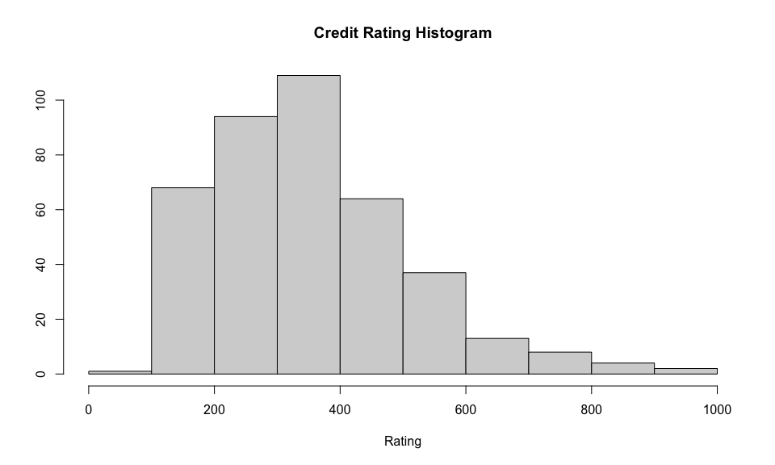

hist(log(Credit$Rating), main = "Log of Credit Rating Histogram", xlab = "Log Rating", ylab = NULL) # log histogram to address skewness

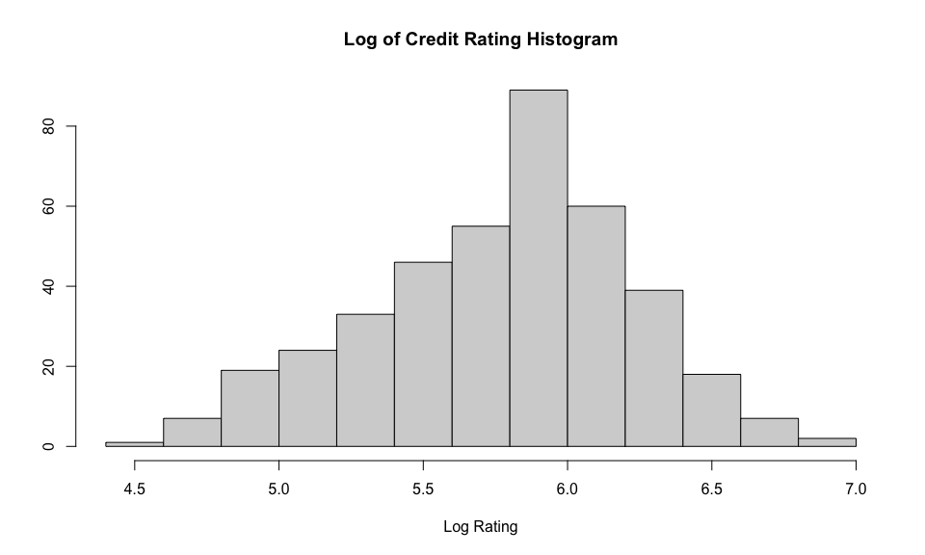

## Q4. Visual Analytics (12.5 pts.)

Let’s do some visual inspection of the data. Divide the plot output into 1 row and 2 columns to display 2 graphs side by side using par(mfrow=c(1,2)). Then display a box plot for **Rating** by **Gender**, and then another box plot for **Balance** by **Student**. Then, reset the graph layout to 1 by 1 using par(mfrow=c(1,1)).

#par(mfrow=c(1,2)) # set parameters  
par(mfrow=c(1,1)) # reset parameters  
  
boxplot(Credit$Rating~Credit$Gender, main = "Box Plot by Gender", xlab = "Gender", ylab = "Credit Rating") # gender boxplot

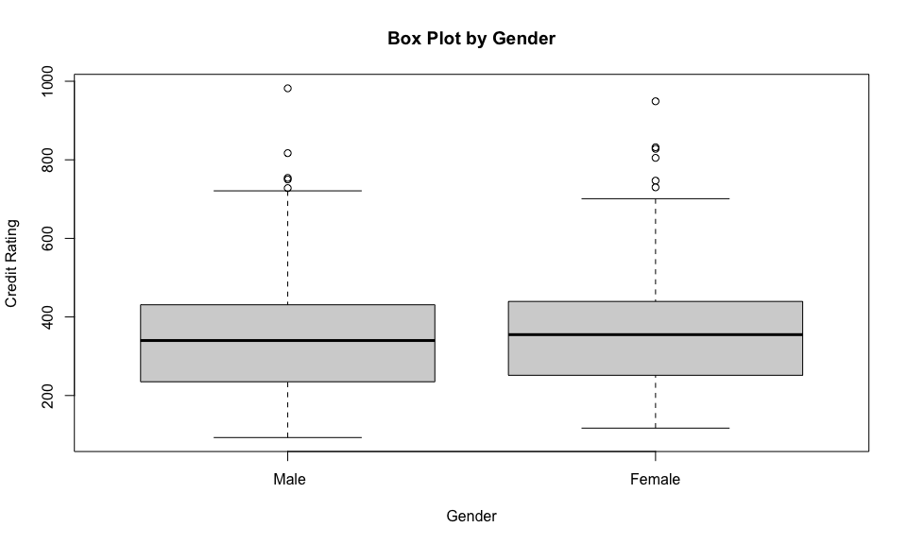

boxplot(Credit$Rating~Credit$Student, main = "Box Plot by Student", xlab = "Student", ylab = "Credit Rating") # student boxplot

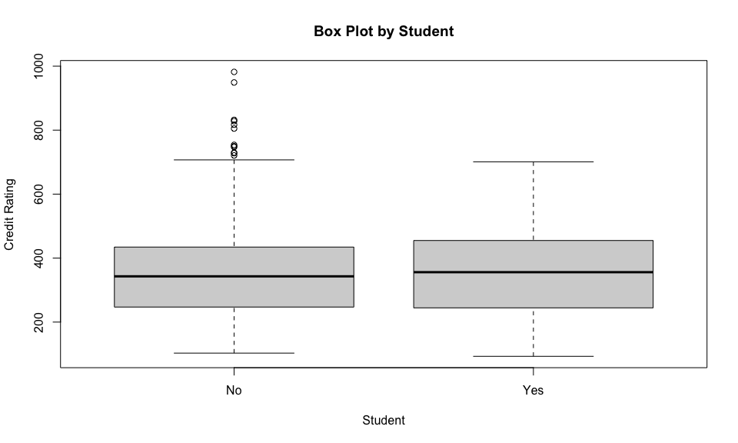

Divide again the plot output into 1 row and 2 columns to display 2 graphs side by side using par(mfrow=c(1,2)). Then plot Credit **Rating** (Y axis) against **Income** (X axis), with respective labels **Income** and **Credit Rating**. Then another plot for Credit **Rating** (Y axis) against **Balance** (X axis), with respective labels **Credit Rating** and **Balance**. Then, reset the graph layout to 1 by 1 using par(mfrow=c(1,1)).

#par(mfrow=c(1,2)) # set parameters  
par(mfrow=c(1,1)) # reset parameters  
plot(Credit$Income, Credit$Rating, main = "Income vs. Credit Rating Plot", xlab = "Income", ylab = "Credit Rating") # income vs. credit rating plot

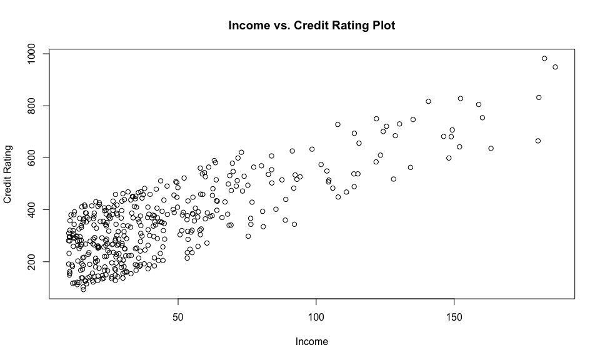

plot(Credit$Balance, Credit$Rating, main = "Balance vs. Credit Rating Plot", xlab = "Income", ylab = "Credit Rating") # balance vs. credit rating plot

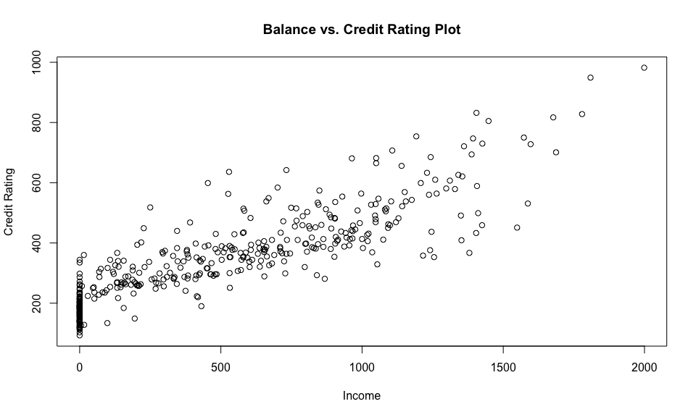

Again, divide the plot output into 1 row and 2 columns to display 2 graphs side by side using par(mfrow=c(1,2)). Display a qqplot (using the qqnorm() function and qqline()) for the credit rating variable, with the main title **Credit Rating QQ PLot** (use the main= attribute). Since the QQ Plot shows some deviation from the normal distribution line, display a QQ Plot for the **Log of Credit Rating**, with the main title **Log of Credit Rating QQ PLot** and X label **Log Rating**. Then, reset the graph layout to 1 by 1 using par(mfrow=c(1,1)). It looks more normally distributed, right?

#par(mfrow=c(1,2)) # set parameters  
par(mfrow=c(1,1)) # reset parameters  
  
qqnorm(Credit$Rating, main = "Credit Rating QQ Plot", xlab = "Theoretical Quantiles", ylab = "Sample Quantiles")  
qqline(Credit$Rating, col = "red")

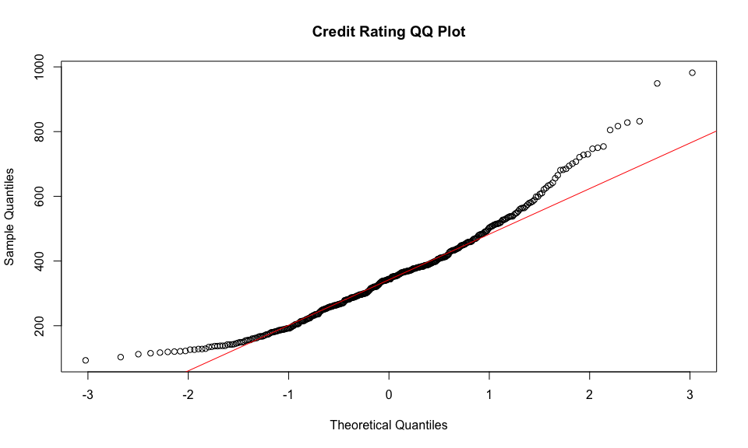

qqnorm(log(Credit$Rating), main = "Log of Credit Rating QQ Plot", xlab = "Log Rating", ylab = "Sample Quantiles")  
qqline(log(Credit$Rating), col = "red")

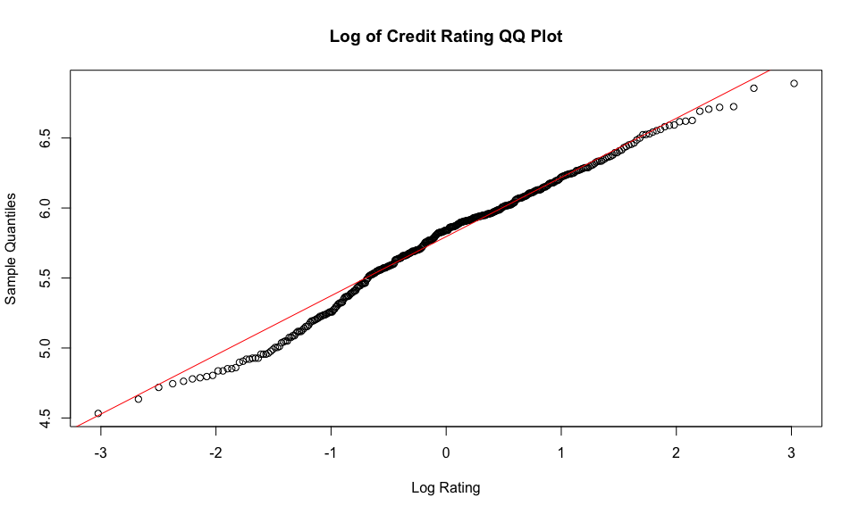

## Q5. {ggplot} Graphs (12.5 pts.)

**{ggplot2}** is one of the best visual analytic packages out there. Let’s explore it briefly. Load the **{ggplot2}** library.

***Note:*** ggplot() renders one plot at a time, so there is no need to split the plot window into more than one row or column.

Then, use the ggplot() function to draw a histogram of the **Rating** variable and then draw another histogram for **log(Rating)**. Tip: you need to use ggplot(Credit) first to point to the data set you want to use. You then need to add the necessary graph attributes with the **+** operator. In this case you need to use the geom_histogram(aes(etc.)) graph attribute and aesthetic.

Then, use the ggplot() function again to draw a couple of scatter plots. In the first one, plot **Income** (x axis) against **Rating** (y axis), but separated by **Gender**. Tip, use ggplot(Credit, aes(x=Income, y=Rating)) to use the 2 variable plot aesthetic with the **Credit** data set. Then add geom_point() to draw a scatter plot, and then add facet_wrap(~Gender) to draw two **facets by Gender**.

Then draw a similar scatter plot, but this time use **Balance** (x axis) by **Rating** (y axis), faceted by **Student**.

ggplot(Credit, aes(Rating)) +   
 geom_histogram(color = "black", fill = "grey") + # adjust histogram aesthetics  
 labs(title = "Rating Histogram", y = NULL) + # label updates  
 theme(plot.title = element_text(hjust = 0.5)) # label adjustment

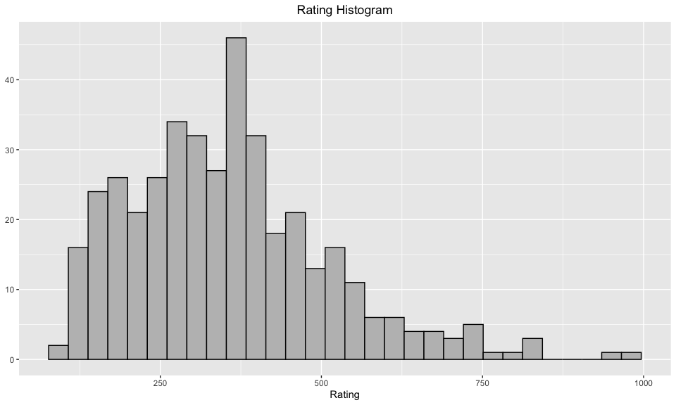

ggplot(Credit, aes(Income, Rating)) +  
 geom_point() + # scatterplot  
 labs(title = "Income vs. Rating Scatterplot", x = "Income", y = "Credit Rating") + # label updates  
 facet_wrap(~Gender) + # gender facet wrap  
 theme(plot.title = element_text(hjust = 0.5)) # label adjustment

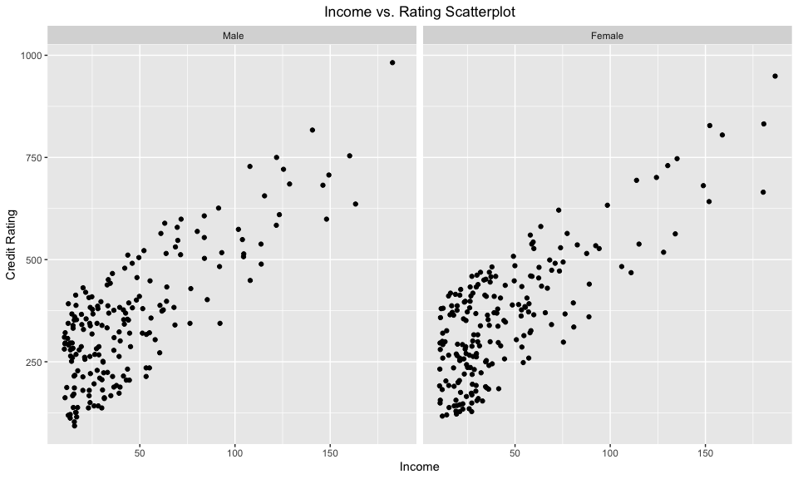

ggplot(Credit, aes(Balance, Rating)) +  
 geom_point() + # scatterplot  
 labs(title = "Balance vs. Rating Scatterplot", x = "Balance", y = "Credit Rating") + # label updates  
 facet_wrap(~Student) + # student facet wrap  
 theme(plot.title = element_text(hjust = 0.5)) # label adjustment

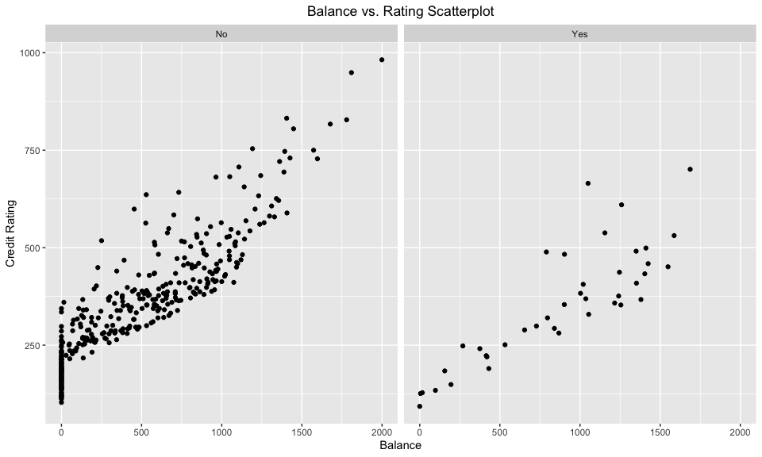

## Q6. Linear Regression Models (12.5 pts.)

Fit a **small** linear regression model object with the lm() function to predict credit **Rating** using **Income** and **Balance** as predictors. Name the resulting linear model **fit.small**. Then display the summary() results.

fit.small <- lm(Rating ~ Income + Balance, Credit) # build a lm model  
summary(fit.small) # compute summary statistics

##   
## Call:  
## lm(formula = Rating ~ Income + Balance, data = Credit)  
##   
## Residuals:  
## Min 1Q Median 3Q Max   
## -103.485 -9.665 14.543 24.576 53.931   
##   
## Coefficients:  
## Estimate Std. Error t value Pr(>|t|)   
## (Intercept) 1.454e+02 3.285e+00 44.25 <2e-16 ***  
## Income 2.186e+00 6.063e-02 36.06 <2e-16 ***  
## Balance 2.129e-01 4.648e-03 45.81 <2e-16 ***  
## ---  
## Signif. codes: 0 '***' 0.001 '**' 0.01 '*' 0.05 '.' 0.1 ' ' 1  
##   
## Residual standard error: 37.82 on 397 degrees of freedom  
## Multiple R-squared: 0.9405, Adjusted R-squared: 0.9402   
## F-statistic: 3140 on 2 and 397 DF, p-value: < 2.2e-16

Now fit a larger linear regression model, same as **fit.small**, but add 2 more predictors this time, **Age** and **Gender**. Name the resulting linear model **fit.large**. Then display the summary() results.

fit.large <- lm(Rating ~ Income + Balance + Age + Gender, Credit) # build a lm model  
summary(fit.large) # compute summary statistics

##   
## Call:  
## lm(formula = Rating ~ Income + Balance + Age + Gender, data = Credit)  
##   
## Residuals:  
## Min 1Q Median 3Q Max   
## -104.760 -9.683 14.686 24.959 50.408   
##   
## Coefficients:  
## Estimate Std. Error t value Pr(>|t|)   
## (Intercept) 1.380e+02 7.022e+00 19.660 <2e-16 ***  
## Income 2.171e+00 6.190e-02 35.078 <2e-16 ***  
## Balance 2.134e-01 4.673e-03 45.680 <2e-16 ***  
## Age 1.370e-01 1.120e-01 1.223 0.222   
## GenderFemale 1.591e-01 3.789e+00 0.042 0.967   
## ---  
## Signif. codes: 0 '***' 0.001 '**' 0.01 '*' 0.05 '.' 0.1 ' ' 1  
##   
## Residual standard error: 37.84 on 395 degrees of freedom  
## Multiple R-squared: 0.9408, Adjusted R-squared: 0.9402   
## F-statistic: 1569 on 4 and 395 DF, p-value: < 2.2e-16

## Q7. ANOVA (12.5 pts.)

Do an anova() test to evaluate if **fit.large** has significantly more predictive power than **fit.small**.

Then provide a brief **interpretation** of your results for Q5, Q6 and Q7. Which predictors are significant? which are not? and why? which of the two models is preferred? why?

anova(fit.small) # anova of small model

## Analysis of Variance Table  
##   
## Response: Rating  
## Df Sum Sq Mean Sq F value Pr(>F)   
## Income 1 5982140 5982140 4182.1 < 2.2e-16 ***  
## Balance 1 3001866 3001866 2098.6 < 2.2e-16 ***  
## Residuals 397 567878 1430   
## ---  
## Signif. codes: 0 '***' 0.001 '**' 0.01 '*' 0.05 '.' 0.1 ' ' 1

anova(fit.large) # anova of large model

## Analysis of Variance Table  
##   
## Response: Rating  
## Df Sum Sq Mean Sq F value Pr(>F)   
## Income 1 5982140 5982140 4176.7861 <2e-16 ***  
## Balance 1 3001866 3001866 2095.9310 <2e-16 ***  
## Age 1 2142 2142 1.4958 0.2220   
## Gender 1 3 3 0.0018 0.9665   
## Residuals 395 565733 1432   
## ---  
## Signif. codes: 0 '***' 0.001 '**' 0.01 '*' 0.05 '.' 0.1 ' ' 1

# IMPORTANT: I'm writing my commentary inside the R code chunk with a # text entry, only because I want to hide it for the homework. Once I turn the echo on with echo=T to show the code you will see my answer. However, you should NEVER write your interpretation reports inside the R code chunk. It looks unprofessional and some times {knitr} does not knit it well. Write all your answers outside of the code chunk.

#### ANOVA Analysis

While the SSE is slightly less in the **fit.large** model than in the **fit.small** model (565733 < 567878, respectively), neither of the additional variables that we added to the **fit.large** model are statistically significant (p (0.222) > 0.05 and p (0.966) > 0.05) to the model. To adhere to the principle of model simplicity, the minimal change in SSE does not offset the two additional variables and complication of the model, therefore the **fit.small** model should be used.

#### Q5 Analysis

There **Rating** variable is right skewed looking at the histogram and is confirmed by the clustering of data points in the lower ends of the scatterplots. The scatterplots also indicate a possible linear relationship between **Gender** and **Student** with **Rating**, but the skewness could result in a nonlinear relationship with further investigation. I recommend plotting the residuals to assess skewness and homoscedasticity.

#### Q6 Analysis

Comparing **fit.small** and **fit.large** models through summary statistics, we see that all variables are significant to the **fit.small** model (p (2.2e-16) < 0.05 for both **Income** and **Balance**), while adding **Gender** and **Student** to the **fit.large** model does not increase the Adjusted R-squared value (r^2 = 0.9402 in both models). The variables **Gender** and **Student** are not statistically significant the **fit.large** model either (p (0.222) > 0.05 and p (0.966) > 0.05, respectively).

#### Q7 Analysis

As stated above in *ANOVA Analysis*, the SSE of the **fit.large** model does not significantly decrease compared to the **fit.small** model and the variables **Gender** and **Student** are confirmed to be statistically insignificant to the model.

#### Conclusion

**fit.small** is the better model because the **fit.large** model does not present significant improvement by any measure and the complication of the model by adding new variables is not justified.

## Q8. Regression Plots (12.5 pts.)

As you should know, the linear model object contains 4 plots. But in this exercise we will only plot the first 2. So, divide the plot window into 1 rows and 2 columns to display the 2 plots side by side. Then plot the **fit.large** linear model object, but use the attribute which=1. Then plot it again, but using which=2 instead. Then reset the plot window to a single graph as you did earlier.

Then provide a brief interpretation of what you see in the two graphs and what issues the may entail.

par(mfrow=c(1,2)) # set parameters  
  
plot(fit.large, which = 1) # plot 1  
plot(fit.large, which = 2) # plot 2

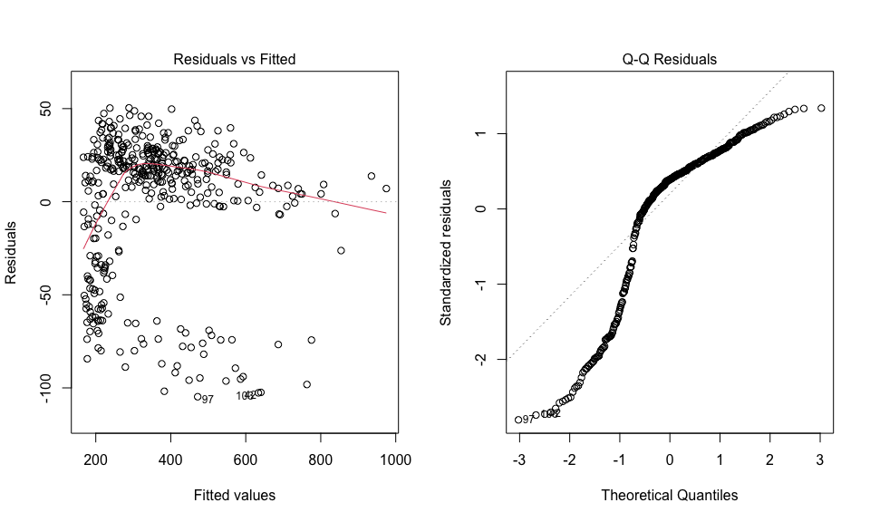

#par(mfrow=c(1,1)) # reset parameters

#### Analysis

**Plot 1** (Residual vs. Fitted Plot) shows a clear nonlinear relationship in the distribution of residuals. **Plot 2** (Residual QQ Plot) also confirms this nonlinearity. The model should be first computed using a log function to see if there is a deeper nonlinear relationship that requires a multivariate quadratic model to assess. The model should also be computed using a Weighted Least Squares model to address heteroscedasticity or the fact that certain variables may not meet the independence assumption of linear models.