Exercise 3 - Basic Models

WLS, GLM and Logistic

O’Malley

`r Sys.Date()

Table of Contents

knitr::opts_chunk$set(echo=T, warning=F, message=F)  
library(lmtest)

## Loading required package: zoo

##   
## Attaching package: 'zoo'

## The following objects are masked from 'package:base':  
##   
## as.Date, as.Date.numeric

library(tidyverse)

## ── Attaching core tidyverse packages ──────────────────────── tidyverse 2.0.0 ──  
## ✔ dplyr 1.1.4 ✔ readr 2.1.5  
## ✔ forcats 1.0.0 ✔ stringr 1.5.1  
## ✔ ggplot2 3.5.1 ✔ tibble 3.2.1  
## ✔ lubridate 1.9.3 ✔ tidyr 1.3.1  
## ✔ purrr 1.0.2

## ── Conflicts ────────────────────────────────────────── tidyverse_conflicts() ──  
## ✖ dplyr::filter() masks stats::filter()  
## ✖ dplyr::lag() masks stats::lag()  
## ℹ Use the conflicted package (<http://conflicted.r-lib.org/>) to force all conflicts to become errors

library(tree)

## Warning: package 'tree' was built under R version 4.3.3

## Submission

Download the **Ex3_BasicModels_YourLastName.Rmd** R Markdown file and save it with your own last name. Complete all your work in that template file, **Knit** the corresponding Word or PDF file. Your knitted document **must display your R commands**. Submit your knitted homework document. No need to submit the .Rmd file, just your knitted file.

Also, please prepare your R Markdown file with a **professional appearance**, as you would for top management or an important client.

Please, write all your interpretation narratives outside of the R code chunks, with the appropriate formatting and businesslike appearance. I write all my comments inside of the R code chunk to suppress their display until I print the solution, but you should not do this. I will read your submission as a report to a client or senior management. Anything unacceptable to that audience is unacceptable to me.

## Setup

This analysis will be done with the **Hitters{ISLR}** basseball player dataset, using AtBat, Hits, Walks, PutOuts, Assists and HmRun as predictors and player **Salary** as the outcome variable. Let’s start with an OLS model and we will then test for heteroskedasticity.

# Done for you  
  
library(ISLR) # Contains the Hitters dataset  
  
# Enter the commands below in the R Console window, but NOT in the R Markdown file. Inspect the data and the description of each predictor, to familiarize yourself with the data  
  
# ?Salaries  
# View(Salaries)  
  
# This dataset has several records with omitted data, let's remove them  
Hitters=na.omit(Hitters)   
  
# Fit an OLS model to start with  
fit.ols <- lm(Salary ~ AtBat+Hits+Walks+PutOuts+Assists+HmRun, data=Hitters)  
summary(fit.ols)

##   
## Call:  
## lm(formula = Salary ~ AtBat + Hits + Walks + PutOuts + Assists +   
## HmRun, data = Hitters)  
##   
## Residuals:  
## Min 1Q Median 3Q Max   
## -920.3 -215.7 -47.7 175.4 2007.9   
##   
## Coefficients:  
## Estimate Std. Error t value Pr(>|t|)   
## (Intercept) 124.48415 72.75876 1.711 0.088308 .   
## AtBat -2.43104 0.66358 -3.664 0.000302 ***  
## Hits 8.98051 1.97223 4.553 8.17e-06 ***  
## Walks 6.34231 1.41170 4.493 1.07e-05 ***  
## PutOuts 0.25462 0.08960 2.842 0.004847 **   
## Assists 0.06698 0.19649 0.341 0.733485   
## HmRun 7.02439 3.61990 1.940 0.053418 .   
## ---  
## Signif. codes: 0 '***' 0.001 '**' 0.01 '*' 0.05 '.' 0.1 ' ' 1  
##   
## Residual standard error: 378.8 on 256 degrees of freedom  
## Multiple R-squared: 0.311, Adjusted R-squared: 0.2949   
## F-statistic: 19.26 on 6 and 256 DF, p-value: < 2.2e-16

# As the output shows, there are 4 significant predictors: AtBat, Hits, Walks and PutOuts, and 2 non-significant predictors: Assists and HmRun.

## 1. Heteroskedasticity Testing

1.1 Conduct a **Breusch-Pagan** test for Heteroskedasticity for the **fit.ols** model above.

bptest(fit.ols) # Breusch-Pagan test

##   
## studentized Breusch-Pagan test  
##   
## data: fit.ols  
## BP = 15.456, df = 6, p-value = 0.01699

#### Analysis

After conducting the Breusch-Pagan test, we can conclude that there is heteroscedasticity in our model. Since p (0.01699) < 0.05, we reject the null hypothesis that homoscedasticity exists in our model.

1.2 Display the first residual plot for **fit.ols** by using which=1.

plot(fit.ols, which = 1)

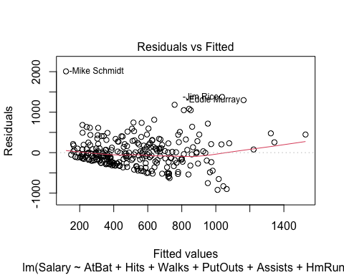

residuals_df <- data.frame(fitted = fitted(fit.ols), residuals = resid(fit.ols)) # create data frame   
ggplot(residuals_df, aes(fitted, residuals)) +  
 geom_point() +  
 geom_hline(yintercept = 0, color = "red") +  
 geom_smooth(method = "loess", color = "blue", se = FALSE) +  
 labs(x = "Fitted Values", y = "Residuals", title = "Residual vs. Fitted Plot") +  
 theme(plot.title = element_text(hjust = 0.5))

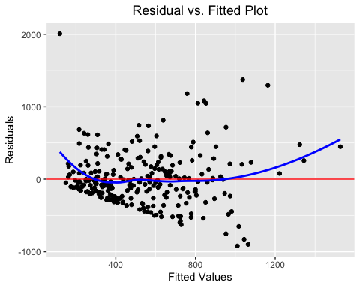

1.3 Is there a problem with Heteroskedasticity? Why or why not? In your answer, please refer to **both**, the BP test and the residual plot.

#### Analysis

Yes, there appears to be heteroscedasticity in the model. The Breusch-Pagan test causes us to reject the $H0$ that homoscedasticity exists in the model because p (0.01699) < 0.05 and the residual plot shows a cone-patterned dispersion of residuals, which supports the existence of heteroscedasticity in the model.

## 2. Weighted Least Squares (WLS) Model

2.1 Set up the parameters of the WLS model. Use the abs() and residuals() functions compute the absolute value of the residuals from the OLS model **fit.ols** and store the results in a vector object named **abs.res** . Then use the fitted() function to extract the fitted (i.e., predicted) values from **fit.ols** and store the resuts in a vector object named **fitted.ols**. The run an lm() model using the predicted values in **fitted.ols** as a predictor of the absolute value of the residuals in **abs.res**.

**Technical tip:** Because you are using one data vector to predict another data vector, you don’t need the data= parameter.

As a sanity check, display the first 10 rows of the fitted() values of **lm.abs.res**

abs.res <- abs(residuals(fit.ols)) # extract absolute residuals  
fitted.ols <- fitted(fit.ols) # extract fitted values  
  
lm.abs.res <- lm(abs.res ~ fitted.ols) # second OLS Model  
  
fitted(lm.abs.res)[1:10] # sanity check

## -Alan Ashby -Alvin Davis -Andre Dawson -Andres Galarraga   
## 270.2217 406.4748 291.4550 285.5487   
## -Alfredo Griffin -Al Newman -Argenis Salazar -Andres Thomas   
## 270.8002 149.4738 141.2410 162.5797   
## -Andre Thornton -Alan Trammell   
## 257.5593 342.6095

2.2 To visualize the lm.abs.res regression line, plot the **fitted.ols** vector against the **abs.res** vector. Then draw a red line using the abline() function for the **lm.abs.res** regression object.

plot(fitted.ols, abs.res, xlab = "Fitted Values", ylab = "Absolute Residuals", main = "Fitted vs. Absolute Residuals Plot")  
abline(lm.abs.res, col = "red")

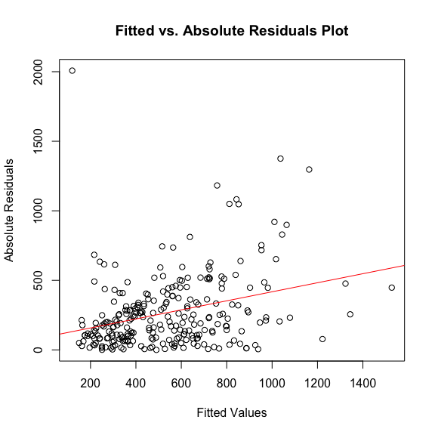

2.3 Specify and Run the WLS Model. First, a vector named **wts** equal to the inverse squared predicted values of **lm.abs.res** (use wts <- 1/fitted(lm.abs.res)^2).

Then fit the WLS regression model using the same predictors you used in ols.fit, but using **wts** as the weights. Name this regression object **wls.fit**. Display the summary results.

While we are at it, also fit a similar weighted GLM model (**WGLM**), by using the glm() function and storing the results in an object named **fit.wglm**. Then display the summary() results for the WGLM.

wts <- 1/fitted(lm.abs.res)^2 # calculate weights  
  
wls.fit <- lm(Salary ~ AtBat+Hits+Walks+PutOuts+Assists+HmRun, data=Hitters, weights = wts) # WLS Model  
summary(wls.fit) # summary statistics

##   
## Call:  
## lm(formula = Salary ~ AtBat + Hits + Walks + PutOuts + Assists +   
## HmRun, data = Hitters, weights = wts)  
##   
## Weighted Residuals:  
## Min 1Q Median 3Q Max   
## -2.0512 -1.0607 -0.2793 0.6520 13.6904   
##   
## Coefficients:  
## Estimate Std. Error t value Pr(>|t|)   
## (Intercept) 259.2218 61.2878 4.230 3.26e-05 ***  
## AtBat -2.6758 0.6914 -3.870 0.000138 ***  
## Hits 8.4446 2.2715 3.718 0.000247 ***  
## Walks 4.4277 1.5889 2.787 0.005723 **   
## PutOuts 0.2953 0.1157 2.553 0.011257 *   
## Assists 0.4160 0.2022 2.057 0.040679 *   
## HmRun 10.4194 4.0230 2.590 0.010150 *   
## ---  
## Signif. codes: 0 '***' 0.001 '**' 0.01 '*' 0.05 '.' 0.1 ' ' 1  
##   
## Residual standard error: 1.542 on 256 degrees of freedom  
## Multiple R-squared: 0.1747, Adjusted R-squared: 0.1554   
## F-statistic: 9.034 on 6 and 256 DF, p-value: 5.81e-09

fit.wglm <- glm(Salary ~ AtBat+Hits+Walks+PutOuts+Assists+HmRun, data=Hitters, weights = wts) # WGLM Model  
summary(fit.wglm) # summary statistics

##   
## Call:  
## glm(formula = Salary ~ AtBat + Hits + Walks + PutOuts + Assists +   
## HmRun, data = Hitters, weights = wts)  
##   
## Coefficients:  
## Estimate Std. Error t value Pr(>|t|)   
## (Intercept) 259.2218 61.2878 4.230 3.26e-05 ***  
## AtBat -2.6758 0.6914 -3.870 0.000138 ***  
## Hits 8.4446 2.2715 3.718 0.000247 ***  
## Walks 4.4277 1.5889 2.787 0.005723 **   
## PutOuts 0.2953 0.1157 2.553 0.011257 *   
## Assists 0.4160 0.2022 2.057 0.040679 *   
## HmRun 10.4194 4.0230 2.590 0.010150 *   
## ---  
## Signif. codes: 0 '***' 0.001 '**' 0.01 '*' 0.05 '.' 0.1 ' ' 1  
##   
## (Dispersion parameter for gaussian family taken to be 2.378078)  
##   
## Null deviance: 737.69 on 262 degrees of freedom  
## Residual deviance: 608.79 on 256 degrees of freedom  
## AIC: 3897.9  
##   
## Number of Fisher Scoring iterations: 2

2.3 Observe the similarities an differences between the OLS, WLS and WGLM model and provide a brief commentary of your observations.

#### Analysis

The r-squared value has decreased from the original OLS model to the WLS, although the WLS model now accounts for heteroscedasticity. Two statistically insignificant variables - Assists and HmRun - have now become significant to both the WLS and WGLM models. Finally, in the WGLM model, Residual Deviance < Null Deviance, which means the model is more accurate than random guessing - a good sign for the WGLM model.

## 3. Logistic Regression

3.1 Download the **myopia.csv** file to your working directory. Then read it using read.table() with the parameters header=T, row.names=1, sep=",". Store the dataset in an object named **myopia**.

Dataset documentation at: <https://rdrr.io/cran/aplore3/man/myopia.html> Please note that **myopic** is coded as 1 (Yes), 0 (No) (not 1 and 2)

For sanity check, list the first 10 rows and 8 columns of this dataset.

read.table("myopia.csv", header = TRUE, row.names = 1, sep = ",") -> myopia # assign table to vector  
  
myopia[1:10, 1:8] # sanity check

## study.year myopic age female spheq al acd lt  
## 1 1992 1 6 1 -0.052 21.89 3.690 3.498  
## 2 1995 0 6 1 0.608 22.38 3.702 3.392  
## 3 1991 0 6 1 1.179 22.49 3.462 3.514  
## 4 1990 1 6 1 0.525 22.20 3.862 3.612  
## 5 1995 0 5 0 0.697 23.29 3.676 3.454  
## 6 1995 0 6 0 1.744 22.14 3.224 3.556  
## 7 1993 0 6 1 0.683 22.33 3.186 3.654  
## 8 1991 0 6 1 1.272 22.39 3.732 3.584  
## 9 1991 0 7 0 1.396 22.62 3.464 3.408  
## 10 1991 0 6 1 0.972 22.74 3.504 3.696

3.2 Fit a logistic model to predict whether a kid is **myopic**, using age + female + sports.hrs + read.hrs + mommy + dadmy as predictors. **Tip:** use family="binomial"(link="logit"). Store the results in an object named **myopia.logit**. Display the summary() results. Then display the summary() results.

myopia.logit <- glm(myopic ~ age + female + sports.hrs + read.hrs + mommy + dadmy, data = myopia, family = binomial(link = "logit")) # logreg model  
summary(myopia.logit) # summary statistics

##   
## Call:  
## glm(formula = myopic ~ age + female + sports.hrs + read.hrs +   
## mommy + dadmy, family = binomial(link = "logit"), data = myopia)  
##   
## Coefficients:  
## Estimate Std. Error z value Pr(>|z|)   
## (Intercept) -8.83835 2.21222 -3.995 6.46e-05 ***  
## age -0.03073 0.29219 -0.105 0.916   
## female -0.15787 0.46980 -0.336 0.737   
## sports.hrs -0.13993 0.03507 -3.990 6.60e-05 ***  
## read.hrs 0.79920 0.09929 8.049 8.35e-16 ***  
## mommy 2.93733 0.54288 5.411 6.28e-08 ***  
## dadmy 2.77087 0.54069 5.125 2.98e-07 ***  
## ---  
## Signif. codes: 0 '***' 0.001 '**' 0.01 '*' 0.05 '.' 0.1 ' ' 1  
##   
## (Dispersion parameter for binomial family taken to be 1)  
##   
## Null deviance: 480.08 on 617 degrees of freedom  
## Residual deviance: 131.00 on 611 degrees of freedom  
## AIC: 145  
##   
## Number of Fisher Scoring iterations: 8

3.3 For interpretation purposes, display the log-odds alongside the odds. Use the coef() function to extract the log-odds coefficients from **myopia.logit** and save them in a vector object named **log.odds**. Then use the exp() function to convert the log-odds into odds and store the results in a vector object named **odds**. The enter the options(scipen=4) command to minimize the use of scientific notation. Finally, list the log-odds and odds side by side. To do this, use the cbind() function to bind the two vectors into one table and name the columns **“Log-Odds”** and **“Odds”** respectively. Embed the cbind() function inside the print() function with the parameter digits=2 to get a more compact display.

log.odds <- coef(myopia.logit) # logodds coefficients  
odds <- exp(log.odds) # calculate odds  
print(cbind("Log-Odds" = log.odds, "Odds" = odds), digits = 2)

## Log-Odds Odds  
## (Intercept) -8.838 1.5e-04  
## age -0.031 9.7e-01  
## female -0.158 8.5e-01  
## sports.hrs -0.140 8.7e-01  
## read.hrs 0.799 2.2e+00  
## mommy 2.937 1.9e+01  
## dadmy 2.771 1.6e+01

3.4 Provide a brief interpretation of both, the log-odds and odds effects of read.hrs and mommy. Please refer to the respective variable measurement units in your discussion.

#### Analysis

On average, holding everything else constant, there is a positive relationship between read.hrs and myopia (Log-Odds = 0.799) and a one unit increase in read.hrs multiplies the odds of myopia by 2.22 (increase of 122.2%). On average, holding everything else constant, there is a stronger positive relationship between mommy and myopia (Log-Odds = 2.937) and since mommy is a binary variable, if the value is 1, then the odds of myopia are multiplied by 18.86 (increase of 1787.5%).

## 4. Decision Trees

4.1 Regression Tree. Load the **{tree}** library. Then fit the regression model **ols.fit** above, but this time as a **regression tree** using the tree() function and save the results in an object named **fit.tree.salary**. Then plot the tree using the plot() and text() functions (use the pretty=0 parameter). Also use the title() function to title you tree diagram **“Baseball Salaries Regression Tree”**.

tree(fit.ols) -> fit.tree.salary # regression tree model  
# plot creation  
plot(fit.tree.salary)   
text(fit.tree.salary, pretty = 0)  
title("Baseball Salaries Regression Tree")

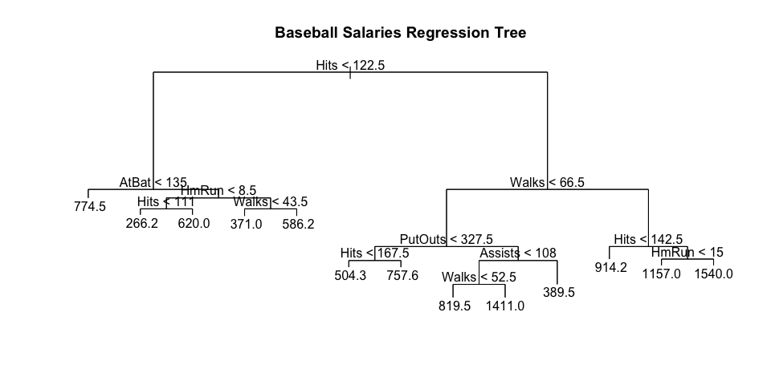

4.2 Classification Tree. Fit the Logistic model **myopia.logit**, but this time as a **classification tree** using the tree() function and save the results in an object named **fit.tree.myopia**. Then plot the tree using the plot() and text() functions (use the pretty=0 parameter). Also use the title() function to title you tree diagram **“Myopia Classification Tree”**.

fit.tree.myopia <- tree(myopia.logit) # classification tree model  
  
# plot creation  
plot(fit.tree.myopia)  
text(fit.tree.myopia, pretty = 0)  
title("Myopia Classification Tree")

