ITEC 621 Exercise 1 - R Refresher

O’Malley, Conie

2025-01-18

Table of Contents

## General Instructions

Download the R Markdown template for this exercise **Ex1_R_YourLastName.Rmd** and save it with your own last name **exactly**. Then open it in R Studio and complete all the exercises and answer the questions below in the template. Run the code to ensure everything is working fine. When done, knit your R Markdown file into a **Word document** and submit it. No need to submit the **.Rmd**, file just the Word knitted file. If for some reason you can’t knit a Word file, you can knit to a PDF file, or to an HTML file and then save it as a PDF. Some LMS systems don’t accept HTML submissions.

This exercise is similar to HW0 in KSB-999, which you were required to complete before starting this course. So, if you already did that, this should be an easy exercise and a good warm up refresher. If you didn’t do it, this is you opportunity to catch up. This course moves fast and it assumes that you have some familiarity with R.

## R Markdown Overview (please read carefully)

R Markdown is a package that allows you to write R code and prepare an analytics report in a single file. To use R Markdown, you first need to install it in your computer using the command install.packages("rmarkdown"). If you have not done this yet, go to the **R Console** and install R Markdown. Once you have done this, you can create R Markdown files from the File -> New File menu.

When you create an R Markdown file, it will look like text comingled with R code. You will see a button option named **Knit** in your tool bar (if you don’t, then R Markdown is not installed). Once you are done with all the coding, click on the **Knit** button and R Markdown will knit a Word, HTML, PDF or PowerPoint document for you, depending on the output type you specified, with all your typed text and R results.

**Important:** This is a business course and, as such you are required to submit all exercises, homework and project reports with a professional, businesslike appearance, free of grammatical errors and typos, and with well articulated interpretation narratives. No knitting, improper knitting and submissions with writing and formatting issues will have up to 3-point (out of 10) deductions for exercises and up to 10-point (out of 100) deductions for homework.

R Markdown contains three main types of content:

1. The **YAML** (YAML Ain’t Markup Language) header, which is where you place the title, author, date, type of output, etc. It is at the top of the R Markdown file and starts and ends with ---. I suggest using an output type word_document. HTML works well, but blackboard will not read HTML files submitted by students (for security reasons).
2. **Markup** sections, which is where you type any text you wish, which will show up as typed text. You will learn these later.
3. **Code chunks**: which is where you write your R code. An R code chunk starts with a **```{r}** and ends with a **```**.

I recommend that you first write your R code in an R Script file to try your R code first. Once you are satisfied that the R code is working fine, then you can copy/paste the respective code segments to the corresponding R Markdown code chunks.

Your knitted file must:

* Display all your R commands (leave echo=T in the global options; echo=F suppresses the R code)
* Display the resulting **R output results**
* Contain any necessary text and explanations, as needed; and
* Be formatted for good readability and in a business like manner
* Be in the same order as the questions and with the corresponding question numbers

## 1. Basic R Concepts

1.1 Write a simple R function named **area()** that takes 2 values as parameters (x and y, representing the two sides of a rectangle) and returns the product of the two values (representing the rectangle’s area). Then use this function to display the area of a rectangle of sides 6x4. Then, use the functions paste(), print() and area() to output this result: **The area of a rectangle of sides 6x4 is 24**, where 24 is calculated with the area() function you just created

area <- function(x, y) {  
 area = x*y  
 return(paste('Thea area of a rectangle of sides', x, 'x', y, 'is', area))  
}  
  
area(6,4) # function test

## [1] "Thea area of a rectangle of sides 6 x 4 is 24"

1.2 Write a simple **for loop** for i from 1 to 10. In each loop cycle, compute the area of a rectangle of sides i and i*2 (i.e., all rectangles have one side double the length than the other) and for each of the 10 rectangles display “The area of an 1 x 2 rectangle is 2” for i=1, “The area of an 2 x 4 rectangle is 8”, and so on.

for (i in 1:10) {  
 a = i * (i*2)  
 print(paste('The are of an', i, 'x', i*2, 'rectangle is', a))  
}

## [1] "The are of an 1 x 2 rectangle is 2"  
## [1] "The are of an 2 x 4 rectangle is 8"  
## [1] "The are of an 3 x 6 rectangle is 18"  
## [1] "The are of an 4 x 8 rectangle is 32"  
## [1] "The are of an 5 x 10 rectangle is 50"  
## [1] "The are of an 6 x 12 rectangle is 72"  
## [1] "The are of an 7 x 14 rectangle is 98"  
## [1] "The are of an 8 x 16 rectangle is 128"  
## [1] "The are of an 9 x 18 rectangle is 162"  
## [1] "The are of an 10 x 20 rectangle is 200"

## 2. Data Manipulation

2.1 Copy the **Credit.csv** data file to your working directory (if you haven’t done this yet). Then read the **Credit.csv** data file into a data frame object named **Credit** (Tip: use the read.table() function with the parameters header=T, sep=",", row.names=1). Then, list the first 5 columns of the top 5 rows (Tip: use Credit[1:5,1:5])

credit <- read.table("~/Library/CloudStorage/OneDrive-Personal/001. Documents - Main/023. Programming Tools/025. R Studio/Predictive Analytics/Credit.csv", header = T, sep = ",", row.names = 1)  
  
credit[1:5,1:5]

## Income Limit Rating Cards Age  
## 1 14.891 3606 283 2 34  
## 2 106.025 6645 483 3 82  
## 3 104.593 7075 514 4 71  
## 4 148.924 9504 681 3 36  
## 5 55.882 4897 357 2 68

2.2 Using the class() function, display the object class for the Credit dataset, and for Gender (i.e., Credit$Gender), Income and Cards

class(credit$Gender)

## [1] "character"

class(credit$Income)

## [1] "numeric"

class(credit$Cards)

## [1] "integer"

2.3 Create a vector named **income.vect** with data from the Income column. Then use the head() function to display the first 6 values of this vector.

income.vect <- credit$Income  
head(income.vect, 6)

## [1] 14.891 106.025 104.593 148.924 55.882 80.180

## 3. Basic Descriptive Analytics

3.1 Compute the mean, minimum, maximum, standard deviation and variance for all the values in this income vector. Store the respective results in variables name mean.inc, min.inc, etc. Then, use the c() function to create a vector called **income.stats** with 5 values you computed above. Then use the names() function to give the corresponding names “Mean”, “Min”, “Max”, “StDev”, and “Var”. Then display Income.stats.

**Technical Note:** The names() needs to create a vector with the respective names above, which need to correspond to the values in **incom.vect**. Therefore, you need to use the c() function to create a vector with these 5 names.

mean.inc <- mean(income.vect)  
min.inc <- min(income.vect)  
max.inc <- max(income.vect)  
sd.inc <- sd(income.vect)  
var.inc <- var(income.vect)  
income.stats <- c(mean.inc, min.inc, max.inc, sd.inc, var.inc)  
names(income.stats) <- c("Mean", "Min", "Max", "StDev", "Var")  
print(income.stats) # confirm correct name application

## Mean Min Max StDev Var   
## 45.21889 10.35400 186.63400 35.24427 1242.15879

3.2 Display a boxplot for the predictor Income. Tip: you can do this 2 ways. First you can attach() the Credit data set (which loads the data set in the work environment) and then do a boxplot() for **Income**. Or, do it without attaching, but using the table prefix (i.e., **Credit$Income). Use the **xlab** attribute to name include the label "Income". Then display similar boxplots but this time broken down by **Gender** (i.e., `Credit$Income ~ Credit$Gender`).

# Income box plot  
ggplot(data = credit, aes(y = Income)) +  
 geom_boxplot() +  
 xlab("Income") +  
 ylab("") +  
 theme_economist()

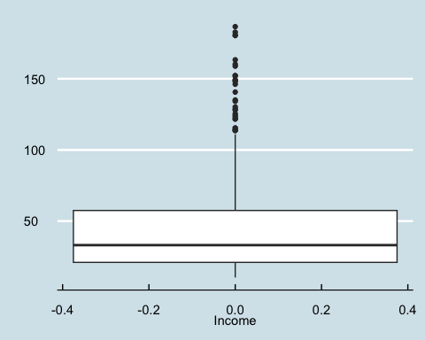

# Income based on gender boxplot  
ggplot(data = credit, aes(x = Gender, y = Income)) +  
 geom_boxplot() +  
 xlab("Income") +  
 ylab("") +  
 theme_economist()

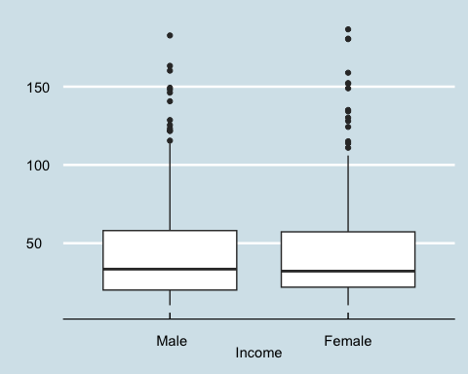

3.3 Display a histogram for the variable **Rating**, with the main title “Credit Rating Histogram” (main=) and X label “Rating” (xlab=). Then draw a QQ Plot for **Rating** (Tip: use the qqnorm() function first to draw the data points and then use the qqline() function to layer the QQ Line on top).

# histogram  
ggplot(credit, aes(Rating)) +  
 geom_histogram() +  
 xlab("Rating") +  
 ylab("Frequency") +  
 ggtitle("Credit Rating Histogram") +  
 theme_economist()

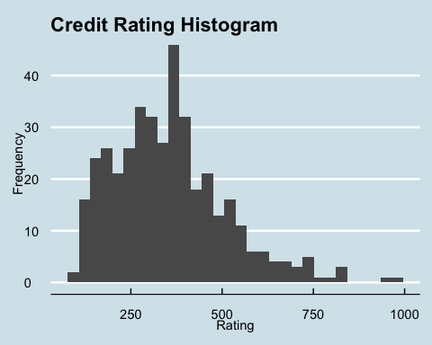

# qqplot  
qqnorm(credit$Rating, main = "Credit Rating Q-Q Plot")  
qqline(credit$Rating, col = "red")

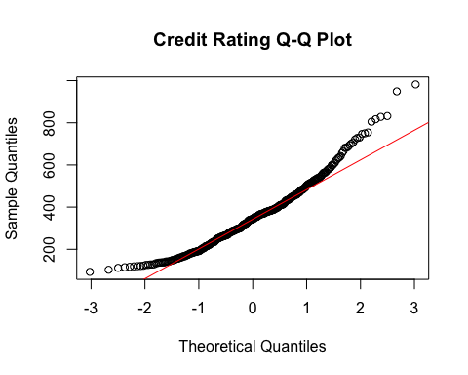

3.4 Briefly answer: Do you think that this data is somewhat normally distributed? Why or why not? In your answer, please refer to both, the Histogram and the QQ Plot.

The data does not appear to be normally distributed because, while there is a large number of data points that intersect or fall very close to the trendline, the majority of data points fall above or well above the trendline, which means the data is not normally distributed.

## 4. Basic Predictive Analytics

4.1 First, enter the command options(scipen=4) to minimize the display values with scientific notation. Then, create a simple linear regression model object with the lm() function to fit credit **Rating** as a function of **Income** and save the results in an object named **lm.rating**. Then display the model summary results with the summary() function. Tip: use the formula Rating ~ Income, data=Credit inside the lm() function.

lm(Rating ~ Income, data = credit) -> lm.rating  
summary(lm.rating)

##   
## Call:  
## lm(formula = Rating ~ Income, data = credit)  
##   
## Residuals:  
## Min 1Q Median 3Q Max   
## -173.855 -79.417 -0.384 79.747 171.955   
##   
## Coefficients:  
## Estimate Std. Error t value Pr(>|t|)   
## (Intercept) 197.8411 7.7089 25.66 <2e-16 ***  
## Income 3.4742 0.1345 25.83 <2e-16 ***  
## ---  
## Signif. codes: 0 '***' 0.001 '**' 0.01 '*' 0.05 '.' 0.1 ' ' 1  
##   
## Residual standard error: 94.71 on 398 degrees of freedom  
## Multiple R-squared: 0.6263, Adjusted R-squared: 0.6253   
## F-statistic: 667 on 1 and 398 DF, p-value: < 2.2e-16

4.2 Now, plot Credit Rating (Y axis) against Income (X axis), with respective labels “Income” and “Credit Rating”. Tip: feed the same formula you used in the lm() function above, but using the plot() function instead. Then draw a regression line by feeding **lm.rating** into the abline() function.

plot(Rating ~ Income, data = credit, xlab = "Income", ylab = "Credit Rating")  
abline(lm.rating, col = "red")

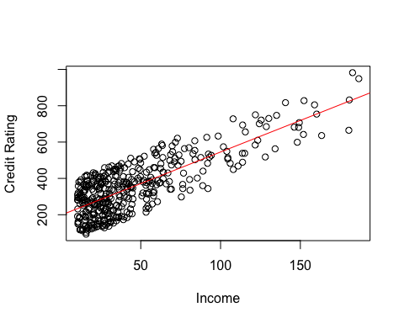

4.3 Write a simple linear model to predict credit ratings using these predictors: **Income**, **Limit**, **Cards**, **Married** and **Balance**. Name the resulting model **lm.rating.5**. Then display the regression using the summary() function. No need to answer, but what do you think are the most influential predictors of credit rating?

lm.rating.5 <- lm(Rating ~ Income + Limit + Cards + Married + Balance, data = credit)  
summary(lm.rating.5)

##   
## Call:  
## lm(formula = Rating ~ Income + Limit + Cards + Married + Balance,   
## data = credit)  
##   
## Residuals:  
## Min 1Q Median 3Q Max   
## -24.0051 -7.0024 -0.9291 6.3789 26.2751   
##   
## Coefficients:  
## Estimate Std. Error t value Pr(>|t|)   
## (Intercept) 2.711e+01 2.187e+00 12.396 < 2e-16 ***  
## Income 9.750e-02 3.352e-02 2.909 0.00383 **   
## Limit 6.415e-02 9.004e-04 71.247 < 2e-16 ***  
## Cards 4.711e+00 3.762e-01 12.521 < 2e-16 ***  
## MarriedYes 2.122e+00 1.044e+00 2.032 0.04281 *   
## Balance 8.436e-03 3.131e-03 2.694 0.00735 **   
## ---  
## Signif. codes: 0 '***' 0.001 '**' 0.01 '*' 0.05 '.' 0.1 ' ' 1  
##   
## Residual standard error: 10.14 on 394 degrees of freedom  
## Multiple R-squared: 0.9958, Adjusted R-squared: 0.9957   
## F-statistic: 1.85e+04 on 5 and 394 DF, p-value: < 2.2e-16

The most influential predictors based on statistical significance are Limit and Cards because they have the lowest p values, with the Limit being the best because it also has the lowest standard error. All variables are statistically significant at p = 0.05 level.