Date: <<date_placeholder>>

Location: <<location_placeholder>>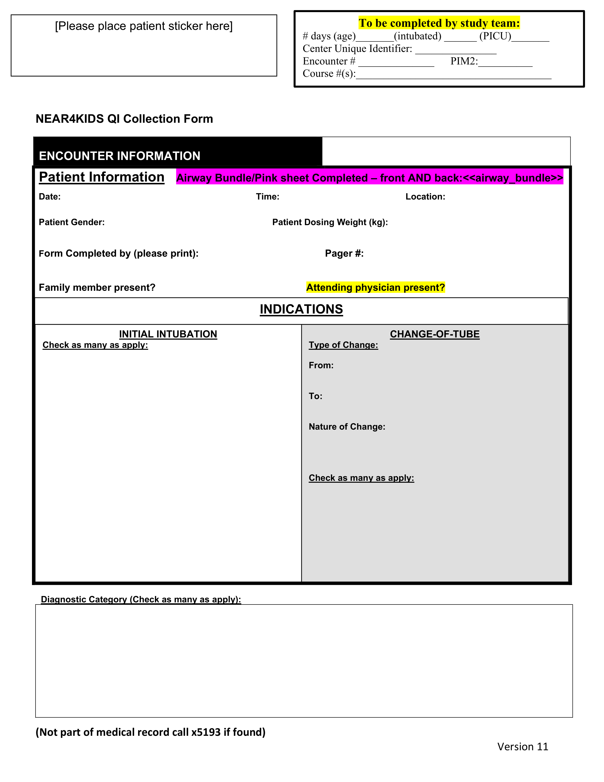

<<date_placeholder>> <<time_placeholder>> <<location_placeholder>>

<<sex_placeholder>> <<weight_placeholder>>