FT_Cropout conversion
Pull the crop-out sample: connahKendrickMMU/FT_Cropout: A Blueprint demo of Unreals Cropout Game
Open up the .uproject
Let all the shaders build
Understanding the Blueprints:
First, understand Blueprints and identify their key components. Let's have a look at the game manager; find it in Content->Blueprint->Core->Game Mode->BP_GM
We are looking at this one because the game manager is always running and checking in-game conditions, so it’s an easy win for performance: responses will be quicker, and overall gameplay will be smoother.
Let's have a look at some of our coding concepts:

Variables
Firstly, variables are defined on the left and are used as nodes in the graph:
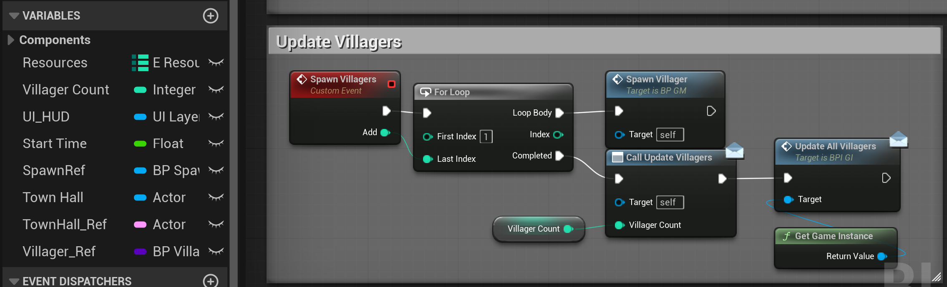
Figure 1: The variables on the right and their usage in the script.
You can see these variables are private as the eye icon is closed, so only this class can see them.

Functions
For functions, you can also see them defined on the right, but they live in the tabs above, or double-click to see the definition.
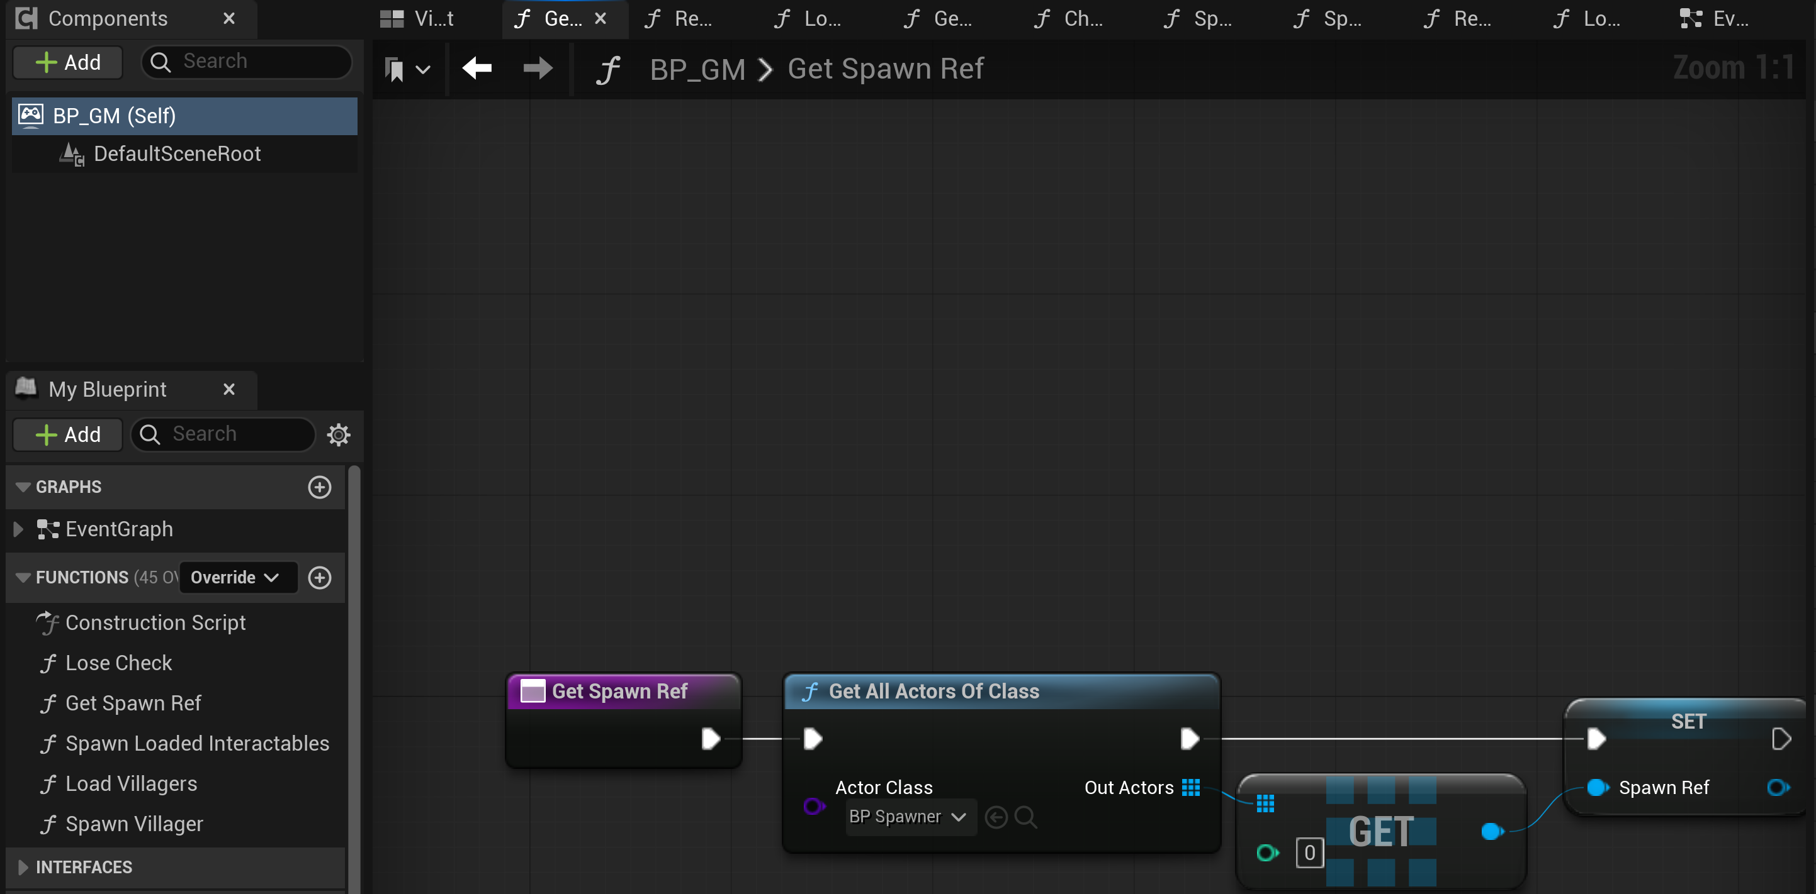
Figure 2: The functions list right and the top tabs of the available functions.

Notice how the Get All Actors Of Class returns an array, so the variable colour is the same, but becomes a grid to symbolise arrays.

Parent Classes

Unreal makes full use of inheritance, with parent classes that define functionality the engine expects: an Actor has a transform, a Pawn can be possessed by an AI or a Player, a Character can walk, and an Actor Component has aspects like health. We should try to match these as best we can
We can check the parent class by checking the blueprint's parentage:
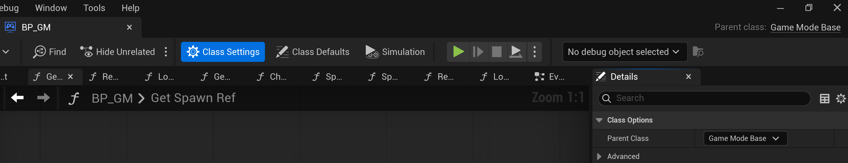
Figure 3: The method to reparent scripts

By following this, we can ensure that new C++ Classes are compatible by matching the Blueprint's parent class.

Add C++ to a Blueprint Project:
Follow me along on MMUTube .
Let's make the first steps towards optimisation. In the main Unreal window, go to Tools-> New C++ Class: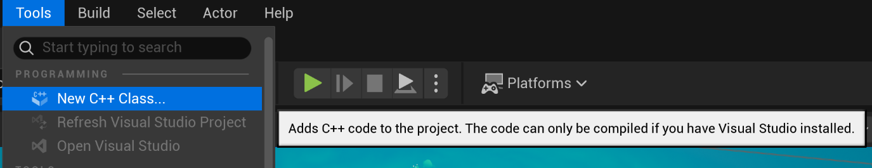
Figure 4: Creating a new C++ script
You will have to scroll down and match the Class we are interested in:
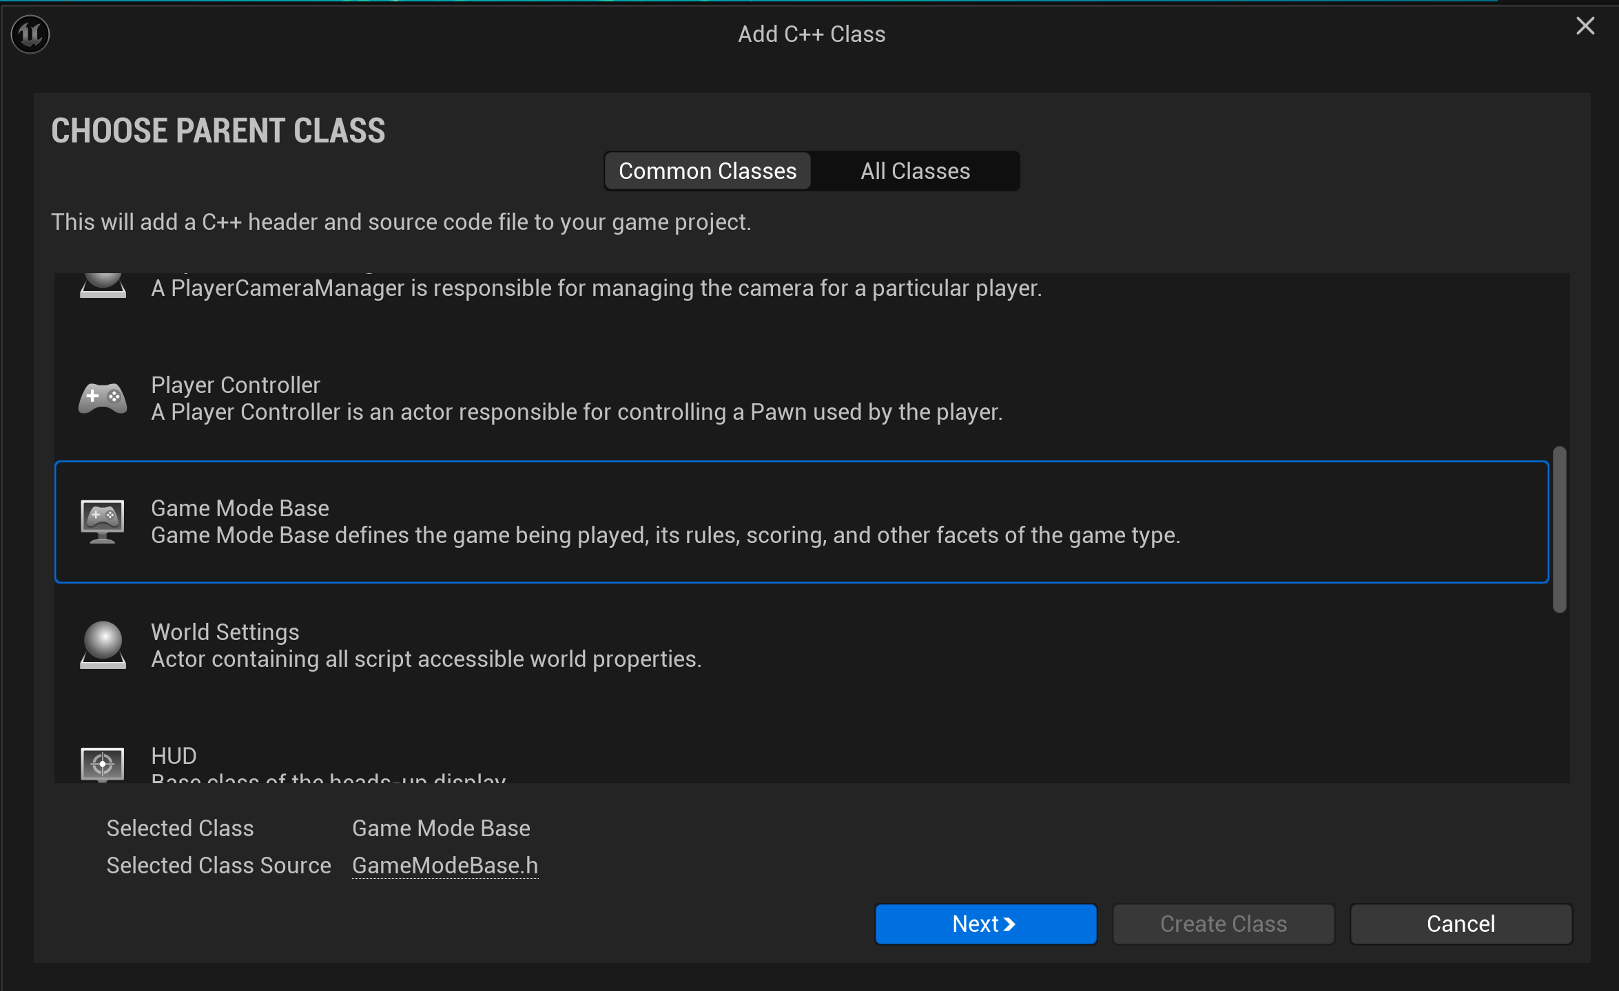
Figure 5: The Gamemode class base
Notice how, in large-scale engines like Unreal, inheritance plays a key role in its functionality. It drives use toward a more structured game development pipeline.
We will also need to set some basic class properties. We want to make the class Public and give it a good name.
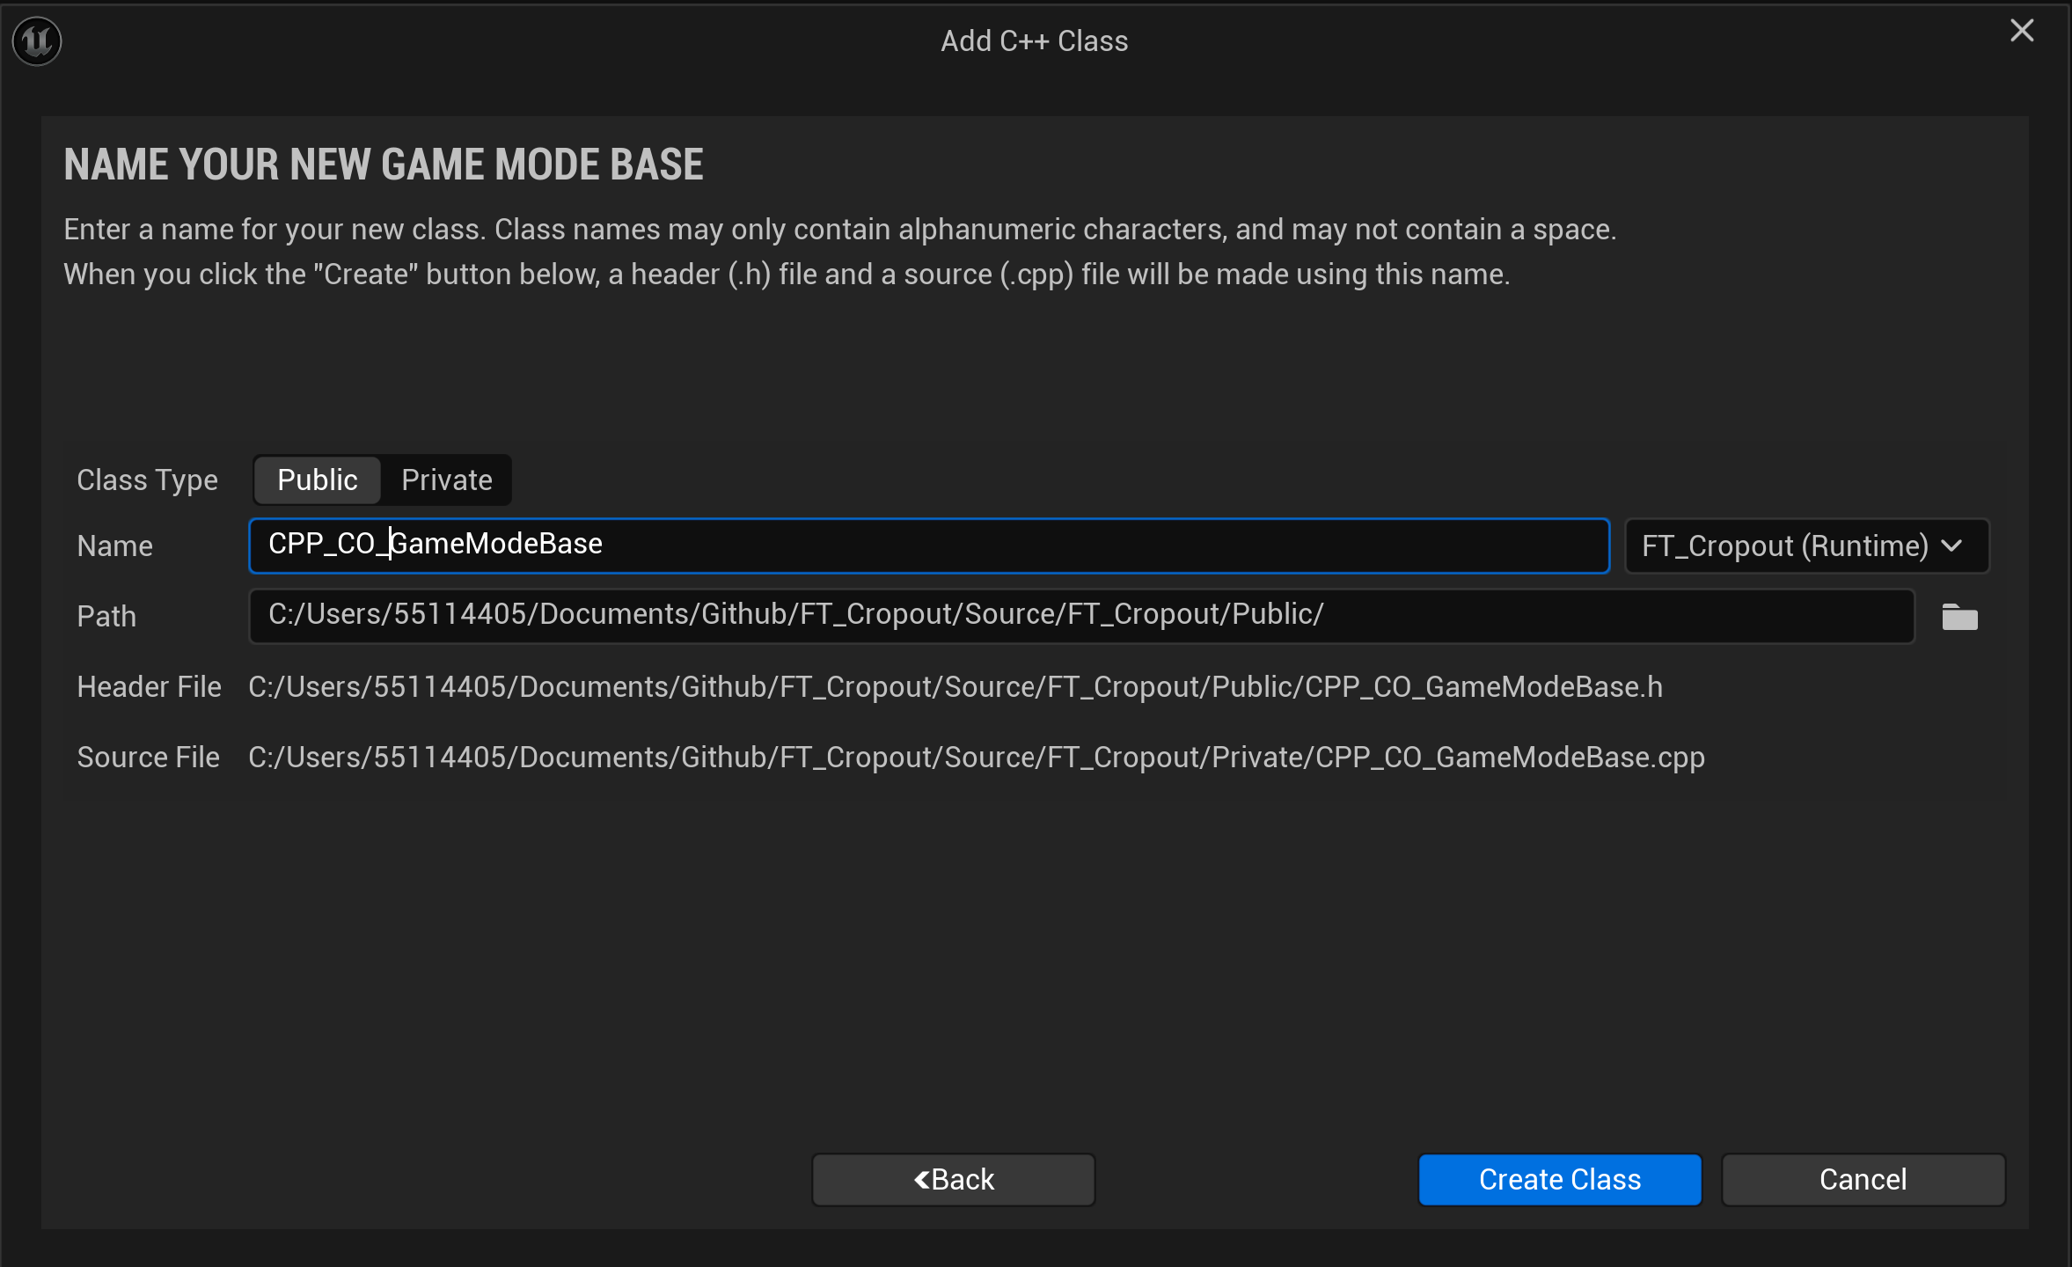
Figure 6: Naming the script and making it public
I have called mine CPP_CO_GameModeBase (C++ Cropout GameMode). If you have multiple game modes, name them properly, e.g., Team Deathmatch, Tag Racing, or Battle Royale.
Click Create Class.
If this is your first class, it might take a couple of minutes. You can enjoy unreal engines DUEL LOADING BARS!
You will now get a warning like this: DO NOT PANIC:
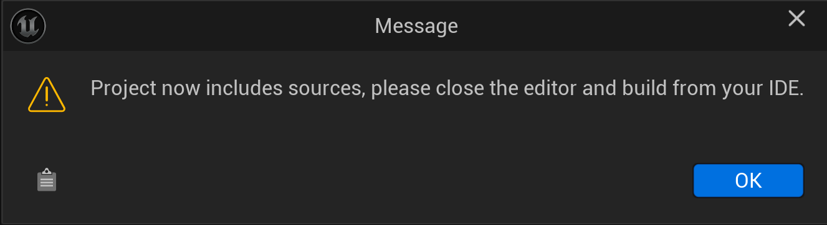
Figure 7: A simple warning
The message basically acknowledges that the project will now be treated as a C++ project; thus, the engine must recompile itself for that workflow. You do not need to edit the code now, so for the next message, click No. Save all your changes. Right-click the Content folder and choose Show in Explorer.
Close Unreal.

No going back now:
In the File Explorer, if you move to the project's main folder, you will notice now we have a Source folder and a .sln file:
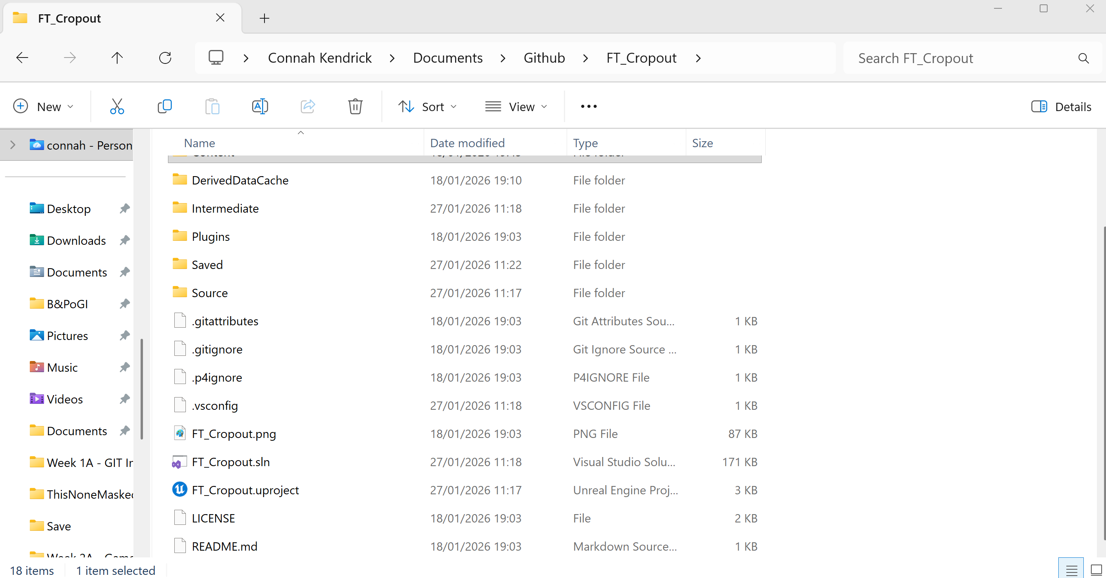
Figure 8: The key files in the structure

The source is now a key folder; all the C++ scripts will live here. This folder will not regenerate, so do not delete it under any circumstances.
The SLN file is the Visual Studio project that tells us how the scripts are set up and function.
Open the Uproject file, and when prompted, click Yes to rebuild the module files. This will also take a couple of minutes, so you may want a short break. The project will then reopen.

Re-parent the Blueprint Class
Follow me along on MMUTube.
Reopen the BP_GM Blueprint. We're going to move our new class in as a middleman; this preserves all current functionality while letting us convert the script in stages. This lets us test the code and revert if our C++ introduces bugs.
Where we checked the class's parentage, we can now search for our newly created class and replace it.
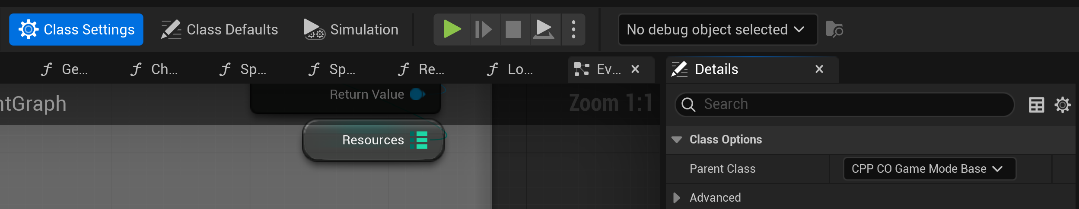
Figure 9: The class reparented.

Save, compile, and run the game. You will see everything works as before, but now we can begin our conversion.

C++ Headers and Classes:
In the Content Explorer, go to C++ Classes-> FT_Cropout->CPP_CO_GameModeBase
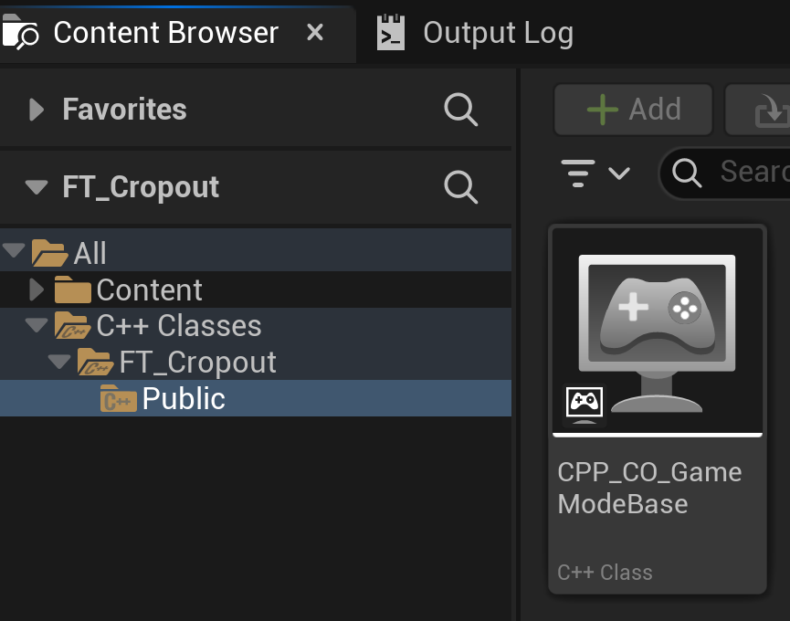
Figure 10: The location of the c-plus files.

This will open the Visual Studio SLN file. You will get two files:
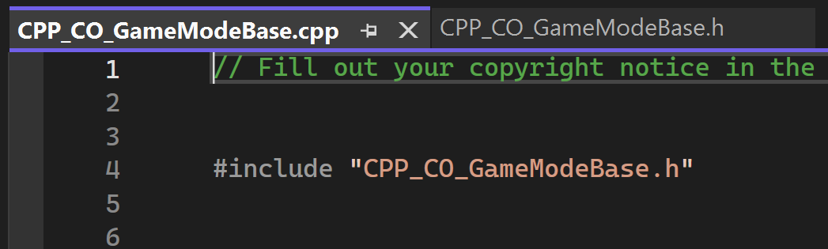
Figure 11: The CPP file for the game mode.
A CPP and an H file. Remember
- H (Header) files are for Declarations; we create our variables and say what functions we need there
- CPP (Class) files are for Implementations, we implement our functions and use our variables
For now, we will just use the Header file.

Replacing our variables:
In our header file, let’s begin adding some code:
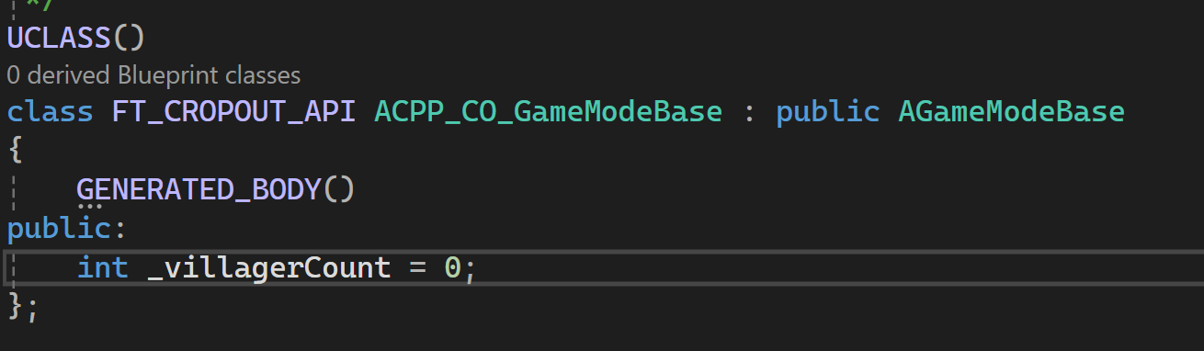
Figure 12: Our new variable.
Public means everything below this is public. Notice that I use an underscore to differentiate my current int, and I also provide it a default value as good practice, 0 is also the default value set in the blueprint always try to match this.
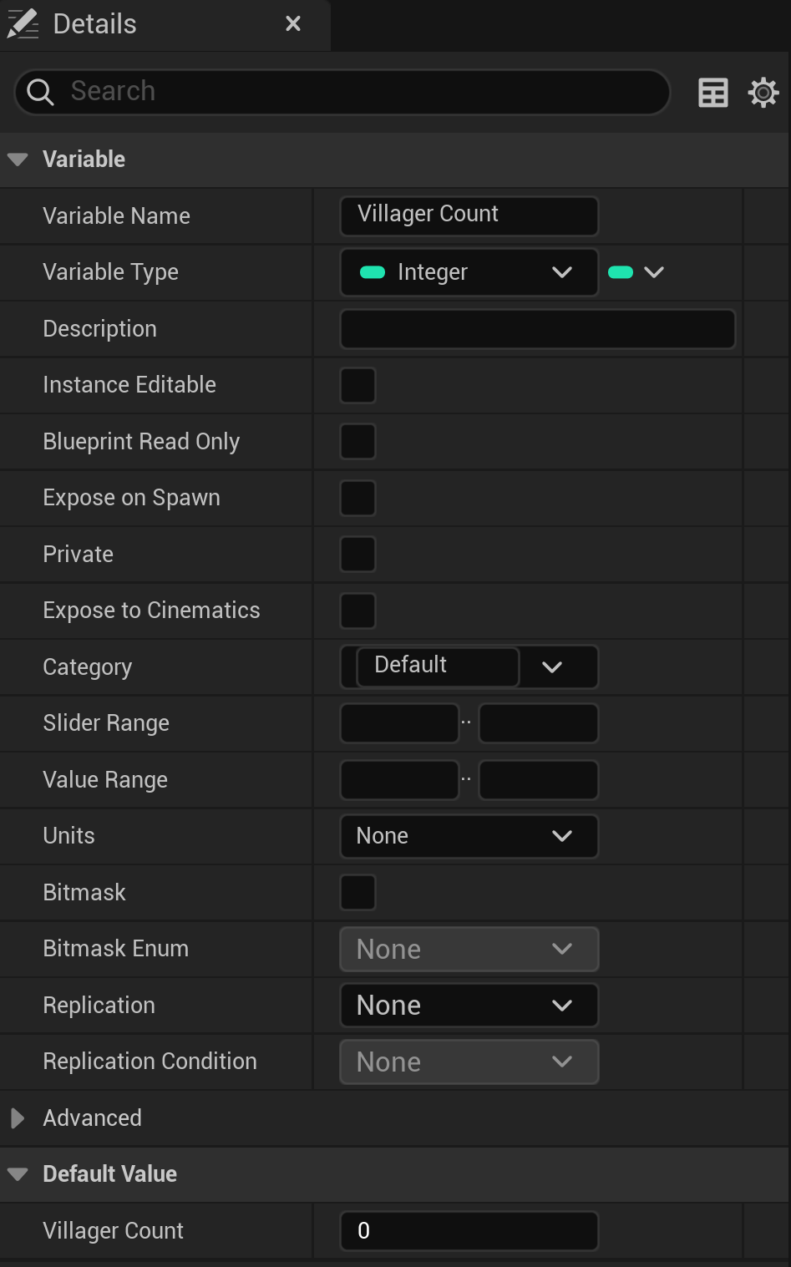
Figure 13: The blueprint variable plain.
Save and compile the code in Unreal:
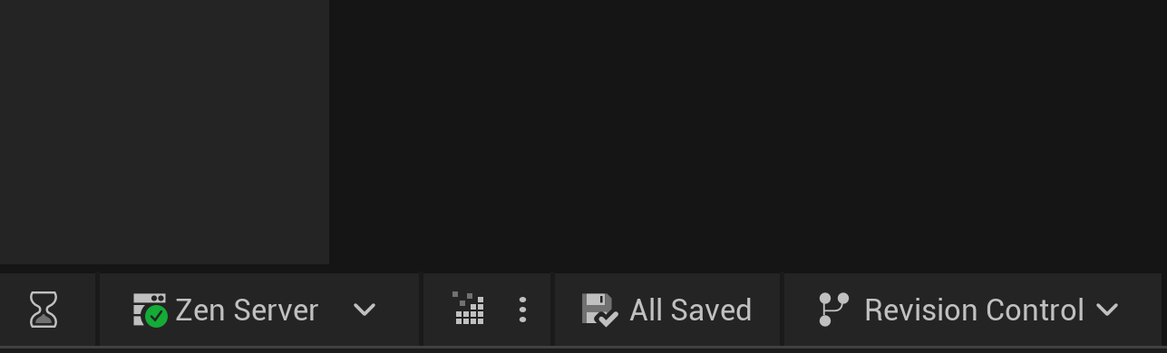
Figure 14: The compile button, your best friend, the others are fake. The compile button will never let you down.
This will work, but you’ll notice we can’t see it in the Blueprints, even if we search for it.

UProperties
We can’t see it as we need to provide it with some UProperties so Unreal knows what we want to do with the variable. Let's adjust the code to this:
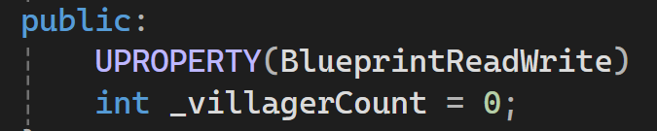
Figure 15: Revealing the variable to unreal.
Now, if we save and recompile the code, in the blueprint, if we search (right click) for the variable, we get a more desirable result:
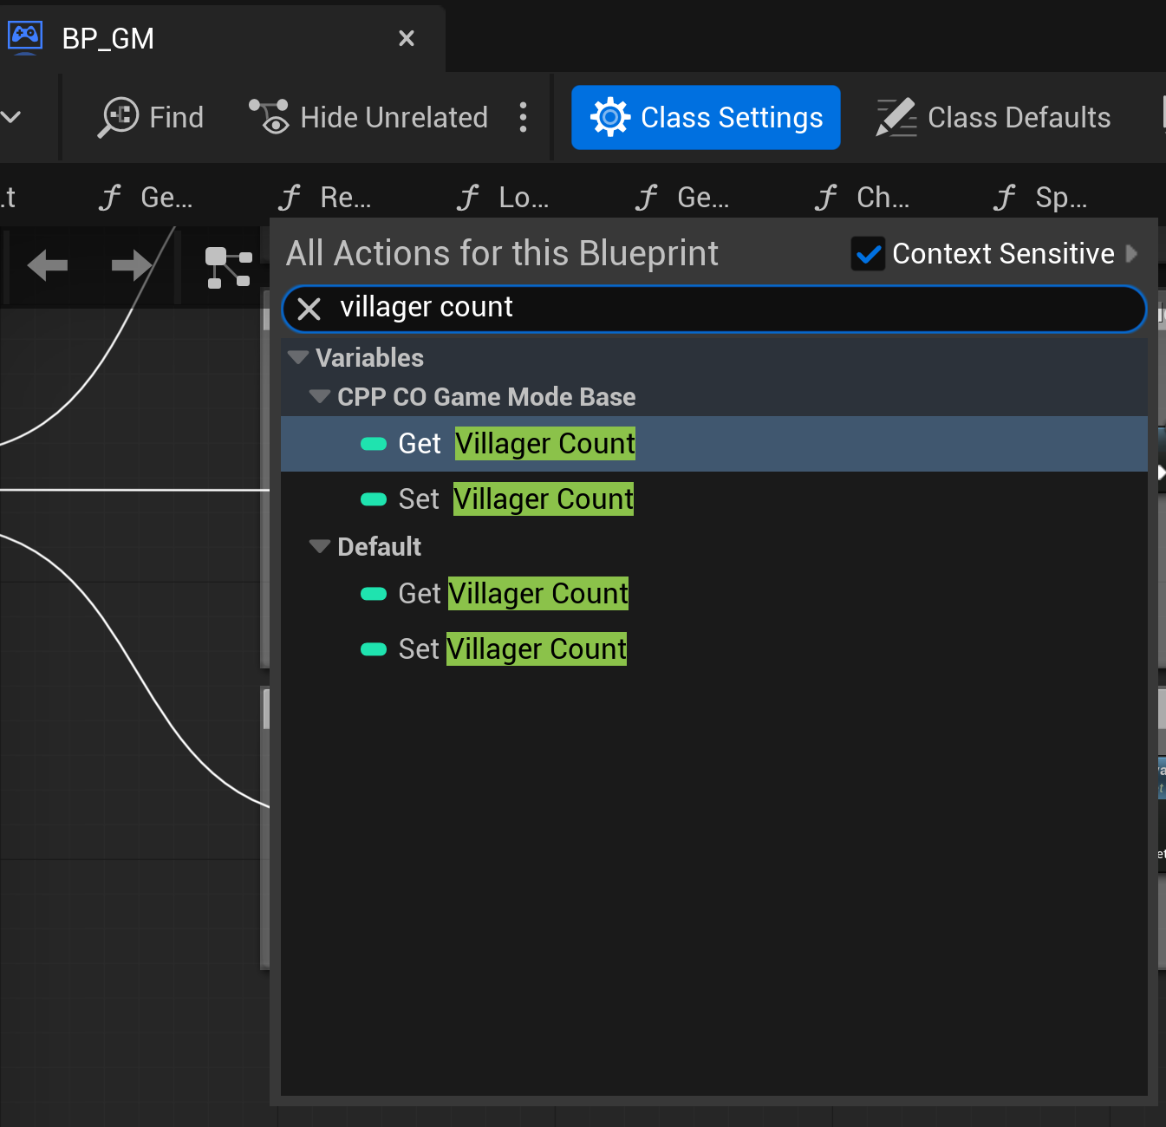
Figure 16: The default (blueprint) and the C++ Script.
If this worked, CONGRATULATIONS! You have some code you can work with. Next, hunt down and replace the various references to the variable in the code. You can do this by right-clicking the variable and choosing the Replace References option. Try that out; some may fail and need a manual replacement, or right-click and refresh the node.
Save Compile and try the code.
You will know this has worked if the top-right icon for villagers is not 0 at the start. If it has worked, the Blueprint variable has fulfilled its duty, and only in death does duty end, so delete it.
If you have a bit of time, try a few other variables. If you are short on time, converting a function would be more useful.

Converting a Blueprint function
Now we can convert some of the functionality, but we have to be specific, a simple-looking function is Get Spawn Ref; however, if you notice that it uses a Blueprint class, it is difficult to reference in C++.
We will target the Get Spawn Ref function. The first step, is to reparent the Postponer -> the script is in Plugins->Island Generator->Spawner or you can also choose Edit Blueprint on the BP_Spawner in the outliner. I have called the new class C_spawner.
Using the instructions above, try to reparent the script.

Of course, we need a variable for our C class, and we have a slight difference now: we need to include the new file in our game mode header file (CPP_CO_GameModeBase). This should go above the generated h file:
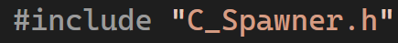
Figure 17: The new header include

This allows us to reference this class and its functions. Thus, we can create a C_Spawner object like so, just under where we created our villager:
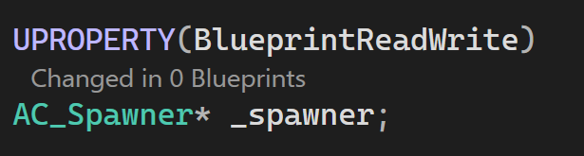
Figure 18: The new spawner variable.
Note that it is AC, not just C, because it is an actor. The * means a pointer, which we will cover later in week 4. Next we need to declare a method to call in the header file:
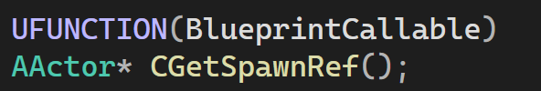
Figure 19: The new method to get the spawn points.
We can then implement the function in the CPP file:
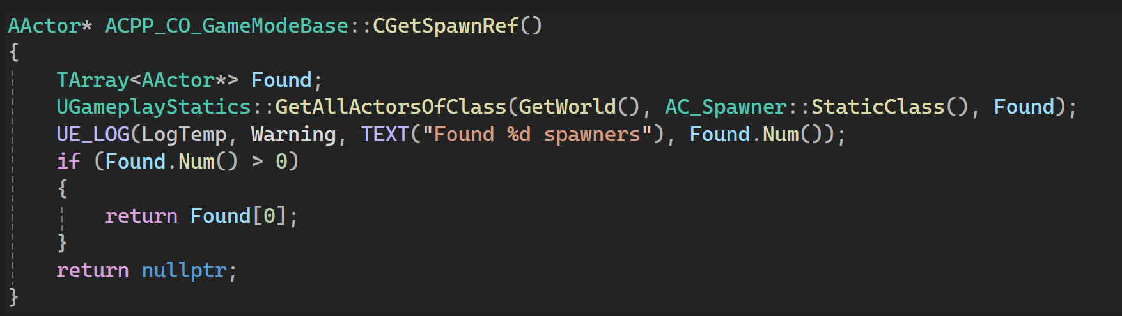
Figure 20: The method implementation.
Include the check, as this will be key for debugging later.
You will need the following header file, in addition to the C_Spawner:
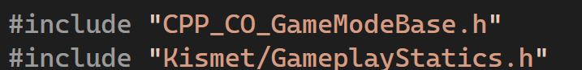
Figure 21: Kismet allows use wider access to gameplay functionality
Since we still need the original blueprint's functionality for the BP spawner, our code isn’t fully converted yet. Keep the original code and add a cast to BP_Spawner for the moment in the Get Spawner Ref Blueprint function.
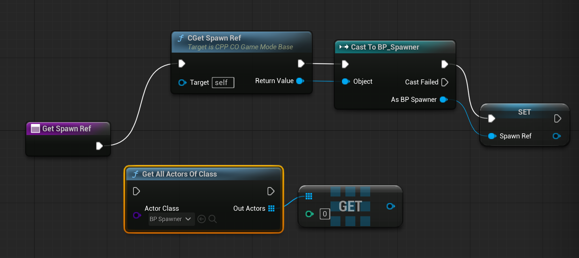
Figure 22: The remapped blueprint, note we keep the original flow just incase things go wrong.
Now save, compile and run the code!

Easy:
Try converting the other variables.

Medium:
Try converting the other functions.

Hard:
Try to standardise the scripts.

