BAHRIA UNIVERSITY KARACHI CAMPUS
Department of Computer Science

Software Engineering — Project Report

Sprint-Flow

Agile Project Management and Sprint Tracking Platform

Full-stack web application for organizations, workspaces, projects,
Kanban boards, sprints, tickets, collaboration, and reporting

Submitted By  Abdul Basit | 23K-0526  Alishba Rasheed | 23K-0756  Taaha Khan | 23K-0583 | Supervised By  Prof. Engr. Abdul Rahman  Professor

May 2026

Table of Contents

1. Abstract 3
2. Introduction & Problem Statement 3
2.1 Introduction 3
2.2 Problem Statement 4
3. Objectives & Scope 4
3.1 Objectives 4
3.2 Scope 5
4. System Architecture 5
4.1 Overview 5
4.2 Tier 1 — Presentation 6
4.3 Tier 2 — Application (Modular Monolith) 6
4.4 Tier 3 — Data 6
4.5 External Integration 6
5. System Design 7
5.1 Use Case Diagram 7
5.2 Class Diagram 7
6. Database Design 8
6.1 Schema Overview 8
6.2 Core Entities 8
6.3 Key Design Decisions 9
7. Tech Stack & Implementation 9
7.1 Technology Stack 9
7.2 Frontend 10
7.3 Backend 10
7.4 Available Scripts 10
8. Testing 11
8.1 Static Analysis 11
8.2 Manual Test Cases 11
8.3 Known Gaps 11
9. Conclusion 12

1. Abstract
Sprint-Flow is a multi-tenant agile project management platform built for software teams to organize work, plan sprints, and track tasks on customizable Kanban boards. It provides role-based access control, ticket lifecycle management, threaded comments, notifications, time logging, and workspace-level reporting. The system is built on Next.js 16 with the App Router, React 19, TypeScript, Tailwind CSS 4, and PostgreSQL 15 via Drizzle ORM, with JWT-based dual-token authentication and optional Google OAuth 2.0.

2. Introduction & Problem Statement

2.1 Introduction
Agile methodologies like Scrum and Kanban have become the standard for managing software projects. Teams need a tool that lets them plan sprints, assign work, track progress on a board, and collaborate — all in one place. Commercial tools exist, but Jira is overly complex and expensive for smaller teams, while Trello is too simple and lacks sprint management, proper RBAC, and reporting.
Sprint-Flow fills this gap. It is a full-stack web application that gives teams the structure they need — organizations, workspaces, projects, sprints, and tasks — without the overhead of enterprise tools. It was built as a Software Engineering course project to demonstrate real-world, production-shaped application development.

2.2 Problem Statement
Without a dedicated project management tool, software teams scatter work across chat messages, spreadsheets, and documents. Sprint commitments become unclear, task ownership is ambiguous, and there is no data to review at the end of a sprint. The result is missed deadlines, unclear priorities, and a team that cannot improve because it has no visibility into its own performance.
Existing tools either require significant configuration overhead and licensing costs (Jira), or lack the features needed for structured agile practice (Trello). Sprint-Flow solves this by providing a lightweight, free-to-host tool that enforces the natural hierarchy of agile work and gives teams the visibility they need.

3. Objectives & Scope

3.1 Objectives
- Implement a multi-tenant hierarchy: Organizations → Workspaces → Projects → Sprints → Tasks, with role-based access control at the workspace level.
- Enable full sprint lifecycle management: create, start, complete, with backlog migration of incomplete tasks.
- Model tasks with rich attributes: type, priority, status, assignee, story points, due date, stable per-project ticket numbers, and inter-task dependencies.
- Build a collaboration layer: threaded comments, @mentions, file attachments, and time entry logging.
- Enforce RBAC with three workspace roles (admin, project_manager, member) mapped to a granular permission catalogue.
- Provide reporting and visibility through workspace dashboards, board views, backlog views, and a reports page.
- Implement secure authentication with JWT dual-token sessions, HTTP-only cookies, rate limiting, and optional Google OAuth 2.0.

3.2 Scope

In Scope
- User registration, email/password login, Google OAuth, and session management.
- Organization and workspace management with member invitations and role assignment.
- Project creation with configurable Kanban board columns stored as JSONB.
- Sprint management: create, start, complete with date ranges and goals.
- Task management: full CRUD, ticket numbering, dependencies, image upload.
- Comments with threading and @mentions; file attachments; time entries.
- Notifications with read/unread state; workspace and project activity logs.
- Workspace reports page with status and priority breakdowns.

Out of Scope
- Production file storage (object storage like S3) — attachments use URL references.
- Real-time push notifications via WebSockets — requires manual refresh.
- Payment or billing integration.
- Native mobile applications.

4. System Architecture

4.1 Overview
Sprint-Flow is a modular monolith — a single deployable Next.js application containing both the server-side API and the client-side UI. It follows a three-tier architecture: Presentation, Application, and Data.

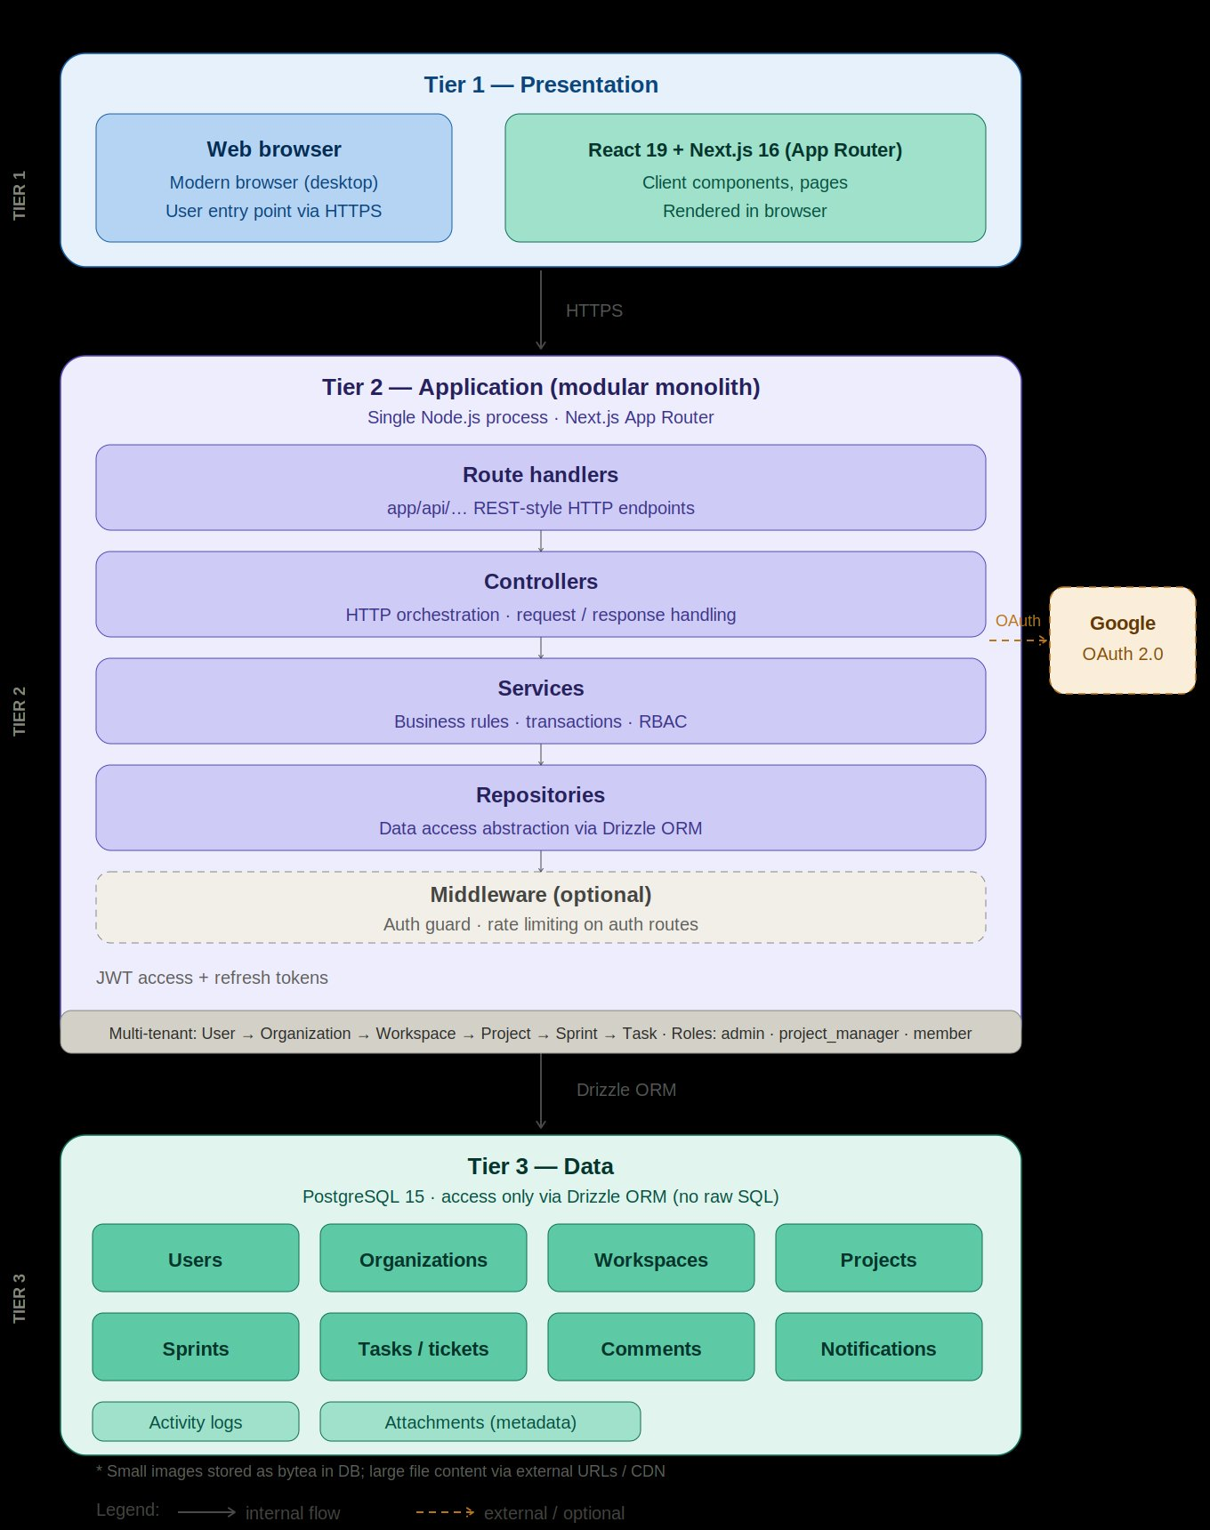
Figure 1: Three-Tier System Architecture Diagram

4.2 Tier 1 — Presentation
The browser renders the Next.js application over HTTPS. React 19 server components handle data fetching at the page level, while client components manage interactive UI such as the Kanban board, modals, and forms. Tailwind CSS 4 provides utility-first styling.

4.3 Tier 2 — Application (Modular Monolith)
This tier runs as a single Node.js process using the Next.js App Router. It is organized into four internal layers: Route Handlers act as the HTTP boundary, Controllers handle request parsing and response serialization, Services contain all business rules and RBAC enforcement, and Repositories encapsulate all database access via Drizzle ORM with no raw SQL in business logic.
Two cross-cutting components operate across all requests: src/middleware.ts enforces authentication on protected routes and transparently refreshes expired access tokens; src/lib/auth/rbac.ts defines the complete permission catalogue.

4.4 Tier 3 — Data
PostgreSQL 15 accessed only through Drizzle ORM. The database stores all persistent state: users, sessions, tenancy, work items, and audit logs. A connection pool singleton in src/lib/db.ts prevents exhaustion during hot-reload in development.

4.5 External Integration
Google OAuth 2.0 is the only external dependency, used optionally for social sign-in. All OAuth exchange happens server-side via dedicated callback routes.

5. System Design

5.1 Use Case Diagram
The use case diagram shows all system interactions organized by actor. Five roles are defined: Guest (unauthenticated), Authenticated User, Org Owner/Admin, Workspace Admin, and Workspace Member. Use cases span eleven functional packages — Auth & Onboarding, Workspaces, Sprints, Collaboration, Visibility, Invites, Organizations, Membership, Projects, Tasks, Notifications, and Reporting.

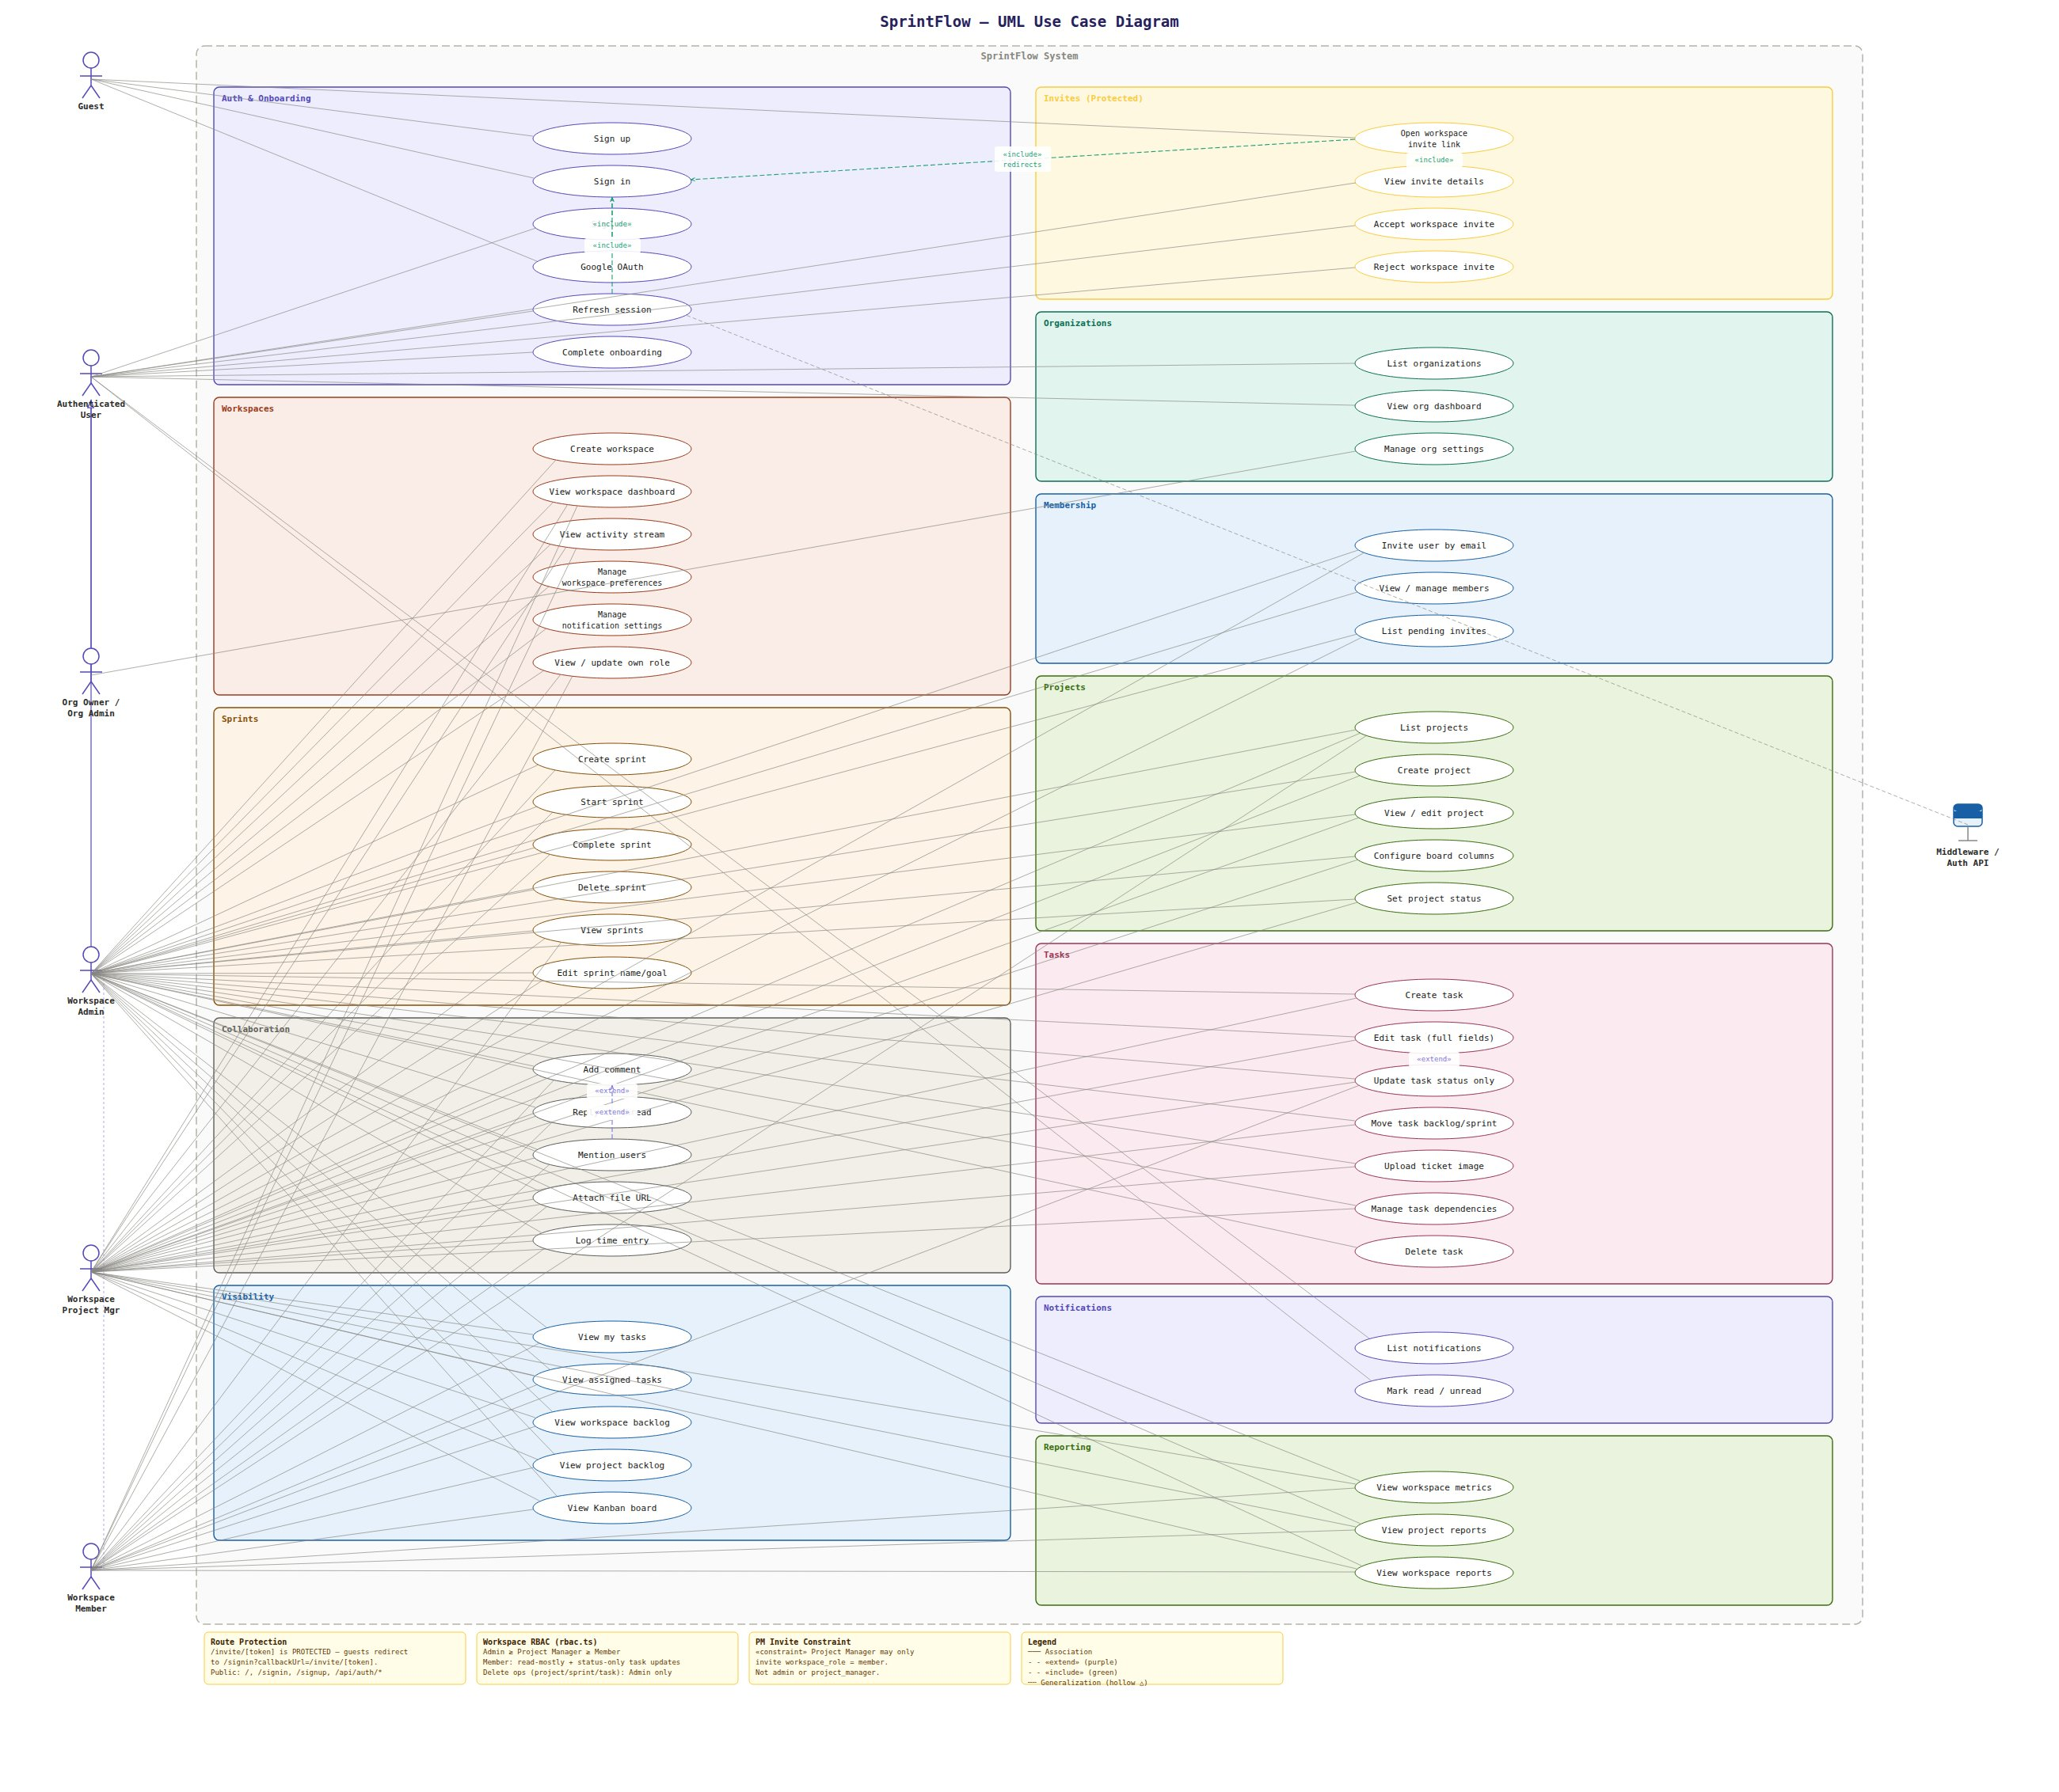
Figure 2: UML Use Case Diagram
Key access rules: guests can only sign up or sign in; members can update task status and comment but cannot manage sprints or projects; project managers manage sprints and tasks but not workspace settings; admins have full workspace control. The Middleware / Auth API actor represents the system's internal session refresh mechanism.

5.2 Class Diagram
The class diagram models core domain entities and their associations. The Task entity is central, associated with User (assignee, reporter), Project, Sprint (optional), Comment, Attachment, TimeEntry, TaskDependency, and Notification. Workspace acts as the primary organizational unit holding members, projects, and invites. Session is associated with User and stores the refresh token with expiry metadata enabling instant revocation.

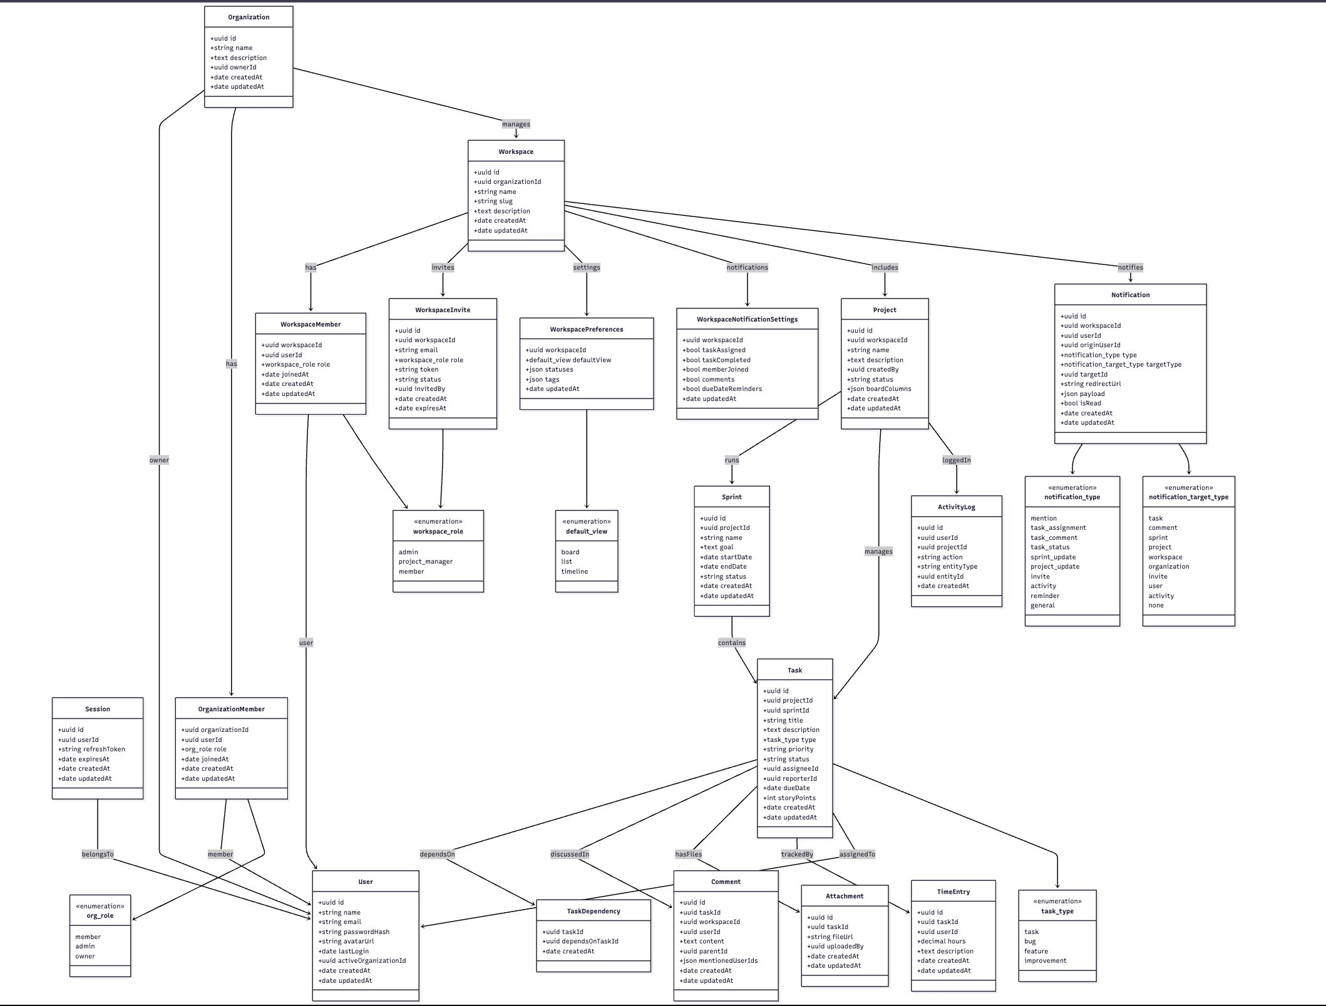
Figure 3: UML Class Diagram

6. Database Design

6.1 Schema Overview
The schema is defined in drizzle/0000_initial.sql and managed through Drizzle Kit migrations. It is normalized to 3NF with one deliberate exception: board_columns on the projects table is stored as JSONB, allowing flexible column configuration without additional joins.

6.2 Core Entities
Table | Key Columns | Notes
users | id, name, email, password_hash, avatar_url | Root anchor for all entities
sessions | id, user_id, refresh_token, expires_at | Server-side store; enables revocation
organizations | id, name, slug, owner_id | Top-level tenancy unit
organization_members | org_id, user_id, role (enum) | Roles: member, admin, owner
workspaces | id, org_id, name, slug | Workspace-level tenancy
workspace_members | workspace_id, user_id, role (enum) | Roles: admin, project_manager, member
workspace_invites | id, workspace_id, email, token, role, expires_at | Expiring tokenized invitations
projects | id, workspace_id, name, status, board_columns (JSONB) | board_columns defines Kanban stages
sprints | id, project_id, name, goal, start_date, end_date, status | Status: planning, active, completed
tasks | id, project_id, sprint_id, ticket_number, type, priority, status, assignee_id, story_points | ticket_number unique per project
task_dependencies | task_id, depends_on_task_id | Blocking relationships
comments | id, task_id, parent_id, content, mentioned_user_ids | Threading via parent_id
attachments | id, task_id, file_url, uploaded_by | URL references to files
time_entries | id, task_id, user_id, hours, description, date | Time tracking per task
notifications | id, user_id, type, target_type, read, payload | Typed notification system
activities / activity_logs | id, workspace_id / project_id, actor_id, action, created_at | Audit trail

6.3 Key Design Decisions
- Ticket Number Allocation: Task creation uses a SELECT FOR UPDATE transaction to atomically increment the per-project ticket number, preventing race conditions under concurrent writes.
- Referential Integrity: ON DELETE CASCADE for membership and comment chains; ON DELETE SET NULL for optional sprint references on tasks, so completing a sprint does not orphan tasks.
- Indexes: All foreign key columns are indexed. Additional indexes on tasks(project_id, status) for board queries, notifications(user_id, read) for unread counts, and workspace_invites(token) for O(1) invite lookup.

7. Tech Stack & Implementation

7.1 Technology Stack
Layer | Technology | Version
Framework | Next.js — App Router | 16.1.6
UI | React / React DOM | 19.2.3
Language | TypeScript | 5.x
Styling | Tailwind CSS | 4.x
Database | PostgreSQL (pg driver) | 15 / ^8.18.0
ORM | Drizzle ORM | ^0.45.1
Auth | bcryptjs + custom JWT | —
Icons | lucide-react | ^0.577.0
Analytics | @vercel/analytics | —
Code Quality | ESLint, Prettier, Husky / lint-staged | —

7.2 Frontend
All routes live under src/app/ using the Next.js App Router convention. Workspace routes are nested under src/app/workspace/[workspaceId]/ with sub-routes for board, backlog, sprints, team, settings, notifications, and reports. Server components handle initial data fetching; client components manage interactive state including Kanban drag-and-drop, modals, and form interactions. Reusable components are organized in src/components/ and styled exclusively with Tailwind CSS 4.

7.3 Backend
Each feature module under src/modules/ exposes a Controller, Service, and Repository. Controllers handle HTTP parsing and response serialization. Services contain all business rules — sprint lifecycle transitions, notification dispatch, activity logging, and RBAC checks. Repositories expose typed Drizzle query methods with no raw SQL in business logic.
Authentication is implemented in src/lib/jwt.ts. Access tokens carry a minimal user ID payload and expire quickly. Refresh tokens are opaque IDs stored in the sessions table; the middleware validates them server-side before issuing a new access token, enabling instant revocation by deleting the session row.

7.4 Available Scripts
- npm run dev — start development server
- npm run build / start — production build and serve
- npm run lint / type-check / format — code quality gates
- npm run db:generate / db:migrate / db:push / db:studio — schema management

8. Testing

8.1 Static Analysis
TypeScript strict mode was enabled throughout, providing compile-time type checking across the entire codebase. ESLint was configured with a zero-warning policy. Prettier enforced consistent formatting. Husky pre-commit hooks ran lint and type-check on every commit, preventing regressions from entering the repository.

8.2 Manual Test Cases
# | Test Case | Expected Result | Status
1 | Register with valid email and password | Account created; JWT access token issued in HTTP-only cookie | Pass
2 | Login with wrong password | 401 Unauthorized returned; rate limiter increments | Pass
3 | Google OAuth sign-in flow | User created or bound; session cookie issued | Pass
4 | Create organization and workspace | Org and workspace created; slug uniqueness enforced | Pass
5 | Invite user by email; accept invite | User added to workspace with correct role | Pass
6 | Create project and configure board columns | Project saved; custom columns reflected on board | Pass
7 | Create sprint, start it, complete it | Incomplete tasks returned to backlog on completion | Pass
8 | Create task; move status on Kanban board | Task status updated; activity log recorded | Pass
9 | Add comment with @mention | Notification generated for mentioned user | Pass
10 | RBAC: member attempts admin-only action | 403 Forbidden returned | Pass
11 | Log time entry against task | Time entry saved and displayed on task detail | Pass
12 | View reports page | Task counts by status and priority match test data | Pass

8.3 Known Gaps
- No automated unit or integration tests are present. Planned: Jest tests for the RBAC permission matrix and ticket number concurrency logic.
- No end-to-end tests. Planned: Playwright tests for core user journeys (sign up → create workspace → create sprint → move task).

9. Conclusion
Sprint-Flow successfully delivers a production-shaped agile project management platform that addresses a real and well-defined problem. The system provides multi-tenant organizational structure, full sprint lifecycle management, a configurable Kanban board, rich task modeling, threaded collaboration, role-based access control, and workspace reporting — all backed by a normalized PostgreSQL schema and a disciplined modular backend.
The technology stack — Next.js 16, React 19, TypeScript, Tailwind CSS 4, Drizzle ORM, PostgreSQL 15 — reflects current industry practice and supports deployment on Vercel or any Node.js-capable host with minimal configuration. The dual-token authentication strategy and server-side session store represent a considered security design that mirrors production patterns.
The main limitations are the absence of automated tests and real-time push notifications, both identified as the highest-priority future enhancements. Overall, the project meets all stated objectives and demonstrates competency across the full software engineering stack — from schema design and API construction to a usable, well-structured frontend.

