
PUCIT
Punjab University College of Information Technology

Project VoiceCraft
Version 1.0

.

Table of Contents

1. Introduction 3
1.1 Project Title 3
1.2 Project Overview Statement 3
1.4 Project Goals & Objectives 5
1.5 High-level system components 5
1.6 List of optional functional units 5
1.7 Exclusions 6
1.8 Application Architecture 6
1.9 Gantt chart 7
1.10 Hardware and Software Specification 7
1.11 Tools and technologies used with reasoning 7

Project VoiceCraft

1. Introduction

1.1 Project Title

VoiceCraft: Audio to audio with voice over global languages model

1.2 Project Overview Statement
In a world increasingly driven by multimedia content, the demand for personalized and engaging voiceovers is growing rapidly. "VoiceCraft" is a cutting-edge project that specializes in transforming audio or written text into compelling, customized voiceovers featuring the unique characteristics of different individuals. Whether it's for video narrations, virtual assistants, or any application requiring spoken content, VoiceCraft delivers an unprecedented level of voice customization.
Project Overview Statement Template
Project Title: VoiceCraft

Group Leader: Abdul Aziz
Project Members:
Name | Roll no. # | Email Address | Signature
Abdul Aziz | BCSF19A026 | BCSF19A026@pucit.edu.pk
Muhammad Umar | BCSF20A012 | BCSF20A012@pucit.edu.pk
Maryam Ali | BCSF20A025 | BCSF20A025@pucit.edu.pk
Fatima Ansari | BCSF20A046 | BCSF20A046@pucit.edu.pk
Yasir khan bahadar | BCSF20A013 | BCSF20A013@pucit.edu.pk

Project Goal:
To provide users with the ability to seamlessly transform written audio or text into highly customizable, lifelike voiceovers to meet diverse communication and content needs.
Objectives:
Sr.#
1 | Customize voices to meet specific needs.
2 | Convert text into natural, expressive speech.
3 | Serve various applications with versatility.
4 | Ensure a user-friendly interface.
5 | Scale for individual users and enterprises.

Project Success criteria:
Delivering high-quality voiceovers with customizable accents, genders, and tones, ensuring a high level of user satisfaction through feedback, accurate text-to-speech conversion, versatility across applications, a user-friendly interface, scalable performance, successful API integration, compliance with legal and ethical standards, robust market adoption, positive ROI, long-term sustainability, and the ability to maintain a competitive edge in the text-to-voice customization market.
Assumptions and Risks:
- Adequate voice data, with security risks.
- Tech support, with potential challenges and delays.
Obstacles:
1-User may be required to record voice for more than 15 sec for better performing.

Organization Address (if any):

Type of project: Research Development
Target End users:
- Global
Development Technology: Object Oriented Structured
Platform: Web based Distributed
Desktop based Setup Configurations
Other_____________________
Suggested Project Supervisor: Sir Kashif Murtaza
Approved By: Sir Kashif Murtaza
Date: September 28, 2023

1.4 Project Goals & Objectives
Goal
To enable users to swiftly transform written audio or text into highly configurable, realistic voiceovers to satisfy various communication and content needs.
Objectives

Create voices that are specific to your requirements.

Transform text into expressive, genuine voice.

Serve a variety of purposes with flexibility.

Ensure that the UI is user-friendly.

Scale up for both private individuals and businesses.

1.5 High-level system components
- User Interface
- Application Logic
- Database
- Security
- Integration
- Logging and Monitoring
- Scalability and Performance
- Configuration Management
- Error Handling
- Backup and Recovery
- User Management
- Documentation
Top of Form

1.6 List of optional functional units
- Reporting and Analytics
- Notification and Alerting

1.7 Exclusions
There will be no exclusions in our project.

1.8 Application Architecture
We will follow 3-tier Architecture.
- React (Front End)
- Python (Back End)
- MongoDB (Database)

1.9 Gantt chart
Sr | Task Name | Start Time | End Time | Duration (Days)
1 | Orientation |  |  | 0
2 | Proposal Submission |  |  | 11
3 | 1st Del |  |  | 27
4 | 2nd Del |  |  | 27
5 | P I |  |  | 43
6 | GUI Design |  |  | 10
7 | Coding |  |  | 80
8 | Testing |  |  | 8
9 | Deployment |  |  | 2
10 | Maintenance |  |  | 10

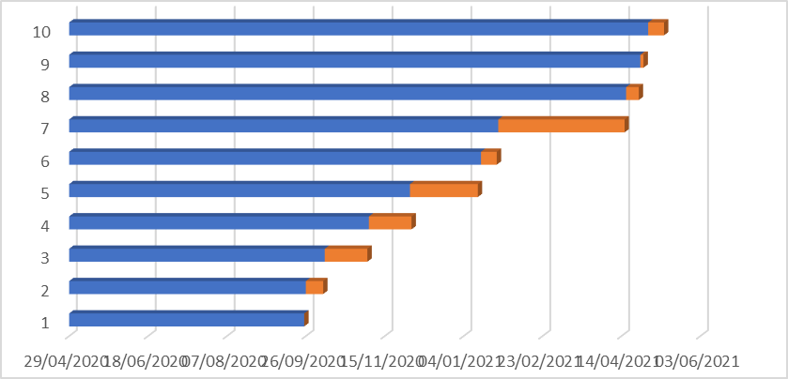

1.10 Hardware and Software Specification
Hardware: (Recommended)
- GPU
- Core i7 above 7th generation
- 8 GB Ram
- 50 GB Storage
Software: (Recommended)
- Python
- TensorFlow
- PyTorch
- scikit-learn
- Collaboratory

1.11 Tools and technologies used with reasoning

Tools:

- Python:
For audio data processing, analysis, and scripting.
- Visual Studio Code:
Code editor for writing and debugging Python scripts and applications.
- Jupyter Notebook:
Interactive environment for audio algorithm experimentation and documentation.
- Collaboratory (Google Collab):
Cloud-based environment with GPU support for training voice-related machine learning models.
- MongoDB Compass:
GUI tool for managing audio data in MongoDB databases.
- GitHub:
Version control and collaboration platform for managing project codebase.

Technology:

- React
To build the user interface (UI) of your voice-over project's web application or platform. It provides the capability to create a visually appealing and responsive interface where users can interact with voice-related features and content.

- Python
For audio processing, analysis, and scripting to manipulate voice recordings or generate synthetic voices. Python's rich ecosystem of libraries also supports machine learning and natural language processing tasks, which can enhance voice recognition and synthesis capabilities.

- MongoDB
For storing and managing voice-related data in your project. This may include audio files, user profiles, metadata about voice recordings, and more. MongoDB's flexible document-based structure can accommodate the diverse data types associated with voice-over projects.

