**THINGSPEAK**

ThingSpeak is an IoT analytics platform service that allows you to aggregate, visualize, and analyze live data streams in the cloud. You can send data to ThingSpeak from your devices, create instant visualization of live data, and send alerts without setting up servers or developing web software.

**Installing the ThingSpeak Library**

To send sensor readings to ThingSpeak, we’ll use the thingspeak-arduino library. You can install this library through the Arduino Library Manager. Go to **Sketch**> **Include Library** > **Manage Libraries…** and search for “**ThingSpeak**” in the Library Manager. Install the ThingSpeak library by MathWorks.

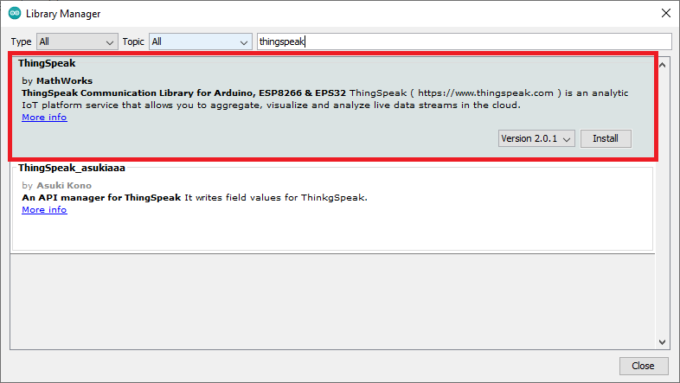

## ThingSpeak – Getting Started

Go to ThingSpeak an click the “**Get Started For Free**” button to create a new account. This account is linked to a Mathworks account. So, if you already have a Mathworks account, you should log in with that account.

**Creating New Channel**

After your account is ready, sign in, open the “**Channels**” tab and select “**My Channels**“.

Press the “New Channel” button to create a new channel.

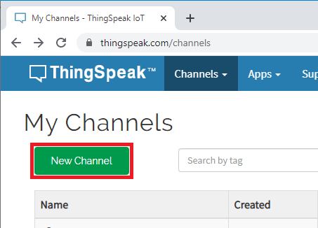

Type a name for your channel and add a description.For example, If you want to publish multiple readings (like humidity and temperature), you can enable more fields as you’ll see later in this if needed.

ThingSpeak Edit Add New Channel Settings Configuration

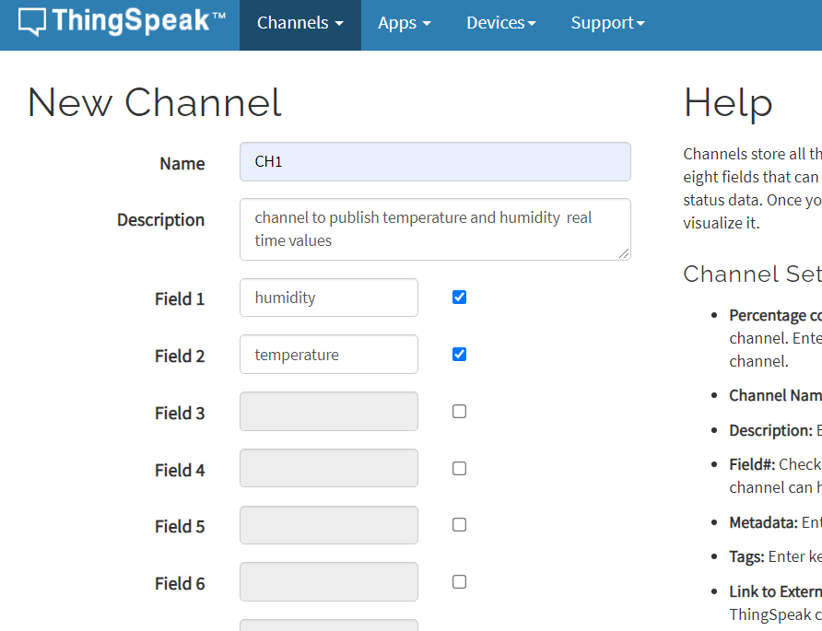

Click the **Save Channel** button to create and save your channel.

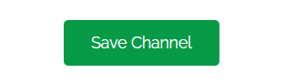

Customizing Chart

The chart can be customized, go to your **Private View** tab and click on the edit icon.

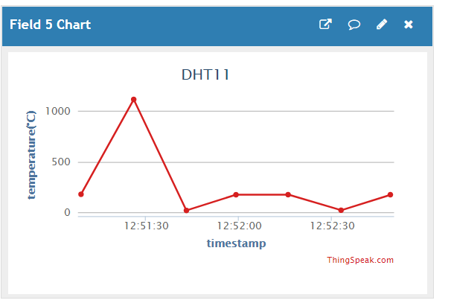

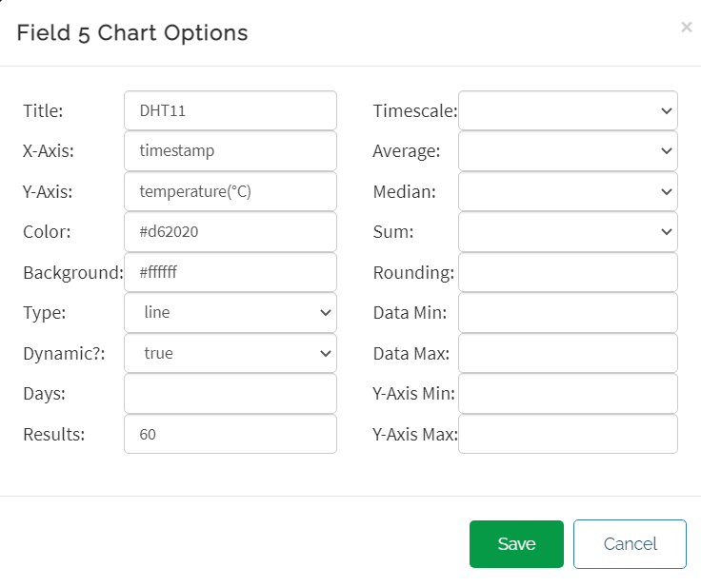

### API Key & channel ID

To send values from the ESP32 to ThingSpeak, you need the Write API Key.

Open your newly created channel and select the **API Keys** tab to copy your API Key.

