**Lab Note - Application Server Setup with Node-RED**

This lab note explains how to set up a Rackspace cloud instance and install Node-RED on the instance. A demo Node-RED flow is provided to control the onboard LED resource from the mbed and Device Server demo.

**Set up the server instance**

Go to <http://iwantaserver.io> and fill in the form on the free server page.

Event name: <string you were given>

Email address: your email address

Make note of the IP address and root password displayed on the success page.

Using a terminal emulator, log into the server using the root password provided

$ ssh -l root 104.239.231.176

The authenticity of host '104.239.231.176 (104.239.231.176)' can't be established.

RSA key fingerprint is 00:d9:52:95:94:79:99:42:17:ed:8f:2b:54:e3:80:0d.

Are you sure you want to continue connecting (yes/no)? yes

Warning: Permanently added '104.239.231.176' (RSA) to the list of known hosts.

root@104.239.231.176's password:

Welcome to Ubuntu 15.04 (GNU/Linux 3.19.0-15-generic x86_64)

* Documentation: https://help.ubuntu.com/

The programs included with the Ubuntu system are free software;

the exact distribution terms for each program are described in the

individual files in /usr/share/doc/*/copyright.

Ubuntu comes with ABSOLUTELY NO WARRANTY, to the extent permitted by

applicable law.

Last login: Thu Jan 1 00:00:10 1970

root@calpoly-20150429040032:~#

**Create a user and add the user to the sudo group**

root@calpoly-20150429040032:~# adduser demo

Adding user `demo' ...

Adding new group `demo' (1001) ...

Adding new user `demo' (1001) with group `demo' ...

Creating home directory `/home/demo' ...

Copying files from `/etc/skel' ...

Enter new UNIX password:

Retype new UNIX password:

passwd: password updated successfully

Changing the user information for demo

Enter the new value, or press ENTER for the default

Full Name []:

Room Number []:

Work Phone []:

Home Phone []:

Other []:

Is the information correct? [Y/n] Y

root@calpoly-20150429040032:~# adduser demo sudo

Adding user `demo' to group `sudo' ...

Adding user demo to group sudo

Done.

root@calpoly-20150429040032:~#

**Log out and log back into your instance using the username you just created:**

$ ssh -l demo 104.239.231.176

demo@104.239.231.176's password:

Welcome to Ubuntu 15.04 (GNU/Linux 3.19.0-15-generic x86_64)

* Documentation: https://help.ubuntu.com/

The programs included with the Ubuntu system are free software;

the exact distribution terms for each program are described in the

individual files in /usr/share/doc/*/copyright.

Ubuntu comes with ABSOLUTELY NO WARRANTY, to the extent permitted by

applicable law.

To run a command as administrator (user "root"), use "sudo <command>".

See "man sudo_root" for details.

demo@calpoly-20150429040032:~$

**Update the Linux using apt:**

**$ sudo apt-get update**

**$ sudo apt-get upgrade**

Node-RED requires the legacy version of nodejs which is installed using apt. Install nodejs and NPM, the nodejs package manager:

**$ sudo apt-get install nodejs-legacy**

**$ sudo apt-get install npm**

**Install Node-RED using NPM:**

**$ sudo npm install -g node-red**

When installation is finished, start Node-RED from the command line:

**$ node-red**

If you want Node-RED to autostart on reboot, you can use pm2:

**$ sudo npm install -g pm2**

**$ pm2 start /usr/local/bin/node-red -- -v**

**$ pm2 save**

**$ sudo env PATH=$PATH:/usr/bin pm2 startup linux -u <your user name>**

(e.g. sudo env PATH=$PATH:/usr/bin pm2 startup linux -u demo)

**Set up the demo flow to control the LED on your board**

When Node-RED is running, open a browser window and go to the IP address of your instance, port 1880.

http://<your_instance_ip_address>:1880/

You should see a blank Node-RED workspace when the page loads.

Copy the following block of text to your clipboard and paste into Node-RED using the menu selection Import -> Clipboard. The menu is in the top right corner of the Node-RED window and looks like 3 horizontal bars.

[{"id":"531b26d5.ace4d8","type":"inject","name":"RED","topic":"","payload":"01000000","payloadType":"string","repeat":"","crontab":"","once":false,"x":102,"y":112,"z":"bf45c706.40ba38","wires":[["f41213a7.0bedf"]]},{"id":"4c392da2.b3c6d4","type":"inject","name":"GREEN","topic":"","payload":"00010000","payloadType":"string","repeat":"","crontab":"","once":false,"x":102,"y":172,"z":"bf45c706.40ba38","wires":[["f41213a7.0bedf"]]},{"id":"6d5bed5a.92a414","type":"inject","name":"BLUE","topic":"","payload":"00000100","payloadType":"string","repeat":"","crontab":"","once":false,"x":103,"y":232,"z":"bf45c706.40ba38","wires":[["f41213a7.0bedf"]]},{"id":"f41213a7.0bedf","type":"http request","name":"","method":"PUT","ret":"bin","url":"http://smartobjectservice.com:8080/domain/endpoints/Changeme-LED-demo/3311/1/5706?sync=true","x":345,"y":172,"z":"bf45c706.40ba38","wires":[["e9d18563.162e78"]]},{"id":"e9d18563.162e78","type":"debug","name":"message","active":true,"console":"false","complete":"true","x":531,"y":172,"z":"bf45c706.40ba38","wires":[]},{"id":"e0f370b1.1f0c9","type":"inject","name":"OFF","topic":"","payload":"00000000","payloadType":"string","repeat":"","crontab":"","once":false,"x":104,"y":291,"z":"bf45c706.40ba38","wires":[["f41213a7.0bedf"]]}]

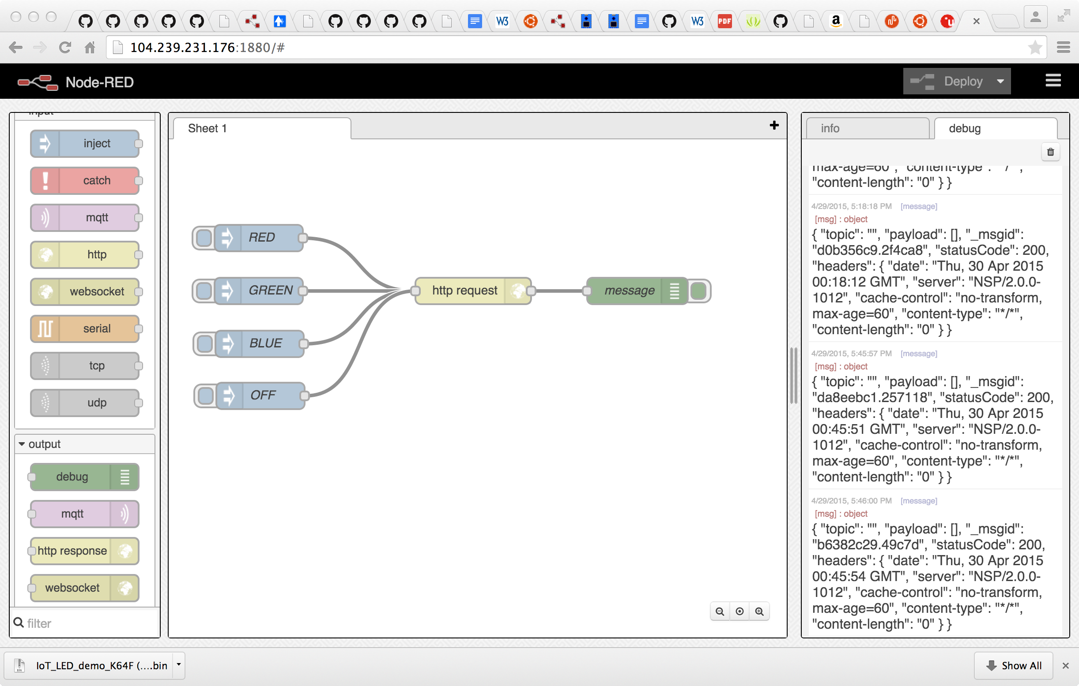

Place the flow onto the workspace and edit the node labeled “http request” by double clicking. Change the URL to point to the HTTP address of your OnBoard LED resource. Also change the Username and Password to your Device Server login credentials.

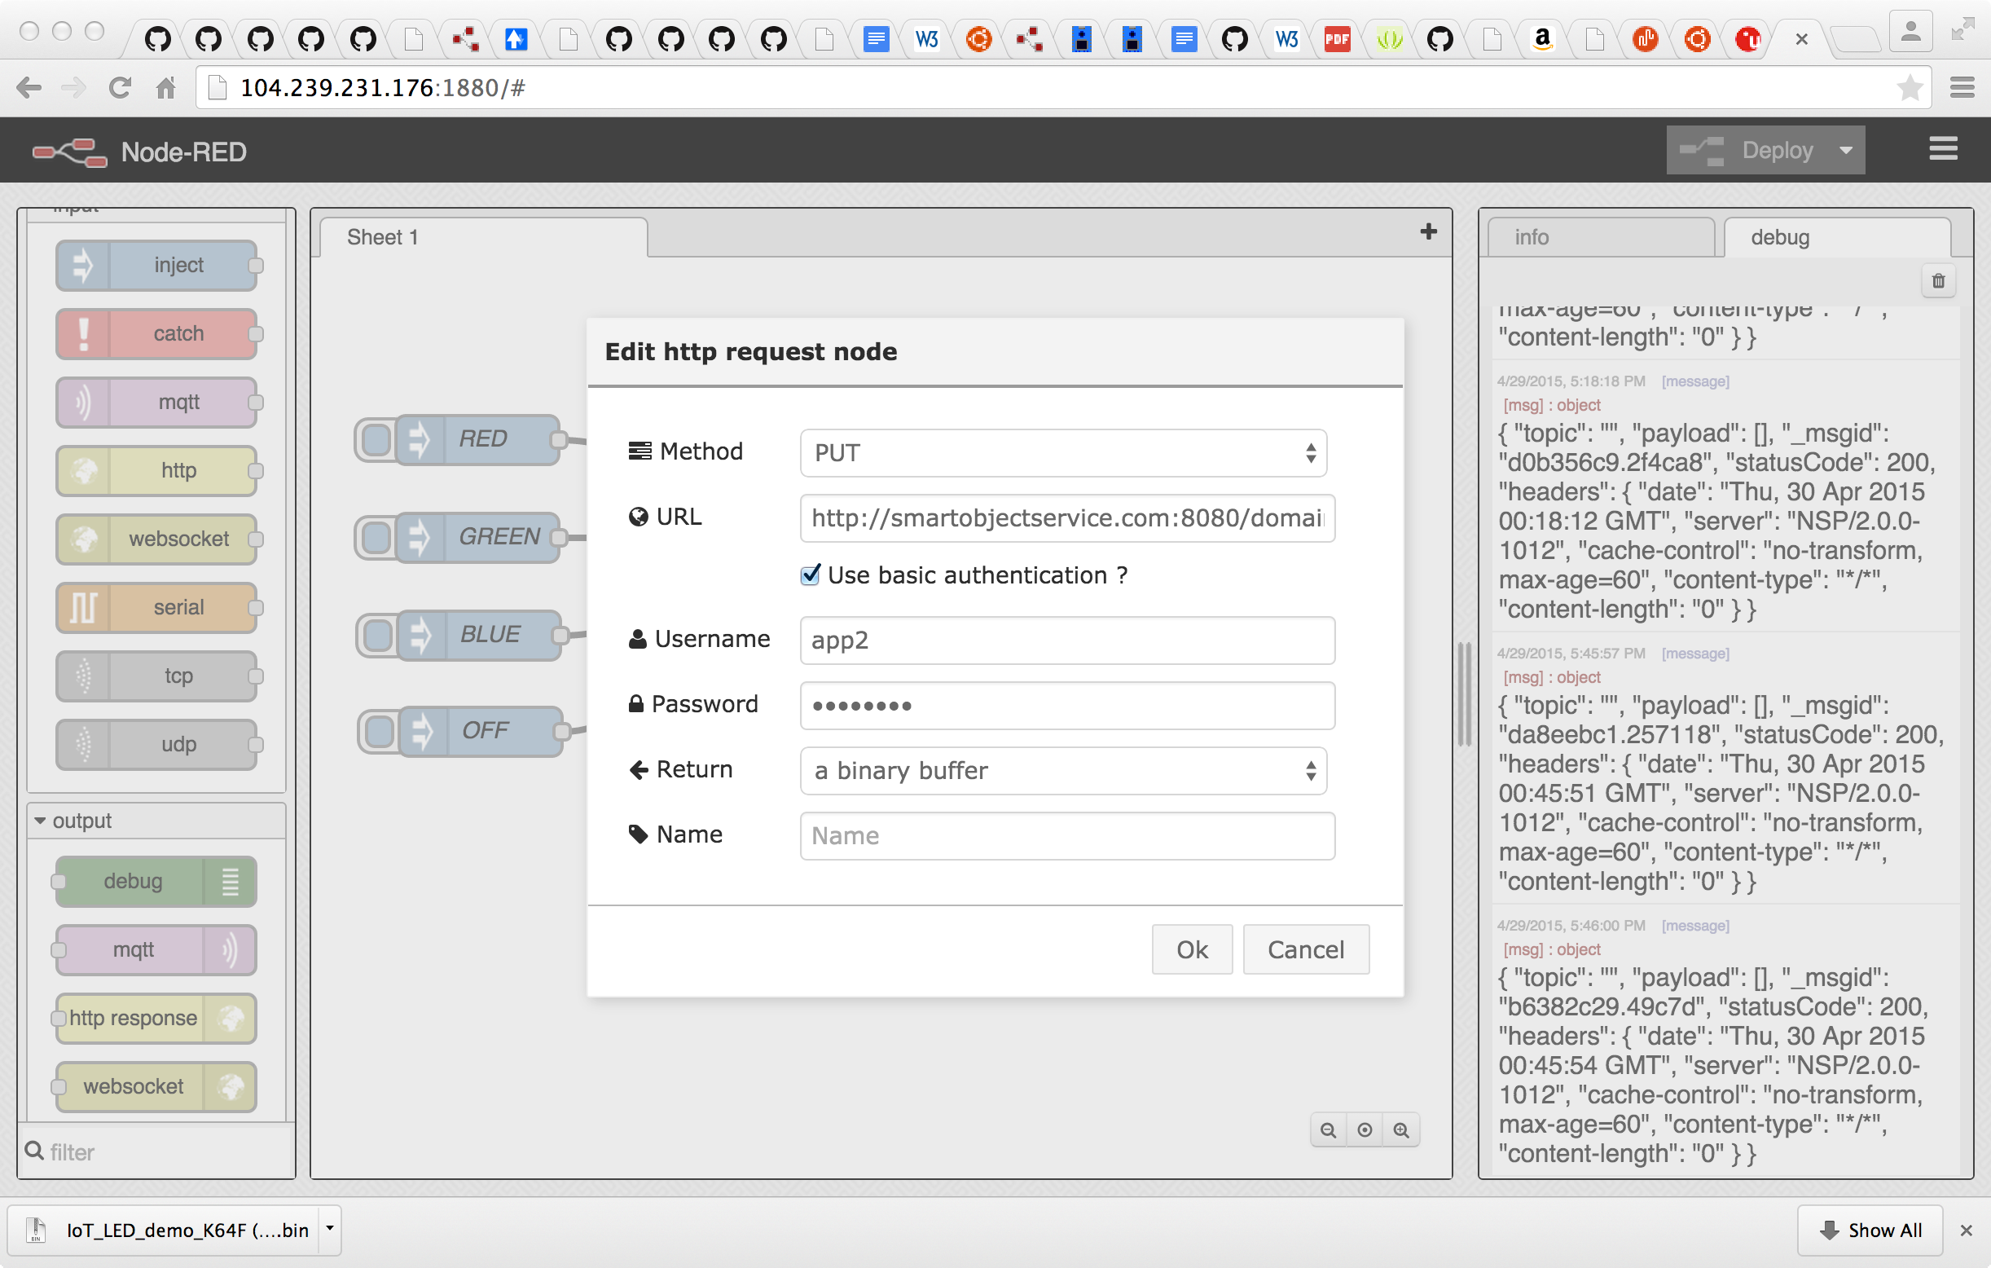

If you have everything working end-to-end, you will be able to change the color of your on-board LED by clicking on the Node-RED inject node corresponding to the desired color.