**Lab Note 2 - Using Grove Sensors in mbed projects**

For an overview of the Seeed Grove system, see the Seeed Wiki:

<http://www.seeedstudio.com/wiki/GROVE_System>

**Hardware**

The Grove Base Shield is a good place to start to illustrate the connection and use of Grove modules with the mbed system. The Base Shield works with any Arduino-compatible mbed board.

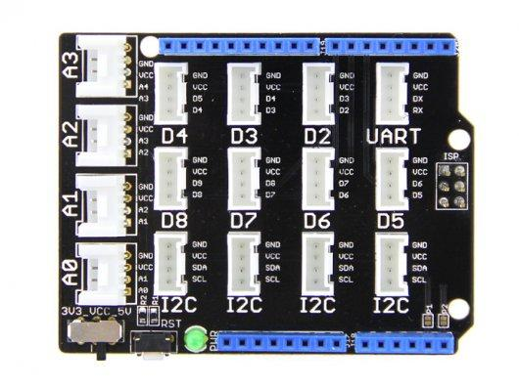

Each 4 pin connector can potentially connect to a Grove module. Each connector provides power (VCC and GND) and contains 2 signal connections. There are 4 basic Grove module personalities:

**Analog**

Labeled A0-A3, each Analog connector has 2 analog inputs. Most sensors use only one of the 2 inputs. You specify in mbed software which pin a given module is connected to based on this label. The default pin connection is the same as the label of the connector. For example, connector A2 has connections to both A2 and A3, and connecting a typical analog module with one connection will use A2.

**Digital**

Labeled D2-D8, each Digital has 2 digital I/O pins. some digital modules use both pins, in which case the next highest numbered connector may not be used. You specify in mbed software which pin a given module is connected to based on this label.

Some options, such as the WiFI shield, make use of several digital I/O pins. These pins are not available for connecting Grove modules when using these optional shields. Refer to the lab notes covering these optional configurations for further guidance.

**I2C**

I2C devices, such as the Accelerometer, will use connectors labeled I2C.

**UART**

UART Devices, such as some radio and network transceivers, connect using the UART interface to the connector labeled UART.

**Voltage setting**

**Pay close attention to the VCC voltage setting and the VCC voltage requirements of the Grove modules you intend to connect. Some modules require 5 volts, but most will work properly with 3.3 volts. Make sure the VCC switch is set correctly for the combination of modules you are using.**

**Wiring to the Nordic BLE mKit board using jumper wires**

The Nordic mKit BLE platform does not use the Arduino form factor and doesn’t accommodate the Base Shield. Instead, there are special grove jumpers that have loose end leads for connecting to individual pins on the mKit.

The VCC pins on the mKit supply 3.3V. 5V is only available when the mKit is connected to USB power. Each group of pins can supply power to a sensor. Refer to the mbed platform page for the Nordic mKit to determine which pins support analog inputs, I2C, and UART connections if needed. Most pins can be configured for digital I/O.

<https://developer.mbed.org/platforms/Nordic-nRF51822/>

Use the pin names on the mbed platform page in the mbed project to initialize the drivers and library instances.

**Grove Libraries in mbed**

There are libraries and demo programs in mbed for most Grove modules. It’s usually helpful to run the demo first to make sure the module works as expected and verify the connections, then integrate the library into your project.

When configuring the mbed software for the I/O pin assignment, simply use the pin number(s) the sensor is using in the constructor statement for the sensor. For example, to use a simple Analog Input connected to A2, create a declaration like this:

AnalogIn my_input(A2);

The library or demo program for each sensor should have an example of the pin assignment.