If you are wanting to map the Status field from airfocus.

It allows you to use field Value Mapping within ConnectAll.

You would need to do:

1. In the Universal Adapter, Fields Configure:

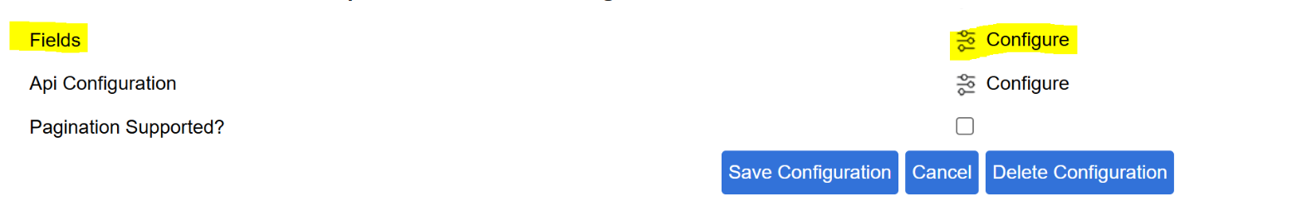

Add the statusId to the other fields and click the edit button, and this is where you will add all your airfocus statusId values with their values for each of the Status' used within the workspace chosen on the Entity mapping tab :

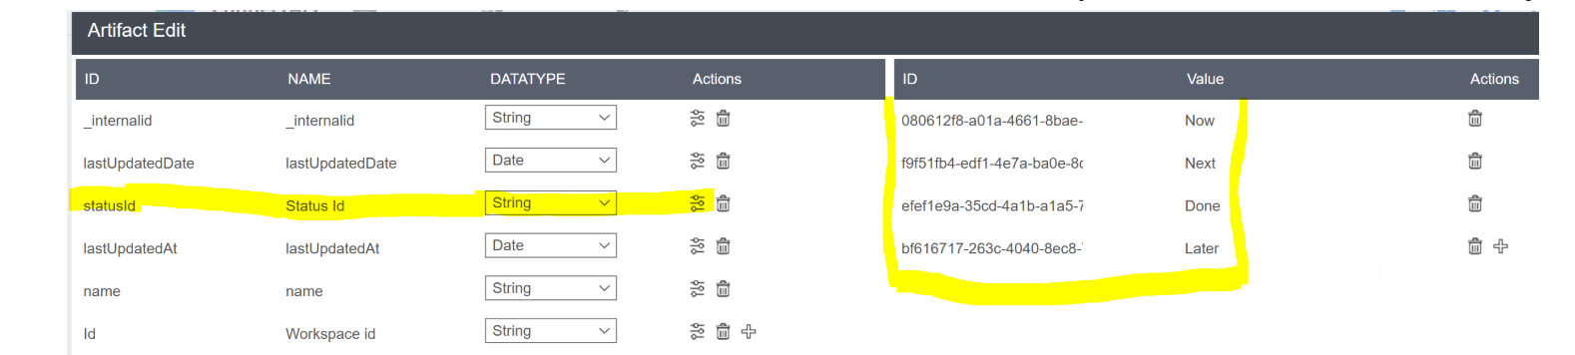

Then, in the Field mapping, you would edit, and set the Value Mapping accordingly to the airfocus status values that you want to map to which Jira status values!  Be sure to click both Save buttons.

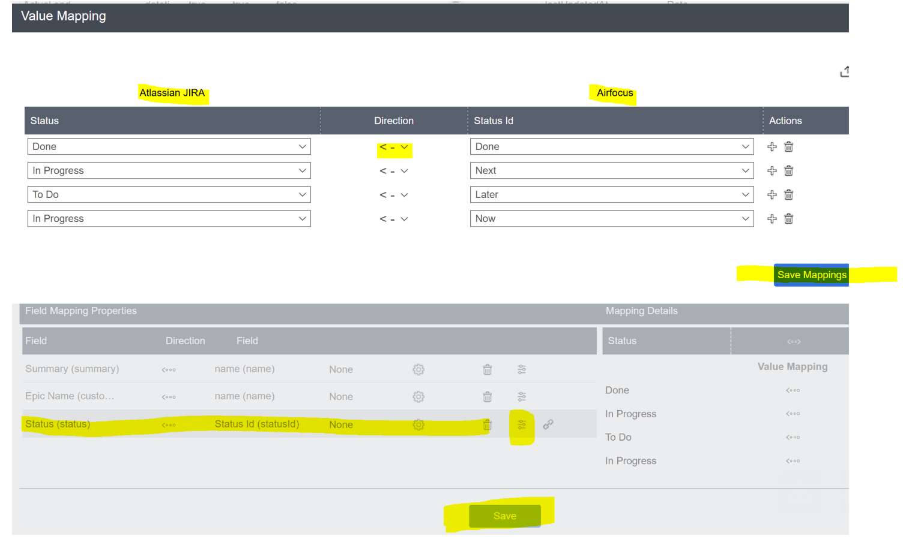

Note: The Automation will be limited to check within the Workspace designated on the Entity Mapping tab:

So the mappings shouldn't be too large to handle and readable enough to easily change.

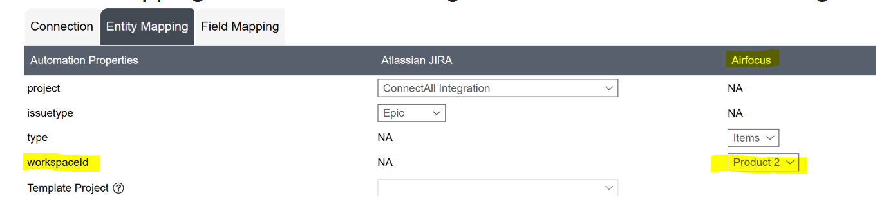

You can have more than one Automation running at a time for multiple workspaces.