

Vision
10.29.2019
─
Rethinking Technology
Memphis, TN

Philosophy

Technology is too (damn) complicated
Our vision is to move the technology industry forward by reducing the complexity of using and developing technology. We intend to do this by revolutionizing how we interact with computers.
If this sounds like another company you’ve heard of, you’re on the right track. We were inspired by Apple’s commitment to excellence in design. We believe that all people are consumers first, including developers. Nobody has become a great developer in a vacuum.

People buy Apple because it provides facility and finish.
Facility is the killer app of an operating system.

We must Begin Again
To make technology better, we have to make it accessible to the beginner, so we feel that the principles of simplicity and effective communication are most important in the design of technology. We feel that technology companies are teachers first and foremost. Anyone who has had the experience of learning from a teacher that can’t relate to their level of knowledge knows that this is not a positive experience. It is no way to pass on knowledge to tomorrow’s leaders and innovators. Companies have a responsibility to make their technology trustworthy and transparent, and this starts with making it simple to understand. This is why we adhere to the design principles of Dieter Rams, who was the inspiration for Apple’s design philosophy going back to the iPod. However, unlike Apple, we believe that technology should be interoperable with technology we did not make; and the only way to do this is to make it open and friendly to developers and users, without making it exploitable by competitors. Developers should be free to modify the system to provide enhanced usability for a specific niche, as long as it helps the source project grow.

First Contact
Apple grew, because MacOS was a better alternative to the unintuitive experience and lack of productivity in Microsoft Windows. While Microsoft’s strategy was to proliferate the market by supporting every device manufactured, Apple’s strategy was to provide a simple and well-tailored experience to users.

Like what we hope for in human-kind’s first contact with aliens, the first contact between a user and his computer must be friendly. A user’s first contact with the computer is in deciding what to buy. Apple improved the purchasing experience by removing the complexity of deciding what computer to buy.
In comparison, purchasing a Windows computer is like playing the lottery: the parts could be mismatched, unreliable, or poorly supported by their manufacturers (Qualcomm, Intel, etc), and the computer could be poorly supported by the vendor (Dell, HP, Lenovo). Furthermore,
- Mismatched parts yield performance bottlenecks.
- A part’s hardware can be flawed, and its driver can be buggy. These problems make it inoperable or frustrating and tedious to use.
- Quality control can be sub-par. Companies reduce quality to avoid the costs of recycling flawed parts. This achieves higher profits at the expense of the consumer. Consumers suffer because a part may fail shortly after the warranty period. Companies do this, because users are often don’t notice the problem or don’t care about it enough to complain.
- When users run into problems, the companies often don’t care. If it’s a problem with the interaction between two parts (such as a CPU overheating because the chassis is not designed properly), the companies point at each other and say it’s the other one’s problem to fix. If the problem is identified and attributed to a company correctly, it is often not in the company’s interest to fix the problem, because it is not profitable. This is a problem for customers that have bought a particular device that not many other users have. If you’re one of those people, you’re lucky if the company acknowledges the problem but doesn’t know how to fix it.

You’re on your own, kid
As a result, you must be prepared to do a large amount of research to know if you are buying a good, reliable machine that fits your needs, and if the company will stand behind its product. This complexity and uncertainty left a hole in the market for Apple to fill. Apple gave non-technical users a simpler answer to the question “What do I buy?” Apple also became the go-to answer for technical people as well, because Apple has perfected their products to provide a well-rounded experience. Steve Wozniak’s engineering skills and perfectionism were the driving force behind Apple’s early success. Apple’s quality control and Research and Development were unparalleled in the consumer industry, and they still are. Then, Steve Jobs died.

The Plan

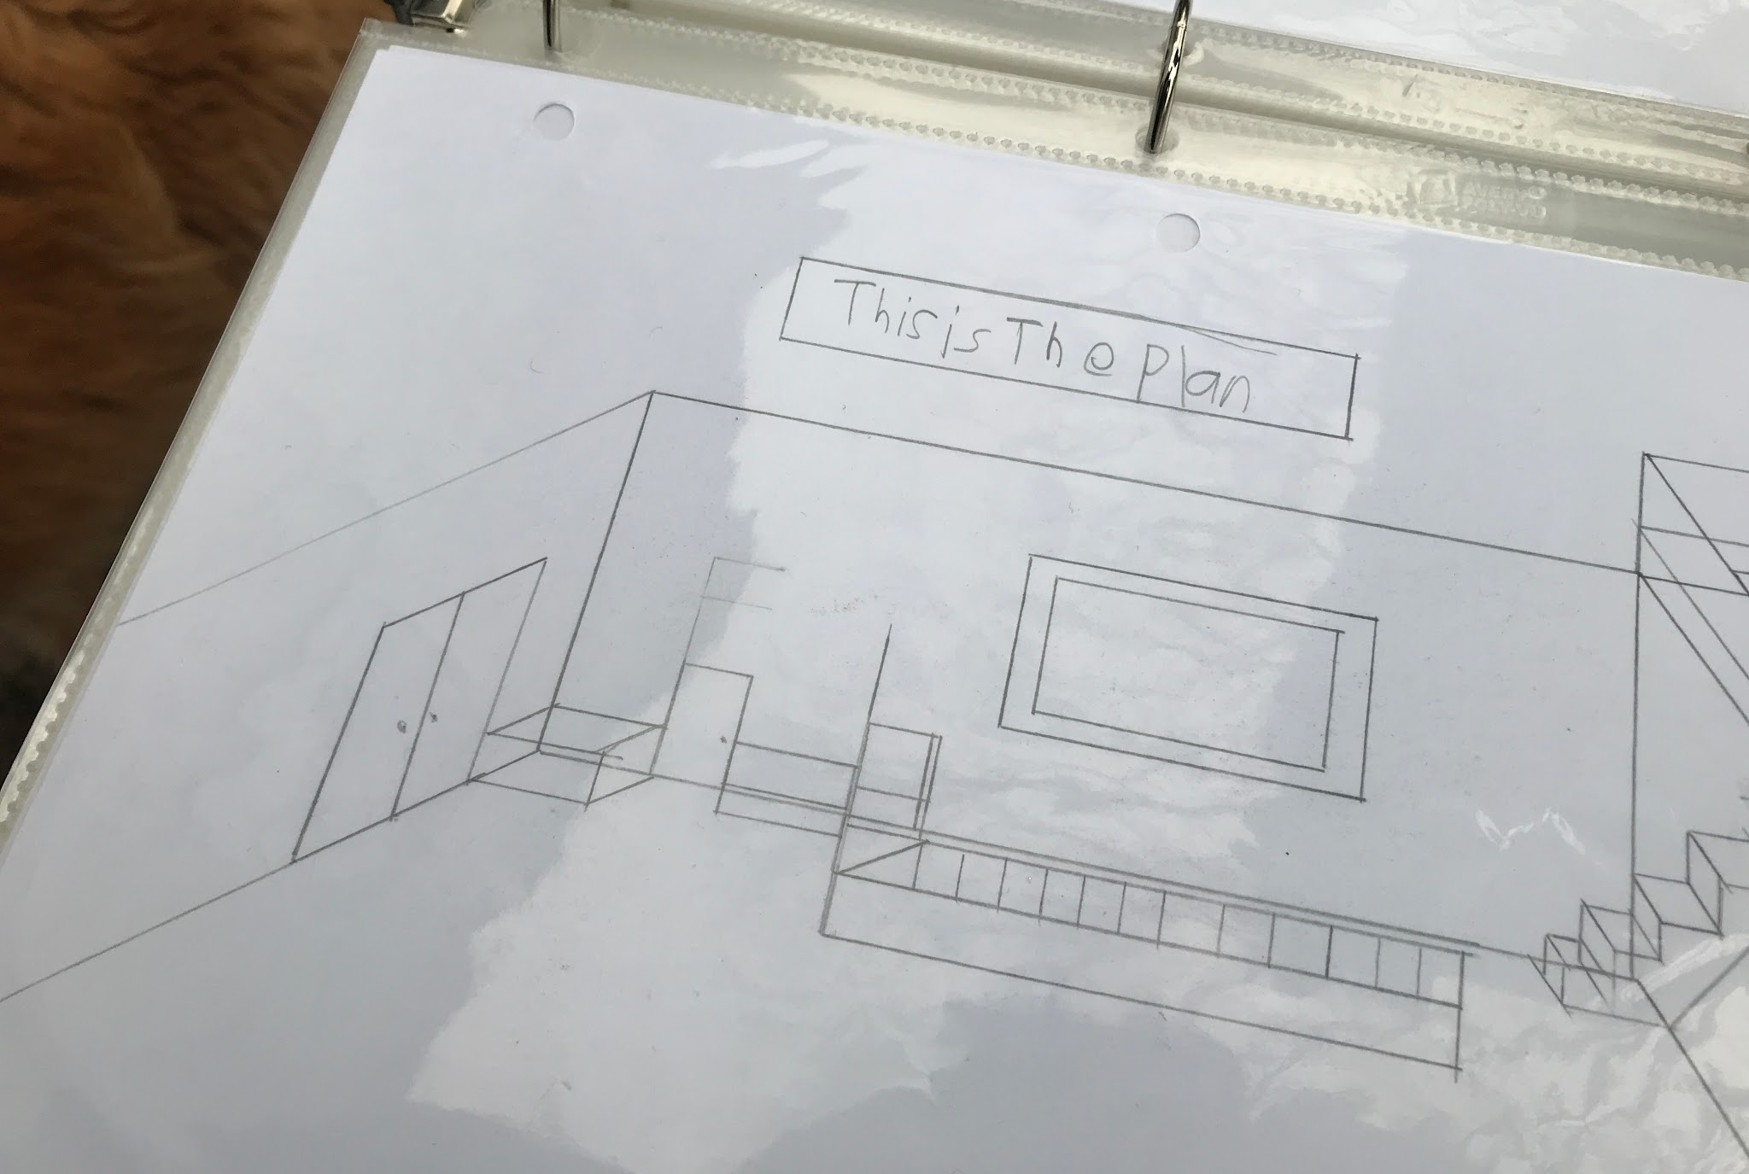
The Plan, by Nolan Johnson

Giving people what they don’t want
Apple has lost their visionary leader, so it is time for a new leader to step up and offer innovation and excellence. We aim to be this new leader. Our long term vision involves replacing existing technology with improvements that people never expected.
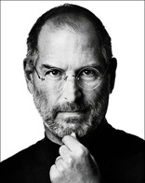
Some people say, "Give the customers what they want." But that's not my approach. Our job is to figure out what they're going to want before they do. I think Henry Ford once said, "If I'd asked customers what they wanted, they would have told me, 'A faster horse!'" People don't know what they want until you show it to them. That's why I never rely on market research. Our task is to read things that are not yet on the page.
—Steve Jobs

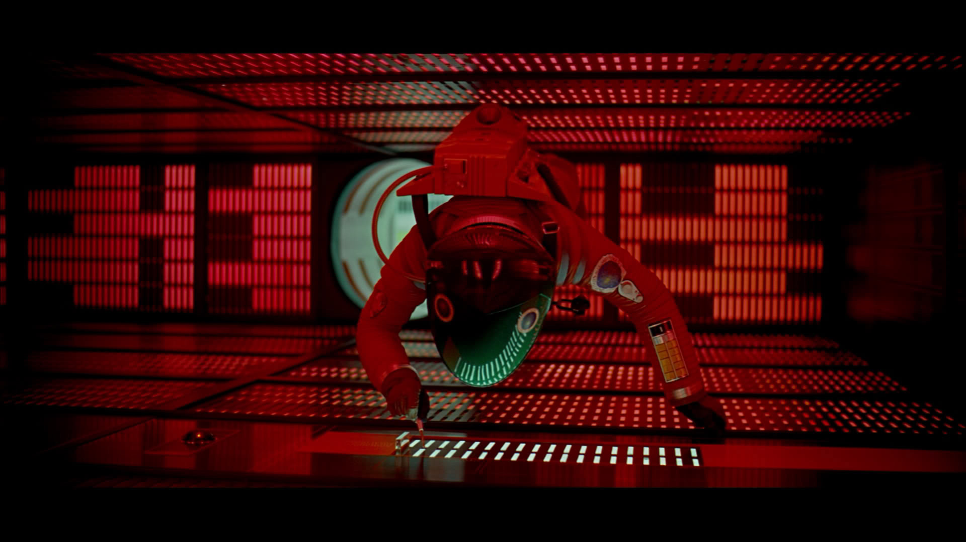
The plan, Stan
We will be replacing three fundamental concepts that have limited the computer ecosystem for half a decade. These concepts are the file system, the peripheral devices, and the operating system’s user interface.
The file system is where you store and organize your files. We will be replacing the hierarchical model of organization with the Associative model.
Peripheral devices (input/output devices) are what you use to interact with the computer; for example, your keyboard and mouse, and monitor. We will be augmenting and extending the keyboard, mouse, and monitor, and providing a system in which the user can define their own workflow using any set of devices.
The operating system is what coordinates the file system and peripheral devices. In essence, it organizes the user’s interaction with the computer and allows the user to make use of the devices that are connected. An operating system is divided into two parts: the kernel, and the user land (tools and user programs, including the user interface). We will be replacing only the user land software, and we will be choosing an existing kernel.

What are the kernel and user land?
The role of a kernel is to handle low-level details of operation like deciding which process to run, switching between processes, and choosing where to put information in short-term memory.
In comparison, the user land consists of a set of tools to manage your computer, access files, run programs, and create new programs. The tools in use today are further divided into two types of user interface: the command line interface, and the GUI (graphical user interface).
Although we are not creating our own kernel, it is an important part of our project. We are choosing a kernel based on performance characteristics, security and reliability determined by formal verification, and feature set, including the intuitiveness of the language used to write the kernel. We are committed to excellence in all aspects, but we are particularly concerned with eliminating failures in the system.

Branches of the project

File System
Project Proposal

Goals
- Replace the Hierarchical model with the Associative model.
- Provide a level of intelligence to the file-system by connecting file-systems together in a distributed hash table that contains reusable information.
- Connect local storage drives together in a meshable filesystem. We think it is stupid that files on external drives must be indexed by the host operating system, and the index information is not transportable between hosts.
  - The indexing information about files is stored in a database on the host system’s local drive (e.g. C:\). As a result, the information is not transported with the external drive to another host system (e.g. between home and non-specific work PCs).
  - After removing a drive from a system, the host system retains invalid links to information on the external drive, after it is disconnected.

Peripheral Devices

General-purpose interface screens
Project Proposal (not created)

Goals
- Make general purpose programmable displays that can be configured by the user to do one job for the rest of their life, such as displaying a calendar on the wall.

Context-aware Keyboard
Project Proposal

Goals
- Replace and augment keyboard shortcuts with context-aware keyboards.

How?
- Replace Menus with interactive controls displayed on peripheral devices.

Operating System userland
Project Proposal

Goals
- Improve the system management process, workflow
- Simplify development of software and data

How?
- Replace Menu lists with interactive controls displayed on peripheral devices.
- Replace the command line with windows that can be connected to one another in a pipe-line.
- Extend the windowing metaphor
  - Replace the windowing system with a window system that makes better use of single monitors, multiple monitors and multiple input/output devices.
    - Idea 1: 2D windowing system with a fractal window system that zooms in and out on a 2D plane.
    - Idea 2:
  - Replace the command line. Bring the command line’s pipe metaphor to the GUI environment.
    - Historical context: The pipe metaphor allows Linux command line programs to be used in conjunction with other command line programs to do more complex tasks. For example, you can automatically delete every file in a folder whose name contains a word you hate, like “Teletubbies”. To do this, you pass the output of one program to the input of another program by typing the pipe character ‘|’ in between the commands.
Demo: https://www.youtube.com/watch?v=19mmVar-s5Y
    - The windowing system allows users to connect windowed processes to each other, creating a flow diagram.
    - The windowing system displays nodes on a window’s edges to show that it is ready to be connected to another window.
    - Each window exposes its inputs and outputs via an API call to the windowing system. This allows apps to provide different functionality depending on the current configuration of the program (its state). This is a 1:1 replacement for the command line programs’ unintuitive command options, like “ls -laR”. In a command line, every program has its own command line options, and they are rarely intuitive or consistent across commands, so they are a pain in the ass to memorize. Nobody memorizes every command line option, and they shouldn’t have to. Command line options are effectively their own little domain-specific language---but with no rhyme or reason to their abbreviations.
    - Windowed pipes can be implemented via IPC (interprocess communication) that uses a standard object representation format, like json.
      - A more extensible alternative would involve having the pipe consult the file-system for information regarding file formats, and the format definitions are loaded into a decoding procedure. This allows programmers to re-define the types of data (formats) that can be transferred between programs by providing file-system extensions that can tell the programs how to extract the appropriate resource from the data stream. Extraction involves navigating through a file’s internal file-system and decoding complex formats into more primitive formats. For example, extracting an image’s 24-bit bit map from an encoded JPEG file stored inside an archive file.
  - Replace scripting by generating scripts from the configuration of the data flow diagram.
  - Graphs on the file-system. The file-system will learn and spread its knowledge with the distributed collective.

Milestones

Scalable window system
Lorem ipsum dolor sit amet, consectetuer adipiscing elit, sed diam nonummy nibh euismod tincidunt ut laoreet dolore magna aliquam erat volutpat.

Context-aware keyboard
Lorem ipsum dolor sit amet, consectetuer adipiscing elit, sed diam nonummy nibh euismod tincidunt ut laoreet dolore magna aliquam erat volutpat.

