GI4C Application

Title: LetsSankalp

Category: IT and communication

Group: Group C – U.G./P.G./P.H.D Students

Type: Prototype in Progress

Summary:
LetsSankalp is a web application that creates an interface between NGOs and their prospective investors with easy user interface.

Novelty and Usefulness:
Crowd sourcing for NGO projects provides NGOs a platform to show their project to the world. Also contributors can fund projects rather than NGOs, providing flexible choice to the contributors.

Description of Innovation:
“LetsSankalp” shall be a web application which would allow NGO registration. After registration, NGOs shall update their profile and submit future projects with detailed description. Donors on the other hand would create their account and browse the list of NGOs and their projects based on user preference and location. System will also rank NGOs according to their past performance. If donor selects an NGO and decides to fund it, as donor proceeds through payment gateway, the decision will be recorded in the database. NGOs will update their project as the project further progresses. Any progress in the project by the NGO will be informed to the donors by the means of customized report e-mailed to them. They will also be able to watch the progress of the project using the web interface. This whole system will be administered by administrators which shall verify if the NGOs are genuine and whether NGO is actually working on the project, providing sense of accountability.

Tags: web application, crowd sourcing, NGO, app engine

Application of the innovation:
The web application can increase the reach of the NGO to their prospective contributors. Funding a project becomes as easy as matter of few clicks.

Current Stage:
The idea has been partially implemented as a web application on app engine. Limitations of these innovation include human error in authentication of the NGOs and their project by administrator of the system.

Further Research:
Full implementation on innovation in progress. Business plan to make this web application self sufficient has to be chalked out.

Patent Information:
Has patent filing made already? : No
Has patent been granted already? No

Competitors:

Awards:
Top 3 Idea in Tech Pitch, a contest by CIBA (Center For Incubation and Business Acceleration)

Contributors:
Tanay Gahlot, Amey Kamat, Vidit Shah, Anuja Deshpande

About:
We are CSE undergraduates from National Institute of Technology Goa, working as a team under our co-founded organization called “Connectree” (www.connectree.in).

Images/Flowcharts:

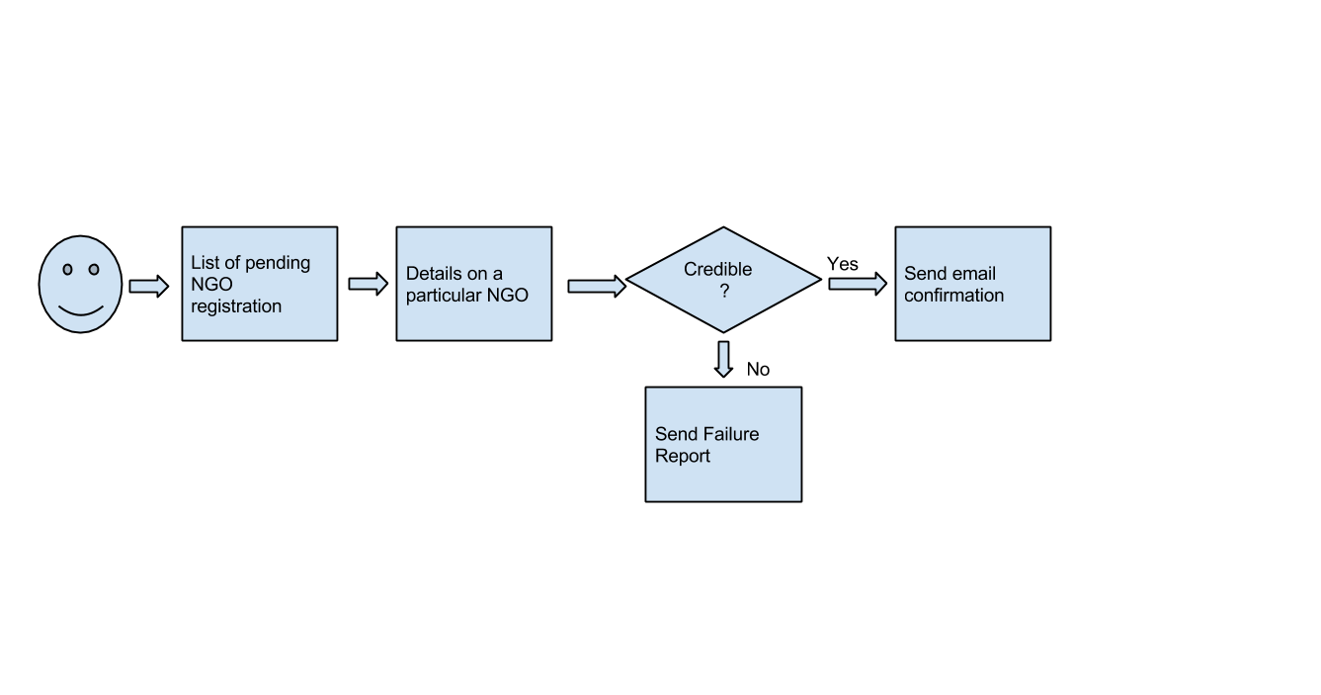
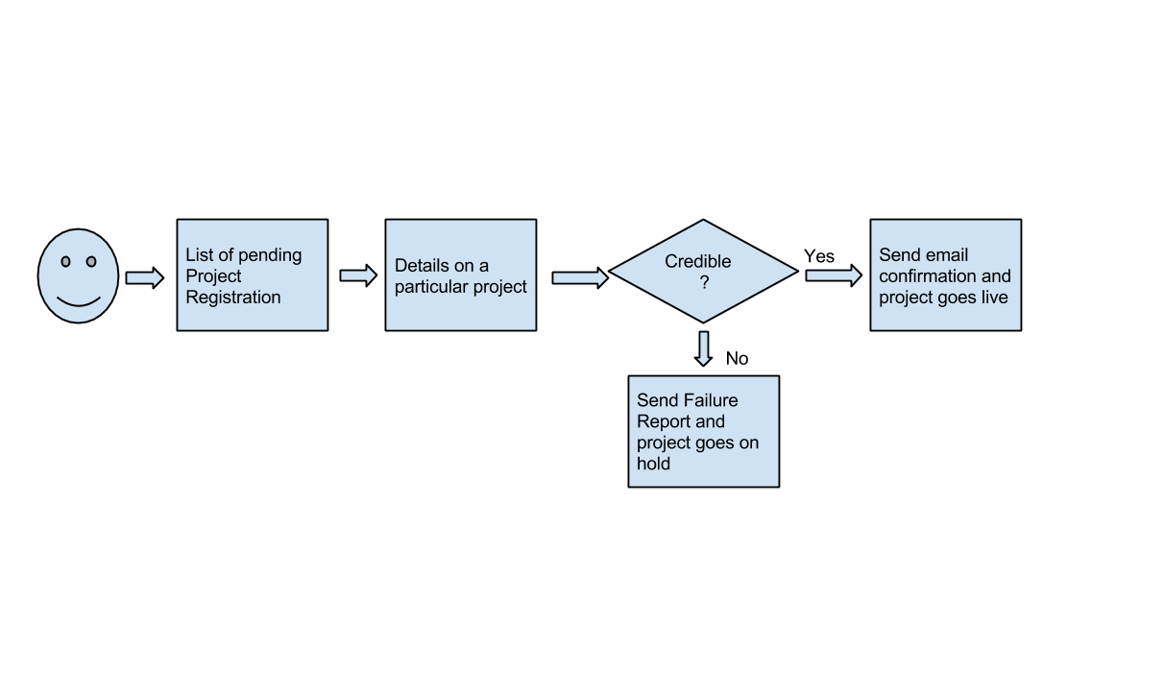
Fig. 1: NGO Verification

Fig.2: Project Verification

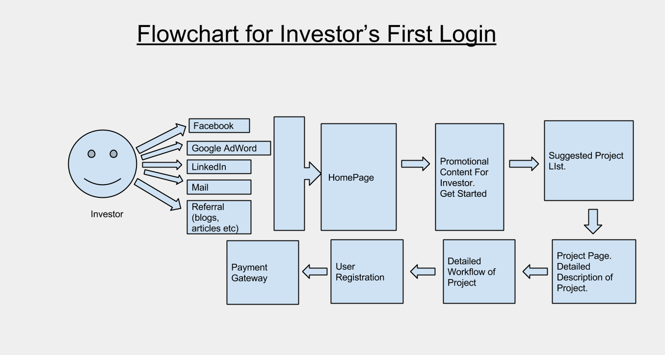
Fig.3: Donor/Investor First Login
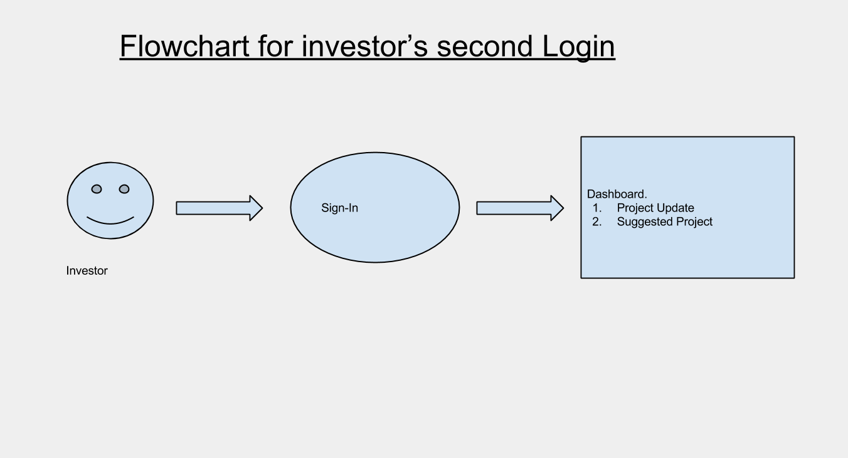

Fig.4:Investor/Donors second login

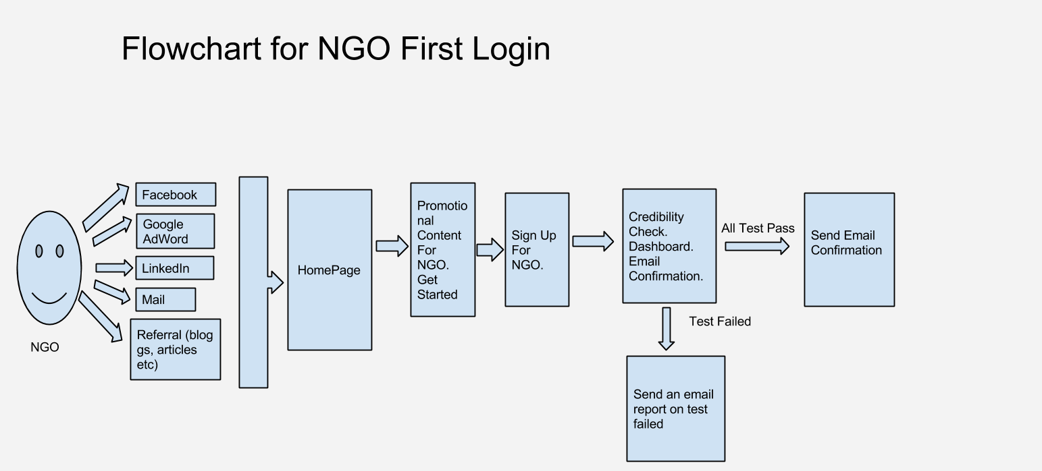
Fig.5: NGO First Login

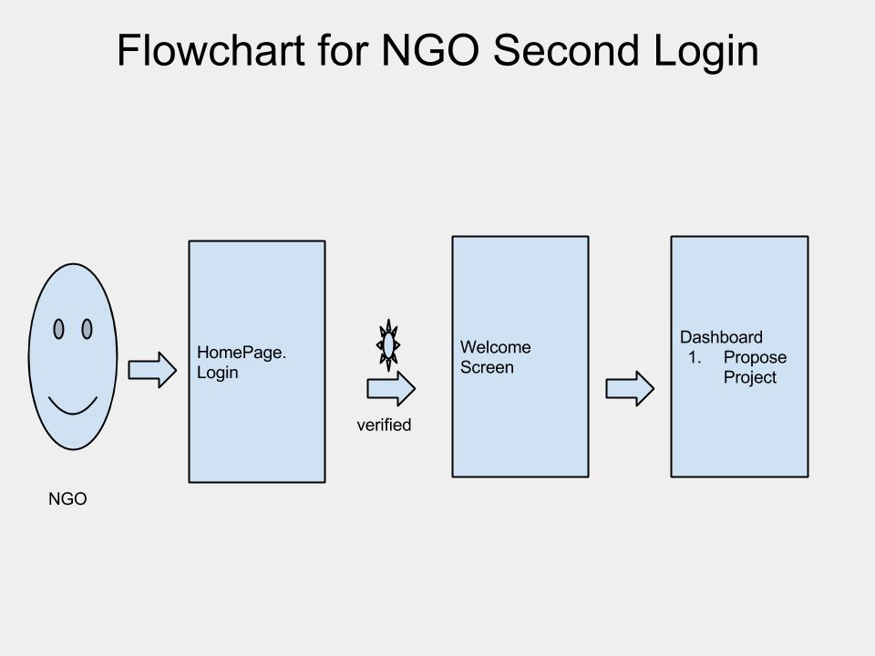
Fig.6: NGO Second Login

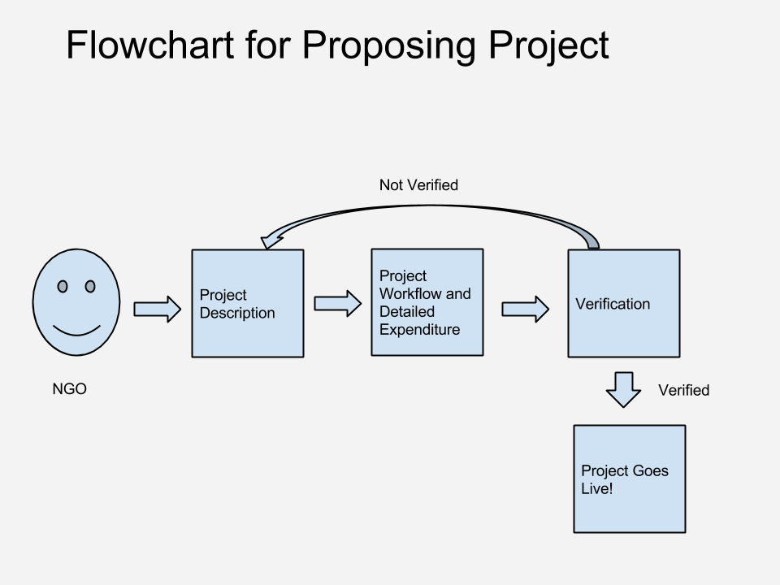
Fig.7: Project Submission

