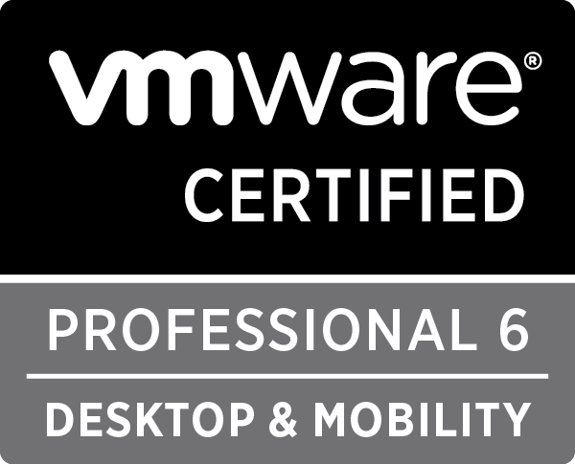**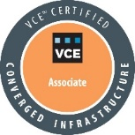Vigneshbabu. A**

**Mob:** +91-7710014147

**Email:** [connectvigneshbabu@gmail.com](mailto:connectvigneshbabu@gmail.com)

**Website:** researchvigneshbabu.blogspot.in

**CAREER OBJECTIVE**

Seeking a permanent position with promising, growing and a prestigious organisation to contribute the value of my diverse talents and offering me a challenging opportunity in the area of virtualisation, automation and cloud infrastructure.

**SUMMARY**

* Management of Windows server 2008, 2008 R2, 2012, 2012 R2.
* Hands on Experience on managing VMWare VSphere 5.5 and 6.0 and Horizon 6.0 over Datacentre level.
* Management and configuration of Citrix XenApp 7.6 and 7.15, NetScaler MPX 5550 device.
* Proficient and expertise in the Windows clustering on SQL Services.
* L2 and L3 experience in performance troubleshooting over Windows servers and VMware Vsphere.
* Installation and Configuration and upgradation of ESXi and Windows server on bare metals.
* Vulnerability assessment using Nexpose for windows servers and hypervisor such ESXi, Hyper-V and Xenserver.
* Datacentre level hands on experience on configuring HP C7000 enclosure with flex fabric interconnects, CISCO UCS with UCSM 3.1e, HP blade server (G7, G8, G9).
* PowerShell scripting for daily task automation and process optimisation.

**SKILLS**

**Computer Skills:**

|  |  |
| --- | --- |
| **Operating Systems handled** | Windows server 2008, 2008 R2, 8.1, 10 and ESXi 5.0, 5.5, 6.0 and Xenserver 7.1.0 and 7.2.0 |
| **OS Feature Skill set** | PowerShell scripting, Windows clustering, VSphere HA, DRS and Clustering, Horizon Installation and Application deployment, Citrix Flexcast management |
| **Tools handled** | Citrix Director , Citrix studio and Storefront, Symantec Netbackup, Citrix FMA 7.6, 7.11, 7.15, Netmon , Vsphere 5.5, VMware Horizon 6.0, PowerShell ISE, putty, Sysinternals Pro, UCSM 3.1e, Nexpose Scan suite, Thinapp packaging. |

**Leadership Skills:**

* Windows and Hypervisor Security Analyst and SPOC for Internal IT TCS for user reconciliation, vulnerability assessment solutions and Closure, Event log analysis in TCS Corporate Data Centre.
* SECRETARY of Association of Computer Technology and Chairman for Students committee at Rathinam College of arts and science.

**CERTIFICATION**

CCSK, VCP-DTM, MCP, VCE - CIA

**ACHIEVEMENTS**

* Got Many Appreciations across the globe in TCS for making the internal application secure and safe and indicating the application security flaws and helping the application team to close the application flaws in terms of security vulnerabilities and maintaining the compliance of the machines.
* Achieved **BEST PERFORMER AWARD** in the TCS IT IS Security Division in making the systems safe and secure and closing a huge count of vulnerabilities detected in the windows servers
* Best Outgoing student for the academic year 2014 from Rathinam College and **University Rank Holder** from Bharathiar University Coimbatore.

**TOTAL WORK EXPERIENCE:** 3 Years 8 Months

**WORK HISTORY**

**Year:** June 2016 – Present

**Designation:** System Engineer at TCS Corporate Data Centre

**Role:** VMware and Citrix Administrator

**Description:**

* Windows System Engineer and L3 Implementation specialist for customisable application (In-house Application)
* Patching of ESXi and HyperV as per the Industry security standards.
* SME for VMWare VDI Implementation and management of VDI desktops.
* DHCP, FTP, SFTP Implementation and configuration.
* Maintenance of security compliance by performing multiple security scans on periodic intervals.
* PowerShell automation for daily routine activities.
* Configuring HP Blade Chassis and Managing dell, IBM Hblade and Flex System hardware.
* Configuring UCS Blades and Chassis and managing through UCSM.
* VM Deployment over the Xenserver, Hyper-V and ESXI hypervisors.
* SME for Citrix Xenapp Environments and Netscaler device management.

**Year:** June 2014 – June 2016

**Designation:** System Programmer at TCS Corporate Data Centre

**Role:** System Engineer

**Description:**

* L1 Patch management of windows servers.
* Installation of Windows, Linux and ESXi server in bare metal hardware.
* Template management in the VMware Infrastructure.
* L1 Tape management for backup using Symantec Netbackup solutions.
* Handling Desktop related issues in terms of hardware failure.
* Installation of VXL and HP Thinclient and managing the Thinclient using VXL FDM.
* Installation and management of WSUS server for patch management.

**RESEARCH WORKS**

* Back office automation using UIPath (Robotic Process Automation)
* Creating Workflows, Processes and sample architecture for simplification of tasks based on windows administration
* Home Automation works based on Raspberry PI3 on IOT platforms
* Veridium biometric authentication over Citrix Xenapp

**EDUCATION DETAILS:**

|  |  |  |  |
| --- | --- | --- | --- |
| **Course** | **Duration** | **College / Institute** | **Division** |
| BSc(Computer Technology) | 2011-2014 | Rathinam college of Arts and science | 84.1 |
| HSC | 2009-2011 | Kadri Mills Higher Secondary School, Coimbatore | 75.7 |
| Matriculation(SSLC) | 2009 | VKN Matriculation School, Coimbatore | 74.4 |

**PERSONAL DETAILS:**

Parents Name : Thilagavathi

Date of Birth : 02 - November - 1993

Gender : Male

Nationality : Indian

Languages Known : Tamil, English

Marital Status : Single

Contact Address : 44 - Devi Illam, S.k.k Nagar, Sulur, Coimbatore, TN -641402

I hereby declare that information given above is true as per my knowledge and belief

**SIGNATURE**

(Vigneshbabu A)