Project Summary

How do DRG’s, discharges, and medicare payments vary state-to-state?

What we found was that the top DRG does not vary significantly state-to-state, only having 5 DRG’s for all 50 states & DC:



The number of discharges, normalized for population, does appear to be correlated with % over 65, but not entirely:

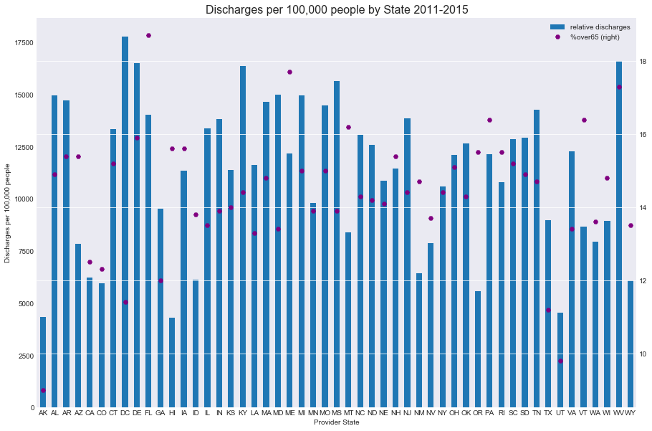

The number of medicare payments state-to-state, when normalized for population, does not appear to be entirely correlated with discharges:

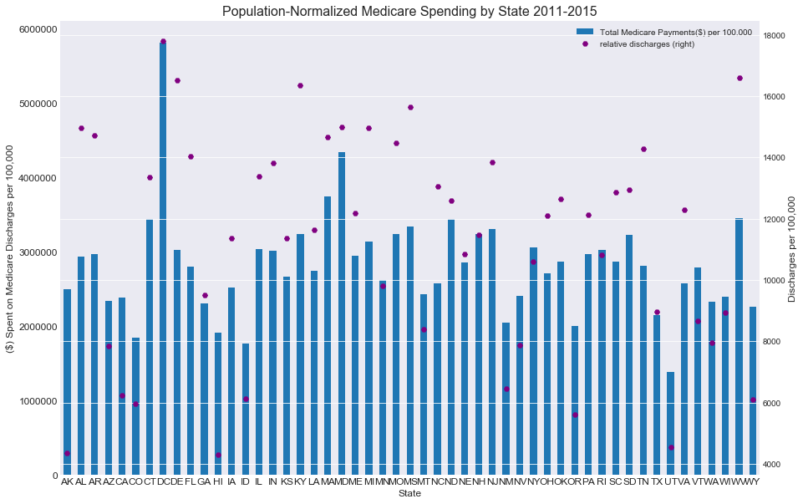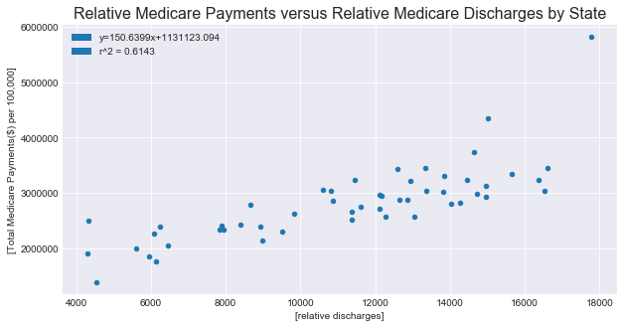

The total payments by medicare to each state, when normalized, is variable, but several rural, low-population states consume a larger share:



How have the total and top DRG’s changed over time?

Discharges of the top 100 DRG’s were trending down, due to a modification of data, it is unclear if this trend has continued in 2014 & 2015:

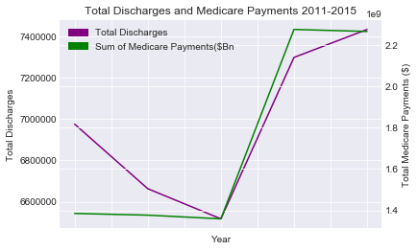

Medicare payments however, have largely remained flat

The top 5 discharges nation-wide have not varied significantly, although sepsis peaked and fell in 2014, perhaps reflecting some larger commitment :