CSCI 491 – Assignment 1
Mary Kate Connelly
Jan 30, 2025

A Trifecta (All Good)
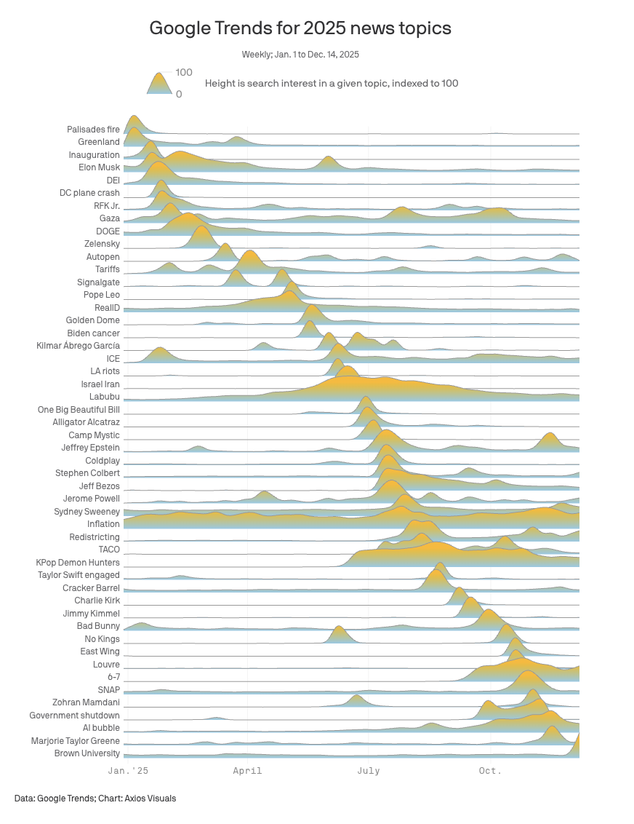

Source
https://www.axios.com/2025/12/29/google-trends-news-cycle-2025-charlie-kirk-trump

Context
The author s trying to convey what the biggest news topics in the US were in 2025, and when in 2025 they were trending.

Data Source
Google Trends search data.

Variables
- Time (x-axis)
- Topic (y-axis)
- Search density (height of trend line): The height of the trend line represents the relative popularity of the given search topic at the given time.

Visual Type
Ridgeline plot

Junk Chart Category
Trifecta – question, data, and visual form are all in sync

Critique
I love this chart! I think the overall question this chart answers is, “What happened in 2025?”. The visual form is interesting and engaging and presents the data in a way that is easy to understand. The data is from a reputable source (Google trends), but one minor critique is that it is not clear if the data is limited to google searches in the US, or in English, which I suspect it may be.
I think the chart also passes all four of David McCandless’s criteria to be a successful visualization. The information is high quality and informative, the visualization tells a story (what topics were trending when), the visualized accomplishes the goal, and the visual form is pleasing and informative.

A Single (One Element is Bad)
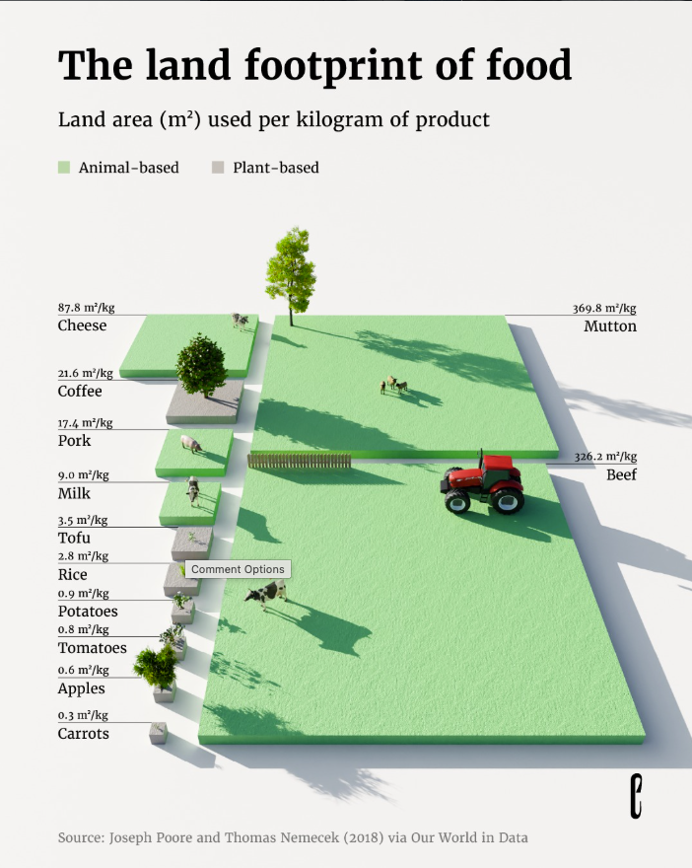

Source
https://www.instagram.com/p/DTkbJZGDHrg/?hl=en

Context
The author is trying to convey how much more land it requires to produce animal-based food.

Data Source
The data used is from a paper published at “Our World in Data” in 2018

Variables
-Food (including a visual element that reflects the method of production)
- Food type (animal- based vs plant-based)
- Land area needed per 1 kg of food (Shown as text and a relative sized land mass)

Visual Type
Proportional area chart

Junk Chart Category
Single (D) – I think the question and visual form of this chart are both excellent, but the data is misleading

Critique
I think the chart presents a clear and valid question (what the land requirements are to produce some animal based foods vs some plant based foods) and the visual form is informative and pleasing. However, I think the data presentation is mis-leading because it does not normalize for calorie density.
Although it takes much less land to produce 1 kg of carrots than 1 kg of beef, the calorie density of beef is much higher. This is a very important factor in evaluating which food sources are most efficient in feeding the human population. If the data were normalized by calorie density, for example: land area used per 1000 kcal of product, I think the chart would be more effective.
On the David McCandless criteria: I think the story and the visual form are both good. I also think the data is “good”, as it is from a reliable source. But I think there is an issue with the goal of the visualization, which I believe is misleading. This makes the visualization useless, according to his criteria.

A Double (Two Elements are Bad)
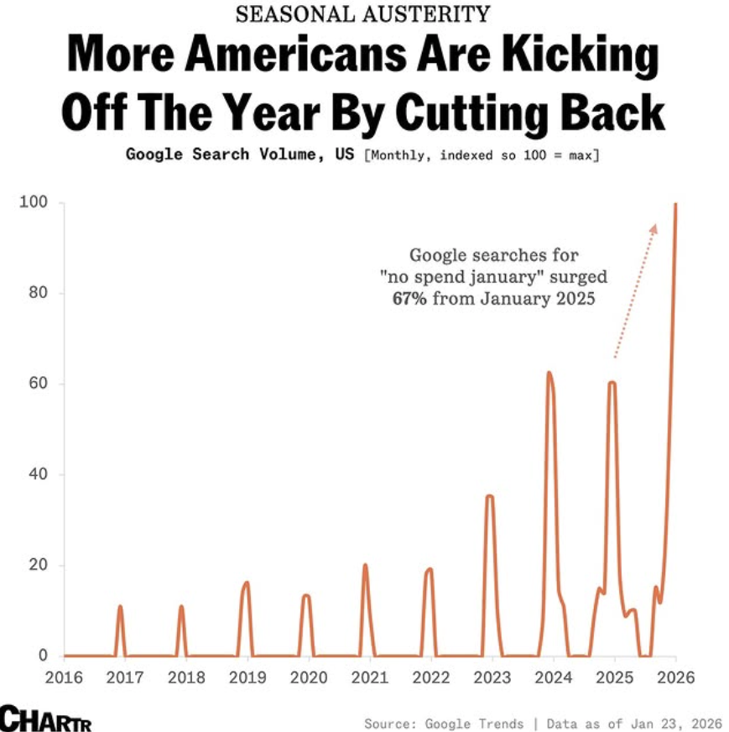

Source
https://www.instagram.com/p/DUBKXhBClj5/?hl=en

Context
The author is trying to convey that more Americans are searching for ways to spend less money in January than in past years.

Data Source
Google trends data

Variables
- Year (x-axis)
- Relative search density (y-axis)

Visual Type
Line chart

Junk Chart Category
Double – the data is misleading (not normalized by population), and the visual form is not very effective (why include other months?)

Critique
I think the question of the chart is useful (Does search data indicate that American’s are feeling financial pressure?) but the data and visual form are lacking. The data is not normalized by population, which means that the results do not account for population growth. Some of the increase in searches could be attributed to the greater number of people making searches. I think the visual form is also lacking, the question is specific to January, so there is a lot of wasted space on the chart plotting zero data from other months.
I think the chart shows some elements of a story and has a goal but is lacking good data and visual form. Per David McCandless’s definition, this makes the visualization a proof of concept or prototype, which I think is appropriate. With some refinement the visualization could become more effective.

A Triple (All Bad)
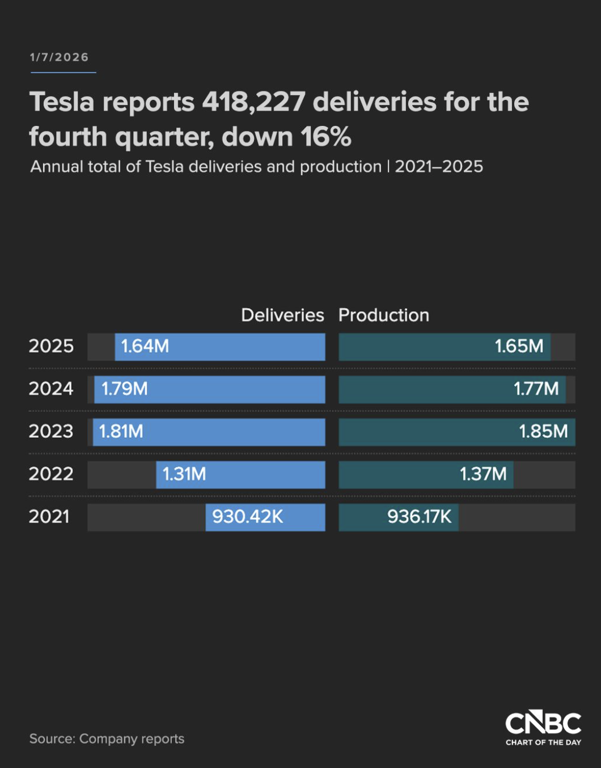

Source
https://www.cnbc.com/2026/01/02/tesla-tsla-q4-2025-vehicle-deliveries.html

Context
I think the author is trying to show the decline in Tesla deliveries but I’m not really sure

Data Source
Tesla company reports (vague and hard to verify).

Variables
- Year (y-axis)
- Delivered units per year on one bar axis
- Produced units per year on another bar axis

Visual Type
Side-by-side horizontal bar chart with a shared y-axis

Junk Chart Category
Triple – question, data, and visual form are all bad

Critique
The cited data source is vague (“company reports”) and would be difficult or impossible to verify. In addition, the title references quarterly data but the chart shows yearly data.
It’s unclear what the question is and the chart does not seem to match the title. The title references a quarterly decline in deliveries, but the chart shows yearly data for both delivery and production.
The visual form is also very bad. I think it would have been more effective to plot the year on the x-axis, so the reader can read from left to right. It’s unclear why the Production data is presented at all, but if the goal is for the user to be able to compare delivery with production, it would be more effective to plot the data on the same axes. Overall, I find the chart very difficult to read.
I think the chart is also lacking most elements in David McCandless’s criteria for a good visualization. The information and the visual form are both bad. I think there are some elements of a story and goal, but neither are effective.

