SnowPyt MechParams Graph Algorithm

Background and Description:
There can be many ways to calculate a specific parameter, given a set of available input parameters and methods for parameterization.
The figure below shows a graph representation of current state of SnowPyt MechParams. Square boxes indicate mechanical parameters, arrows indicate methods (arrows without names are just direct data flow), and triangles represent “Merge Nodes” where multiple parameters are collected as an input for a method.
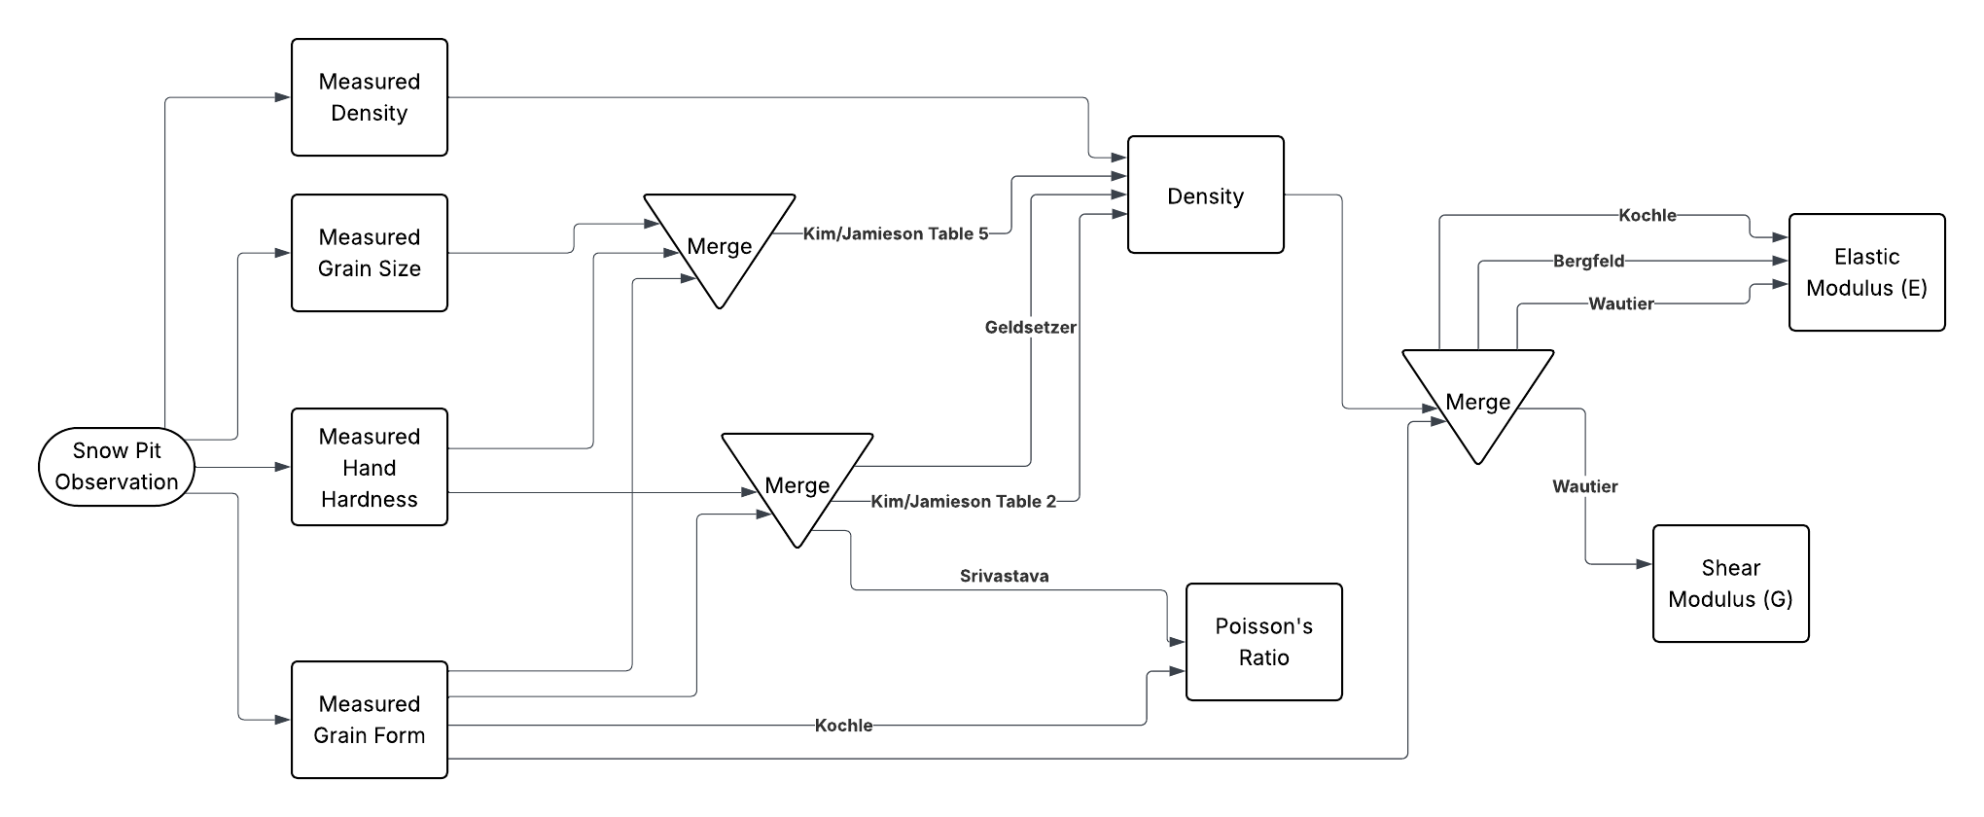
A parameterization is defined as the set of input parameters and methods used to calculate a specific parameter. For example, one parameterization of Elastic Modulus from the graph above could be to go from Measured Density to Density, from Measured Grain form to the Merge with Density, then implementing the Köchle method. This is similar to a “path” through the graph, but there are multiple inputs so in some ways it is more like a tree. I have been calling it a “tree/path”.
We are interested in comparing the results of different parameterizations when applied to the Snow Pilot dataset. Specifically, we would like to compare the results of the calculated values of the specified parameter, the number of samples to which the parameterization can be successfully applied, and the relative uncertainty of the results.

Description of Algorithm
The goal of the algorithm will be to find the set of every possible parameterization for a specified parameter, given the defined set of possible starting parameters (available measurements from snow pits) and methods.
This will require working backwards from the target parameter to traverse the graph and recursively iterate through available input methods.

Using Algorithm Results
Given the output of the algorithm, I can then programmatically implement each parameterization returned by the algorithm to apply the methods defined in SnowPyt MechParams to the SnowPilot dataset, where the output of some methods will serve as the inputs to future methods.
The current state of the SnowPyt MechParams only contains implementations for layer specific parameters, but once the implementations and algorithm are extended to pit parameters and stability criterion, the results can also be compared to stability test results and used to evaluate the stability criterion.

