Getting started with Python3 & Simpy in CSC148 Prof Mitchell, October 2024

You might already be a Python user with your own system. However, CSC148 homework HandIns for grading must be executed on (any one of the 3) IRT servers named

ecs-pa-coding1.ecs.csus.edu, ecs-pa-coding2.ecs.csus.edu, or ecs-pa-coding3.ecs.csus.edu

(Ensures consistent homework grading) These 3 servers share the same file system, Python, and SimPy systems.

X Windows (aka X) is a networked windowing system for bitmap displays used to build graphical user interfaces on Unix, Unix-like, and related operating systems. Python requires that your computer also runs X. However, neither the Windows OS nor more-recent Mac systems natively run X. This document describes workaround tools for these OS-specific limitations.

Python behavior on IRT servers if your (Windows or Mac) computer’s display does not run X

**When logged onto an IRT server**, IF your local system is NOT currently running (a tool that runs) X you will see:

[mitchell@ecs-pa-coding1 ~]$ python -V

Python 3.9.18

[mitchell@ecs-pa-coding1 ~]$ idle

In this document, sections colored RED match the color of Python/SimPy related error messages

Traceback (most recent call last):

File "/usr/bin/idle", line 5, in <module>

main()

File "/usr/lib64/python3.9/idlelib/pyshell.py", line 1490, in main

root = Tk(className="Idle")

File "/usr/lib64/python3.9/tkinter/__init__.py", line 2270, in __init__

self.tk = _tkinter.create(screenName, baseName, className, interactive, want objects, useTk, sync, use)

_tkinter.TclError: no display name and no $DISPLAY environment variable

Note - Each codingx IRT server runs an identical Redhat 9 version of Linux, and default Unix-based command shell bash-5.1.

**WINDOWS OS Users ONLY** - Remote access: mobaXterm backgrounder

If your system is not configured to run X, you can download and install a free & useful app called mobaXterm (abbreviate “moba”). (moba implements X display on your system, and can also be useful in other courses …)

Steps for Installing & Using mobaXterm

1. The free download site is: <https://mobaxterm.mobatek.net>
2. Find the GET MOBAXTERM NOW! Region a little way down the home page, and click on it
3. You are presented with a choice of Home Edition or Professional Edition, so click on Home Edition
4. Scroll down a bit to the Download now button
5. Three choices will be displayed; the green installer edition is the system to download and install.

After successful moba install, use it to launch an IRT session,

In the front display panel, select an IRT server; See Figure 1

Figure 1 – The (default settings) moba user interface at moba startup

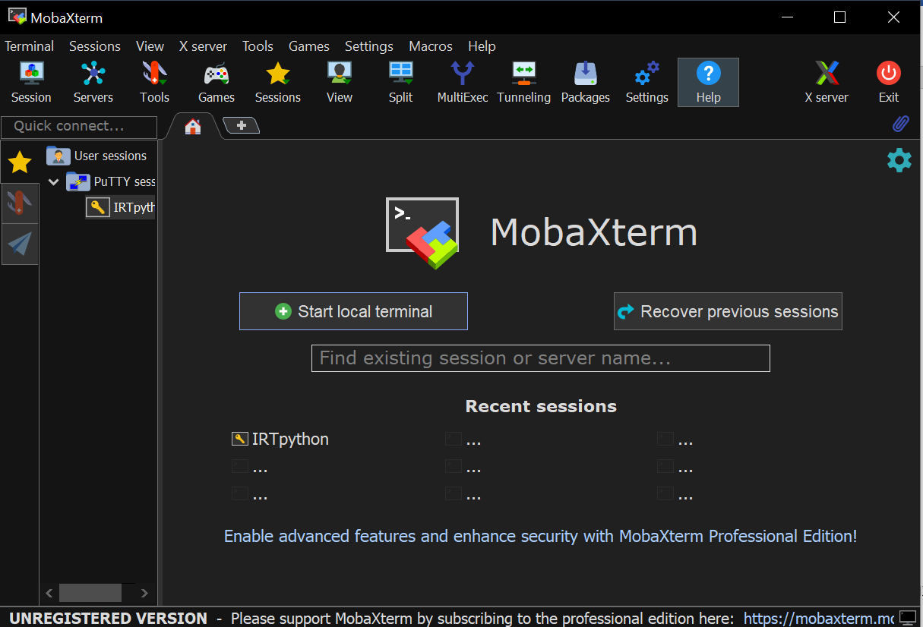

After selecting an IRT session, a user session on that IRT server (that is running X) is started.

This session launches a Python command shell window using the OS shell installed “idle” command (Figure 2).

Figure 2 – Display of IRT user session startup using moba

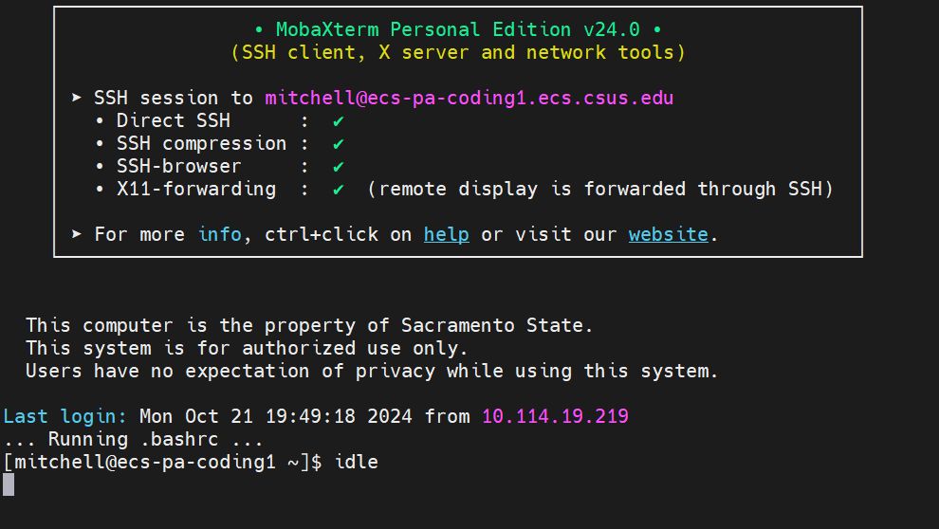

Note that the idle command shell window might launch hidden behind the moba display panel

**MAC OS Users ONLY** – Remote access: Xquartz backgrounder

Similar to Windows OS, recent Mac systems do not natively run X protocol. However, here is info for X support:

<https://www.cyberciti.biz/faq/apple-osx-mountain-lion-mavericks-install-xquartz-server/>

Common Python/Simpy use, assuming your computer is running X

For the rest of this course, as long as you use Moba (Windows OS) **OR** Xquartz (Mac OS) and access any IRT server mentioned above, you will see identical behavior for everything for the rest of the course.

“idle” is an acronym for **Interactive Development Learning Environment**

The **idle** command issued at Linux command level (Figure 2, command) launches a Python ver 3.9 shell command window as in Figure 3.

The shell command window has several purposes, the two for immediate use are:

1. Output is displayed by default here
2. The File menu option at the top-left is a familiar file create/open, file edit interfaces, etc.

Figure 3 – Command shell launched by the idle Linux shell commandcommand

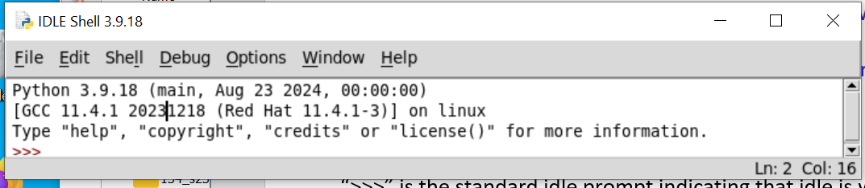

“>>>” is the standard idle prompt indicating that idle is waiting for a command .

Use the idle window’s File menu item for source-code file create, open, save, etc. functionality (See Figure 4)

Figure 4 – Python source file window example display

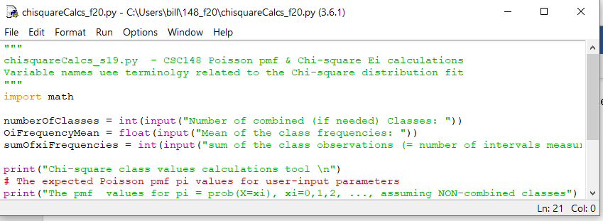

In a source file window, use the Run menu’s “Run (F5)” option to execute this source file (you will be prompted to ok the re-translation of your source code if you have modified it since its last execution).

By default, the results of source file execution are displayed in the idle shell command window.

idle window toggle between compiled vs. interactive source code execution

In addition to the source code edit/run development cycle referred to in Figure 4 is the following.

At the >>> prompt expressions can be evaluated interactively, individual Python statements can be executed, files can be input and run etc.

Some info about using IRT servers

Windows users commonly use putty for ssh an connection to an IRT server. On a Mac, there are several alternatives for connection such as OpenSSH, Attune, Cyberduck, and so on.

**Tip**: On a Linux OS (i.e. for the current discussion) , CPU utilization (  as denoted in this course ) is displayed using

the OS shell command mpstat -P ALL

Per core, calculate (1 – %idle) to get each core’s  value (notice the displayed utilizations by category).

If the IRT server you are using is very busy, you can log onto another less busy IRT server. However, for IRT servers,

an overloaded server has not historically been an issue.

**Unix review Tip**: on a server running the Linux OS, display the name of the server to which you are currently connected using: hostname

**IRT server login**

First, use moba (Windows OS users) or xquartz (Mac OS users) to get an ssh connection

to your chosen ecs-pa_codingx server.

Then, authenticate (i.e., login) to that ecs-pa_codingx server with your csus-issued username and password.

Successful login starts a session on the Redhat Linux version 9.x OS that is installed on these servers. You are now in a Linux OS command shell (that defaults to bash 5.1).