**Special Topics on Intelligent Control： Program Report II**

**工科111林政旭 E94071209**

**工科111謝智丞 E94076013**

**電機碩 孫得肯 N26114390**

**Consider a feedback control system shown in Figure 1. Please design A controller such that output of the closed-loop discrete system is able to track a rectangular command signal, r(k), with magnitude = 1 and period = 60 iterations for 4 periods. The plants are**

$$y\left(k+1\right)=2.6y\left(k\right)-1.2y\left(k-1\right)+u\left(k\right)+1.2u\left(k-1\right)+ηy(k)sin(u\left(k\right)+u\left(k-1\right)+y\left(k\right)+y(k-1))$$

**Where $y\left(0\right)=-2, 0 or+2, y\left(-1\right)=0, 0.3<η<0.8, and \left|u\left(k\right)\right|≤20(or 50)$.**

* **Control System**

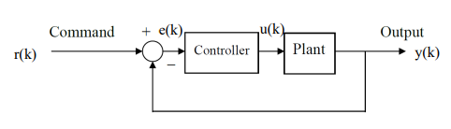

* **Discussions**

1. **Which kind of meta-heuristic optimization algorithm or AI method is adopted? Why?**

In this project, we use **PSO** to find the optimal solution of PID controller parameters $K_{P}K_{I}K_{D}$.

* **Introduction of PSO：**

PSO simulates the predatory behavior of flock of birds. Each particle(bird) refers to two values to determine its movement. The first value is the best solution of the particle’s past iterations and the second value is the best solution of the group’s past iterations.

* **Procedure：**

1. Initialize the positions and velocities of particles with random values.
2. Calculate the fitness value of each particle.
3. Update the velocity and position of every particle.
4. Compare the new value from fitness function with the individual best value. If the new value is smaller than the individual best value, update the previous value to the new value.
5. Compare the new value from fitness function with the group best value. If the new value is smaller than the group best value, update the previous value to the new value.
6. Loop to Step2 until the iteration number is met.

* **The reason why we chose PSO：**

PSO is a simple but efficient algorithm. The convergence speed is faster, while the time consumption is shorter. This makes it suitable for this kind of system that needs to be frequently updated.

1. **Which kind of controller (PID, SMC, FLC, or …) does your program utilize? Why?**

In this project, we use **PID Controller** to adjust the input value so that the system converges on our target output value.

* **Introduction of PID：**

The PID controller is consists of Proportional, Integral and Derivative. The output of controller can be adjusted by tuning parameters $K_{P}、K_{I}、K_{D}$.

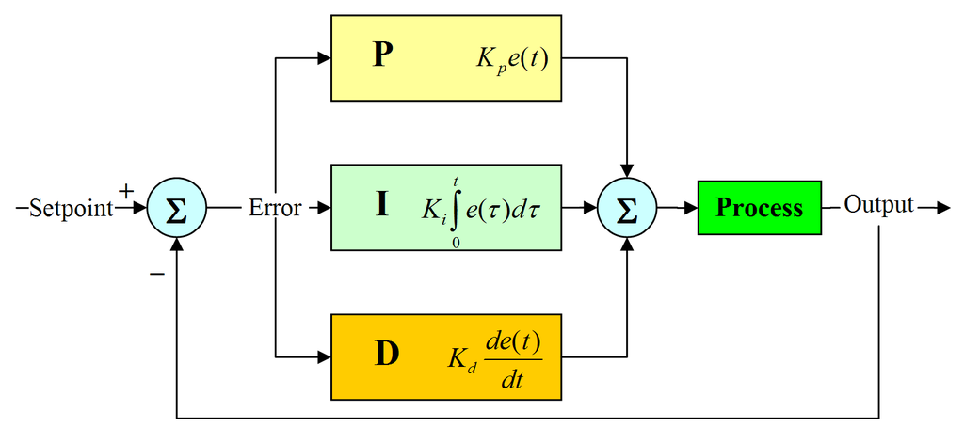

* **The reason why we chose PID：**

We used to study a topic about controlling automatic vehicle with PID, therefore, we chose PID as the controller of system in this project. By observing $K_{P}、K_{I}、K_{D}$, we can notice and adjust the mistakes in system immediately. This is very convenient for us to build a feedback control system.

1. **Please explain why the fitness function, all the parameters and settings that are chosen or involved in the design of such controller.**

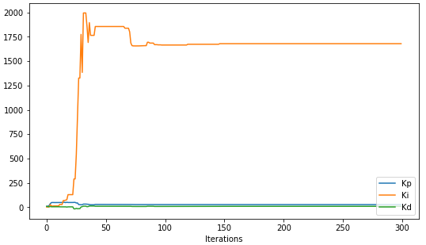

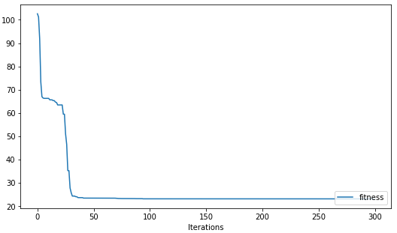

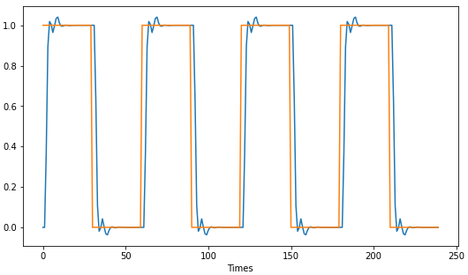

* **Parameters：**

num_particles = 50

num_iterations = 300

pop_size = 10

num_dims = 3

weight = 2

c1 = 1.0

c2 = 1.0

c3 = 0.0

* **Fitness Function：**

In this project, we use MAE（Mean absolute error）as fitness function. Since the error is absolute value, MAE can reflect the actual situation of the error.

$$MAE=\frac{Σ_{i=1}^{n}\left|result\left(i\right)-target(i)\right|}{n}$$

* **Comment for the result：**

Since $K_{I}$ is extremely large, the integral term responds to accumulated errors from the past. It causes the present value to overshoot as the plot shows above. However, fitness function finds and reflects the error, this makes the system’s output converges.