**User Manual for TweetTranslator**

**Overview**

When a user runs this program, they can expect to input a desired Twitter handle to retrieve tweets from, along with other details. Once all of the appropriate information has been received by the program, it will retrieve the tweet of the specified handle, translate it, and post the translation for the user on their personal Twitter feed.

**Running the Program**

This program requires very little setup on the user’s part in order for it to run. All the user needs to do in order to successfully use this program is run the program and respond to the prompts that appear on the terminal screen.

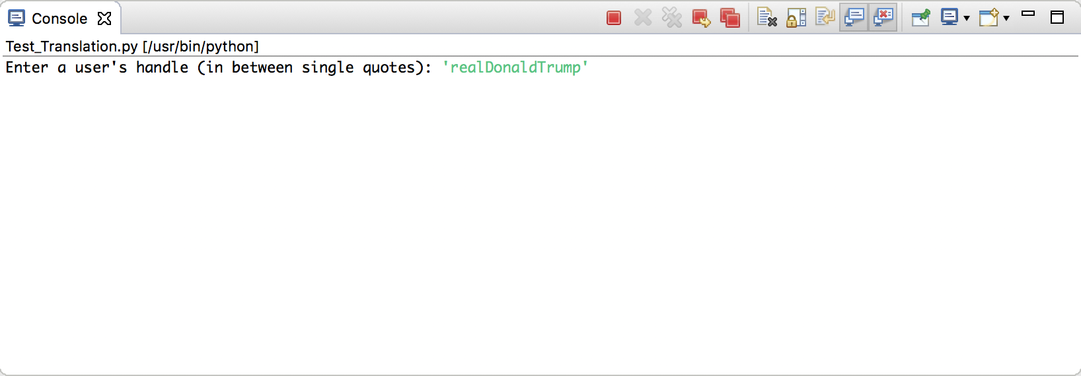

Figure 1: The first prompt

The first thing that the user is prompted for is the twitter handle of the person whose tweets they want to retrieve and save to a .txt file. This is the tweet that we are going to translate.

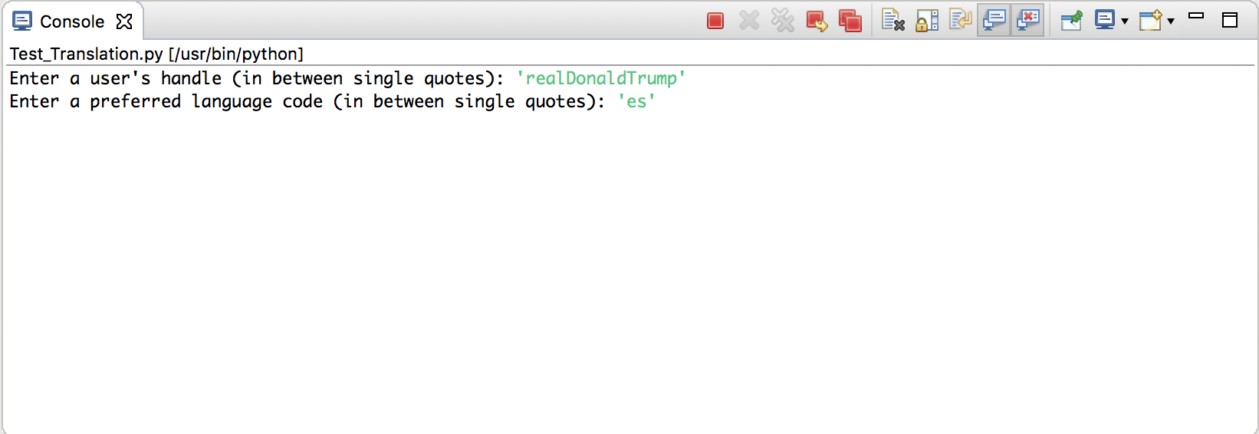

Figure 2: The second prompt

Next, the user will be asked for a language code to input. Since there are dozens of languages that the API can translate for you, the user will have to look up the specific ISO 639-1 code for their language of choice. This is the only thing that the user needs to do aside from inputting the desired choices after being prompted. In the example above, ‘es’ is the ISO 639-1 code for Spanish. Thus, the user is going to retrieve a tweet from ‘realDonaldTrump’ and translate it into Spanish.

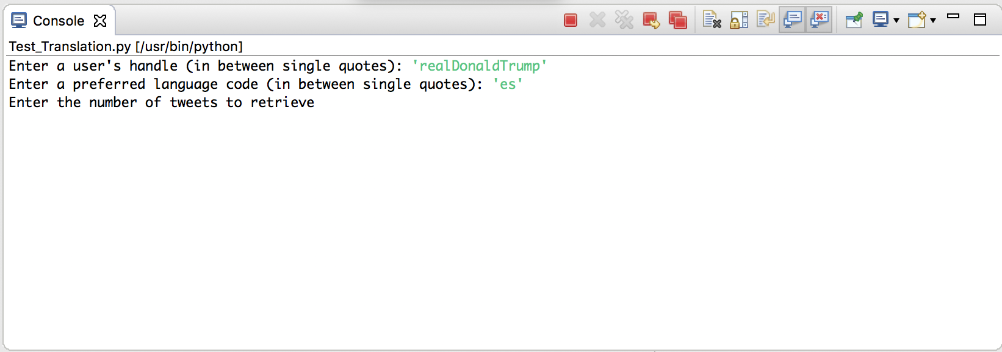

Figure 3: The third prompt

The third prompt asks the user to enter the number of tweets that they want to retrieve. To simply retrieve the most recent tweet, enter ‘1’ (without the single quotes).

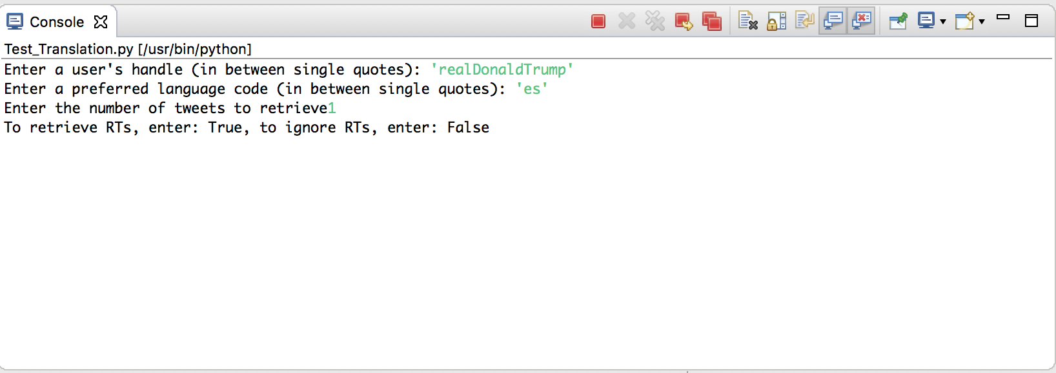

Figure 4: The fourth prompt

Let’s say that you want to retrieve a tweet sent by a handle, but the most recent tweet was actually a retweet of another handle’s tweet. The fourth prompt is meant to handle that situation. If you want to allow the program to retrieve retweets from other accounts than the handle that you have inputted, enter “True” (without the quotes), or “False” (without the quotes).

**One Thing to Avoid**

Make sure you do not attempt to retrieve tweets from the same Twitter handle more than once unless you are sure that the handle has posted a new tweet. Otherwise, you will get an error message telling you that the retrieved tweet was a duplicate. Other than that, you should be able to use this program without fear. As long as you put in the correct ISO 639-1 code and aren’t trying to retrieve a duplicate tweet, you should be fine.