

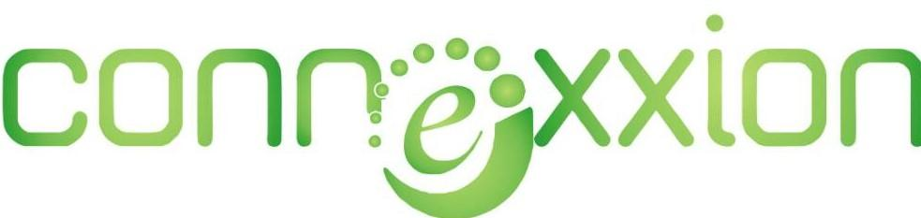



**TABLE OF CONTENT**

1. Title Page
2. Cover Letter
3. Executive Summary
4. About Us
5. Our Approach
6. What to Expect
7. Overview of The Features
8. Research and Outreach
9. Frame Work
10. Functionality and Content
11. Development
12. Testing and Launch
13. Merits of This software Pre & Post COVID-19
14. Timeline

MAY 6, 2020

**The Chairman,**

Federal capital territory

Hospital management board

16, Dunukofia Street area 11,

Garki

Abuja,

Nigeria.

Dear Sir/Ma

**SOFTWARE DEVELOPMENT PROPOSAL**

Please find enclosed our detailed software proposal for your kind consideration.

At Connexxion Group we are aware that creating client-oriented software takes a mixture of technical excellence and clear communication and our firm hires only the very best to ensure you receive both.

We know that every client is unique and we strive to deliver an individual, innovative and affordable proposal every time and to follow it through with an outstanding delivery which is both on time and within budget.

We have over 5 years of development in this area. Please let us know if you would like to get in touch with our existing clients from whom you will receive nothing but positive endorsements.

You may also wish to review our website at <http://connexxiongroup.com/> to see our portfolio of previous work and learn more about our organization.

We also pride ourselves on our after-sales client-care including our guarantees, staff-training and onsite and offsite support.

Finally, we realize that you are very busy and wanted to thank you in advance for your time spent reviewing our proposal.

Yours Faithfully;

**ESAN MAXWELL**

General Managing Director

Connexxion Group Inc.

**EXECUTIVE SUMMARY**

The objective of the proposed software is to design and develop a medical website where patients, doctors among other access levels will be able to register, update medical records of various patients, access patient medical history, keep track of blood bank, generate duty roaster among other day-to-day tasks that occur within the hospital environment.

As a body, the Hospital Management Board will be able to access and monitor in real-time the happenings in the various hospitals under her watch. Armed with this information, the Hospital Management Board will be able to manage her resources, post staff to hospitals in short of human power, and allocate responsibilities to able staff.

**ABOUT US**

Connexxion Group Inc. is a group of companies registered under the Nigerian CAC act, with great expertise in telecommunication, software development, hardware deployment, renewal energy, oil and gas, construction and financial technology. We have staff strength spanning over 10 to 20 years of experience, with vast knowledge in each industry both locally and internationally.

Connexxion Telecom and Solutions is a provider of core IT networking, communication services and consulting services. We provide radio and specific ad-hoc infrastructure and communication platforms, network support services, server administration and video conferencing technologies. We also specialize in remote support systems, wireless networking and preventive maintenance systems for clients and institutions whether in the public or private sector. In the last two years, Connexxion Telecom has expanded its operations to the West African sub-region.

We work with our clients to deploy bespoke solutions to meet their specific business needs. Let your team evolve, improve communications quality and accelerate achievements.

**Project Overview**

Connexxion Group intends to develop a software that will handle all the manual activities that occur within the hospital setting. The software will be developed to automate programs such as room allocation, roasters, blood bank management, diagnosis report, among other important areas that the Hospital Management Board will communicate to us.

As a centralized body saddled with the responsibility of overseeing the various activities that occur on daily basis in the all the hospitals under her watch, the software will serve as a unified data repository for Hospital Management Board to be able to monitor, manage her resources and also generate precise report that will simulate the organization’s operations across the hospitals.

In order to accomplish this, all the hospitals will be mandated to use the software in order to get the best the software has to offer.

1. **Obstacles**

As it is with almost everything new, current staff in the various hospitals may find it challenging using the software. To that, Connexxion Group will train responsible persons on the use of the software.

1. **Technical Obstacles**

In all the hospitals that it will be deployed or will adopt the use of the software to automate their processes.

In the absence of any other unforeseen challenge or obstacle to the use of the application, kindly notify us of anything that may pulse as an obstacle to the use of the software.

One of the functionalities of the software will be the ability to send email, SMS notifications to patients, doctors or any concerned persons in times of need. In that light, the software will require the use of the internet to function properly.

So, to have all the features working, the software will require the use of the internet.

We pride ourselves in providing fibre optics internet service to most organizations that is super-fast; at least their reviews attest to that. So, in addition to the software, Connexxion Group will provide all the necessary network infrastructure that will be needed to ensure the software works efficiently.

For hospitals located outside of town or those that suffer power failure, Connexxion Group will provide a stand-by power supply which could be in the form of solar electricity or a stand-by generator depending on the unique demands of the hospital.

In the absence of computers or laptops needed for the various concerned persons to discharge their duties as pertaining to the software, Connexxion Group will be glad to supply high-tech systems and power-lasting batteries that will enable them to carry out their duties.

For avoidance of doubt, each add-on service to the software will come with its terms of agreement.

1. **Industry and Market Risks**

Common industrial risks such as data lost can be controlled by carrying out periodic data backup. That will enable the system to be restored to an earlier date.

1. **Hardware**

A system with a minimum RAM requirement of 512MB, 250GB hard drive will be able to handle the demands that come with the software.

1. **Software**

The software will be developed using software technologies like;

● PHP/MySQL,

● jQuery

● Laravel framework

● HTML/CSS

1. **Milestones and Reporting**

**Total estimation of man hours: 226**

|  |  |  |  |  |
| --- | --- | --- | --- | --- |
| Milestone | Tasks | Reporting | Hrs | Date |
| 1 - Analysis | | | | |
| 1.1 | Analysis and design stage, gather data and create system mock-up | None | 20 | 12/05/2020 |
| 1.2 | Architecture design | None | 4 | 14/05/2020 |
| 1.3 | Design work plan (distribution of tasks to development teams) | Client meeting to review work plan | 10 | 15/05/2020 |
| 2 - Development | | | | |
| 2.1 | Create database | None | 5 | 16/05/2020 |
| 2.2 | Import existing client data | None | 5 | 19/05/2020 |
| 2.3 | Clean data | None | 5 | 22/05/2020 |
| 2.4 | Create GUI | Client meeting to review GUI | 30 | 25/05/2020 |
| 2.5 | Integration with PaperlessOffice.net | None | 10 | 25/05/2020 |
| 2.6 | Integration with smartphone network | Email report | 10 | 25/05/2020 |
| 3 - Testing | | | | |
| 3.1 | Alpha testing web application (Closed) | Email report | 25 | 27/05/2020 |
| 3.2 | Alpha testing smartphone application (Closed) | None | 25 | 28/05/2020 |
| 3.3 | Open Beta (volunteer employees) | Client meeting | 22 | 29/05/2020 |
| 3.4 | Finalise documentation | None | 20 | 1/05/2020 |
| 4 - Deployment | | | | |
| 4.1 | Software deployment | None | 5 | 01/06/15 |
| 5 - Training | | | | |
| 5.1 | Inhouse training | Client meeting | 16 | 5/06/2020 |
| 5.2 | AdHoc training | None | 4 | 9/06/2020 |

**Users**

* Doctors
* Nurses
* Pharmacist
* Receptionist
* Admin Staff
* Accountant
* Patients

**Our approach**

This project will mostly run on a cloud to enable easy search and access to other hospital’s resources.

**What to Expect**

Software development is serious business. It takes time and patience to create something that works for you and is free of bugs and other issues. Updates are required, but it’s important to start with a sound foundation. At Connexxion Telecom and Solutions, we believe in a thorough approach that provides our clients with as much engagement as they request. While our entire team will be developing your software, we will assign a project lead who will be your main point of contact.

**Overview of Software Features**

1. **Patient Registration** - The software is designed to manage vital information for patients which may include the patient’s name, address and contact information, birth date, employer, and insurance information, medical history, common illness, last blood donors with their contact info, etc. Patient’s contact info will be used in sending updates via SMS or emails.
2. **Appointment & Scheduling** - This module is designed to help doctors and other health workers to maximize time. Assigned persons will be able to book appointments with medical personnel. The concerned person will also be notified via SMS or email of pending appointments.
3. **Outpatient Management** - This module is designed to manage outpatient activities such as manage invoice, payment due, next vaccine dose.
4. **Inpatient Management** - This module is designed to manage all inpatient department needs. Patient Demographics along with the details of admission, room, consultant, surgeon, diet, etc. and the advance payment made are entered into the software. Unique admission numbers will be generated for each patient to ease monitoring activities that pertain to that particular patient. This will also handle

* admissions, discharges, and transfers
* quickly search for and allocate a bed, ward, and room by availability or cost
* ensure correct discharge process is followed
* generates comprehensive discharge summary
* records and generates related documents, e.g., consent forms for electronic signature

1. **Billing** - Billing of all Inpatient and outpatient, consultancy and services with details of patient information, daily services rendered like room rent, operation, delivery, oxygen & other gases, consultation, nursing charges, laboratory tests, x-ray, ultrasound, medicines, procedures, etc. This information will be made available in print or mail to enable the patient to file for insurance or claims when the need arises
2. **Inventory Management**- Inventory Management module of the software is used for inventory store management.
3. Maintain purchase order with due dates of delivery
4. Maintaining stock, reorder levels and show the appropriate warning.
5. Bills can be adjusted against the payments made at other departments.
6. **Blood Bank Management** – Blood Bank Management module provides the platform for the critical functionalities of a Blood bank, encompassing a blood request process and the issuance and management of stock.
   1. It maintains records of blood collection and transfusion, donor, and recipient reactions.
   2. It maintains records of blood group availability at the diagnostic center.
   3. It generates various reports based on the following; Area wise, Stocks-Blood Groupwise, and expiry reports.
7. **Payroll & HR Management** - This module will handle salary payment, management of employees and that covers transfer, retirement, leave request, etc. It will also make available different experts who can be contacted in times of emergency.
8. **Patient Medical History** – This will collect history of the patients to a database, which doctors in all hospitals can access for faster and accurate diagnosis.

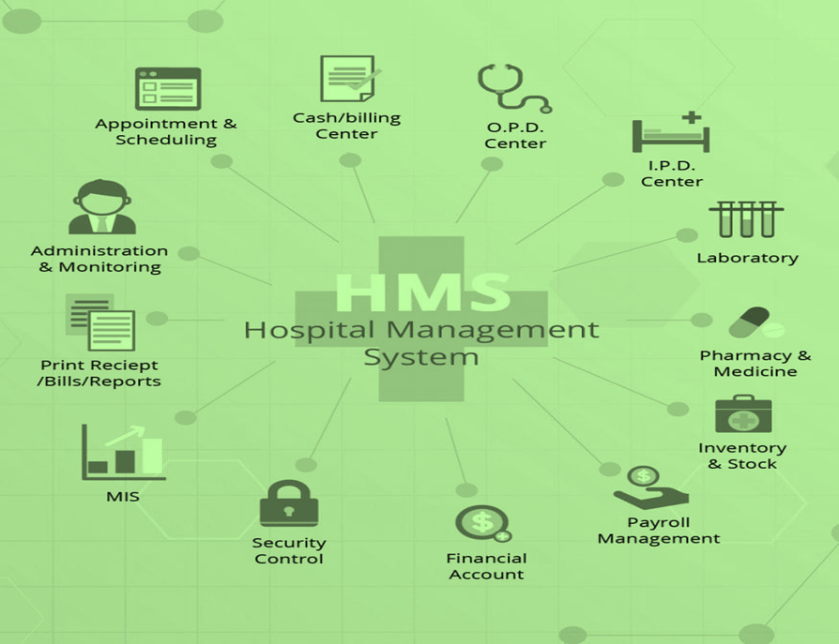**Research and outreach**

A large part of the work Connexxion Telecom and Solutions does is behind the scenes. There will be times when we don’t communicate with HMB for weeks, but that’s only because we’re intimately involved in the development phase. However, before any of that begins, we need to make a checklist of everything you want in your new software.

We will gather information about your company and how it works. We will figure out hospitals you manage and how we can effectively manage all of them through your new software. Audience engagement, research, and branding are key in software development, and we will conduct focus groups to find out how to make HMB more effective to people.

**Framework**

Like a website, a software needs a sitemap and wireframes. Think of this as the structural integrity of a skyscraper. HMB will have an important role in the design process, as it’s important that you are getting what you want. Plus, it’s better to work out issues in this stage than later down the road. Below is a diagram showing data sharing between hospital management board and the hospitals you manage;

**DATA SHARING DIAGRAM**

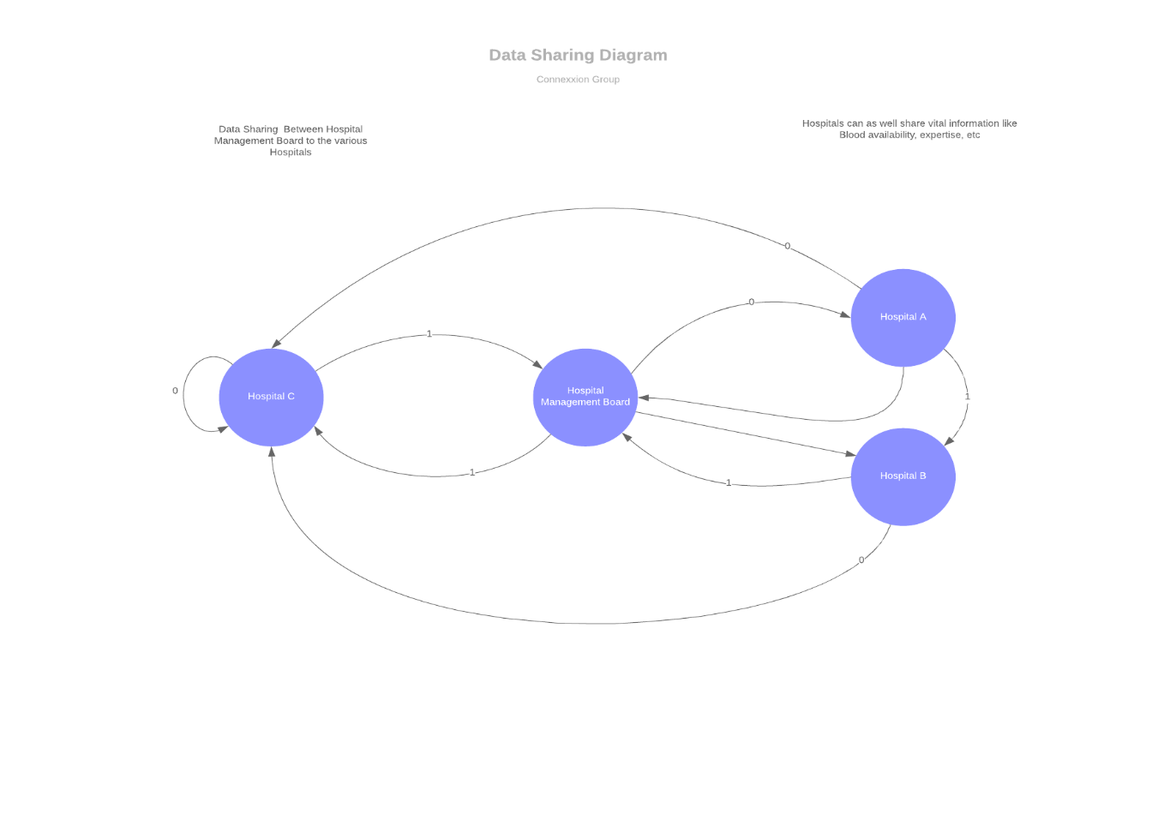

**Functionality and content**

Wireframes, the structural core of your software

Branding and integration of existing digital platforms (i.e., web and email)

User Experience and User Interface, or UX and UI — essentially, how you interact with the software, what makes it easy to use and desirable.

**Development**

As you know, a lot goes into developing new software. Clients need to know what to expect, but don’t use technical language here and don’t be too long-winded. You don’t want to confuse your clients, but you also don’t want to leave important information out. Less is more.

We’ve come a long way at this point. You’ve put in a lot of work, so now you can step aside and let us do the rest. This part of the process is laborious and time-consuming, so don’t expect to hear from us much. But that’s a good thing, as we’ve worked out all the kinks and come to an understanding about everything that will go into your new app. Once development is complete, HMB will be back in the fold for the testing trials.

**Testing and launch**

We’re almost there. Your new software is built and ready to launch. But before that happens, Connexxion Telecom and Solutions and HMB need to collaborate on a marketing strategy. After all, just because you invested all this time and money into your new software, it doesn’t mean anyone will know it exists unless we tell them.

**Merits Of This Software Pre And Post Covid-19**

**Social Distancing:** This software will help staff work effectively from the comfort of their homes or offices, whilst attending to their day to day activities. It enables staff gather information without having to physically visit each hospital.

**Increased productivity:** Fast and better communication contributes to better productivity. It creates a favourable working environment where people can share data/information whenever necessary.

The implementation of E-government in Legislation allows for the entry of data into digital systems exactly where they are in the field. This has led to an increase in data-gathering and a near achievement of real-time operations in getting information out on what the legislative arm of government is achieving and doing

**Access to information:** Due to the timeliness of information as well as the digitized format in which information is made available, this technology will ensure gaps in dissemination of information whilst patient/doctor confidentiality is maintained.

**Faster Decision/Actions:** Decisions and actions can be taken to create an efficient environment where timely attendance to patients would be paramount, and life-threatening situations reduced.

**Faster and Proper Diagnosis.** Doctors would be able to use compiled information assisted by artificial intelligence to properly diagnose patients based on accumulated data gathered from previously treated patients, which showed similar symptoms.

**Timeline**

We’ve offered a basic guide for the timeframe of delivery and what your client can expect to be charged. Of course, you know better than anyone how long the process will take and what it will cost. You can also tailor the “payment options” function to the method(s) of payment you accept. This is all up to you; you’re not hindered by the template.

Connexxion Telecom and Solutions estimates that it will take 2 months to complete your new mobile app. Upon signing this agreement, we can begin immediately.

**Expenses**

We want HMB to receive the utmost value from your investment in a new software, so we will be open for discussions on pricing on the start to finish of this project.