**FORM TITLE: ACCOUNT OPENING FORM**

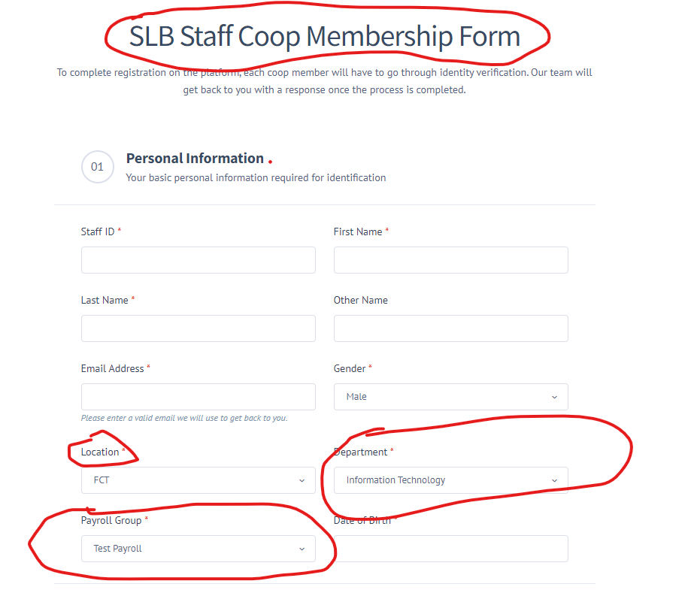

Remove the circled inputs and Add the following fields:   
1. Nationality

2. State of Origin

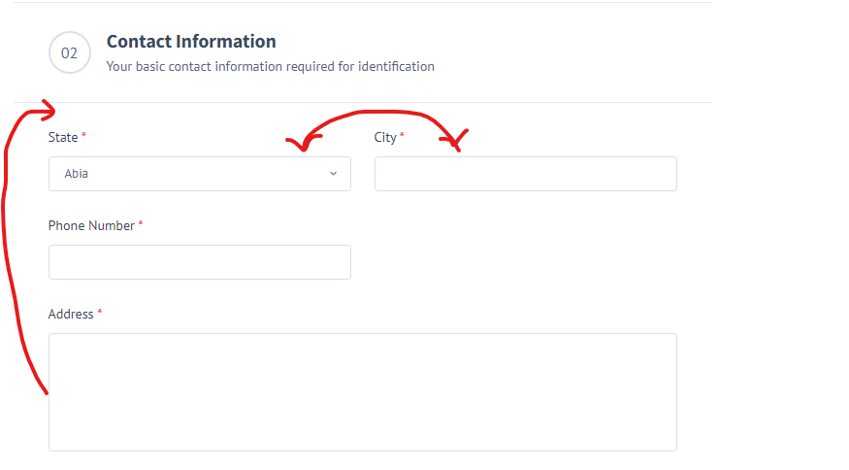

Add following fields:

1. Alternative phone number

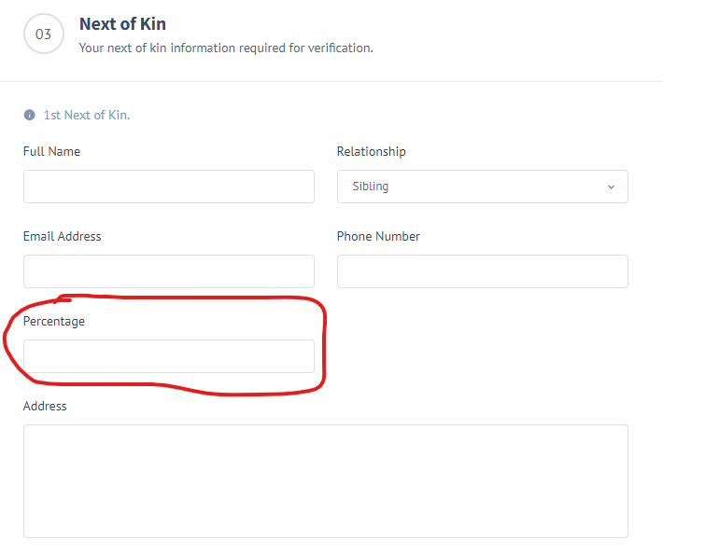

Remove the circled inputs

**Bank Information**Add BVN

**On submission, Move to a next page to upload**Upload passport

Upload ID Card

Authorized Signature

All not compulsory