**Project 05**

**CS2803 – WDB**

**Spring 2016**

This assignment is intended to get you started using PHP to bring data into your web pages. You have been provided a comma separated file (csv) that contains all US zip codes with their corresponding latitudes, longitudes, cities, counties and states.

Your assignment is to use this data to:

* Make a PHP page that contains a form (10pts) to collect user input and a <div> (10pts) to display a map.
* The form should ask the user for a city (10pts) and state (10 pts).
* The form should use the “get” method (10pts) and the action should cause the page to call itself (10pts).
* When the submit button is clicked, a map should be generated in the map <div> (10pts) that has a pointer indicating the location of the city (10pts).
* There should also be a text tab over the pointer that shows the location’s zip code (10pts), city name (10pts), county (10 pts) and state (10 pts)

You should also create another lower panel on your Bio Page that serves as a link to this page. (See example below) (10pts)

City Finder

Lorem ipsum dolor sit amet, consectetur adipiscing elit. Mauris vitae laoreet quam. Phasellus enim metus, facilisis vitae elementum quis, volutpat ut lorem.

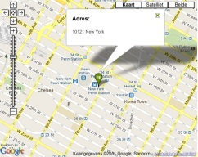

“Turn in” your assignment by adding the necessary files to your Cloud9 folder.