**Project 07**

**CS2803 – WDB**

**Spring 2016**

This project is the beginning of your final project. This will be the SignUp/SignIn part of your application. Your first page will greet the user with a sign in option like the one shown below. (10 points for each text entry field and 10 points for each correctly functioning button.)

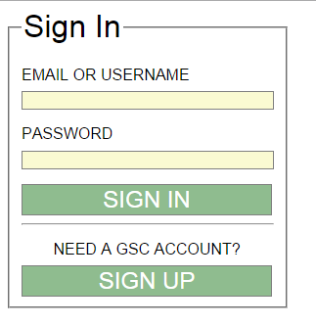

The user will enter their email or username along with their password.

If the user is verified, then the member should be taken to a skeleton data page. (10 points)

If the user is not verified, then the user must be notified that the data provided did not match the database and be given an option to retry sign in or to sign up. (10 points)

If the user chooses to sign up, then the user will see a page like the one shown below. (10 points for each text entry field and 10 points for each correctly functioning button.)

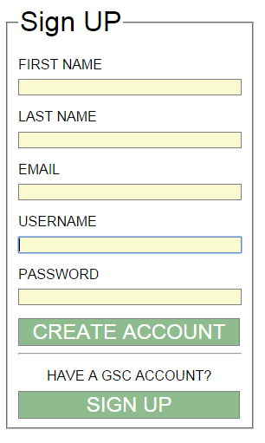

We will assume that the user will enter properly formed information. When the user clicks on “CREATE ACCOUNT” the information provided will be stored in a user’s MySQL table (20 points) and the member will be taken to a skeleton data page. (10 points). Clicking the “SIGN IN” button will take the user to the sign in page described above.

You should also create another lower panel on your Bio Page that serves as a link to the sign in page. (See example below) (10pts)

Final App

Lorem ipsum dolor sit amet, consectetur adipiscing elit. Mauris vitae laoreet quam. Phasellus enim metus, facilisis vitae elementum quis, volutpat ut lorem.



“Turn in” your assignment by adding the necessary files to your Cloud9 folder.