**Project 08**

**CS2803 – WDB**

**Spring 2016**

This project is a continuation of your final project. This will be the data entry part of your application. Your page should look and function something like the one below.

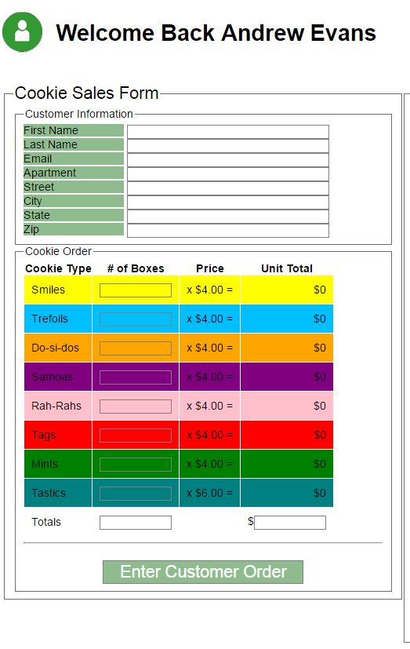Your page should contain the following:

* Some sort of welcome message that addresses the site member by name.(10pts)
* Fields to collect customer information (10pts ea)
  + First and last names
  + Email
  + Mailing Address
* At least 6 fields to collect sales information(10pts ea)
* Client side calculations of sales subtotals and totals(20pts ea)
* A button to submit the data to the appropriate data table within the database you created in project07.
  + (10pts for a properly functioning button)
  + (A total of 20pts for getting all data into the appropriate data table)
  + (10pts for an on screen notification that the data was entered successfully)

“Turn in” your assignment by adding the necessary files to your Cloud9 folder.