**Project 09**

**CS2803 – WDB**

**Spring 2016**

This project is a continuation of your final project. This is the data display part of your application. You are required to make only one horizontal bar graph like the one lectured on in class and shown below. You are to display the total number of units sold per category for the member that is currently logged in to the application.

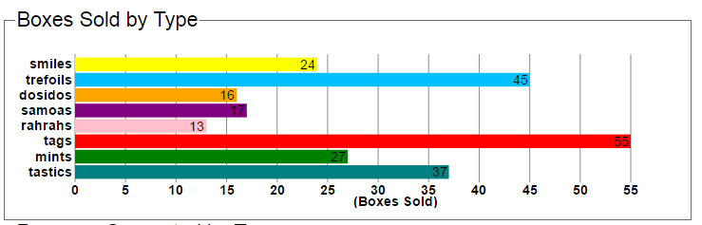

Your graph should be displayed on the same page as your data entry form and should contain the following:

* A title (10pts)
* An X axis label (10pts)
* X axis text showing values of tick marks (10pts)
* Y axis text showing values of tick marks (10pts)
* Each bar should have text on it showing its value (10pts)
* Each bar should be a different color (10pts)

“Turn in” your assignment by adding the necessary files to your Cloud9 folder.