Flowcharts and Pseudocodes

*“Flowcharts A flow chart is a type of diagram representing a process using different symbols containing information about steps or a sequence of events. Each of these symbols is linked with arrows to illustrate the flow direction of the process.”*

Flowcharts are commonly used in developing business plans, designing algorithms and determining troubleshooting steps. Many software programs are available to design flowcharts

It is important to use flowchart in some instances like Process documentation or Training materials, Workflow management and Continuous Improvement, Programming, Troubleshooting guides and Regulatory and Quality Management requirements.

A flowchart in computer science typically has the following types of symbols to represent a process or program:

1. Oval/Rounded Rectangle/Circle: Represents any process having a start and an end activity.
2. Rectangles: Represents a process activity or step.
3. Diamonds: Used when there is a decision to be made or a question to be answered, such as Yes/No or True/False. The path to be taken is determined by the answer to the question.
4. Arrow lines: Used to show the flow of control from one step to the other. They also indicate progress from one step to another.
5. Parallelograms: Used to represent input/output.

Example of Flowchart:

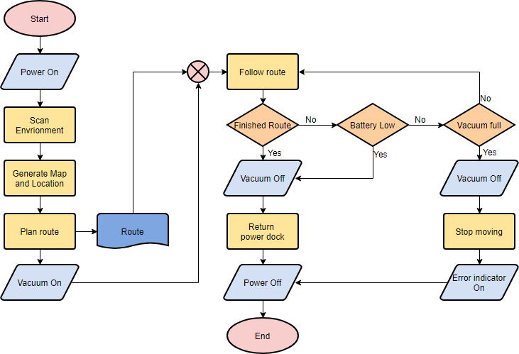

*“Pseudocode is an informal way of programming description that does not require any strict programming language syntax or underlying technology considerations. It is used for creating an outline or a rough draft of a program. Pseudocode summarizes a program’s flow, but excludes underlying details. System designers write pseudocode to ensure that programmers understand a software project's requirements and align code accordingly”*

Pseudocode is often found in scientific publications or textbooks where it can be used to help outline specifically how certain algorithms can be deployed in certain tasks and use cases. Overall it’s useful for straightening out how a function would work for any users who aren’t necessarily versed in a particular language they’re working with at any given time.

Example of Pseudocode:

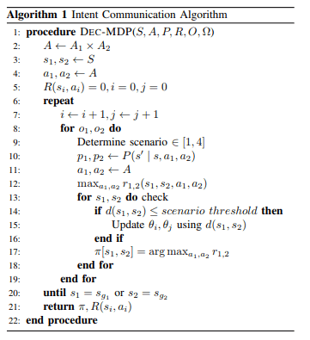

References:

<https://economictimes.indiatimes.com/definition/pseudocode>

<https://www.techopedia.com/definition/5512/flowchart>

<https://www.smartdraw.com/flowchart/>

<https://www.google.com/search?q=flowchart+examples&sa=X&rlz=1C1GCEA_enPH854PH854&tbm=isch&source=iu&ictx=1&fir=8VT_21JVn8LCGM%253A%252C3SREn-11lIrhRM%252C_&vet=1&usg=AI4_-kShxVmNlYNmXR94o4mPyRI8DYFqFw&ved=2ahUKEwih78j8lJPlAhWBd94KHaueBGsQ9QEwA3oECAQQCg#imgrc=0vympxNo-NWe5M:&vet=1>

<https://www.breezetree.com/articles/top-reasons-to-flowchart>