**CS498 AML HW1**

Huiyun Wu

hwu63

**Part1 A**

0.736601307189543

**Part1 B**

0.74640522875817

**Part1 D**

0.777777777777778

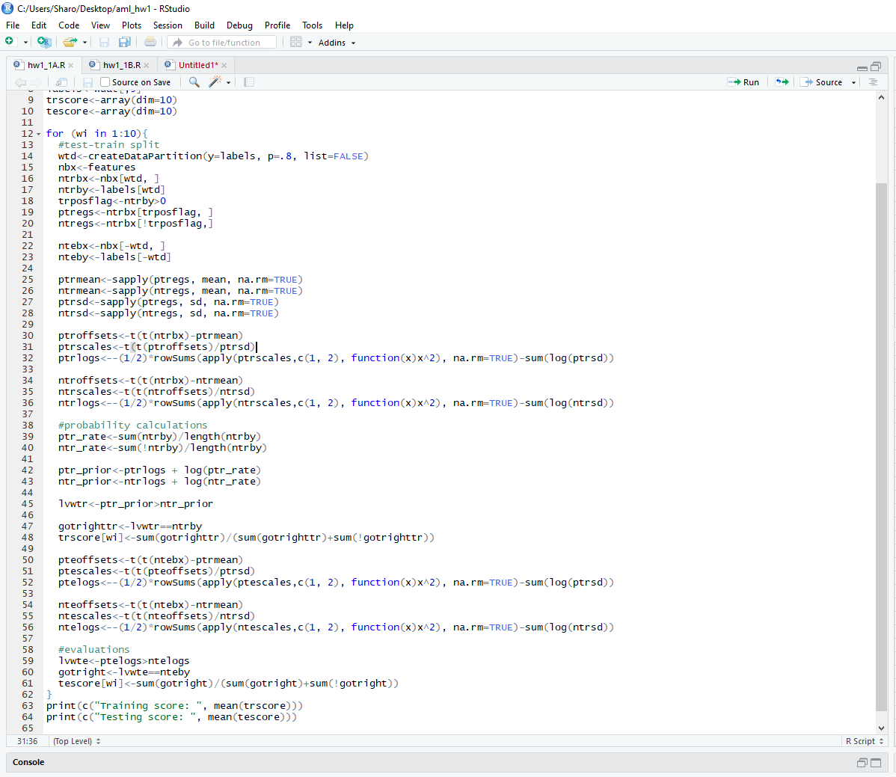

|  |  |  |  |
| --- | --- | --- | --- |
| **Accuracy** | **depth = 4** | **depth = 8** | **depth = 16** |
| **#trees = 10** | 0.8481 | 0.933 | 0.933 |
| **#trees = 30** | 0.8744 | 0.9394 | 0.9649 |

Untounched (I was not able to write these test result to files so I just showed the confusionMatrix results...)

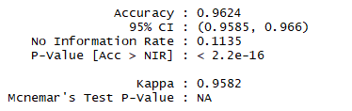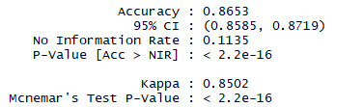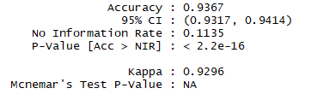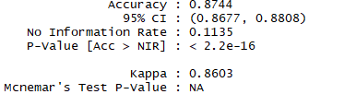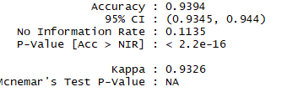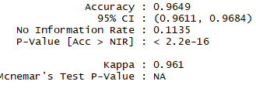

|  |  |  |  |
| --- | --- | --- | --- |
| **Accuracy** | **depth = 4** | **depth = 8** | **depth = 16** |
| **#trees = 10** | 0.8011 | 0.9059 | 0.9385 |
| **#trees = 30** | 0.9385 | 0.9151 | 0.9484 |

Bounded

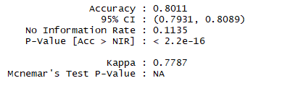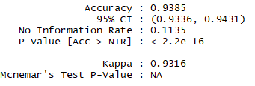

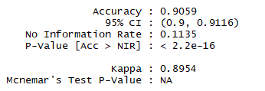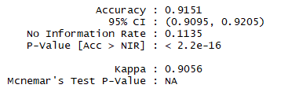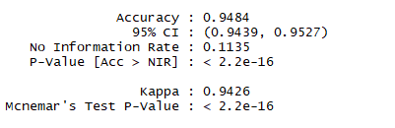

|  |  |  |
| --- | --- | --- |
| **Accuracy** | **Gaussian** | **Bernoulli** |
| **Untouched images** | 0.5352 | 0.1135 |
| **Stretched bounding box** | 0.8289 | 0.8145 |

Gaussian is better in both untouched and stretched bounding box images. Because Bernoulli only recognize 0 or 1 but Gaussian is continuous.

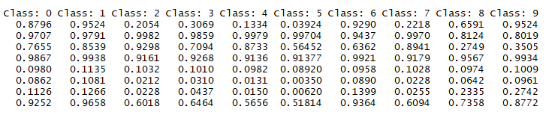

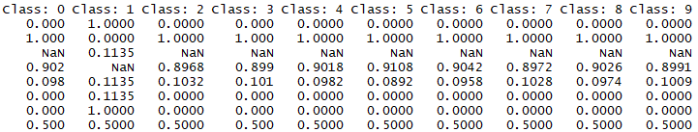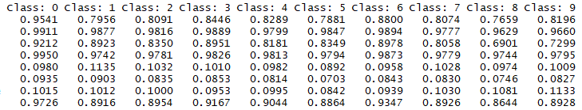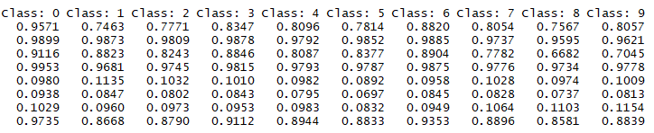

Library:



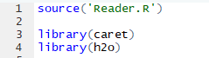



Evaluations:

