Font awesome

Slick

Header

-Home

-About, Resume, Skills, Projects, Hobbies, Social Media

1 1 4 1 4 1

Copyright/Footer

-social media/website icons

- email , linkedin, github , instagram

-copyright c symbol 2017 Connie Lim.

**Main**

Welcome Image

-angel.jpg

-Connie Lim

-Aspiring embedded software developer, amateur kpop dance coverer, ISFP, adventurous

About

-standing_pose.jpg

-Hi! I’m Connie and I am a student at Virginia Tech majoring in Computer Engineering. After I become an alumnus in December 2017, I hope to contribute to society by working with microcontrollers and sensors. I’ve lived near Chinatown, LA for half of my life until I moved to Roanoke, VA where I am deprived of Asian food. I love learning KPop dances and eating.

Resume/Experiences

-little intro

-objective of becoming an embedded software developer. Maybe a little bit about my work personality.

-education 

Virginia Tech

B.S. in Computer Engineering

Expected Graduation: December 2017

-relevant work experience 

LifeFuels, Summer Software Developer Intern

May-August 2015:

May-June 2016:

-resume link

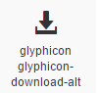

Skills

-C, C++, Java, Python, MatLab, Git,

Projects

-lifefuels website

-lifefuels lentil writer

-embedded project

-grabber.jpg

-senior design project

-senior_design.jpg

Possible Designs

Boxes, small and far away from each other

Rectangles, super close to each other.

Rectangles, side by side

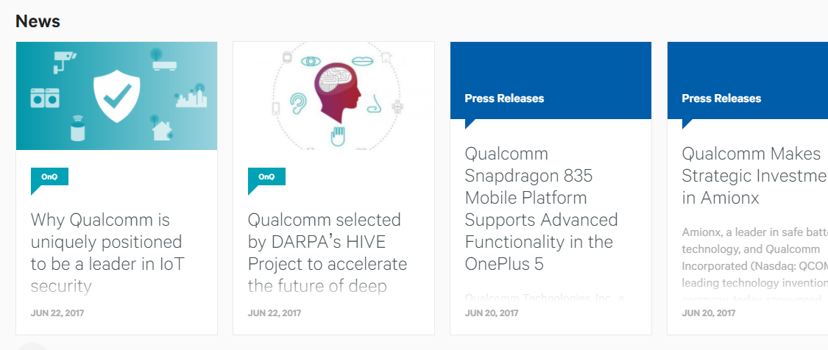

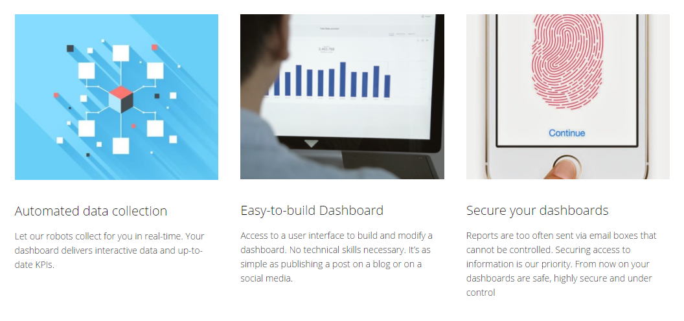

Buttons

Just pictures with the project title and then show descriptions when mouse is hovered over



Hobbies/Passions

-dancing

font awesome

-Korea



-traveling

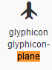



**LifeFuels Projects**

Website

For the summer after my sophomore year, I interned at LifeFuels. During my internship, I developed a couple of pages for the company. I first helped develop the team page for the pre-order site.

Lentil

**Embedded Project**

ECE 4534 – Embedded Systems Design

Problem

ECE 4534 is a capstone class that all computer engineers are required to take. It utilizes the student’s knowledge that has been obtained through classes take sophomore and junior years. In addition to a project, reports, presentations, and design documentation are to be produced. Only a handful of lectures are given and they are about how to get modules to communicate with each other and communication protocols. Other than that, the students in teams of four use their knowledge to code and design the modules with the help of GTAs and the professor.

The goal of the project assigned is to pick up all the unknown number of targets inside an unknown arena and drop them outside without bumping into obstacles or a rover. The project only allows two rovers; one that maps the arena and location of targets and obstacles and the other that is blind whose job is to pick up and drop targets. The four modules are sensor, grabber, pathfinding, and retriever; I was responsible for the grabber module.

The grabber’s task is to pick up the target and drop them when the rover is outside. The grabber module is part of the blind rover that works with the retriever module. The retriever module will move toward the targets based on the map generated by other rover that has the pathfinding and sensor modules. The grabber is disabled until the retriever says that it’s near a target. Due to friction and inaccuracy of the output compare, the position of the rover is different from where it thinks it is. The grabber can have sensors to align itself with the target because of that. After the grabber acquires the target, it is again disabled until the retriever module tells the grabber module that it’s outside the arena.

Solution

grabber.jpg

Check out our solution explained in the video and report below! My part in the video is from 9:26-14:17.

<https://www.youtube.com/watch?v=SH4gUvmH9Hc>

<https://docs.google.com/document/d/1dRLzuv_-AmKCYL8DUuBjY9-71j91lN_ida7YEVxVf9Q/edit?usp=sharing>

**Senior Design**

ECE 4805/4806 – Senior Design Project

The senior design class gives students the opportunity to gain real world experience by allowing students to work with projects given by real companies in teams. It simulates a workplace in the sense that we have a customer, subject matter expert, and an advisor. This is a two-semester course where the first semester is dedicated to designing and the second to implementing. Topics of some of the lectures include patent, RFP, and the process of getting a customer.

The project that was assigned to our team of four is a GE Global project. GE wanted us to create library modules that can be pieced together; the three modules to be created are PID, PWM, and bang-bang controller. The module I was responsible for was the bang-bang controller.

Solution

Check out our poster!

<https://drive.google.com/file/d/0B_zXH23zO7DnTm85WHI4M2c2LURJNkVrVWVwWkxDMWJXSzI4/view?usp=sharing>

**Dancing**

dance_fan.jpg

dance_jump.jpg

I wanted to become a Kpop star when I was in high school. It seemed so fun seeing the stars dancing and singing. Even though I couldn’t fulfill the dream, I can pretend to be one by dancing. Dancing also helps me relieve stress and show off my moves to my family and friends.

Even though dancing is a hobby, it has also honed my observation and perfection skill. Dancing has taught me to perfect the position of every body part of each move such as the angle, how far out the arm should be, how much energy should be put into it, and so much more. A successful dance cover to me is when you place your dance cover and the original dance side by side and notice little to no difference between the two.

Here are some videos of me dancing! I don’t only cover kpop dances; I’ve also participated in the Korean fan dance. Check them out!

VtShiDae – <https://www.youtube.com/watch?v=Pq1JCusjDtg> (0:20 – 1:24 and 6:00 – 6:58)

Fan dance – https://www.youtube.com/watch?v=0A3uIYCYXFQ

Sometimes when I need motivation or I need real people to be my role model, I look at other people’s covers. There are so awesome and I strive to be like them. Check them out too!

Koreos - https://www.youtube.com/user/KoreosUCLA

1million – https://www.youtube.com/channel/UCw8ZhLPdQ0u_Y-TLKd61hGA

Kaotsun – https://www.youtube.com/user/kaotsun

**Korea**

Yonsei_main_gate.jpg

Modern Korea has made a huge impact on my life. I was the weird one in high school, so I got bullied a lot. To cope with the stress, I listened to Kpop. During high school, I felt like the music played on the radio was about topics I didn’t want to hear about. Kpop was my escape from life. From Kpop, I was able to branch out to K-dramas. As of 2017, it has been eight years since I’ve started listening to my kpop. I’ve always wanted to go to Korea to finally visit the source of my happiness and I got to do so during the winter of 2016. I love Kpop, Kdramas, and the language itself. Derp, edit this.

Angel.jpg

Beefsoup.jpg

Bimp.jpg

Bingsoo.jpg

Chingu.jpg

Crab.jpb

Ddeokbokki.jpg

Donkatsu.jpg

Eggbread.jpg

Ehhwa.jpg

Fishcake.jpg

Gosami.jpg

Guardface.jpg

Hongdae.jpg

Jjimjilbangclothes.jpg

Jyp.jpg

Kclass.jpg

Kek.jpg

Mananddog.jpg

Myeongdong.jpg

Namedaemun.jpg

Palace.jpg

Redbeansoup.jpg

Sannakji.jpg

Smtown.jpg

Temple.jpg

Yg.jpg

Winter_back.jpg

Wrap.jpg

Yonsei_jacket.jpg

I’m not Korean, but….

Intro

K-entertainment

Korean

Study abroad

**Traveling**

World_map.png

I love trying new things; it’s not a surprise that I love learning about new culture and trying different foods. As a child, I didn’t travel a lot, even inside the US, because we didn’t have time. I really cherish being able to travel around the world easily because of that. The countries filled in red are the countries I have visited. Before I kick the bucket, I hope the map won’t have any white spots.

Getting a taste of culture one country at a time

-I love trying new things, especially food (cutlery)

-Gaining different perspectives (lightbulb-o)

-Experiencing uniqueness (globe)

-Bleed Red (goal of visiting every country)