THANK YOU to Nick N6VOA and Countycomm https://countycomm.com for donating supplies! Check out their website for tools, gear and more!

Soldering how-to and hints
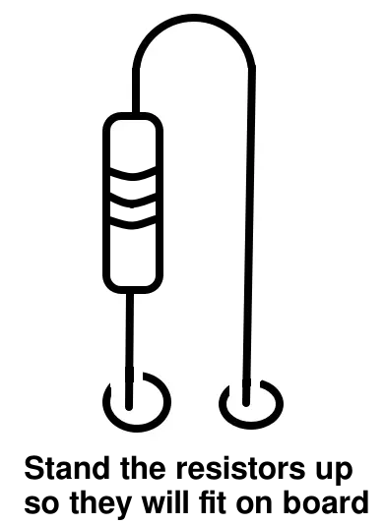
0. Tin the tip, for good heat transfer
1: Hold iron against BOTH part and pad
2: touch solder wire to both, see flow
pull solder wire away, holding iron in place
3: heat for ~1 more second
4: pull iron away
Hints:
- “Wet” the iron tip with a little solder first to help with heat transfer
- BUT you are not dropping molten solder onto cold parts. It is not like glue
- Solder flows toward heat. Need heat to flow, unlike glue.
- Clean tip of iron before starting, and between every couple of parts
Safety notes
- Solder contains lead. Don’t eat it, don’t eat or drink while soldering. Wash after handling solder. Dispose of waste appropriately.
- Use eye protection
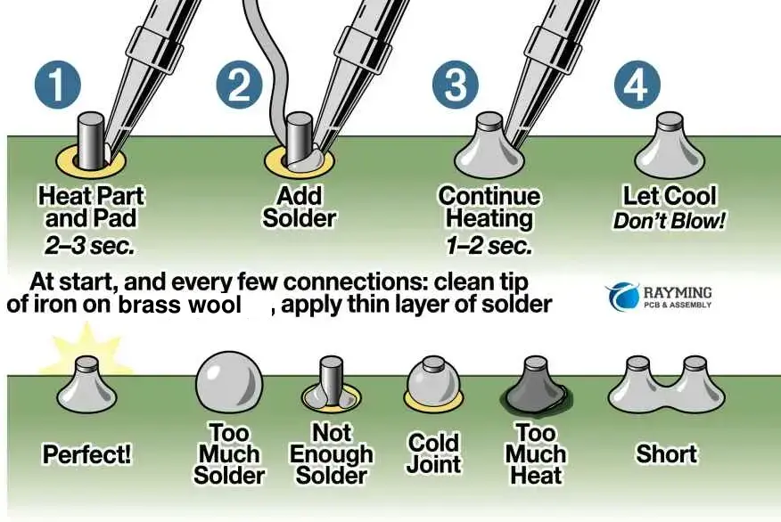
- You will see some smoke. All smoke is irritating so don’t breathe it. That is from the “flux” in the solder and is not vaporized lead.

