Name: Connor Lauerman Collaborators: (Any one you worked with)

R Lab 3: Probability

Please answer all the Exercises and the questions from the “On Your Own” section. If you use any graphs or charts to justify your answer, please include them.

Exercise 1: What does a streak length of 1 mean, i.e. how many hits and misses are in a streak of 1? What about a streak length of 0?

A streak length of one means that Kobe made one shot then missed his next shot

A streak length of 0 means Kobe had missed a shot without making any shots form the last missed shot

Exercise 2: Describe the distribution of Kobe’s streak lengths from the 2009 NBA finals. What was his typical streak length? How long was his longest streak of baskets? (Include plot.)

The distribution of streak length is skewed right. Most of the data is on the left. Kobe’s typical streak was length zero with the next most streak being one. Kobe’s longest streak was 4

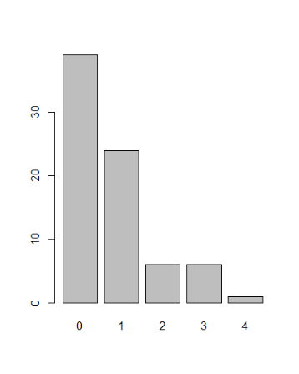

Exercise 3: In your simulation of flipping the unfair coin 100 times, how many flips came up heads?

Heads : 14

Tails: 86

Exercise 4: What change needs to be made to the sample function so that it reflects a shooting percentage of 45%? Make this adjustment, then run a simulation to sample 133 shots. Assign the output of this simulation to a new object called sim_basket.

sim_basket<-sample(outcomes,133,replace = TRUE, prob = c(.45,.55))

probability assignment needs to change to .45 and .55

with the size = to 133

On Your Own:

1) Describe the distribution of streak lengths. What is the typical streak length for this simulated independent shooter with a 45% shooting percentage? How long is the player’s longest streak of baskets in 133 shots? (Include plot.)

The simulated shooter is skewed to the right with most of the data to the left. The typical streak for the simulated shooter is 0 with the next typical being 1. The longest streak for the simulated shooter is 5.

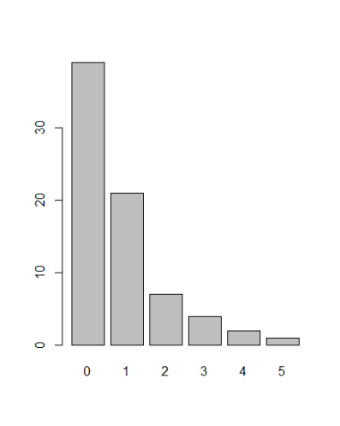

2) If you were to run the simulation of the independent shooter a second time, how would you expect its streak distribution to compare to the distribution from the question above? Exactly the same? Somewhat similar? Totally different? Explain your reasoning.

I think the distribution would be somewhat similar with different frequency of streaks because the shooter has the same probability and same number of attempts with the attempt number being fairly large the streaks should distribute somewhat similarly

3) How does Kobe Bryant’s distribution of streak lengths compare to the distribution of streak lengths for the simulated shooter? Using this comparison, do you have evidence that the hot hand model fits Kobe’s shooting patterns? Explain. (Include plots.)

Kobe Bryant’s distribution of streaks is similar to the simulated shooter distribution. This would be evidence against Kobe having the hot hand model because the distribution of 45% probability hit matches the distribution of Kobe’s streaks.