# CA2 – REPORT

## Introduction

For our Web Development CA, we decided to create a Social Media website. The general concept of the site will be to allow for users to log in and view the activity of the users which they have added as friends, and vice versa on the friend’s end. We intend to use a database of profiles, which can be added to one profile’s individual table to signify friends of the profile, or, including a table which shows which user is friends with which user. We also plan to allow for user privileges, i.e. a limited page is shown when you view a user’s page that is not your friend. This is all detailed below along with all of the design concepts.

Evan Conlon, x00128242,

Glen Curtis x00101556

Gary Dolan X00098899

Glen Connolly X00131787

## Wireframes

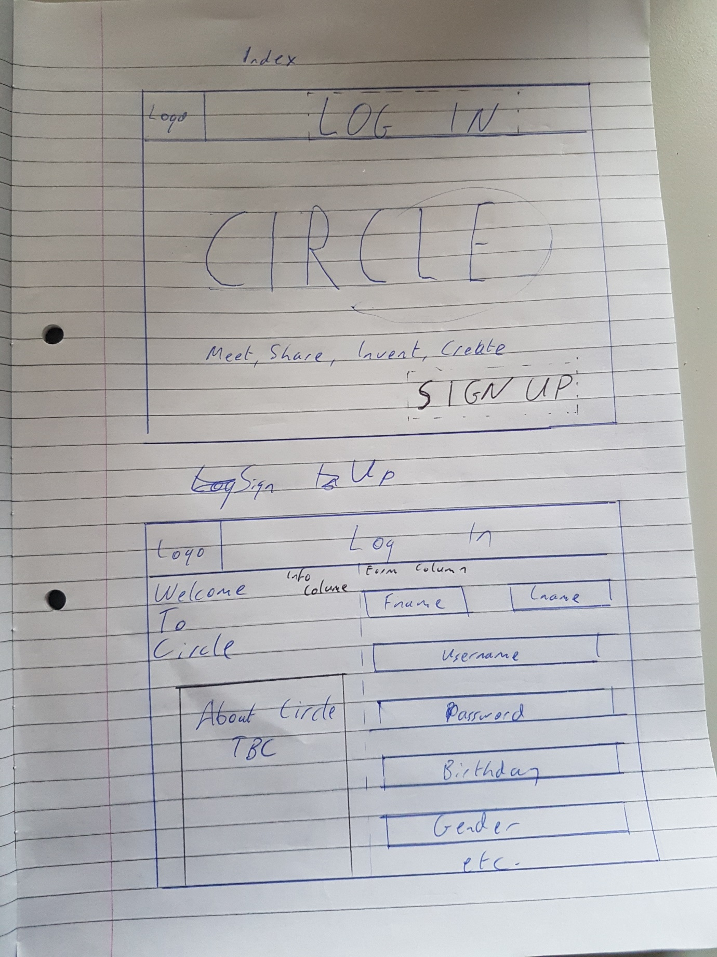

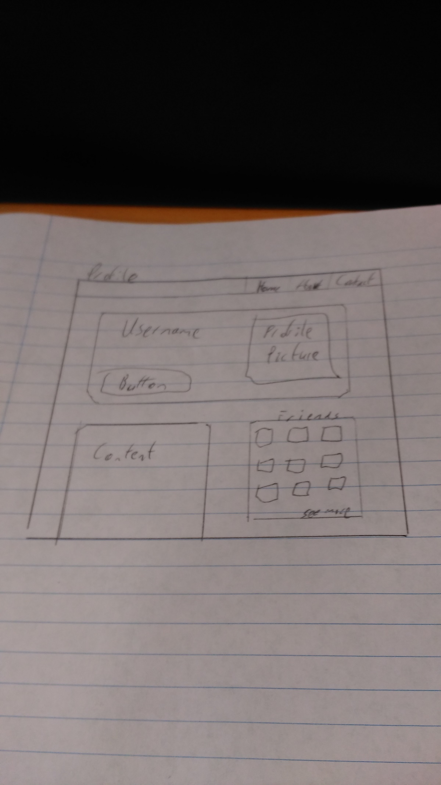

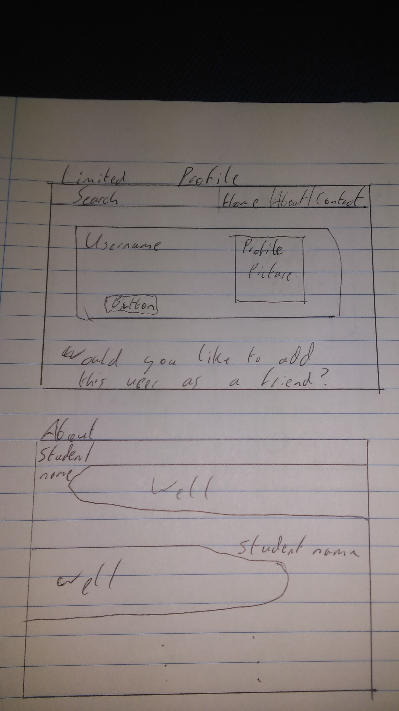

### Wireframe Information

The structure of the site may differ from the final version of the site when the CA is completed, but the general focus on content over functionality in the beginning will remain the same. We want to keep the use of buttons and the depth of the site minimal, and not have too many paths for the user. We included a limited profile page to allow for the use of user privileges, where the logged in user can only see their friend’s information. Any other users will only show their name, picture, and an option to add as a friend. This will also allow for us to implement a guest access option as well, where all pages would return the limited profile page unless they had logged in or signed up.

## Structure

As mentioned above, we planned to make several levels of user privileges which meant having both a log in or a sign up option. With these in mind, we wanted a sign in page on its own which has a form which takes the details of a user and adds it to the database of users. In order for the ‘profile’ page and ‘otherprofilepage’ page to work. To do this, we will need to associate users to friends, such that we can log into each user and see their friends, who are also users which can be logged into.

Examples:

Example 1:

|  |  |  |  |  |  |
| --- | --- | --- | --- | --- | --- |
| UserID | Username | FName | lName | profilePicture | content |

|  |  |
| --- | --- |
| UserID PK | FriendID(references UserID) PK |

Example 2:

|  |  |  |  |  |  |
| --- | --- | --- | --- | --- | --- |
| LoggedUserID PK | Username | FName | lName | profilePicture | content |

|  |  |
| --- | --- |
| LoggedUserID | UserID |

|  |  |  |  |  |  |  |
| --- | --- | --- | --- | --- | --- | --- |
| UserID PK | Username | FName | lName | profilePicture | content | friendStatus (0,1) |

We will need to investigate the practicality of the above implementations through testing to verify whether either are an appropriate method, or whether we may have to research alternative options.



## Design

### Colour Scheme

While we are still undecided on the colour scheme, we have narrowed it down to black and orange after careful discussion. Our decision making process involved researching the psychology of certain colours against tertiary schemes. Black conveying sophistication and Orange conveying comfort and warmth, we feel that black and orange will add a feeling of elite welcome that will entice users.

## Button Concepts

Given the current status of social media sites, we felt that what would really stick out would be a new concept for the buttons. While we will keep the function identical, we plan to consider setting the interaction buttons to the following (based on Facebook terminology):

“Follow” -> “Chase”  
“Like” -> “Agree”  
“Comment” -> “Argue”  
“Add As Friend” -> “Circle”

## Contribution

Up until this point every team member has made a solid contribution. Evan Conlon, x00128242, implemented Twitter bootstrap and designed all of the pages in HTML and CSS. Glen Curtis, x00101556, ensured that the template created by Evan Conlon worked within the Java Play Framework. Gary Dolan, X00098899, drew the wireframes and researched the colour schemes. Finally, Glen Connolly, X00131787, collaborated with each member in their respective roles and constructed this report. This is only a generalization of what has been done. At each stage of every process, every member has been as involved as we could possibly manage. It can be difficult to section certain parts, such as the implementation to the Play Framework, but at every major point we made sure to complete it within the college and with all members present. There is obviously more work to be completed in part 2 of the CA, which will also be equally shared amongst our team.

# Conclusion

While much may still change upon full-implementation of the website to the Play Framework, we have determined the major attributes and functionality of the site.