# Release Information

|  |  |
| --- | --- |
| *Release* | *0* |
| *Leader* | *Nick Buchert* |
| *SVN Revision Number* | *61412* |

The login form directs a user to the Customer or Admin forms based on admin username. All UI components other than the login button are not functional.

# Progress

|  |  |  |  |
| --- | --- | --- | --- |
| **Stories and spike solutions planned for this release** | | | |
| **Story, Spike** | **Description** | **% Impl.** | **Notes, plan for completion** |
| *C1* | *Simple customer payment/order interface* | *100* | *Interface is complete* |
| *A2* | *Admin order list* | *100* | *Interface is complete* |
| *A3* | *Admin login window* | *100* | *Working as expected, scales to the center* |
| *Spike 0* | *Login window centering* | *100* | *Completed and scales to center* |
| *Spike 1* | *Customer UI layout and using custom list views* | *100* | *Completed and has working custom list view* |
| *Spike 2* | *Admin UI layout and custom list views with rich text boxes* | *100* | *Completed and has working custom list view* |

|  |  |  |
| --- | --- | --- |
| **Accomplishments by engineer** | | |
| **Team Member** | **Total Time (hrs)** | **Stories, Spikes implemented** |
| *Nick* | *7.5* | *Spike 0: UI with centering*  *A3: Admin login window* |
| *Dan* | *8* | *Spike 2 (w/Logan): Admin view*  *A2:* |
| *Dustin* | *8.2* | *Spike 1 (w/Spencer): Group containers for payment*  *C1: Payment/order interface* |
| *Logan* | *8.8* | *Spike 2 (w/Dan): Admin view* |
| *Spencer* | *8.75* | *Spike 1 (w/Dustin): Group containers for payment*  *C1: Payment/order interface* |
| TEAM TOTAL | *41.25* |  |

|  |  |
| --- | --- |
| **Document updates** | |
| **Document** | **Changes** |
| *GroupB4StoryBook* | *All initial stories are complete, so no changes yet.* |
| *Release0ClassDiagram* | *Added all classes, attributes, and operations.* |

# Plan for Next Release

Implement a functioning cart where items can be added, removed, and changed. Add functionality for admins to add, remove, and edit items on the menu.

|  |  |  |  |
| --- | --- | --- | --- |
| **Stories and spike solutions planned for upcoming release** | | | |
| **Story, Spike** | **Description** | **Est. Hours** | **Notes, plan for completion** |
| *C5* | *Add and change items in the cart* | *10* | *Modify the shared xml doc* |
| *C7* | *Customer feedback form* | *4* |  |
| *A1* | *Update order list upon completion* | *4* |  |
| *C10* | *Customer description* | *6* |  |
| *A10* | *Edit/Add/Remove items on the menu* | *10* | *Includes xml serialization* |
| *C13* | *Simple receipt interface* | *5* | *Save receipt to text* |
| *Spike 3* | *XML Serialization* | *4* |  |
| *Spike 4* | *Custom item generation* | *12* | *Dynamic button generation* |
|  |  | *55* | Total |

|  |  |  |  |
| --- | --- | --- | --- |
| **Assignments** | | | |
| **Team Member** | **Stories, Spikes implemented** | | **Tot. Hrs.** |
| *Nick* | *Spike 3, A1, A10, C13* | *N/A* | *10.5* |
| *Dan* | *Spike 4, C5, C10* | *N/A* | *10.4* |
| *Dustin (Release 1 Team Manager)* | *Spike 3, A1, A10, C13* | *N/A* | *10.5* |
| *Logan* | *Spike 4, C5, C10, C13* | *N/A* | *10.4* |
| *Spencer* | *Spike 4, C5, C10* | *N/A* | *10.4* |
|  |  | **Total** | **55** |

# Issues

Document anything that is not decided yet and needs to be resolved at some point.

|  |  |  |  |  |
| --- | --- | --- | --- | --- |
| **Issue Number** | **Discovery**  **Date** | **Resolution**  **Date (Est.–Act.)** | **Responsible Person** | **Description (Prob / Resolution)** |
| 1 | 02/07/18 | 02/07/18 | Nick | The group needed extra meeting time to complete spikes, so an additional meeting was scheduled for the weekend. Nick was unavailable and completed his spike alone. |

# Screen Shots

*Insert screen shots of functionality added for this release along with screen shots from spike solutions. Add short descriptions of all screen shots along with a short of list features illustrated by each. The goal is to convince your instructor that you completed the work documented above.*

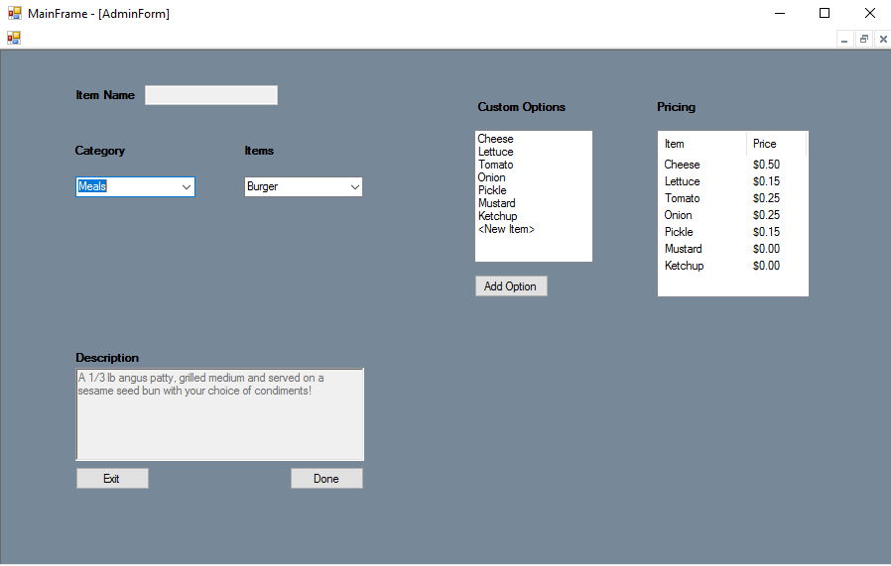

The admin form is not functional, but has all of the required features for A2

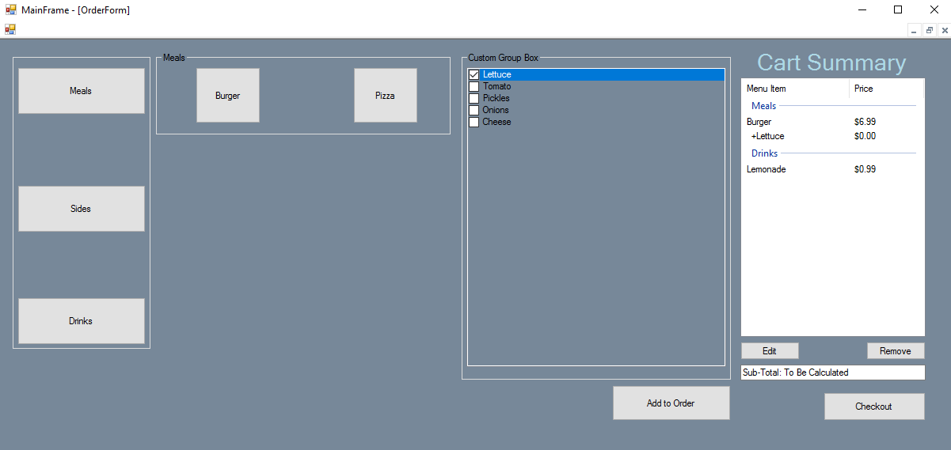

*The customer form is not functional, but has all the UI components for C1*

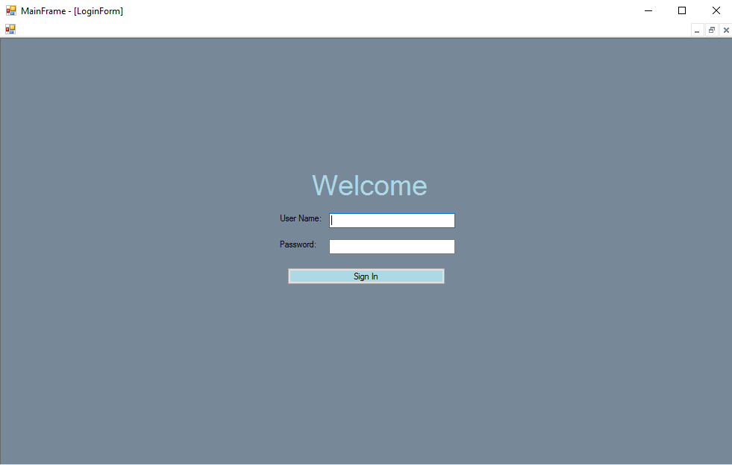

*The login form is centered for any screen size A3.*