# Release Information

|  |  |
| --- | --- |
| *Release* | *2* |
| *Leader* | *Logan Connolly* |
| *SVN Revision Number* | *65122* |

The payment interface has been added, cleaned, and finished, so the customer can choose a tip amount and “pay” for their meal. The options have been enabled for menu items so customers can customize their items to their liking.

# Progress

|  |  |  |  |
| --- | --- | --- | --- |
| **Stories and spike solutions planned for this release** | | | |
| **Story, Spike** | **Description** | **% Impl.** | **Notes, plan for completion** |
| *C5* | *Modify items in cart summary* | *67* | *Get selected item, load corresponding group boxes and check selected options. Allow for override.* |
| *C7* | *Customer feedback form* | *100* | *Create feedback form for feedback class.* |
| *A1* | *Update Order* | *0* | *Utilize the order data.* |
| *C13* | *Receipt Interface* | *100* | *Create form for checkout. This includes tax, tip, total, and payment method.* |
| *C12* | *Clean order interface with proper divisions of menu item types.* | *100* |  |
| *C9* | *Menu items need custom options* | *100* | *When selecting a menu item, show options available for that item.* |
| *U1 & U2* | *Log orders in a text file.* | *100* | *Changed to a digital receipt that is shown when checking out* |

|  |  |  |
| --- | --- | --- |
| **Accomplishments by engineer** | | |
| **Team Member** | **Total Time (hrs)** | **Stories, Spikes implemented** |
| *Dustin* | *13.15* | *A1, C9, U1* |
| *Nick* | *10.25* | *C13, C7, U2* |
| *Spencer* | *11.45* | *C9, C12, U1* |
| *Logan* | *11.55* | *C7, C9, U1* |
| *Dan* | *10.7* | *C13, C7, U2* |
| TEAM TOTAL |  |  |

|  |  |
| --- | --- |
| **Document updates** | |
| **Document** | **Changes** |
| *GroupB4StoryBook* | *Added subtasks to stories in release 3, changed release numbers for some stories and added subtasks to stories that did not have any.* |
| *Release2ClassDiagram* | *Added order statistics class to account for our SQL database, removed feedback class as it is integrated with order controller, changed associations with admin and order controllers with the list of menu items because the list does not know the controllers exist.* |

# Plan for Next Release

Implement the calories and estimated time cost for each menu item. Create a cook UI that displays all current orders and allows the cooks to change the status of the orders.

|  |  |  |  |
| --- | --- | --- | --- |
| **Stories and spike solutions planned for upcoming release** | | | |
| **Story, Spike** | **Description** | **Est. Hours** | **Notes, plan for completion** |
| *A6* | *Order view and status UI* | *6* | *Create order status UI. Create current order list. Add flag attribute to each order indicating current state. Implement timecost attribute for orders.* |
| *A7* | *Cook can update the status of the order* | *8* | *Intertwines with A6* |
| *C2* | *Display order status to customer* | *8* | *Display a notice to the customer about their order* |
| *C3* | *Intuitive food selection interface* | *6* | *Being worked on throughout development* |
| *C4* | *Display menu item calories* | *6* | *Show the calories for menu items and options* |
| *C6* | *Refill button* | *8* | *Add a button to call a waiter to refill a drink* |
| *C8* | *Call waiter button* | *2* | *Add a button to call a waiter to the table* |
| *A2* | *Current order UI* | *4* | *Have a UI to display current orders* |
| *A1* | *Waiter viewer for orders* | *4* | *Display order and table number for waiters to run orders to table* |
|  |  | *52* | Total |
|  |  |  |  |

|  |  |  |  |
| --- | --- | --- | --- |
| **Assignments** | | | |
| **Team Member** | **Stories, Spikes implemented** | | **Tot. Hrs.** |
| *Dustin* | *C3, C4, C6* |  | *14* |
| *Nick* | *A6, A7, C2* |  | *12.67* |
| *Spencer* | *C3, C4, C8* |  | *8* |
| *Logan* | *A6, A7, A1* |  | *8.67* |
| *Dan* | *A6, A7, A2* |  | *8.67* |
|  |  | **Total** | **52** |

# Issues

Document anything that is not decided yet and needs to be resolved at some point.

|  |  |  |  |  |
| --- | --- | --- | --- | --- |
| **Issue Number** | **Discovery**  **Date** | **Resolution**  **Date (Est.–Act.)** | **Responsible Person** | **Description (Prob / Resolution)** |
| 1 | 4/4 | 4/4 – 4/4 | Logan | Prob: Missed meeting day due to spring break taking a Monday away from the week back. Res: Met for as long as need Wednesday to clean for release. |
| 2 | 4/4 | 4/11 | Group | Prob: Forgot to write tests before programming. Res: Wrote tests before submitting release and added more tests for additional functionality. |

# Screen Shots

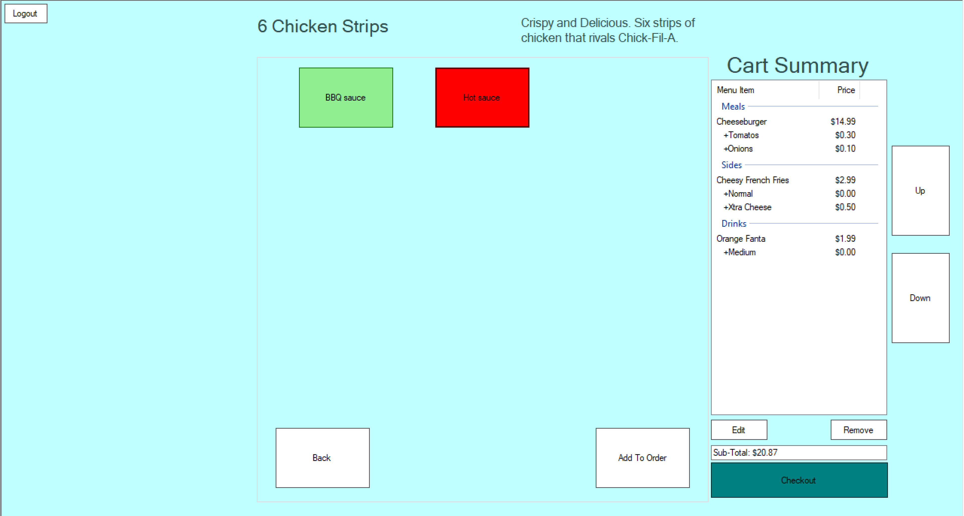

*Up and Down buttons added to navigate the cart summary, togglable options to customize menu items.*

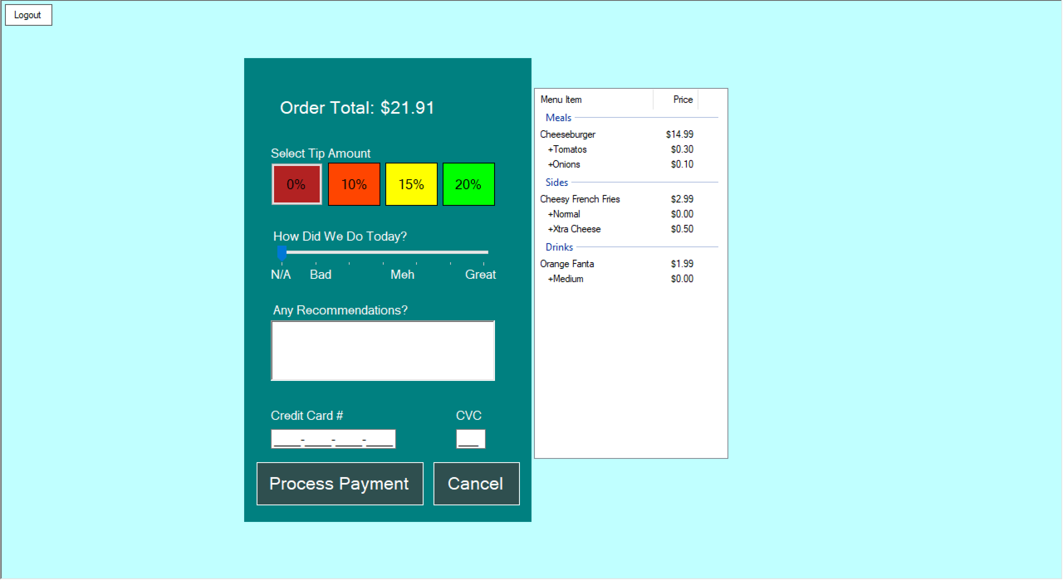

*Checkout and feedback panel, allows user to pick a tip amount and displays their current order, Allows for the entering of a credit card for payment.*

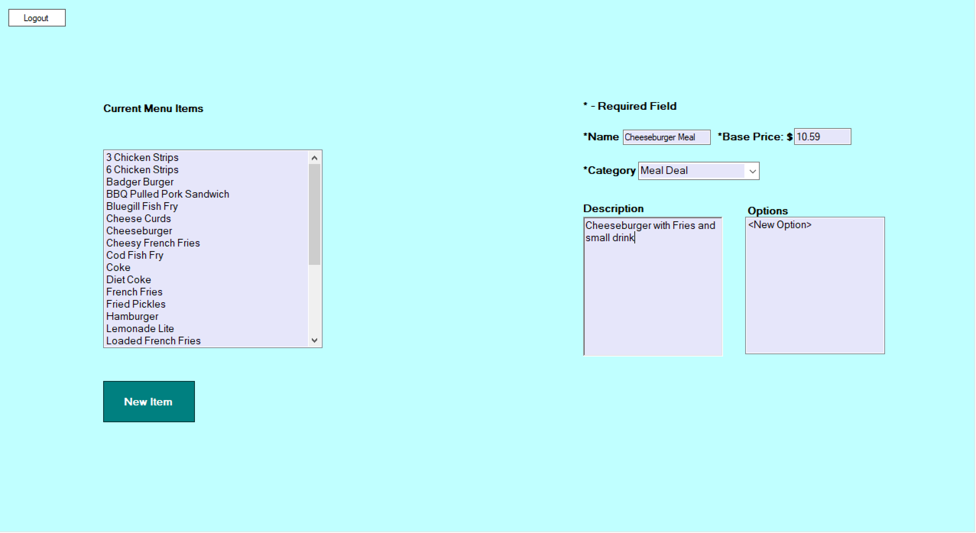

*Admins can now enter information without hitting new item, and adding/updating a number can be done by hitting enter/return*