# Release Information

|  |  |
| --- | --- |
| *Release* | *3* |
| *Leader* | *Daniel Zellmer* |
| *SVN Revision Number* | *68043* |

This release includes the implementation of command pattern on the administrative side of the system, as well as a new kitchen view for current orders. This release also includes a much improved UI, with elements being resized dynamically so as to maintain proper alignments.

# Progress Summary

|  |  |  |  |
| --- | --- | --- | --- |
| **Stories and spike solutions planned for this release** | | | |
| **Story, Spike** | **Description** | **% Impl.** | **Notes, plan for completion** |
| *A6* | *Order view and status UI* | *100* | *Create order status UI. Create current order list. Add flag attribute to each order indicating current state. Implement timecost attribute for orders* |
| *A7* | *Cook can update the status of the order* | *100* | *Update order status flag from kitchen view form* |
| *C2* | *Display order status to customer* | *0* | *Display a notice to the customer about their order* |
| *C3* | *Intuitive food selection interface* | *95* | *Being worked on throughout development* |
| *C4* | *Display menu item calories* | *100* | *Show the calories in the description beneath item options in order form* |
| *C6* | *Refill button* | *0* | *Add a button to call a waiter to refill a drink* |
| *C8* | *Call waiter button* | *0* | *Add a button to call a waiter to the table* |
| *A2* | *Current order UI* | *100* | *Have a UI to display current orders* |
| *A1* | *Waiter viewer for orders* | *100* | *Same interface as A2* |

|  |  |  |
| --- | --- | --- |
| **Accomplishments by engineer** | | |
| **Team Member** | **Total Time (hrs)** | **Stories, Spikes implemented** |
| *Nick* | *14:27* | *A6, A7* |
| *Dustin* | *14:55* | *C3, C4* |
| *Spencer* | *18.39* | *Spike 9, C3, C4* |
| *Logan* | *12:36* | *A2, A7* |
| *Dan* | *12:22* | *A2, A7* |
| TEAM TOTAL | ***72:59*** |  |

|  |  |
| --- | --- |
| **Document updates** | |
| **Document** | **Changes** |
| *Release3ClassDiagram* | *Added kitchen form and kitchen controller and corresponding associations. Also added command pattern classes and corresponding associations.* |
| *groupB4status* | *Updated group status each Monday.* |

# Plan for Next Release

Our work plan for deployment is to polish our UI to create user flow most effectively and reduce visual excise when possible. Also, fixing of all possible bugs will be performed.

|  |  |  |  |
| --- | --- | --- | --- |
| **Stories and spike solutions planned for upcoming release** | | | |
| **Story, Spike** | **Description** | **Est. Hours** | **Notes, plan for completion** |
| *N/A* | *No additional stories will be implemented for deployment.* | *N/A* | *N/A* |
|  |  | ***N/A*** | Total |

|  |  |  |  |
| --- | --- | --- | --- |
| **Assignments** | | | |
| **Team Member** | **Task** | | **Tot. Hrs.** |
| *Dustin* |  | *Commenting, editing to adhere to ground rules, bug fixing, polishing UI, and documentation.* | *6* |
| *Nick* |  | *Commenting, editing to adhere to ground rules, bug fixing, polishing UI, and documentation.* | *6* |
| *Spencer* |  | *Commenting, editing to adhere to ground rules, bug fixing, polishing UI, and documentation.* | *6* |
| *Logan* |  | *Commenting, editing to adhere to ground rules, bug fixing, polishing UI, and documentation.* | *6* |
| *Dan* |  | *Commenting, editing to adhere to ground rules, bug fixing, polishing UI, and documentation.* | *6* |
|  |  | **Total** | **30** |

# Issues

Document anything that is not decided yet and needs to be resolved at some point.

|  |  |  |  |  |
| --- | --- | --- | --- | --- |
| **Issue Number** | **Discovery**  **Date** | **Resolution**  **Date (Est.–Act.)** | **Responsible Person** | **Description (Prob / Resolution)** |
| 1 | 4/4 | 4/25-4/25 | All | Prob: Many stories for this release were determined to be out of scope.  Res: Team members focused on in-scope stories and overall system improvements. |
| 2 | 4/4 | 4/24-4/25 | All | Prob: Dynamically resizing windows forms created several issues with alignment.  Res: Team members made small tweaks to adjustments to fix alignment issues. |
| 3 | 4/10 | 4/25-4/25 | Nick, Dan, Logan | Prob: Tests involving SQL and XML cannot be run in the test directory because the directory does not have access to the corresponding files in the new location.  Res: Undetermined, we’ll look into multiple file paths. |

# Screen Shots

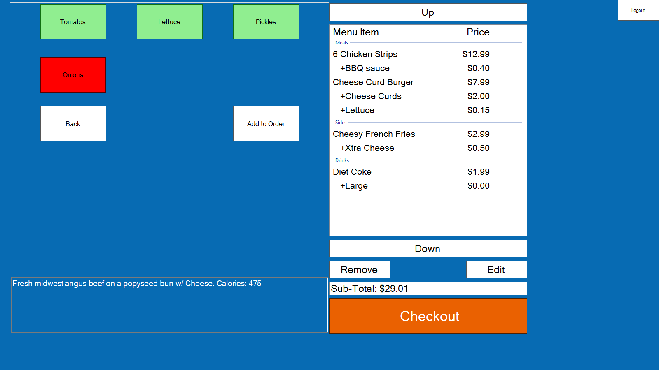

*Improved order interface, including meal description and calorie count for the meal.*

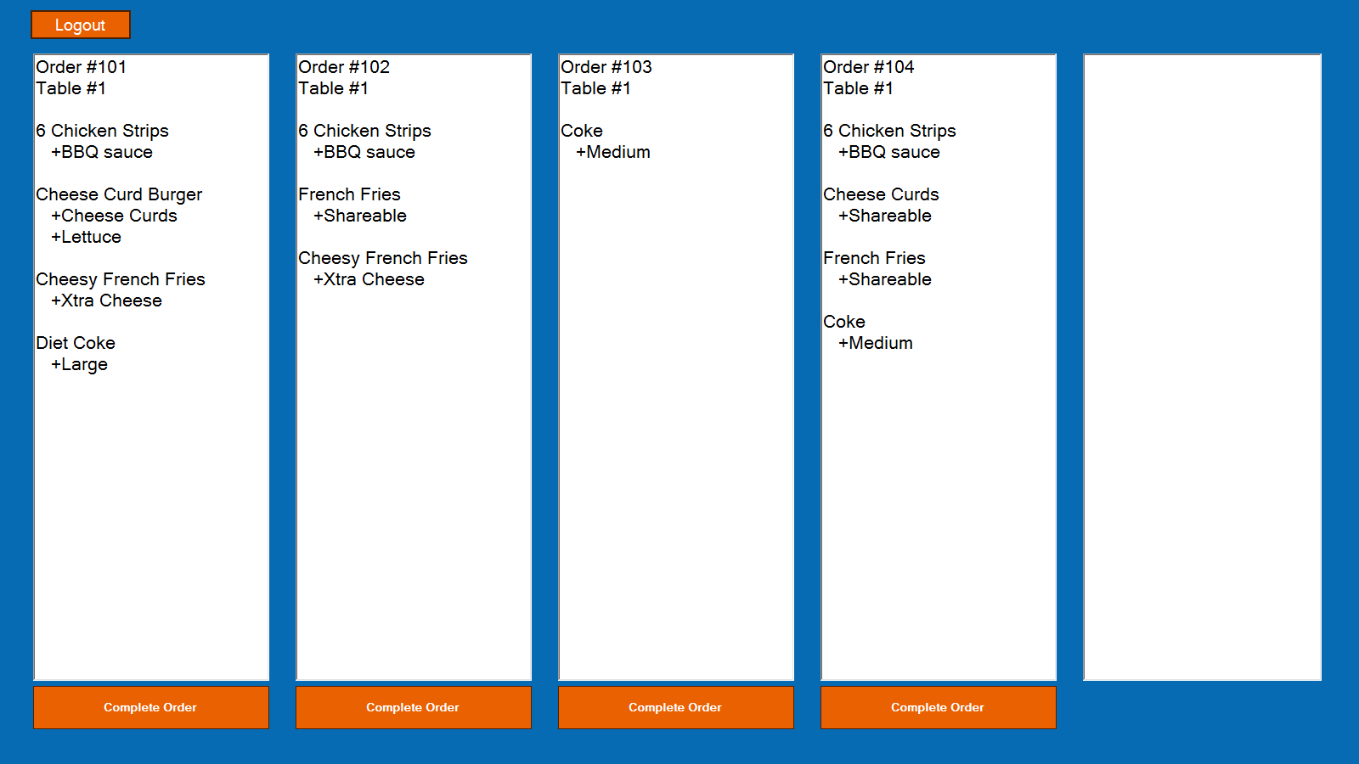

*Kitchen view interface which displays all current uncompleted orders.*

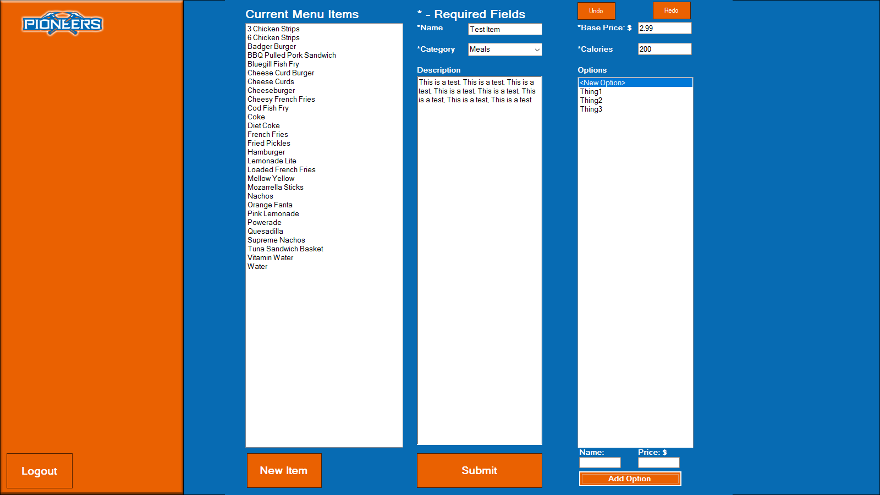

*Improved Administrative view, including undo/redo capabilities.*