Part 1

CybTech: Team Roles
- Ethan Smith
  - Software Engineer
    - The business designs and builds software solutions for contractors, someone must lead the software dev team.
    - Oversees software development and ensures programs work properly.
- Ty Burningham
  - General Manager
    - Every business needs a general / project manager, managing payroll, quality control, and general business management fall to him.
    - Oversees daily business operations and employee responsibilities.
- Connor Okey
  - Network Engineer
    - Designer of the physical layout of network devices and systems, network hardware and general IT support fall to him.
    - Installs and maintains routers, switches, and wireless access points.
- Kaden Donaldson
  - Systems / security Admin
    - Designer / manager of the software side of the network, security training / management, VPN support, Device management falls on him.
    - Monitors network security and protects the company’s data.
- Kelsie Sampson
  - Marketing & Sales lead
    - Graphic design and Project sales lead, no company becomes profitable if they have no work to do. Customer procurement, relations, and support, as well as sales fall on her.
    - Manage sales and attract new clients.

Part 2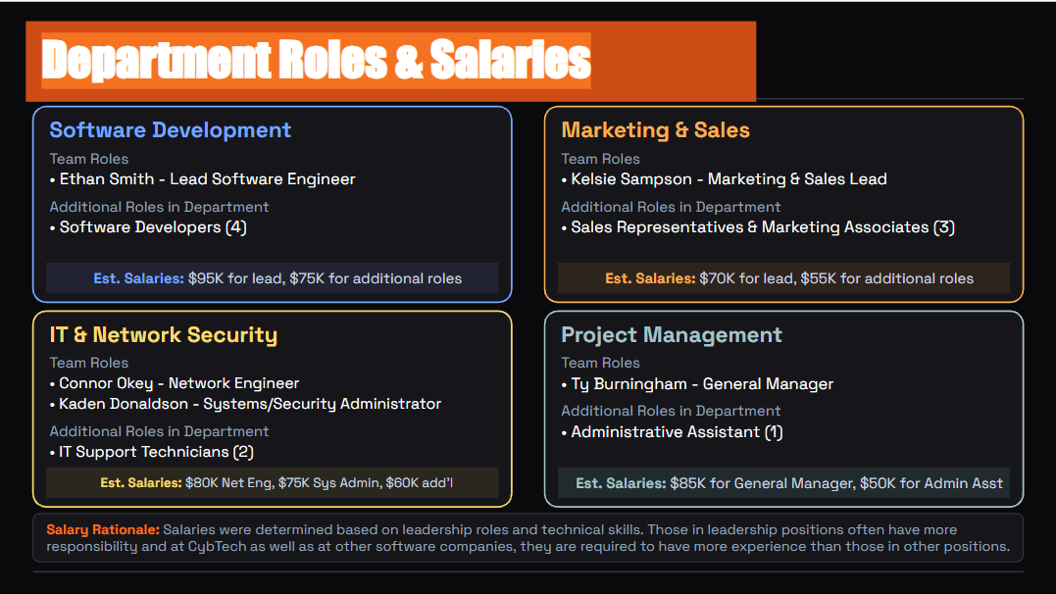

Part 3: (Business Design)
Business Name: Cyb Tech
Business Type: Software Development and Technology Solutions
& Support Business Description:
CybTech is a small technology company consisting of 15 employees who are dedicated to providing Clients with software development, technical solutions, and support for their systems. CybTech works closely with contractors to organize and maintain their systems through routine checks, software updates, and monitoring for any potential failures and suspicious activity while providing reliable Security and high-quality technical Support. Clients will find Cyb Tech beneficial because its software helps organize project information, manage reports, and improve tracking of business operations while keeping important and private data secure. CybTech consists of departments such as management, marketing, customer service, and IT Support, which all work together to provide reliable services, maintain excellent communication with Clients and Contractors, and build strong, trusted business relationships. Furthermore, CybTech relies on locally hosted Servers, Microsoft 365, and a secure, private employee network and a public guest network for daily operations. Overall, CybTech is a business that focuses on providing high-quality technical support and secure software solutions to clients and contractors, ensuring their systems are the best they can be.

Part 4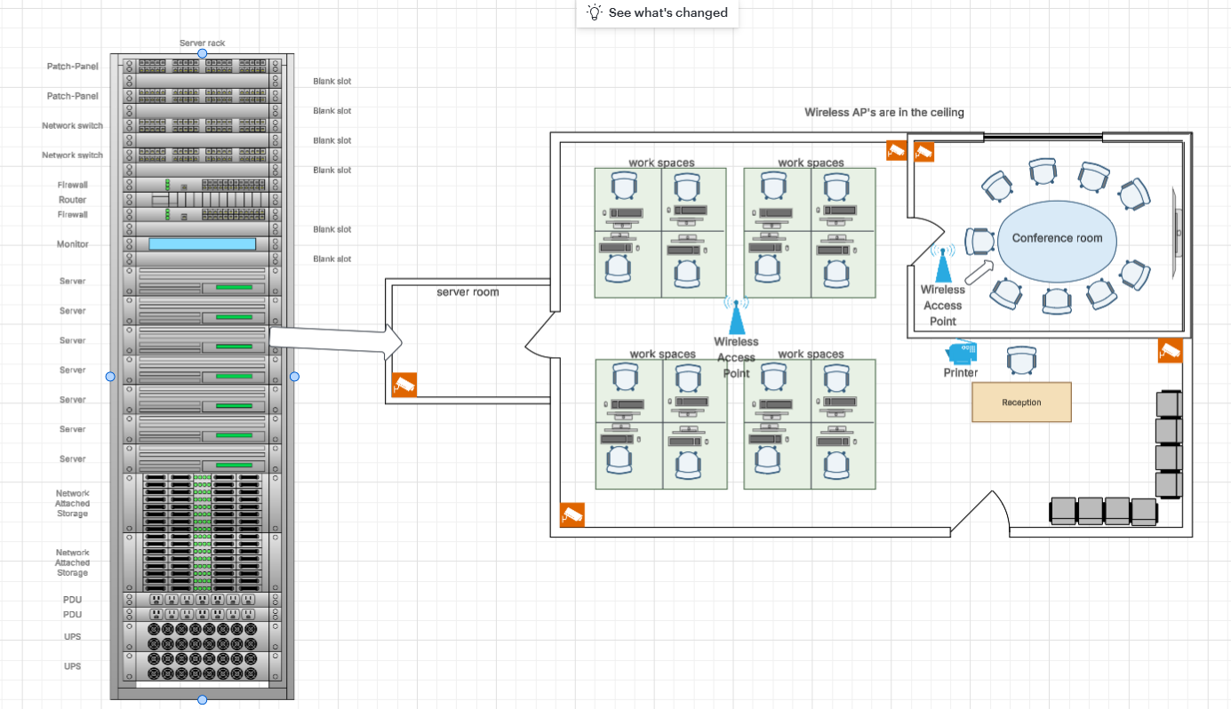
Square footage ~ 1000 square feet

Part 5

CybTech Network Planning (Section 5)
CybTech Network Planning
Kaden Donaldson · Systems / Security/Admin · Team 2
Where is the network closet?
CybTech's network closet is the server room on the west side of the office, with its door opening straight into the main work area. This spot keeps cable runs short to the workstation pods in the middle of the floor, the conference room, and reception. The office is one floor of about 1,000 sq ft, so one MDF is enough and no IDF is needed, since every cable run stays far under the 328 ft (100 m) limit for Ethernet.
The server room door stays locked, and a security camera inside watches the rack. Because the room holds 7 servers and storage, it gets its own power circuit and dedicated cooling, so the equipment does not overheat.
What devices go in it?
Everything is mounted in one full-height server rack, from top to bottom:
Device | Qty | Purpose
Patch panel | 2 | Every cable in the building ends here, labeled to match its wall jack or ceiling device
Network switch (managed, PoE+) | 2 | Connects all wired devices, powers the access points and cameras over Ethernet, and separates staff, guests, and camera traffic with VLANs
Firewall | 2 | Blocks threats and runs the VPN for remote access. The second firewall takes over if the first one fails
Router | 1 | Connects the office network to the internet
Rack monitor (console) | 1 | Let’s IT manage the servers directly from the rack
Server | 7 | Runs company applications, development and testing, and internal services

CybTech Network Planning (Section 5)
Device | Qty | Purpose
Network attached storage  (NAS) | 2 | File storage and backups, with the second unit holding a copy of the first
Power distribution unit (PDU) | 2 | Supplies power to every device in the rack
UPS (battery backup) | 2 | Keeps the rack running through short outages and protects against power surges

The blank slots between devices leave room to grow and help air flow through the rack.
How will cables run through the building?
The internet line enters the building and runs straight into the server room. All cables are Cat6, plenum rated, run as a home run from the patch panels to each device, with no daisy chaining.
Cables leave the server room through the ceiling and run above the drop ceiling on J hooks across the office.
The 4 workstation pods sit in the middle of the floor away from walls, so cables come down to each pod through a ceiling power and data pole. Each pole feeds the 4 desks in its pod.
The conference room, reception desk, and printer get drops that come down inside the walls to wall plates.
The 2 wireless access points and 5 security cameras mount on the ceiling and get power from the switches (PoE), so they need no outlets.
That is about 27 drops: 16 workstations, the reception desk, the printer, the conference room TV, 2 access points, 5 cameras, and 1 spare. Two switches and two patch panels leave plenty of room to grow.
Cables stay away from power lines and lights to avoid interference, and both ends of every cable are labeled so problems are easy to trace.

Part 6:
1. This week, my contribution to the assignment was creating the floor plan. As a group, I think we communicated well. I sent in a picture of the floor plan to our chat, asked if there was anything I should change and got responses quickly.
2. We didn’t really have any challenges, other than I think we could have started the assignment sooner. Also, the group wanted to do a call, but not everyone, including me, could make the time work.
3. My only concern moving forward is starting the assignments sooner. I like being able to get my assignments done earlier in the week instead of waiting till the due date to turn things in.

