Week 11 CYBR 2300
Pt. 1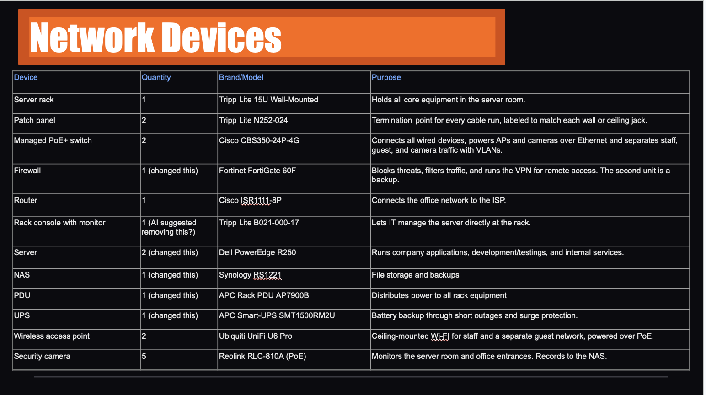
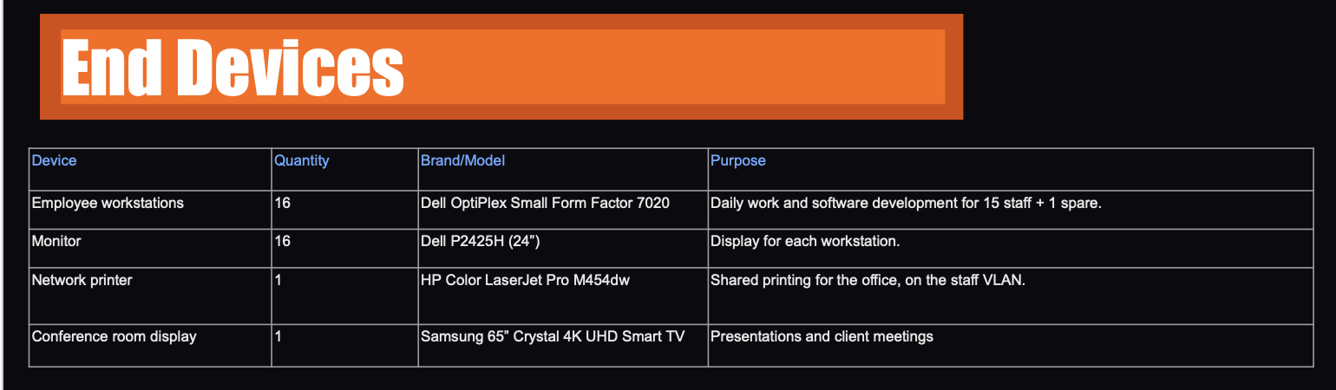
Pt.2
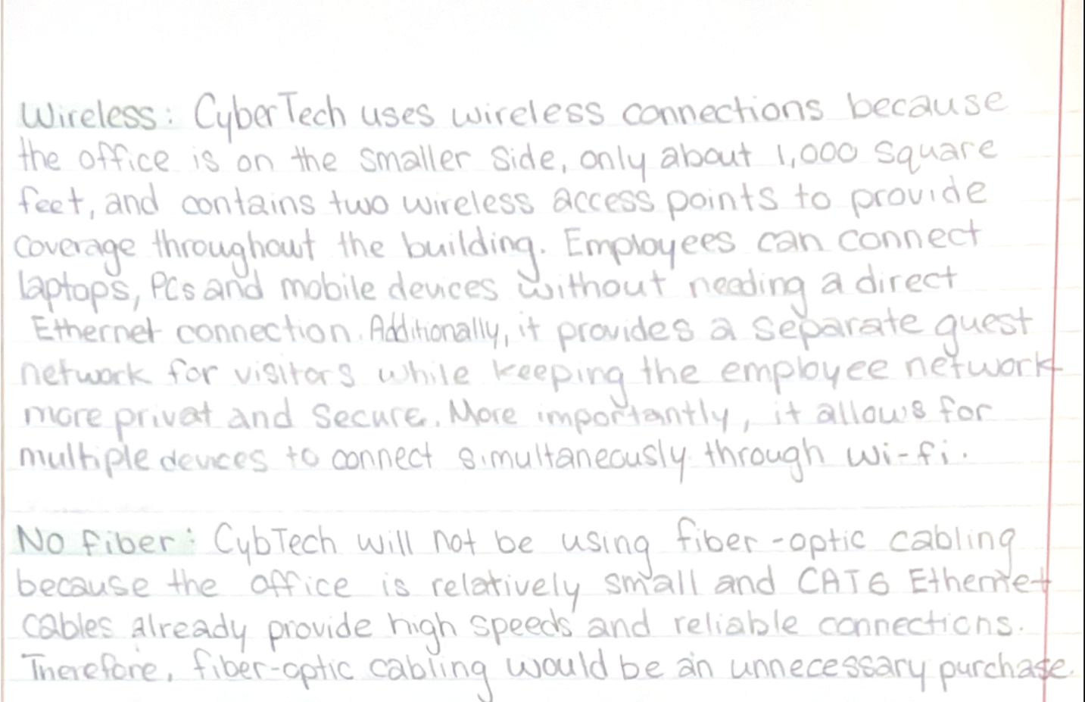

Pt. 3: Services and protocols
- DHCP
  - What it does
    - Dynamically assigns IP addresses to devices on the network.
  - Why our business needs it
    - We have employees who will be working on laptops that will likely come and go; using dynamic IP addressing protocols like DHCP reduces the load on the IT team by eliminating the need for them to manually assign IP addresses to devices.
- HTTPS
  - What it does
    - A network protocol that allows secure access to websites across the internet
  - Why our business needs it
    - Our employees will need to be able to access the internet, and HTTPS will allow for them to access websites through the network.
- FTP
  - What it does
    - Allows for secure file transfers between devices across the network
  - Why our business needs it
    - Our work will include software development for clients, multiple employees may be working on the same project in teams, in order for this to work the files must be accessible to all the employees working on the project, FTP in combination with a NAS will allow for easy access for both in-person and remote workers.
- SSH
  - What it does
    - Provides secure communication between devices and servers.
  - Why our business needs it
    - Like I mentioned earlier our business is one that will be developing software, and that software will be stored on an in-house server. SSH will allow our employees to have secure access to the files/projects stored on the server while maintaining encryption to protect the files and servers from attackers.
- TCP
  - What it does
    - Provides reliable packet delivery across the network.
  - Why our business needs it
    - Our business will be one that heavily relies on the network, file transfers, data transfer, remote access, etc. TCP ensures that the data reaches the intended recipient and when used in combination with internet protocols like HTTPS, it provides an additional layer of security for the network.

Pt. 4 Network Layout:
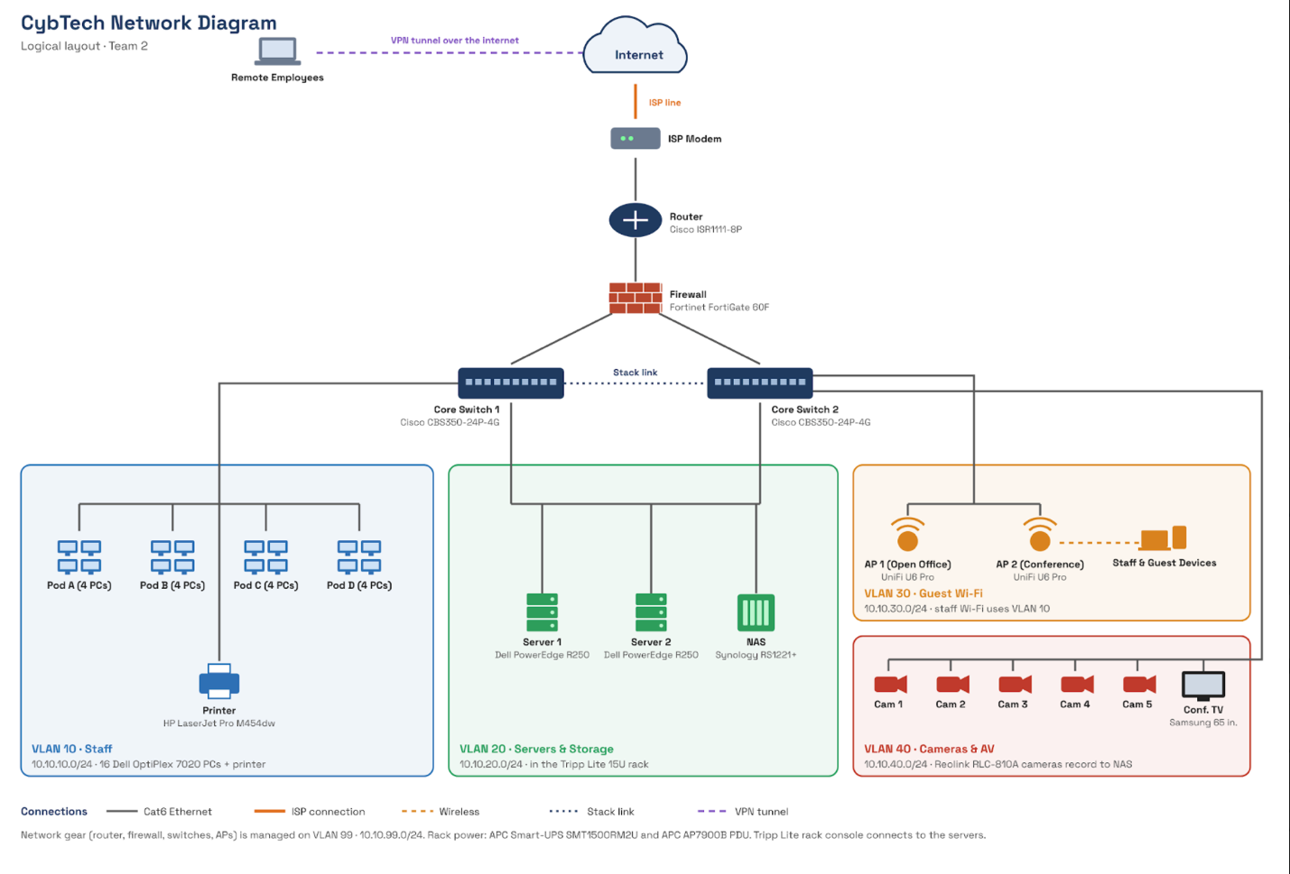

Pt. 5 Pricing and budget
CYBTECH PROJECT BUDGET & EXPENSES
1. NETWORK DEVICES
- Server Rack (Tripp Lite 15U Wall-Mounted, Qty: 1): $605.00
- Patch Panel (Tripp Lite N252-024, Qty: 2): $151.98 ($75.99 each)
- Managed PoE+ Switch (Cisco CBS350-24P-4G, Qty: 2): $1,562.50 ($781.25 each)
- Firewall (Fortinet FortiGate 60F, Qty: 1): $769.81
- Router (Cisco ISR1111-8P, Qty: 1): $1,199.99
- Rack Console with Monitor (Tripp Lite B021-000-17, Qty: 1): $588.99
- Server (Dell PowerEdge R250, Qty: 2): $1,980.00 ($990.00 each)
- NAS (Synology RS1221+, Qty: 1): $1,649.99
- PDU (APC Rack PDU AP7900B, Qty: 1): $953.59
- UPS (APC Smart-UPS SMT1500RM2U, Qty: 1): $1,060.00
- Wireless Access Point (Ubiquiti UniFi U6 Pro, Qty: 2): $318.00 ($159.00 each)
- Security Camera (Reolink RLC-810A PoE, Qty: 5): $499.95 ($99.99 each)
Network Devices Subtotal: $11,339.80

2. END DEVICES
- Employee Workstations (Dell OptiPlex SFF 7020, Qty: 16): $10,079.84 ($629.99 each)
- Monitor (Dell P2425H 24", Qty: 16): $2,799.20 ($174.95 each)
- Network Printer (HP Color LaserJet Pro M454dw, Qty: 1): $449.99
- Conference Room Display (Samsung 65" Crystal 4K UHD Smart TV, Qty: 1): $399.99
End Devices Subtotal: $13,729.02

3. MEDIA & CABLING
- CAT6 Plenum (CMP) 1,000ft Bulk Cable (Qty: 2): $423.98
- CAT6 Patch Cable 10ft, 10-Pack (Qty: 2): $73.96
- CAT6 Patch Cable 1ft, 24-Pack (Qty: 2): $80.96
- CAT6 Keystone Jacks, VCE, 25-Pack (Qty: 2): $51.98
- Ethernet Wall Plates, VCE 1-Port, 10-Pack (Qty: 1): $9.99
- J-Hooks, 50-Pack (Qty: 1): $39.97
- Cable Ties and Labels, Reusable, 70-Pack (Qty: 1): $14.99
- Cable Tester (Klein Tools LAN Scout Jr. 2, Qty: 1): $59.97
Media Subtotal: $755.80

Hardware & Media Total: $25,824.62

4. SOFTWARE LICENSING (16 USERS)
- Microsoft 365 Business Standard ($14.00/user/mo annual commitment): $2,688.00/yr
(Alternative - M365 Business Premium w/ Intune & Defender: $4,224.00/yr)

5. ANNUAL SALARIES & PERSONNEL
- Software Development Department ($395,000 total)
* Ethan Smith - Lead Software Engineer: $95,000
* Software Developers (4): $300,000 ($75,000 each)

- Marketing & Sales Department ($235,000 total)
* Kelsie Sampson - Marketing & Sales Lead: $70,000
* Sales Representatives & Marketing Associates (3): $165,000 ($55,000 each)

- IT & Network Security Department ($275,000 total)
* Connor Okey - Network Engineer: $80,000
* Kaden Donaldson - Systems/Security Administrator: $75,000
* IT Support Technicians (2): $120,000 ($60,000 each)

- Project Management Department ($135,000 total)
* Ty Burningham - General Manager: $85,000
* Administrative Assistant (1): $50,000

Total Annual Salaries: $1,040,000.00

GRAND TOTAL (Hardware + Media + M365 Standard + Annual Salaries): $1,068,512.62
Pt. 6
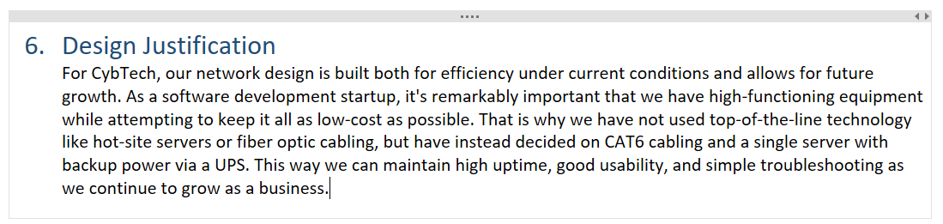
Pt. 7
My contribution this week was completing the budget and pricing part of the assignment. I also contributed to communicating early about what parts of the project each of us would fulfil.
A challenge we faced was making sure all of our parts fit together correctly. We had some minor and some not-so-minor inconsistencies, but we all worked together to complete the project properly.
We still need to iron out our minor inconsistencies within our presentation slides, as well as fix some of the inconsistencies from our last assignment.

