This screenshot is of all the pings working from PC0
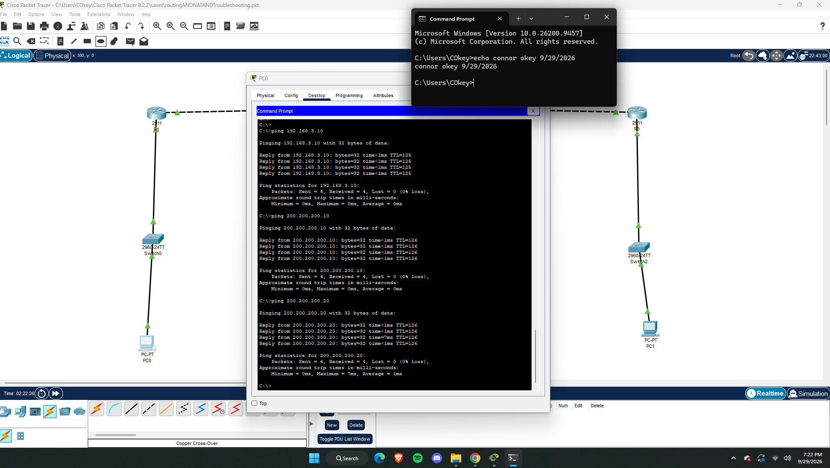
This is the Topology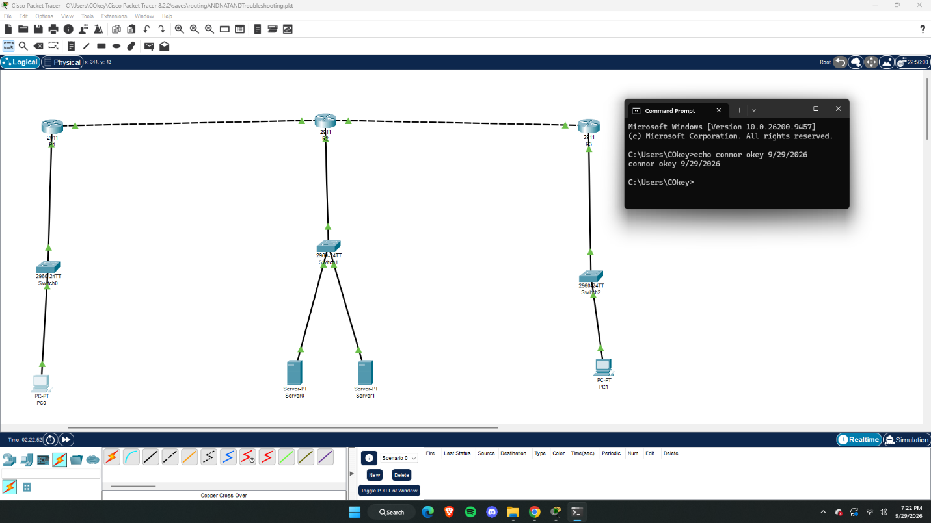
This is proof that the website is accessible from PC0 and server0.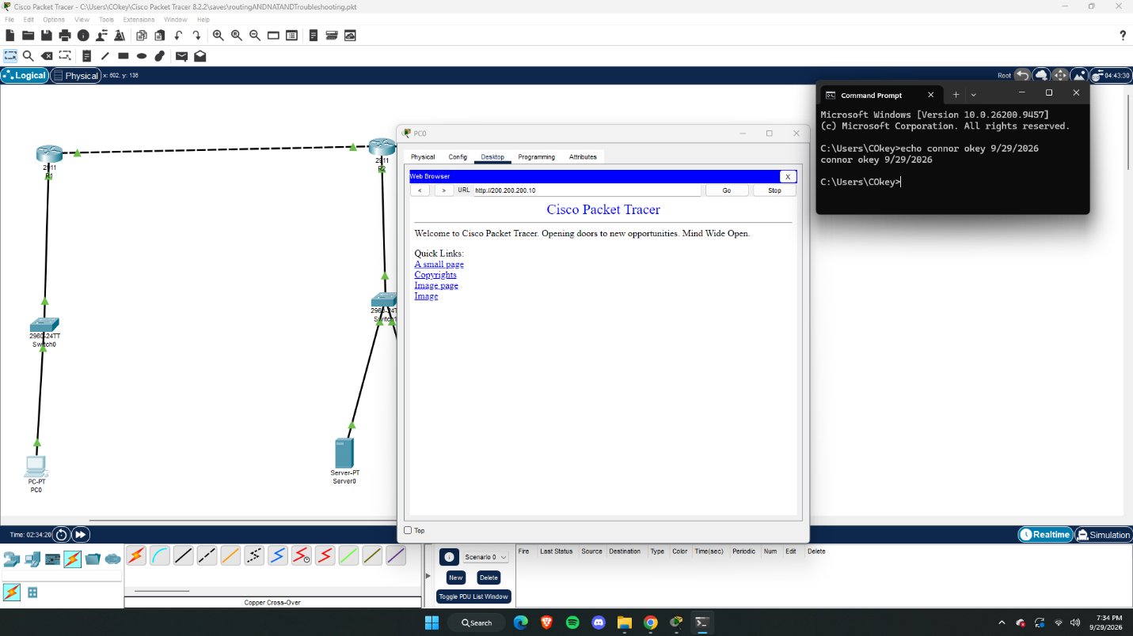
This is the screenshot of the ping not working after removing the route of PC1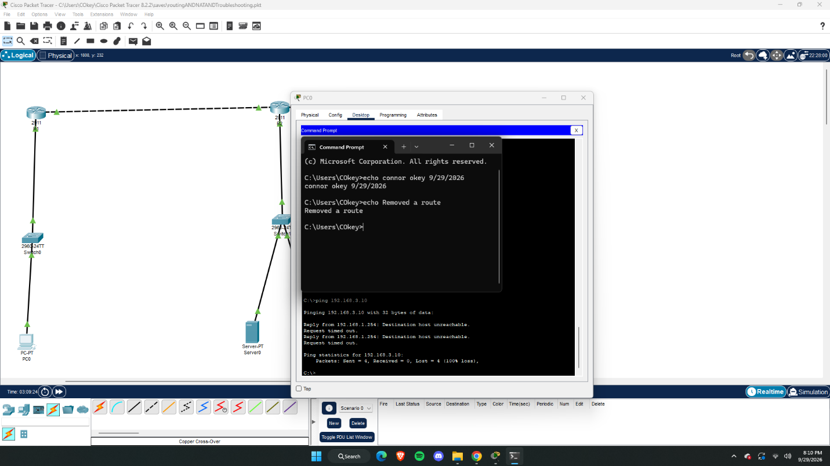

- What stopped working?
When I removed the route IP of PC1, PC0 couldn’t ping PC1 anymore.
- Why did it stop working?
Sending the ping request made it to PC1 because the routers forward the request to PC1. But for PC1 to reply it checks for PC0’s network but since the route was removed it cant find how to reach PC0’s ping and it times out. A ping is 2 way communication between devices.
- What do you THINK caused the issue?
Removing the route from PC1 prevented it from sending data, as it no longer had a path to communicate back with. Since it cant communicate back the ping times out.
- Did it never work? What do you think was the issue?- If you did not get it to work, you must talk way more on your issue. I would try and it to work then break it. Then never getting it to work.
I got it to work after about 5 hours and a couple restart’s. I think one of my main issues was not keeping the IP addresses straight, so I kept mixing them up which kept anything from working. That and keeping all the Ethernet plugs straight was also confusing.

- What type of routing did you configure?
Static and Default routing is what I configured.
- Why did the network fail before routing was added?
The routers cannot forward any information outside of their directly connected networks. This is because LAN uses Address resolution protocol to find the addresses of other devices. If they aren’t directly connected, then they can’t be accessed without routing.
- What does a default route do?
This is the last resort to send information if the original IP address cant be located. Information that is being requested in sent to the default route, the default route then sends the data to the device requesting it.
- What is the difference between static routing and dynamic routing?
Static routing is manually configured by an admin. A static route also never changes unless it is manually changed. A dynamic route is automatically built. A device can receive a different dynamic route when the network changes.
- What is NAT and why is it used?
NAT is what translates private and unregistered IP addresses into Unique IP addresses. Since IPv4 addresses only can only generate 4.3 billion different IP addresses, there wasn’t enough IP addresses for what was being demanded. So NAT allows multiple people to use the same IP address.
- What is the difference between NAT and PAT?
The amount of Private IP addresses to public. NAT is 1 to 1 public and private addresses. PAT allows multiple private IP addresses to 1 public IP address.
- What part of this lab was most confusing and why?
Configuring the IP addresses and the routes was most confusing for me because I’m still getting the hang of using Cisco, I had to resort to AI for help in getting the routes because little problems would come up and I didn’t know how to fix them.
- What issue did you run into and what do you THINK caused it?
The main issue I ran into was remembering which ports the cords were plugged into. My first try on the assignment, the routers I picked didn’t have enough ports all of the cords that needed to be connected. This was super frustrating to figure out that all I had to do was pull the modules from the left side of the physical tab and put them in the router. Which presented its own set of problems later when I was configuring the IP addresses. Ultimately what I think caused the problem was my fear of messing things up so I would just do barely what I needed to and not do anything that I didn’t know would absolutely work. So I need to not be afraid of breaking the program because its better I break it now than during a job and causing a bunch of real world problems.

