Asset Management with Snipe-IT
Connor Okey

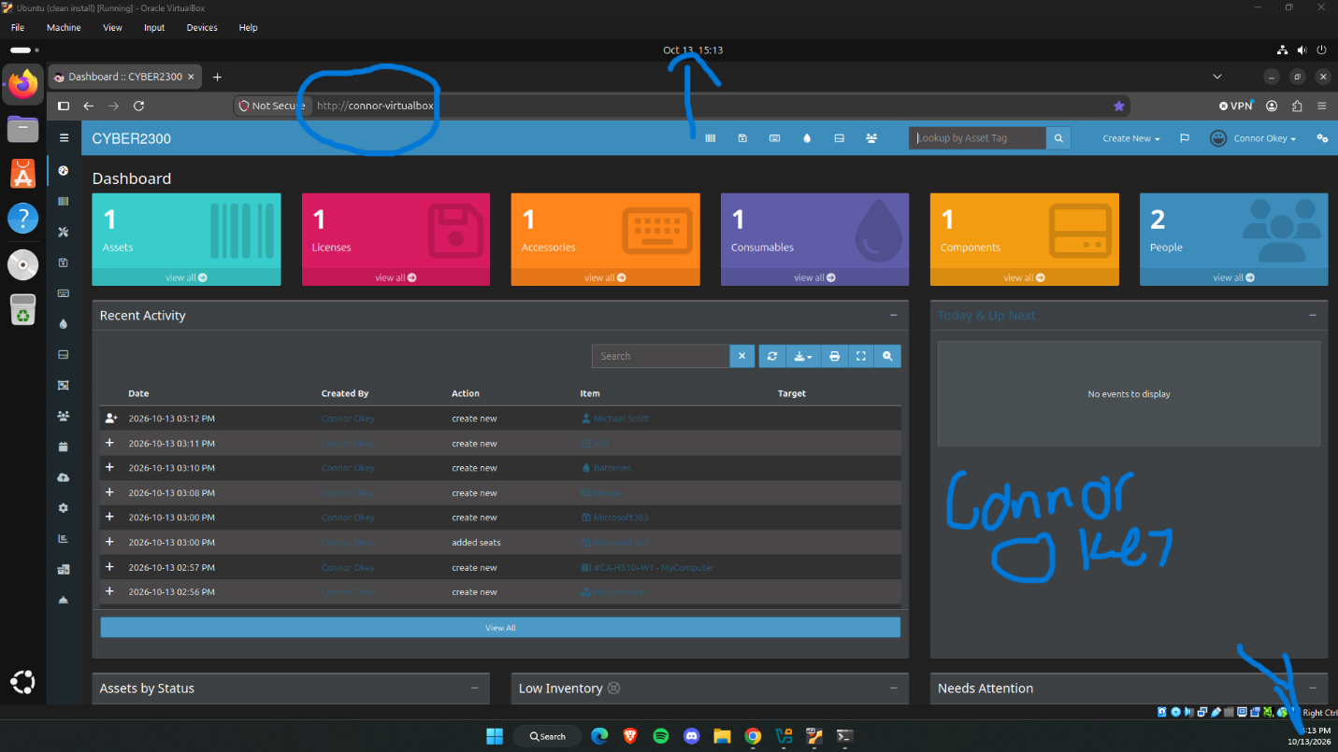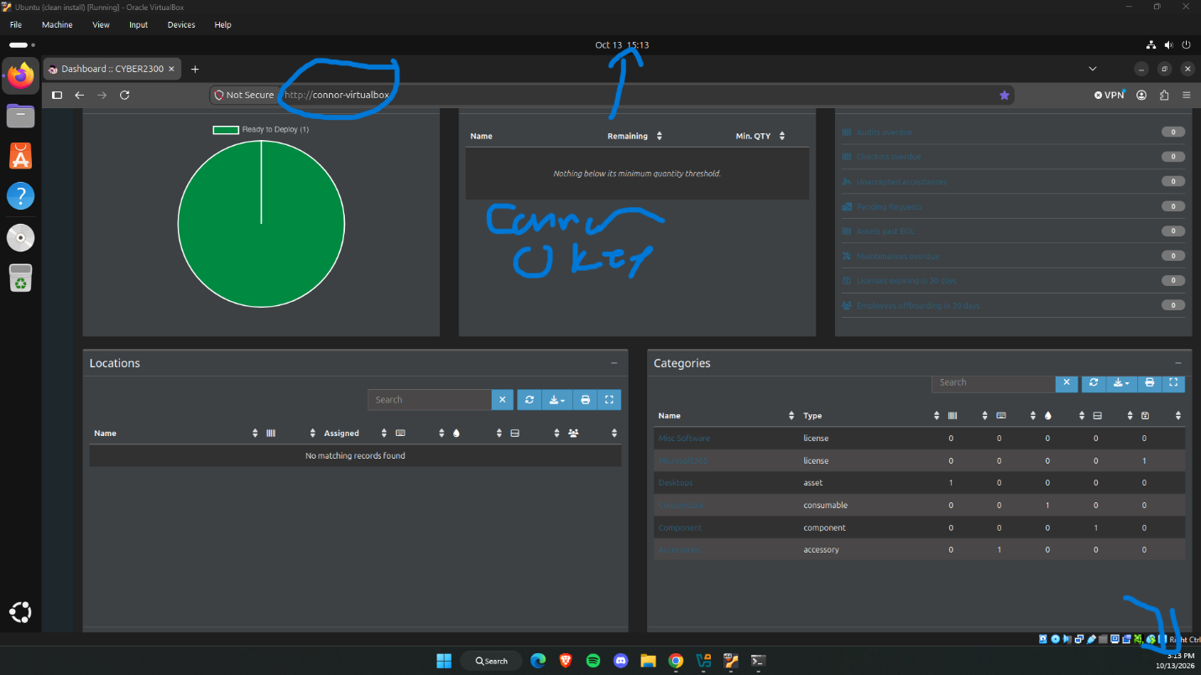

- How do you feel about the software?
- Why a company would track it
- What problem it solves

Asset:
This software is straightforward and easy to understand even for someone that has never used a system like Snipe-IT before. Creating a new asset was confusing at first because I didn’t know how to create a category, so I was poking around the modules and eventually learned how. The system requires you to enter an asset tag, model and the status of an asset when you create it, so it’s simple to create a new asset. A company would track assets to keep track of who currently possesses a certain item. This would help to track a device if it for example got a virus or there was some kind of data breach. This would also prevent people from stealing company property.
License:
A license was simple to add to the system, all that was needed was a name, category, number of seats and a start date. Snipe-IT makes it clear between the total license seat count and the individual users. With this software you can track the number of open seats, and expiration dates. A company would track licenses to make sure they aren’t paying for more than is required of them.
Accessory:
Snipe-IT makes it super easy to see who an accessory is checked out by, the total number of an accessory, the total number of available accessories, as well as their location. A company would track accessories to see what accessories people like using so they can potentially buy an improved version of that accessory. They would also keep track of these to see who is using what devices, if a certain department uses more accessories over another. Overall, they would keep track of things they need to replace. This helps companies maintain a normal number of accessories instead of overbuying one accessory. It also makes it clear what accessories are getting low in count.
Consumable:
Snipe-IT makes it clear that consumables are items that don’t need to be checked back in once they are handed out. It says who checked out and when they checked out an item as well. A company would need to keep track of these to make sure that the minor consumable items that keep things running smoothly like batteries are kept track of them so they can be restocked when the stock gets low. This helps prevent people from taking things from each other in the workplace, or like taking batteries out of one device to put into another.
Component:
A component isn’t attached to a certain user; they are assigned to a device. This makes it easier to keep track of what information might be kept on what computer. It can help differentiate between departments if they use different types of hardware as well. Keeping track of components is important that way a company knows what computers have, like if a computer needs a new SSD, they can see what computers have new SSDs already. This helps a company make sure they have spares so if a certain piece of hardware shorts out they can replace it without having to order and wait for the replacement to arrive.
Additional User:
All the asset creation revolves around the user. When an asset is checked out it is attached to a user. Snipe-IT makes it easy to see what users’ administrators are, the departments of a user, where they are located and keeps a record of everything a user has checked out. A company would need to keep track of users to make sure they aren’t accessing items that they aren’t authorized to. This helps to make sure people aren’t stealing any assets, given they can see what items have been checked back in.

- Why is asset management important?
It’s important to keep track of assets that employees use so there is a digital record of who checked out what asset. It also is important to keep track of the number of assets a company has so if they are running low or need to update different items, they can see specifically what needs to be restored or replaced.
- Why would a system like Snipe-IT be helpful?
These kinds of systems are helpful because this is an easy way to keep track of assets. A company now doesn’t need to develop its own way of tracking things because there already is a way. Snipe-IT is simple and easy to use, its very to understand the data that is contained within its system.
- Why is documentation important?
Its important to keep track so if problems arise with theft, or if a piece of hardware needs to be updated, it’s easy to see what it is that needs the update. Or if someone is not returning assets there is actual documentation instead of accusing people without any evidence.

