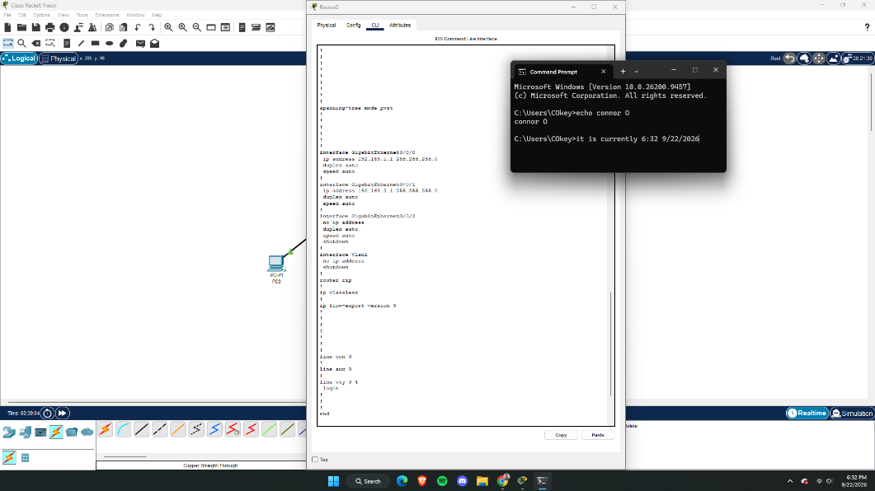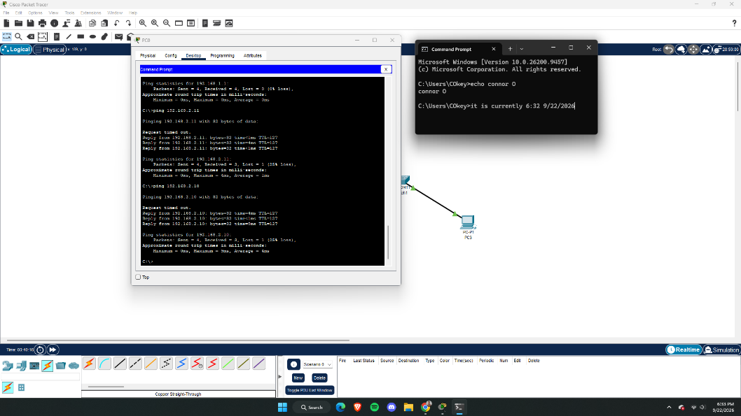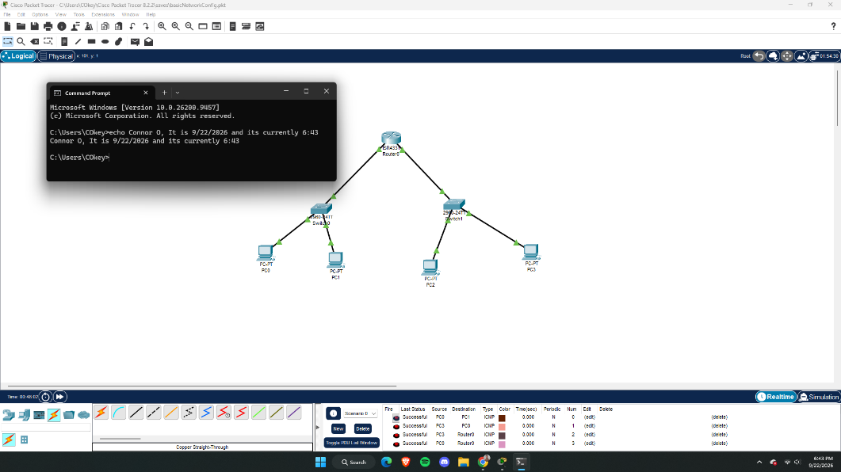

- What IP addressing scheme did you use?
For the PC’s 1-4 their IP’s were:
192.168.1.10 255.255.255.0
192.168.1.11 255.255.255.0
192.168.2.10 255.255.255.0
192.168.2.11 255.255.255.0
- How did you divide your networks (subnets)?
I divided the networks into 192.168.1.1 for the first network which was connected to the GigaEthernet0/0/0, and 192.168.2.1 for the second network which was connected to the GigaEthernet0/0/1.
- What did you label your devices (PCs, router, etc.)?
I left them as the default name that Cisco gave them. Router was left as Router0, Switch0 and Switch1, PC0-PC3.
- What commands did you configure on the router?
This first chunk of code was to configure the first network.
enable
configure terminal interface
GigabitEthernet0/0/0 ip address 192.168.1.1 255.255.255.0
no shutdown
exit

This chunk of code was to configure the second network.
interface GigabitEthernet0/0/1
ip address 192.168.2.1 255.255.255.0
no shutdown
exit
exit
write memory
(Running the commands was confusing for me so I did use AI to help me configure the
Router)
- What is a default gateway?
A default gateway is configured in the router, information being s
- Why was it required for your PCs to communicate with another network?

