Agile Product Portfolio
Software Engineering Group Coursework

<Project Title>

Group number: <#>

Student ID | Student Name
2770406 | Wenqi Li
2844827 | Siyu Chen
2919147 | Zhenghan Zhang
2933017 | Chen Zou
2588695 | Tongming Zheng

Planning (20%)
Conceptual model
Personas Product Vision User Stories Features Prototype Tests

1.1 Personas
Persona Name | Role/User type | Goals | Pain Points | Related User Stories (IDs)
Li Hua | New Master's Student (International) | To stay organized and adapt quickly to the UK academic system. | 1. Information Fragmentation: Deadlines are scattered across Canvas and emails, leading to missed tasks.  2. Context Confusion: Struggles to identify the weight and priority of notifications in an unfamiliar environment. | S1, S2
Lucy | Part-time Working Student | To efficiently balance job shifts with academic responsibilities. | 1. Low Visibility: Lacks a clear, urgency-based view to make quick decisions during limited study breaks.  2. Manual Errors: High risk of missing dates when tracking multiple modules manually in paper notebooks. | S2, S3
Note: You need to have at least two personas. The personas should be used to justify the product vision and user stories.

1.2 Product Vision
FOR (target customer) university students,
WHO (statement of the need or opportunity) are facing multiple assignment deadlines and struggling with fragmented access to wellbeing support,
The (PRODUCT NAME) is a (product category)Uni-Focus (wellbeing-integrated workload management app),
THAT (key benefit, compelling reason to buy)aggregates all academic deadlines, visualizes workload intensity through color-coded alerts, and embeds one-tap access to curated wellbeing resources,
UNLIKE (primary competitive alternative)paper notebooks or basic calendar apps,
OUR PRODUCT (statement of primary differentiation)delivers proactive, context-aware visual warnings for burnout risk and seamlessly connects academic task management with mental health support in a single, ethical platform.

Note: This product vision should be derived from the defined personas and guides backlog prioritisation and design decisions.

1.3 Meeting Logs (Appendix)

Story Writing (20%)

2.1 Product Backlog and User Stories
Story ID | Feature (epics) | Story Title | User Story | Acceptance Criteria | Priority (Must / Should / Could) | Justification of prioritisation /Trade-off | Story Owner
S1 | Task Entry | Manual Deadline Entry | As a new international student, I want to manually input my assignment name and its due date, so that I can centralize scattered deadlines in one place. | (Normal) Given user is on the dashboard, When they input a valid name and a future date, Then the task is saved to SQLite.  (Exception) Given an invalid or past date, When the "Add" button is clicked, Then a Flash Error Message must appear and data must not be saved. | Must | Core behaviour tracking; addresses the "information fragmentation" pain point identified in Persona Li Hua. | Siyu  Chen
S2 | Dashboard | Urgency Visualizer | As a student, I want the system to automatically sort tasks by date and turn them red if due within 24 hours, so that I can focus on the most urgent deadlines first. | (Normal) Given a task list is loaded, When a task's deadline is within 24 hours of current system time, Then the task background must turn Red.  (Processing) When multiple tasks exist, Then they must be automatically sorted by deadline in ascending order. | Must | Primary differentiation; provides the visual priority view promised in the Product Vision. | Siyu  Chen
S3 | Task Management | Completion Tracking | As a busy student, I want to mark tasks as completed, so that I can gain a sense of achievement and keep my dashboard clean. | (Normal) Given a pending task, When the "Mark Done" checkbox is clicked, Then the status in SQLite updates to 'Done'.  (Persistence) When the page is refreshed or re-logged, Then the task must remain greyed out and in its 'Done' state. | Should | Necessary for workflow and "Lucy's" goal of progress tracking, but secondary to core alerts. | Siyu  Chen

2.2 Sprint 1 Summary
Item | Sprint 1 (Weeks2-6)  Discovery, MVP design and partial implementation | Sprint 2(Weeks7-11)  Refinement, testing & evaluation
Planned stories (Plan - P) | S1, S2
Delivered stories (Done - D) | S1
Stories not completed (No - N) | S2
Key change planned for Sprint 2 | Simplify UI | N/A

Note: Stories marked “P” or “N” should be reflected upon in Sprint learning or retrospectives.

2.3 Group contribution and Individual contribution (Appendix)

3. Design (20%)

3.1 Design Models and Evidence
The following table summarises the core Task attributes and methods reflected in the domain model.
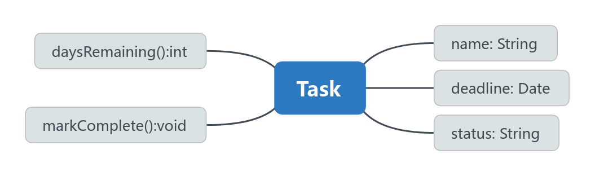

Attribute | Type | Purpose
name | string | Stores assignment name
deadline | date | Stores deadline
status | string | "Pending" or "Done"

Method | Purpose
is_urgent() | Returns True if deadline is within 24 hours
mark_done() | Updates task status to "Done"

3.1.1 Domain Model – Class Diagram (D1)
In Sprint 2, the domain model was extended to support multi-user task ownership and persistent task management.
Two core entities were defined:
User
- id: Integer (Primary Key)
- username: String (Unique)
- email: String (Unique)
- password_hash: String
- Task
- id: Integer (Primary Key)
- name: String
- deadline: DateTime
- status: String ("Pending" / "Done")
- user_id: Integer (Foreign Key → User.id)
Core methods in Task:
- is_urgent(): Returns True if the deadline is within 24 hours
- mark_done(): Updates the task status to "Done"
Relationship:
- One User can own multiple Tasks (1-to-many)
- Each Task belongs to exactly one User
- This design ensures
- user-specific task isolation
- persistent storage
- scalability for future extensions
It also links domain logic directly to the implemented database structure.

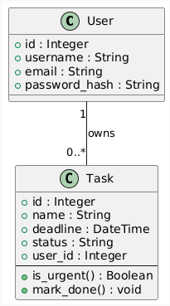
Figure D1. Class diagram showing User–Task relationship

3.1.2 Sequence Diagram – S1 Manual Task Entry (D2)
Actors involved:
User → Frontend → Backend → Database
Flow:
- User enters task name and deadline.
- Frontend sends POST request.
- Backend validates form input.
- Backend creates Task object.
- Backend saves object into database.
- Database confirms persistence.
- Backend redirects to dashboard.
- Updated task list is rendered.
- This diagram demonstrates full end-to-end flow from UI interaction to persistent storage.

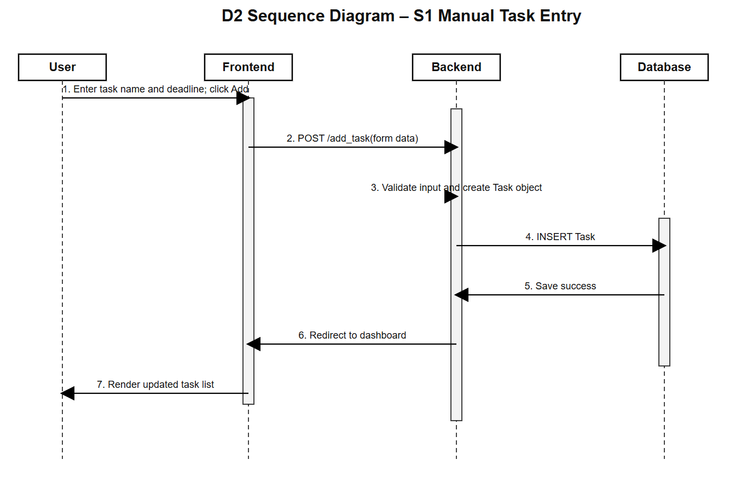
Figure D2. Sequence diagram for S1 manual task entry

3.1.3 Sequence Diagram – S2 Urgency Visualizer (D3)
Actors involved:
User → Frontend → Backend → Database
Flow:
- User loads dashboard.
- Frontend sends GET request.
- Backend retrieves tasks ordered by deadline.
- For each task, is_urgent() is executed server-side.
- Backend returns computed result.
- Frontend renders urgent tasks in red if due within 24 hours.
Key Design Insight:
- Urgency logic is executed on the server side to ensure consistency and to prevent client-side manipulation.
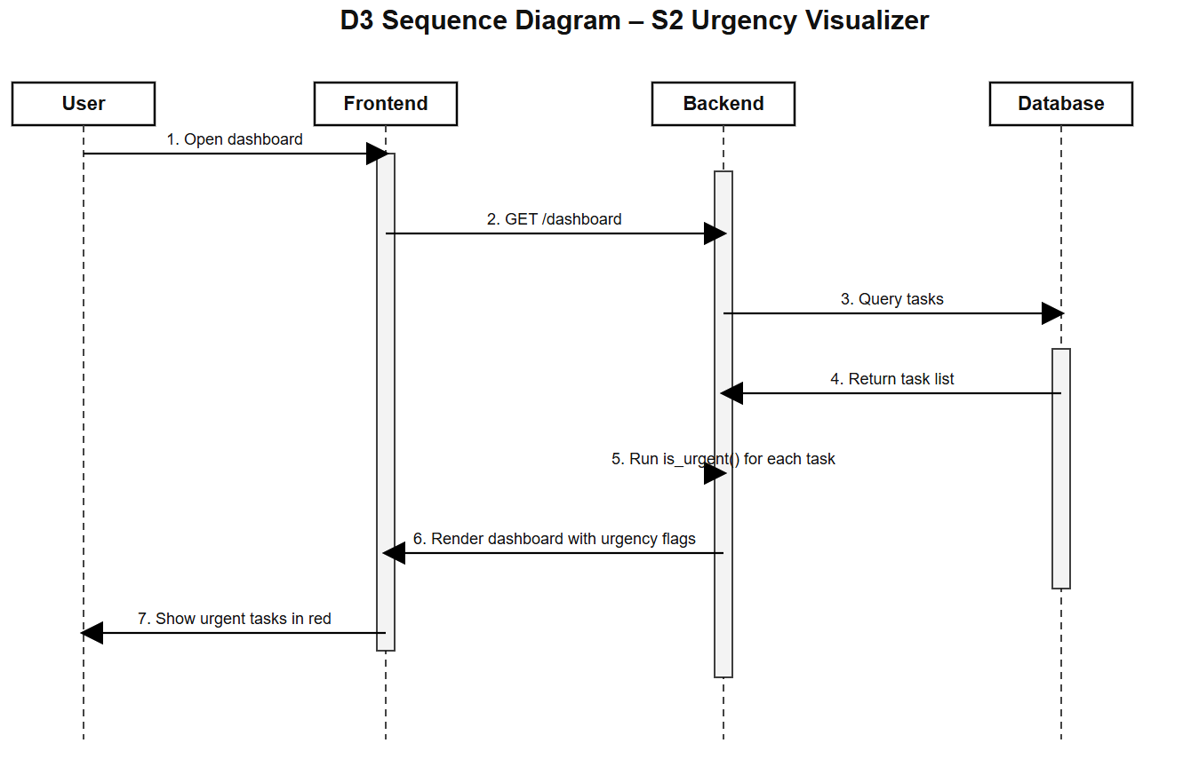
Figure D3. Sequence diagram for S2 urgency visualizer

3.1.4 Sequence Diagram – S3 Completion Tracking (D4)
Actors involved:
User → Frontend → Backend → Database
Flow:
- User clicks “Mark Done”.
- Frontend sends POST request.
- Backend retrieves task by ID.
- Backend executes mark_done().
- Database commits update.
- Backend redirects to dashboard.
- Frontend re-renders task in grey to reflect updated status.
- This ensures real-time synchronization between database state and UI presentation.

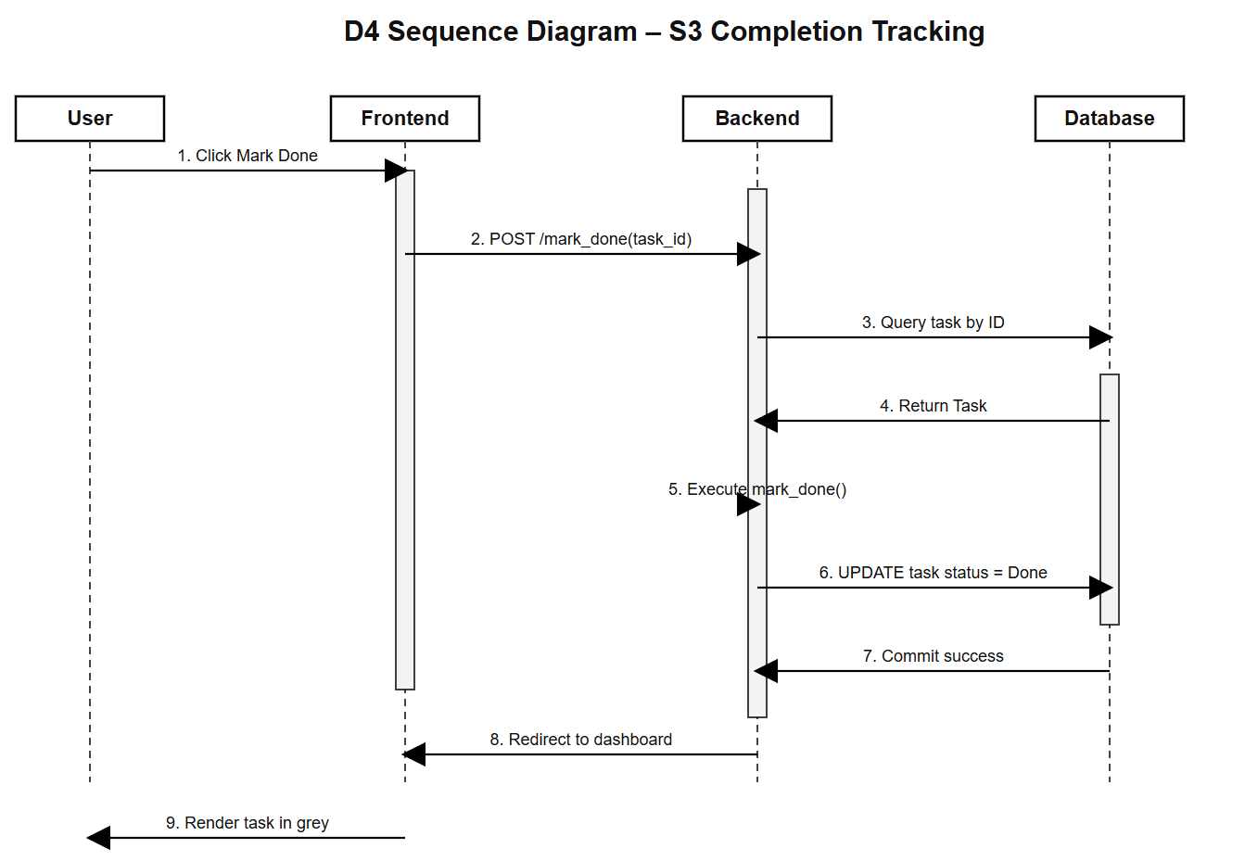
Figure D4. Sequence diagram for S3 completion tracking

3.1.5 Design Decision Rationale
During Sprint 2, the system design was refined from a conceptual prototype into a more structured MVC-based implementation.
A key design decision was to move urgency evaluation into the backend through the is_urgent() method inside the Task class. This ensured that urgency was treated as business logic rather than presentation logic. By placing this rule in the server-side model layer, the system achieved clearer separation of concerns in line with the MVC principle.
This decision also improved reliability. If urgency were calculated only in the frontend, users could potentially manipulate client-side behaviour or bypass visual rules. Server-side evaluation ensures that all users receive consistent urgency results based on the same domain logic.
In addition, encapsulating completion behaviour in the mark_done() method improved object-oriented integrity. Instead of scattering update logic across routes or templates, task state changes were managed within the domain entity itself. This made the design easier to maintain and more extensible for future features.
The relationship between User and Task was also formalised as a one-to-many structure, which supports multi-user ownership, persistent storage, and clearer responsibility boundaries in the system.
Overall, these design decisions demonstrate the transition from Sprint 1 conceptual modelling to Sprint 2 functional integration, where system behaviour is consistently supported by domain structure, backend logic, and persistent data management.

Diagram | Type (Class / Sequence) | Purpose | Related User Stories  (Story IDs) | Design decision rationale
D1 | Class | Domain Structure | S1, S2, S3 | The class diagram formalises the domain structure of the system. The User–Task one-to-many relationship supports multi-user ownership and persistent data isolation. The Task entity contains both state and behaviour, including is_urgent() and mark_done(), which aligns the model with implemented backend logic.
D2 | Sequence | Manual Task Entry Workflow | S1 | The S1 sequence diagram was used to represent the full end-to-end workflow for manual task entry, showing how form input is validated, transformed into a Task object, stored in the database, and rendered back to the user.
D3 | Sequence | Urgency Evaluation and Display | S2 | The S2 sequence diagram highlights that urgency logic is executed server-side through is_urgent(), which supports MVC separation of concerns and prevents client-side manipulation of business rules.
D4 | Sequence | Task Completion Update Flow | S3 | The S3 sequence diagram demonstrates that completion tracking is not only a visual change but also a persistent backend update. This ensures consistency between database state and interface output.

Note: You are not penalised for modifying or discarding models if justified by learning.

3.2 Stories and Evidence
For each story marked as “Done” in Sprint 1 must be mapped to at least one test.

Story ID | Evidence Type (UML Diagram / Git Commit ID(s) / Test Evidence: testcases / their results) | Reference (file / commit / screenshot) | Acceptance Criteria Met (Yes / Partially / No) | Notes  (if partially completed)
S1  Manual Deadline Entry | Implemented backend-driven validation to ensure system robustness. The screenshot shows the Flash Message triggered when entering an invalid date, preventing incorrect data from reaching the SQLite database. | 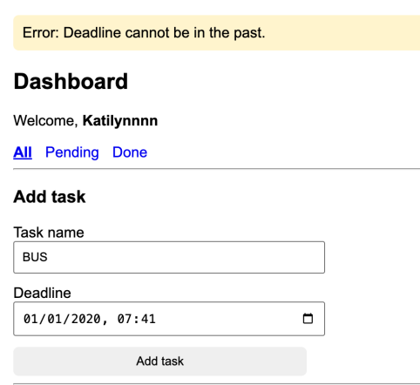 | Yes | Task.name and Task.deadline support manual task creation, validation, and storage.
S2  Urgency Visualizer | Features the Urgency Visualizer. Tasks within 24 hours are automatically calculated by the backend (is_urgent logic), rendered in Red, and dynamically sorted to the top for better priority management. | 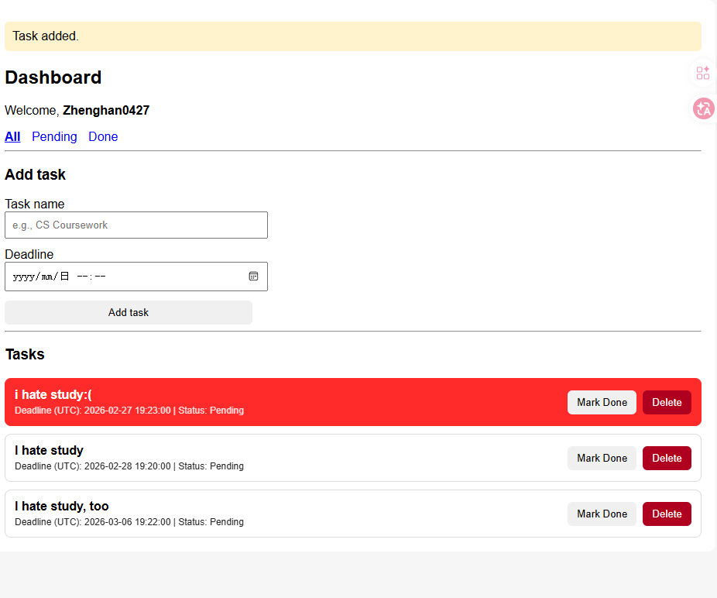 | Yes | The is_urgent() method enables backend urgency evaluation for red highlighting of tasks due within 24 hours.
S3  Completion Tracking | Demonstrates full-stack integration. Marking a task as "Done" updates the SQLite state permanently. This persistence is verified by refreshing the page, where the task correctly remains in its completed state. | 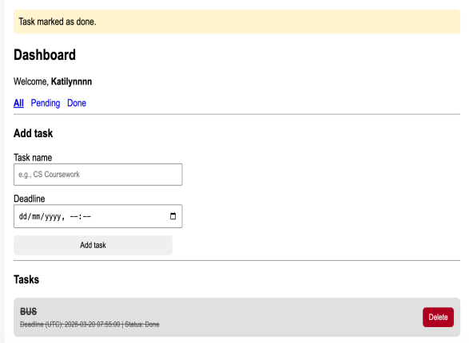 | Yes | Task.status and mark_done() support persistent completion tracking and greyed-out visual feedback.

Note: If a story is marked “Done” without evidence, it will not be treated as complete.

Conclusion: By Sprint 2, all three stories had been integrated into the working prototype through front-end, backend, and database interaction.

4. Working Prototype and Implemented Features (20%)
Submit a short video (3-5 minutes) that demonstrates the implementation of 2 core end-to-end features + refinement of Sprint 1 feature. Each demonstrated feature must be traceable to user stories and acceptance criteria. The video should be submitted under the “Product Video” assignment on Canvas.

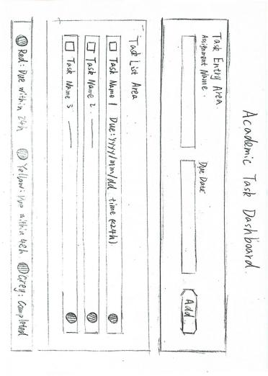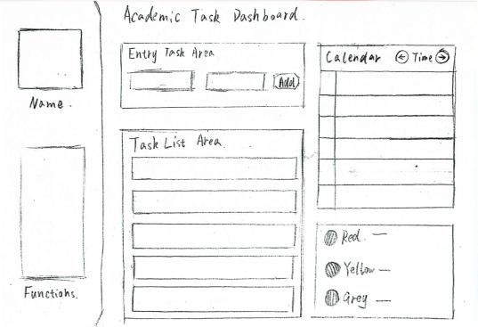
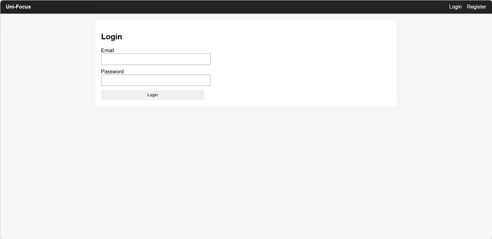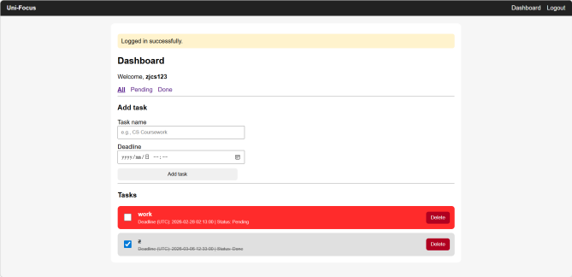
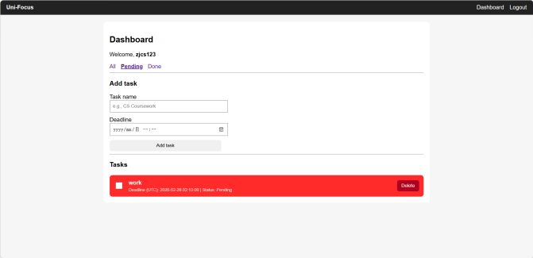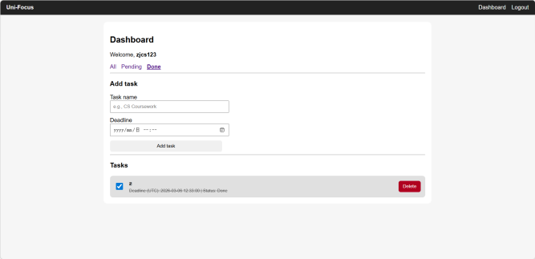
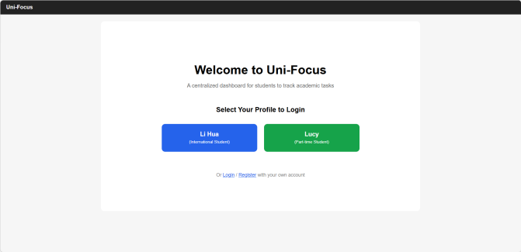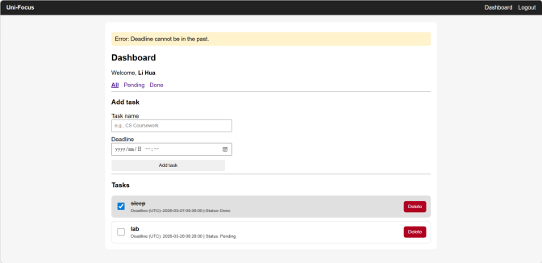

5. Testing and Evaluation (20%)

Story ID | Acceptance Criteria | Test Performed | Outcome (Pass / Partial / Fail) | Accessibility Checked | Notes  (If partially tested)
S1 | Task saved | Boundary Value Analysis (BVA): Set deadline to 23h 59m from now. | pass | Yes (Focus management) | Exception Flow: Backend validation successfully caught the invalid date and triggered a Flash Message.
S2 | Task turns red within 24h | Boundary Value Analysis (BVA): Tested at the 23h 59m threshold to verify the is_urgent boolean logic. | pass | Color contrast | Processing: Verified backend is_urgent() logic returns True at the 24h threshold and triggers CSS.
S3 | Task marked as "Done" | Persistence Test: Marked task as 'Done' and performed page refresh and re-login to verify database state. | pass | Visual state | Data Integrity: Confirmed SQLite status field updated to '1'; state remains consistent across sessions.

Note: You may have more than one test per story. At least one test per story is required.

APPENDIX
- Group Contribution

Story ID | Story Title | Predicted workload in hours | Actual workload in hours | Status  (TODO/In progress / DONE) | Owner name
xS1
S2
S3
S4
S5

- Individual Contribution

Team member | Role (s) | Stories Owned | Evidence (Git / Diagram / Test) | What could have been improved with more time?
StudentName_1 | Backend | S1, S3 | commit a3f9c2, D1

Meeting Logs
You are required to schedule at least 2 meetings with your Customer (TA).

Meeting ID | Team attendees | Customer (TA’s name) | When | Agenda items | Actions and Owner
M1 | StudentName_1, StudentName_2  ….

Meeting Diary for Team meetings
Meeting ID | Team attendees | When | Agenda items | Actions and Owner
M1 | StudentName_1, StudentName_2  ….

Note: Meeting logs are not marked directly and are used only as supporting evidence.

