conr-template

Your Name

2024-02-21

This document has had minor adaptations from the “officedown” package.

**Table of contents**

1.1. Sections 3

1.2. Tables 3

1.3. Figures 4

1.4. Reference 4

**List of figures**

**Figure 1:** A boxplot 4

**List of tables**

**Table 1:** caption 1 3

## Sections

Lorem ipsum dolor sit amet, consectetur adipiscing elit. Nulla eu pulvinar arcu, quis aliquam dui. In at cursus ante. Vestibulum non sagittis lacus. Duis vitae iaculis dui. Vivamus tempor, nibh ut pretium tempus, enim lorem dignissim quam, at euismod massa magna at magna. Sed facilisis dapibus diam nec volutpat. Maecenas facilisis dapibus egestas. Curabitur dignissim pharetra pulvinar. Nunc bibendum elit sed cursus congue. Curabitur ligula quam, iaculis faucibus orci quis, vestibulum lobortis lectus. Suspendisse fringilla nisl pulvinar, laoreet tellus sed, sollicitudin tortor. Donec consequat congue erat in iaculis. Curabitur luctus tellus ut turpis iaculis, nec laoreet ligula scelerisque.

## Tables

**Table** **1:** caption 1

| mpg | cyl | disp | hp | drat | wt | qsec | vs | am | gear | carb |
| --- | --- | --- | --- | --- | --- | --- | --- | --- | --- | --- |
| 21.0 | 6 | 160 | 110 | 3.90 | 2.620 | 16.46 | 0 | 1 | 4 | 4 |
| 21.0 | 6 | 160 | 110 | 3.90 | 2.875 | 17.02 | 0 | 1 | 4 | 4 |
| 22.8 | 4 | 108 | 93 | 3.85 | 2.320 | 18.61 | 1 | 1 | 4 | 1 |
| 21.4 | 6 | 258 | 110 | 3.08 | 3.215 | 19.44 | 1 | 0 | 3 | 1 |
| 18.7 | 8 | 360 | 175 | 3.15 | 3.440 | 17.02 | 0 | 0 | 3 | 2 |
| 18.1 | 6 | 225 | 105 | 2.76 | 3.460 | 20.22 | 1 | 0 | 3 | 1 |

## Figures

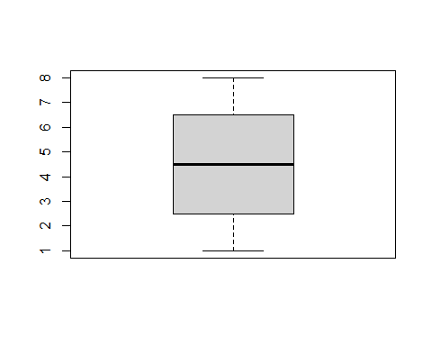

**Figure** **1:** A boxplot

## Reference

see figure **1** and table **1**!