Cafe

Connor Marchand

University of Missouri – Kansas City

Table of Contents
Vision Statement 3
Requirements 4
Product Backlog 5
Sprint #1 6
Review 6
Retrospective 6
Sprint #2 7
Review 7
Retrospective 7
Sprint #3 8
Review 8
Retrospective 8
Sprint #4 9
Review 9
Retrospective 9
Sprint #5 10
Review 10
Retrospective 10
Sprint #6 11
Review 11
Retrospective 11

Vision Statement

This program will allow people who enjoy coffee to be more educated on what different coffee drinks contain and allow them to explore their different tastes. Users will be able to browse drinks, search drinks, filter drinks, and favorite drinks. It would be nice for people who are lactose intolerant and want coffee drinks without milk, but don’t know the difference between different drinks. The app would display what goes into a coffee drink such as a latte, mocha, americano, etc. This would allow people at home to make different drinks other than plain coffee or coffee with creamer. For immediate release, it will be a informative coffee app designed to help people make more informed orders and give them the ability to create more unique coffee drinks at home. Going further, it would be nice to allow coffee shops to implement this app as an informative self-service point of sale system; people can order drinks from this app by themselves and make a more informed order. Reducing the time asking questions and making lines go faster, given there are no order filling bottlenecks.

Requirements
A discussion of what your application is required to have in functionality. It should identify user roles and goals/actions, and what the key features of the app should be.
Actor | Goal
User | View drinks, favorite drinks, add drinks, delete drinks
Store Owner | Add drinks, delete drinks, set prices, edit drinks

Product Backlog
This will be updated throughout the semester as new PBIs are added, larger items are broken into smaller ones, and completed items removed.

Story ID | Story | Story Points  (in est. hours) | Priority | Status
1 | Build outline for app and template | 8 | High | Complete
2 | Search drink: A user should be able to search for a specific coffee drink that they would like. Start building database | 7 | High | Complete
3 | View drinks: A user should be able to just browse all drinks | 3 | Medium | Complete
4 | View favorites: A user should be able to favorite drinks that they enjoy | 4 | Low
5 | Add drink: A user should be able to add a drink if they would like | 2 | Medium | Complete
6 | Filter drinks: A user should be able to filter drinks based on certain criteria | 4 | Low
7 | View history: A user should be able to view a history of passed viewed drinks | 4 | Low
8 | Restyle View: A user should be able to view drinks in a nice list view | 4 | High | Complete

Sprint #1

Sprint Backlog
Story ID | Story / Task | Estimated  Hours | Actual  Hours
1 | Build outline for app and template | 8 | 9

Review

A navigation bar was added and layouts for all of the different options. The basic outline for the application and the navigation was planned for the sprint.

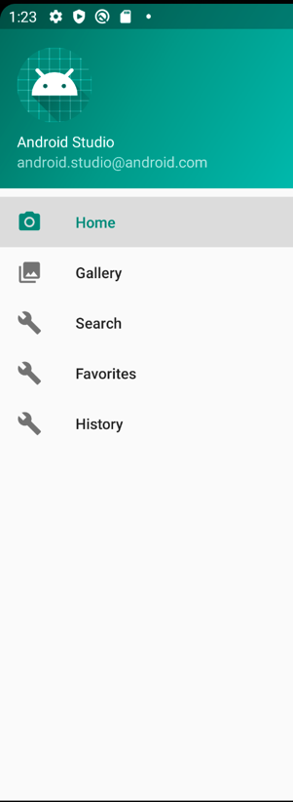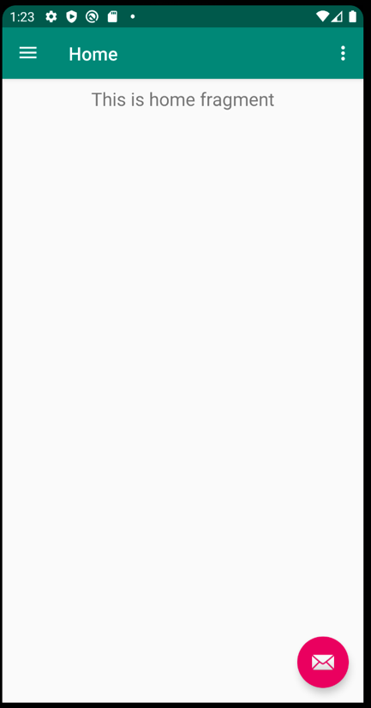

Retrospective
The research implementing all of the screens and implementing the navigation took time. The creation of all the screens was not too difficult, but it took time making all of the files and making the changes. I plan to keep my github more up to date because I did lose some files and I had trouble creating the repository, but I can avoid my issues with git by committing more often. In the next sprint I plan to create the database and fill it with information.

Sprint #2

Sprint Backlog
Story ID | Story / Task | Estimated  Hours | Actual  Hours
5 | Add drink: A user should be able to add a drink if they would like | 2 | 8

Review
The database was implemented and there is now a way to add a drink.

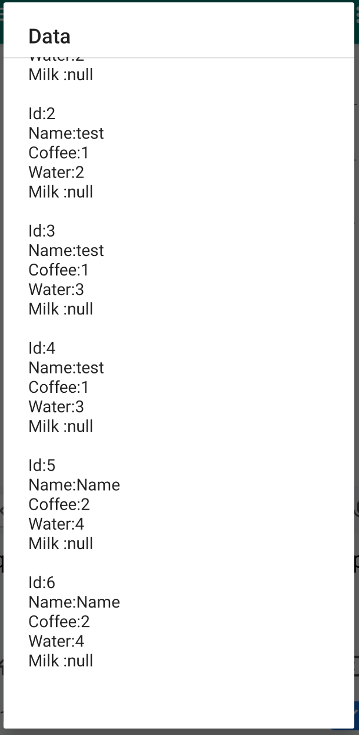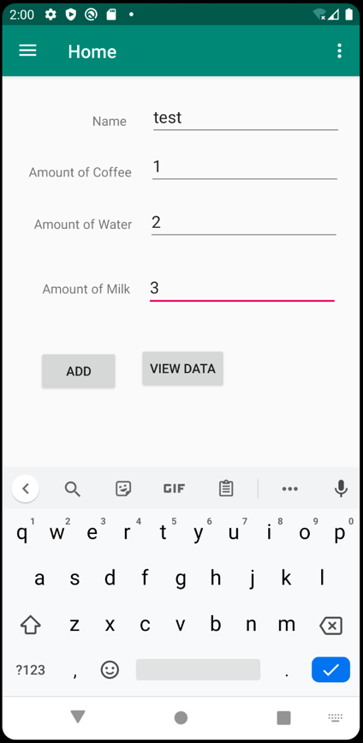

Retrospective
This sprint was much more challenging than the last sprint because it took me a lot more time to create and implement the database than I thought. There were several ways that I tried to create the database that did not work at all. However, I figured out a way that worked with my computer and got it working. I wanted to add a way to view all of the drinks, but now that I got the database set up the next stories will hopefully not take as much time.

Sprint #3

Sprint Backlog
Story ID | Story / Task | Estimated  Hours | Actual  Hours
3 | View drinks: A user should be able to just browse all drinks | 3 | 6

Review

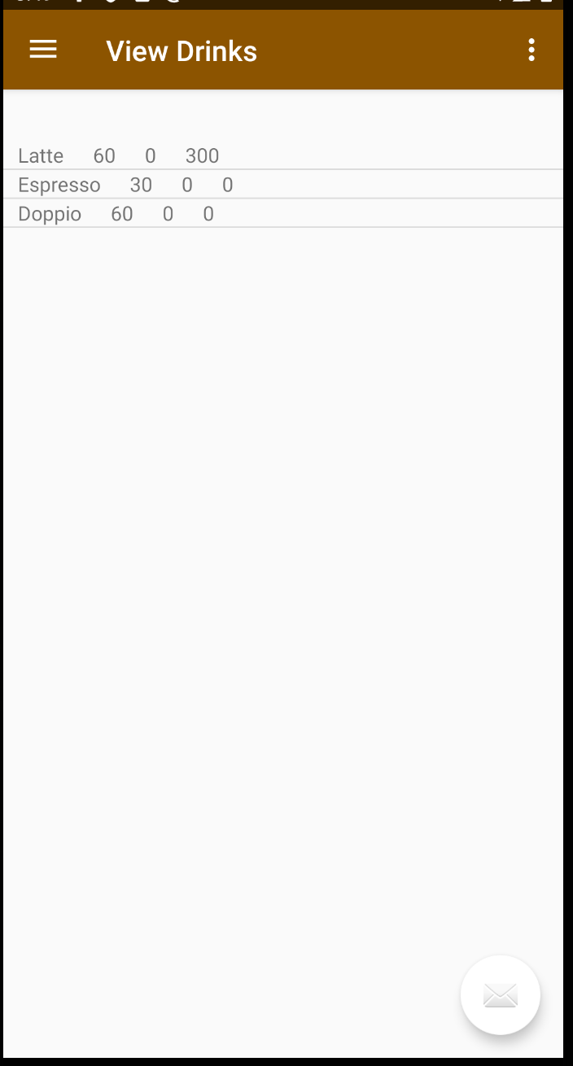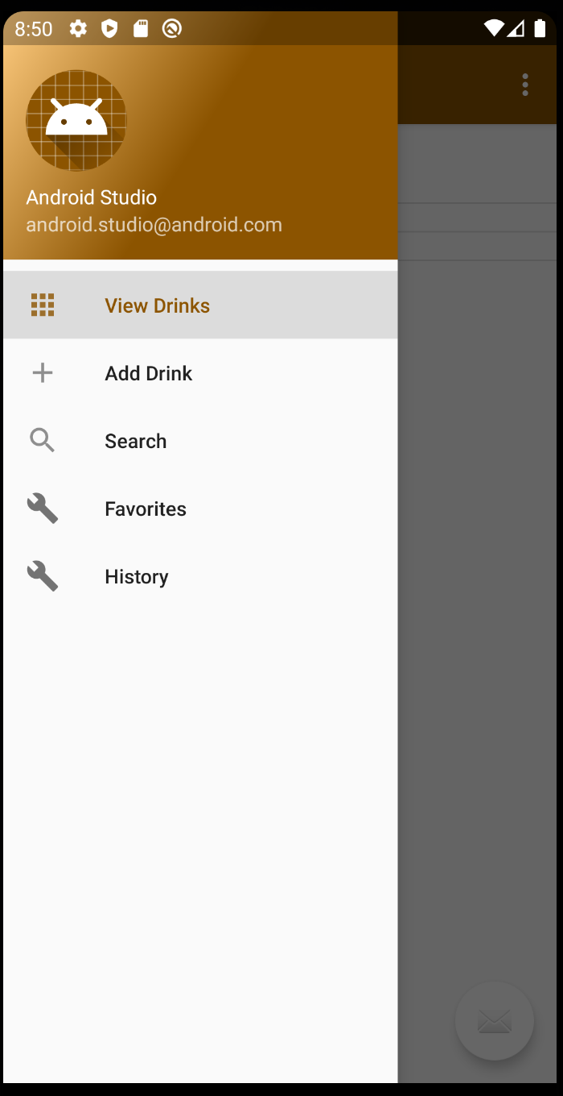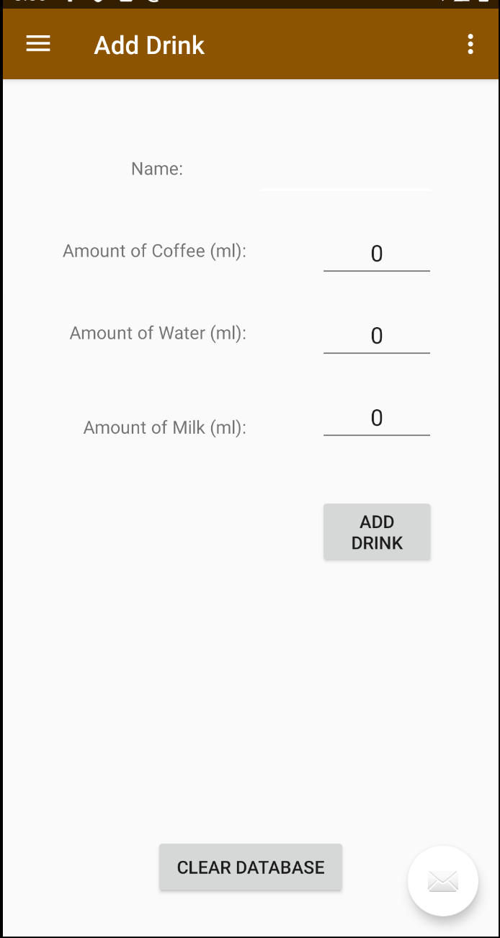

You are now able to view all of the drinks that you have created and there were tweaks to style of the add drink page and the whole app. Some tweaks to the database were also made

Retrospective
This sprint went better than the last sprint because the database was already setup but passing data between fragments was a little harder than I expected. I did a good job making everything in my project modular and named my variables well; there was not much confusion on what I was creating or trying to access. I still need to work more on style, and I can fix that in the next sprint while implementing a search function for the database, which I think will be easier now that I have figured out how to traverse through the database.

Sprint #4

Sprint Backlog
Story ID | Story / Task | Estimated  Hours | Actual  Hours
2 | Search Drinks | 7 | 7

Review

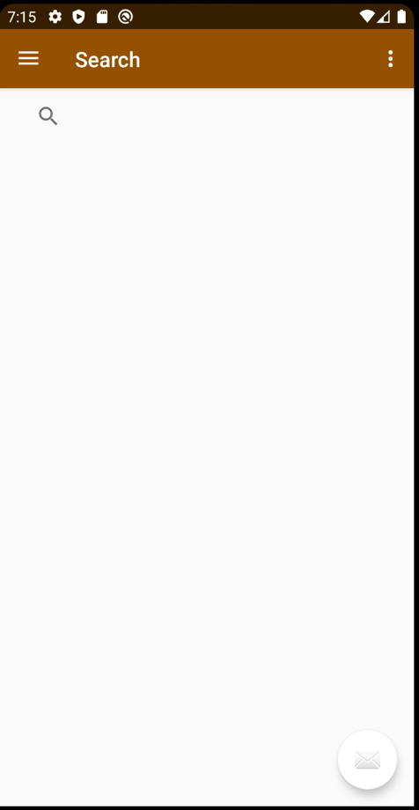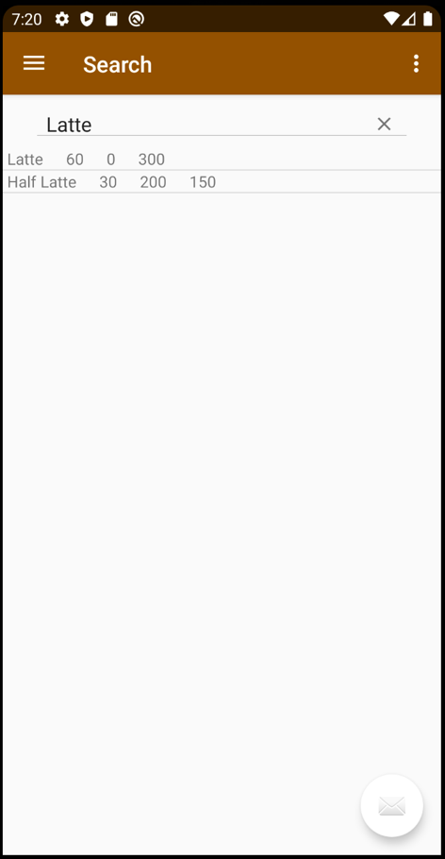

You are now able to search all of the drinks that you have created it will return a list view of the drinks that are like the name that you searched. Some tweaks to the database were also made

Retrospective
This sprint went about the same as the last sprint because view drinks fragment was already setup and I had the creation of the list view already made as well. I did a good job making everything that was related to the search function work properly because I was having a lot of trouble with duplicated and understanding and populating the list view. I still need to work more on style because I did not get to that in this sprint. I think I am going to restyle the list view to more of a tile view. I also plan to implement a feature where you can edit the drink. I did accidently commit a file with sensitive information so I decided to delete the repo and create a new one.

Sprint #5

Sprint Backlog
Story ID | Story / Task | Estimated  Hours | Actual  Hours
8 | Restyle View | 5 | 7

Review
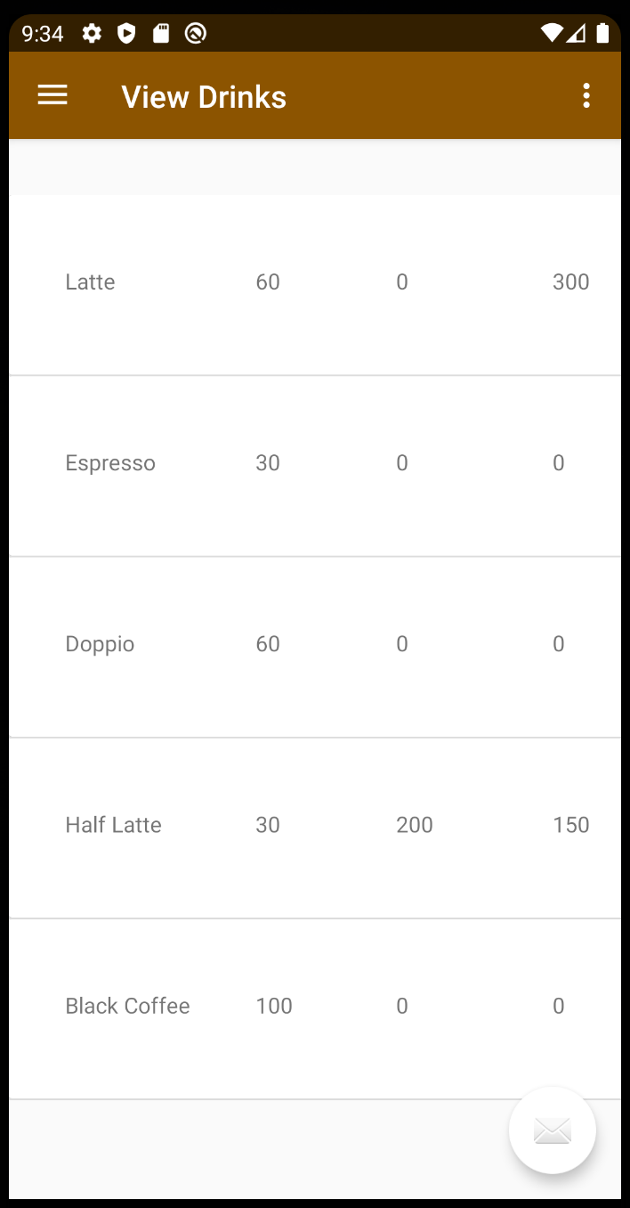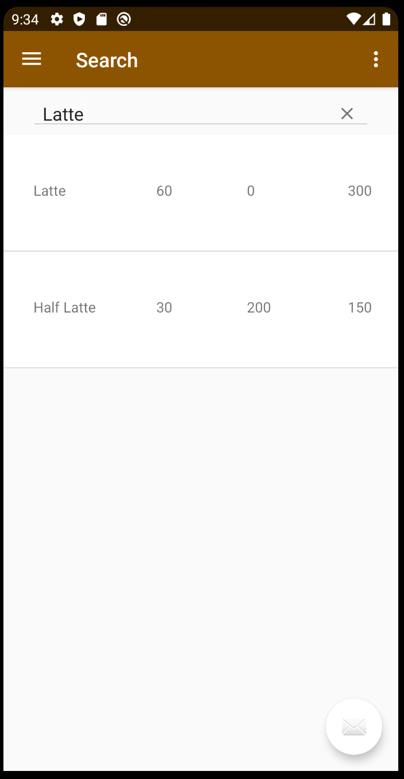

You are now able to view drinks tab and search all of the drinks that you have created it will return them in a nice card view.

Retrospective
This sprint was a lot harder than the last sprint. It was a lot harder to create the card view than I originally anticipated. I tried many different things that did not end up working, but that is how development sometimes goes. I got what I needed to done, it just took a lot longer than I estimated. For the next sprint I want to incorporate an image in the card view and I want to implement the favorites tab for the user.

Sprint #6

Sprint Backlog
Story ID | Story / Task | Estimated  Hours | Actual  Hours

Review

[Screenshots, etc go here. This is where you discuss the product, describing what was done this sprint (potentially shippable product increment) and what was planned for the sprint but was not done. ]

Retrospective
[This is where you discuss the process. What went well (and are you planning to do more of that?) What didn’t go so well (and do you have a way to do less of that)? What changes are you planning to make in how you plan & carry out the next sprint?]

