Connor Petri
CS-158A
21 September 2026
Executive Summary: PA1
Bug Narratives:
Q1:
For the serve_file() bug, the browser returned a 404 error, which meant that it could not find the requested file. To fix this, I stripped the ‘/’ character from the full_path variable assignment, resulting in the line being full_path = os.path.join(WEBROOT, path.lstrip("/")). This fix resulted in both about.html and index.html being served properly to the client.
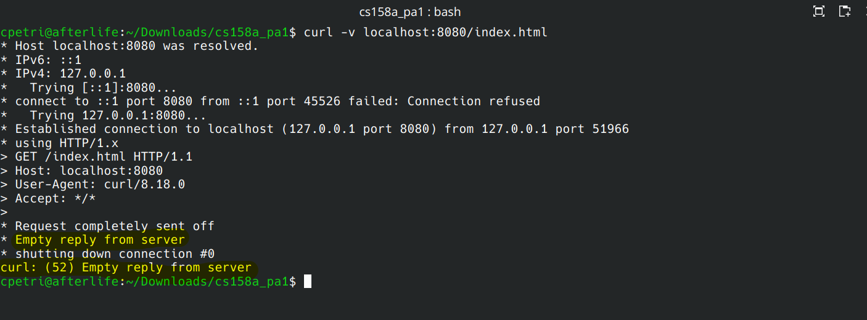Before serve_file() fix

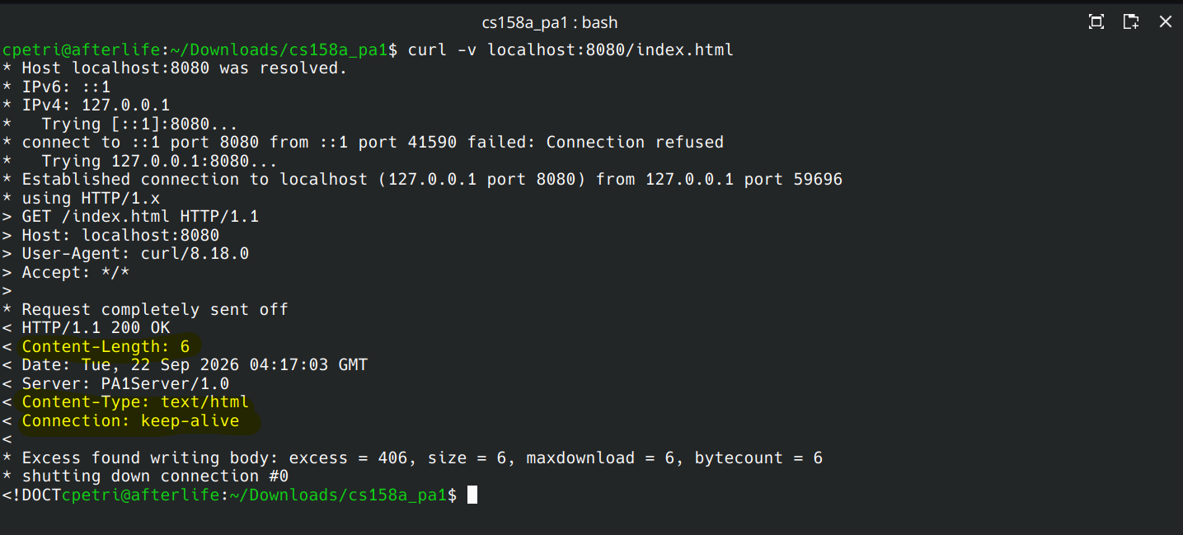After serve_file() fix
Q2:
For the build_http_response() bug, the incorrect amount of content was being transmitted. This was due to the Content-Length header being set to str(len(‘200 OK’). I changed this to be str(len(body_bytes)) to allow it to transmit the entire body. This was confirmed when the entire about.html and index.html were served to the client.
Before build_http_response() bug fix (content length is only 6)
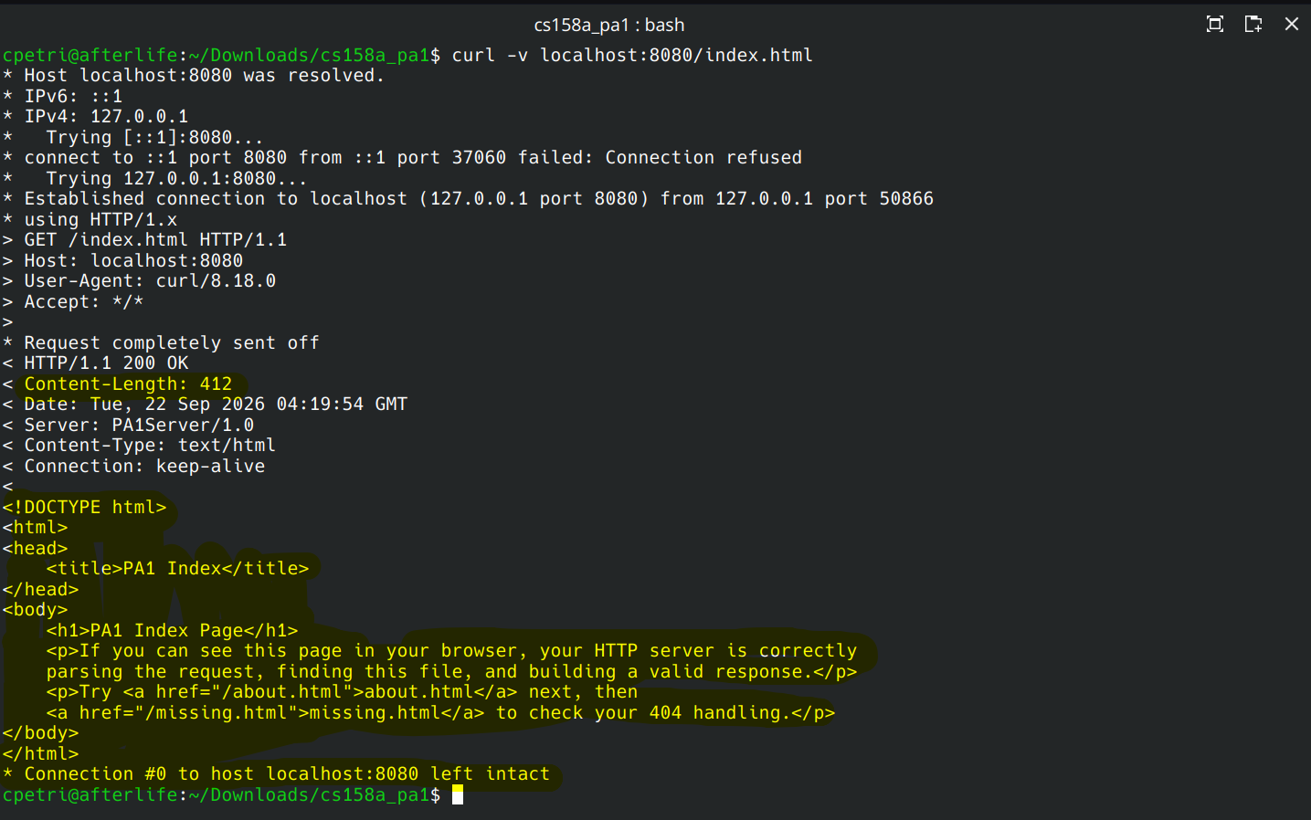After build_http_request() fix. Note the Content-Length of 412

Part A Recap: Q3
The server has the option to handle a single-request, non-persistent connection or a multi-request, persistent connection. In both cases, the connection handler requests a specific file using serve_file(). If the file is found, for example if index.html is requested, serve_file() returns a tuple (200, file_content, content_type). If the file is not found, for example if missing.html is requested, serve_file() returns (404, None, None). The connection handler function then calls builds_http_response() using the output of serve_file() and transmits the built https request.

Part B Recap:
Q4:
The persistent connection exits on 3 conditions. If the client requests a close, we handle it gracefully, sending the final packet with a confirmation of socket closure. If the parse_http_request() function returns nothing, then we respond with a 400 Bad Request message and close the connection. If the request isn’t a GET request, the server responds with a 405 Method Not Allowed message and closes the connection.

Q5:
If the client doesn’t close the connection or sends any data, the socket will time out and close the connection. My code uses the socket.timeout() method to handle the timeout implementation. I used the provided TIMEOUT global constant which is 10 seconds.
Part C Evidence:
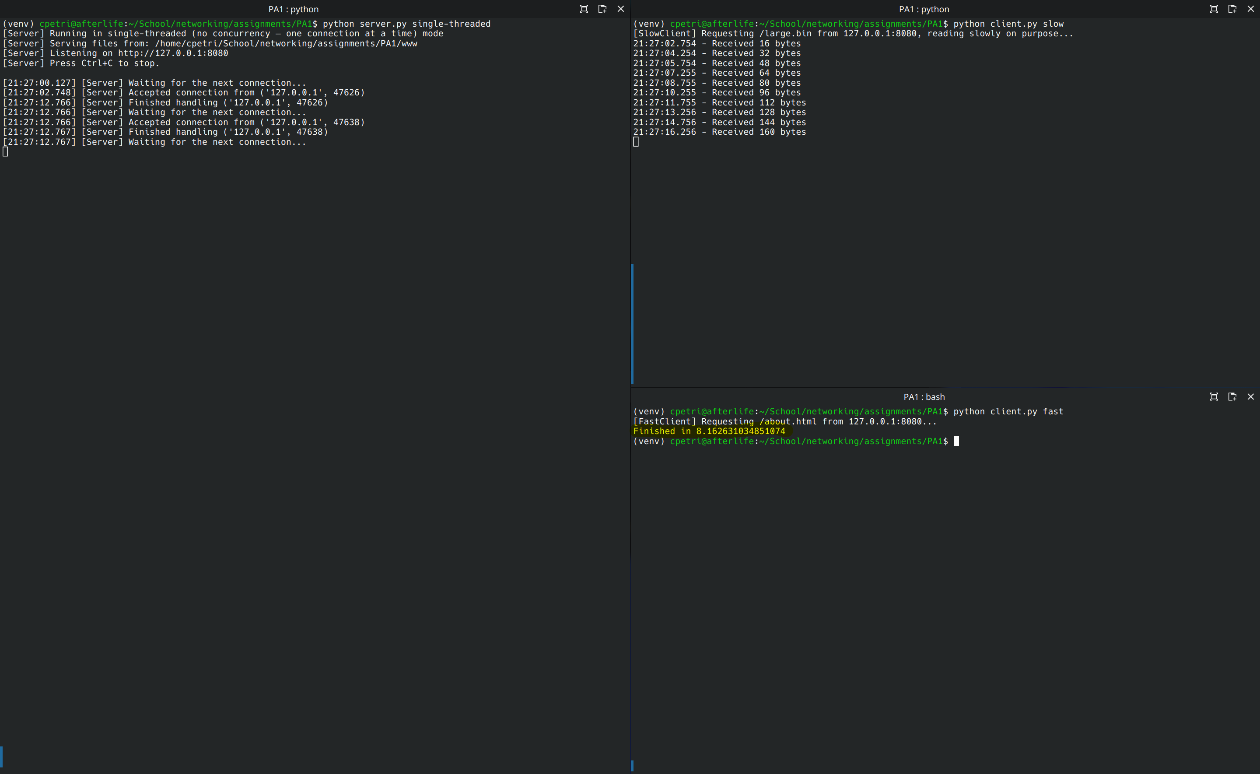Single-threaded test complete in 8.16 seconds
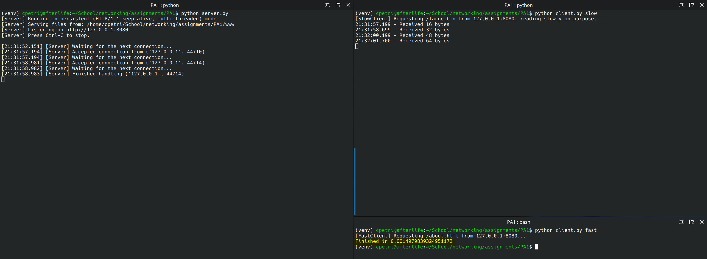Multi-threaded test complete in 0.001 seconds

Wireshark Evidence:
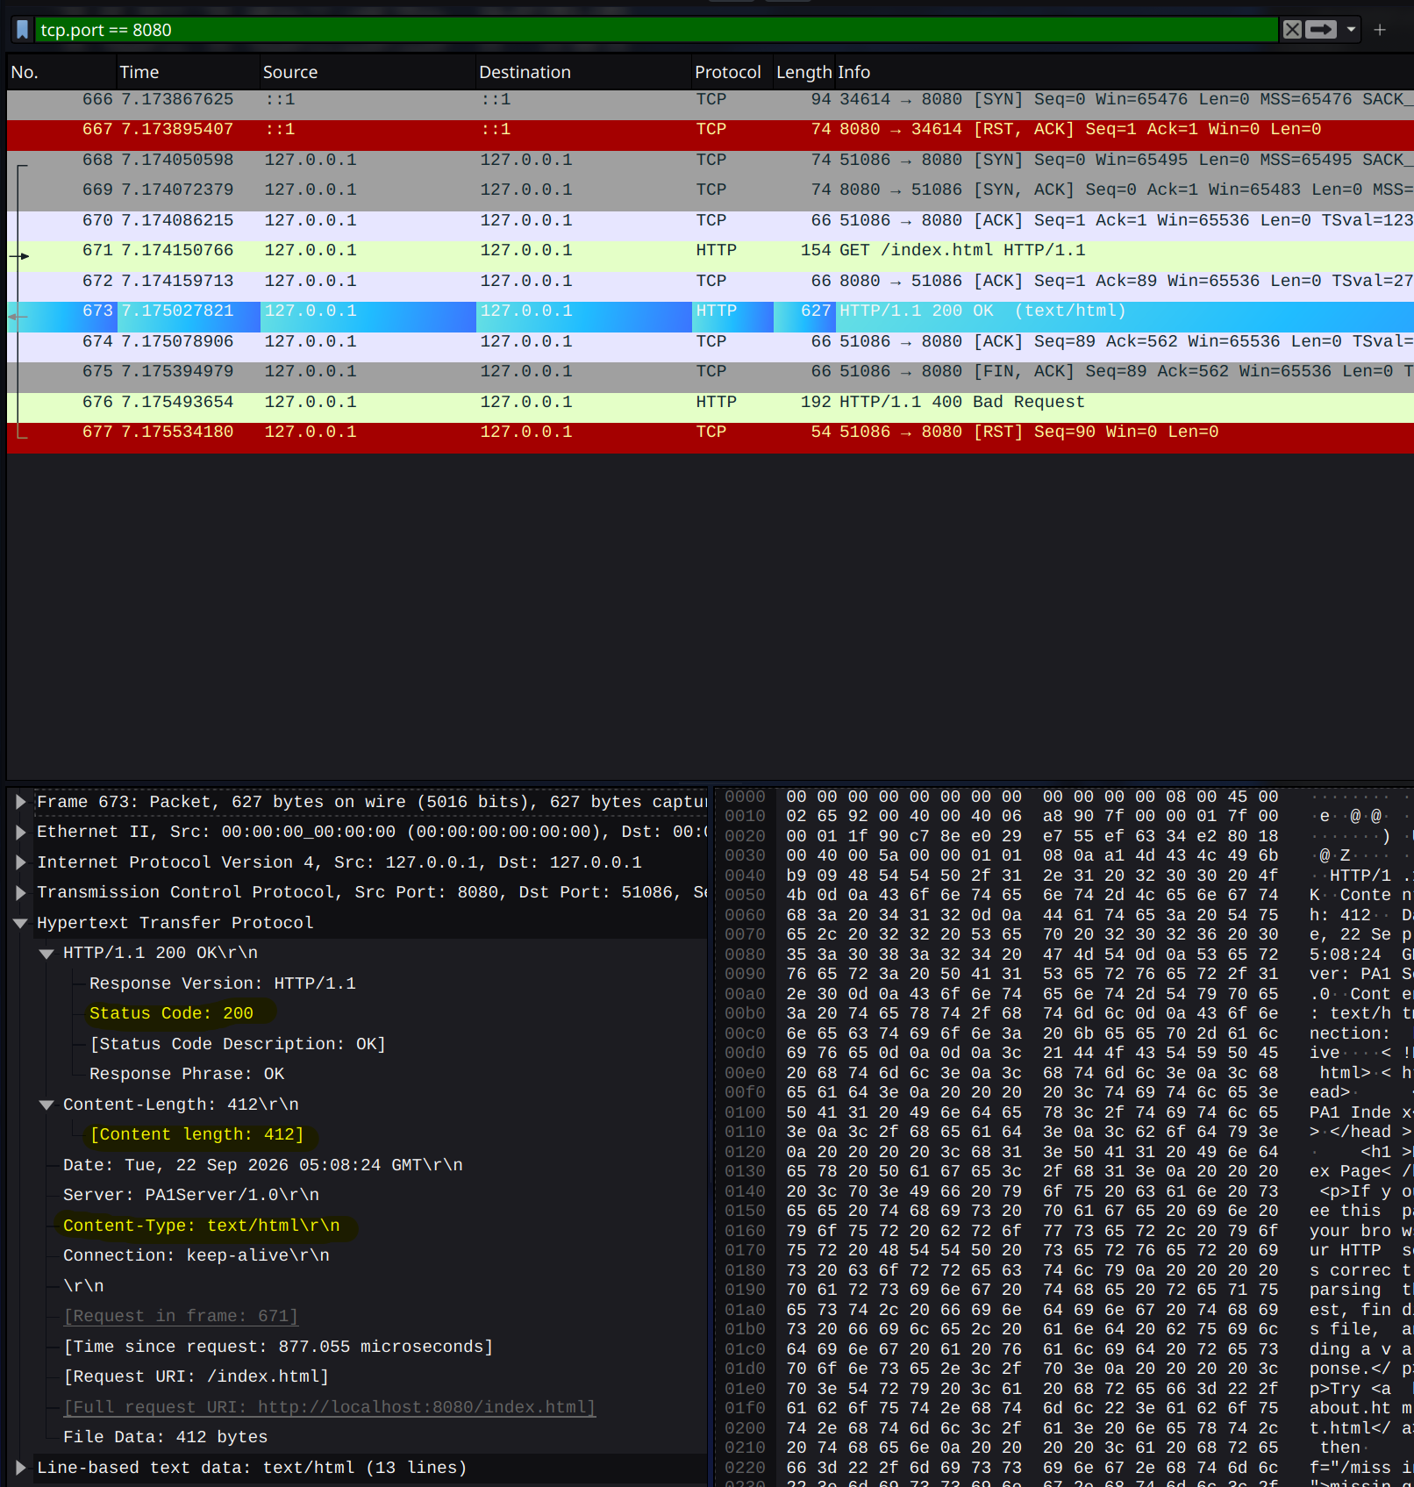A successful GET request with code 200, length 412, and typ text/html

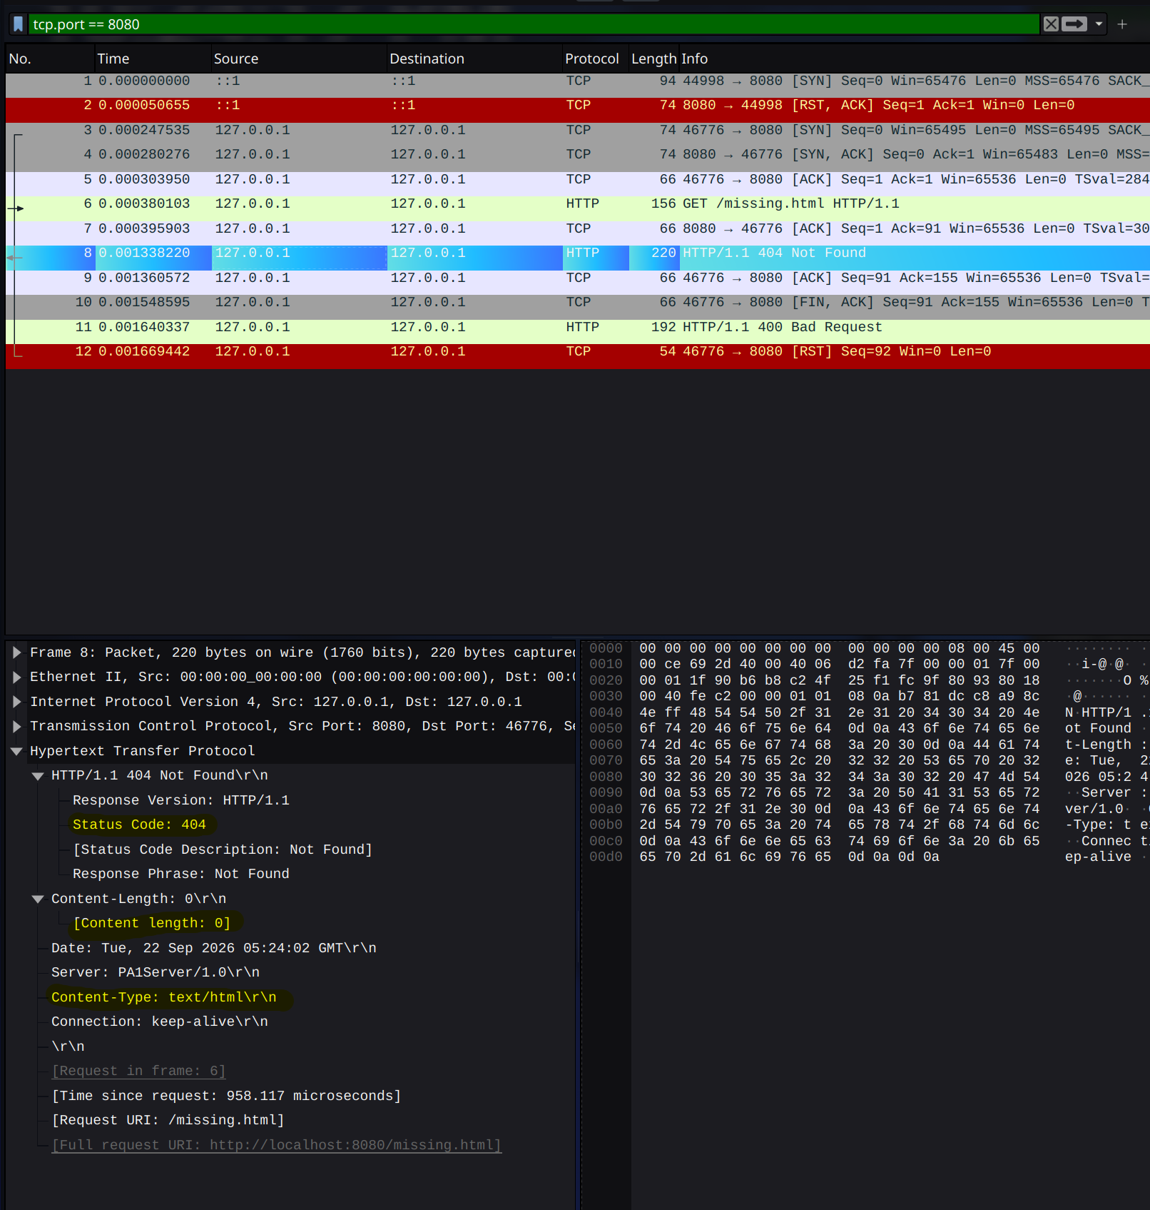An error 404 for no file found, content length of 0, and type text/html
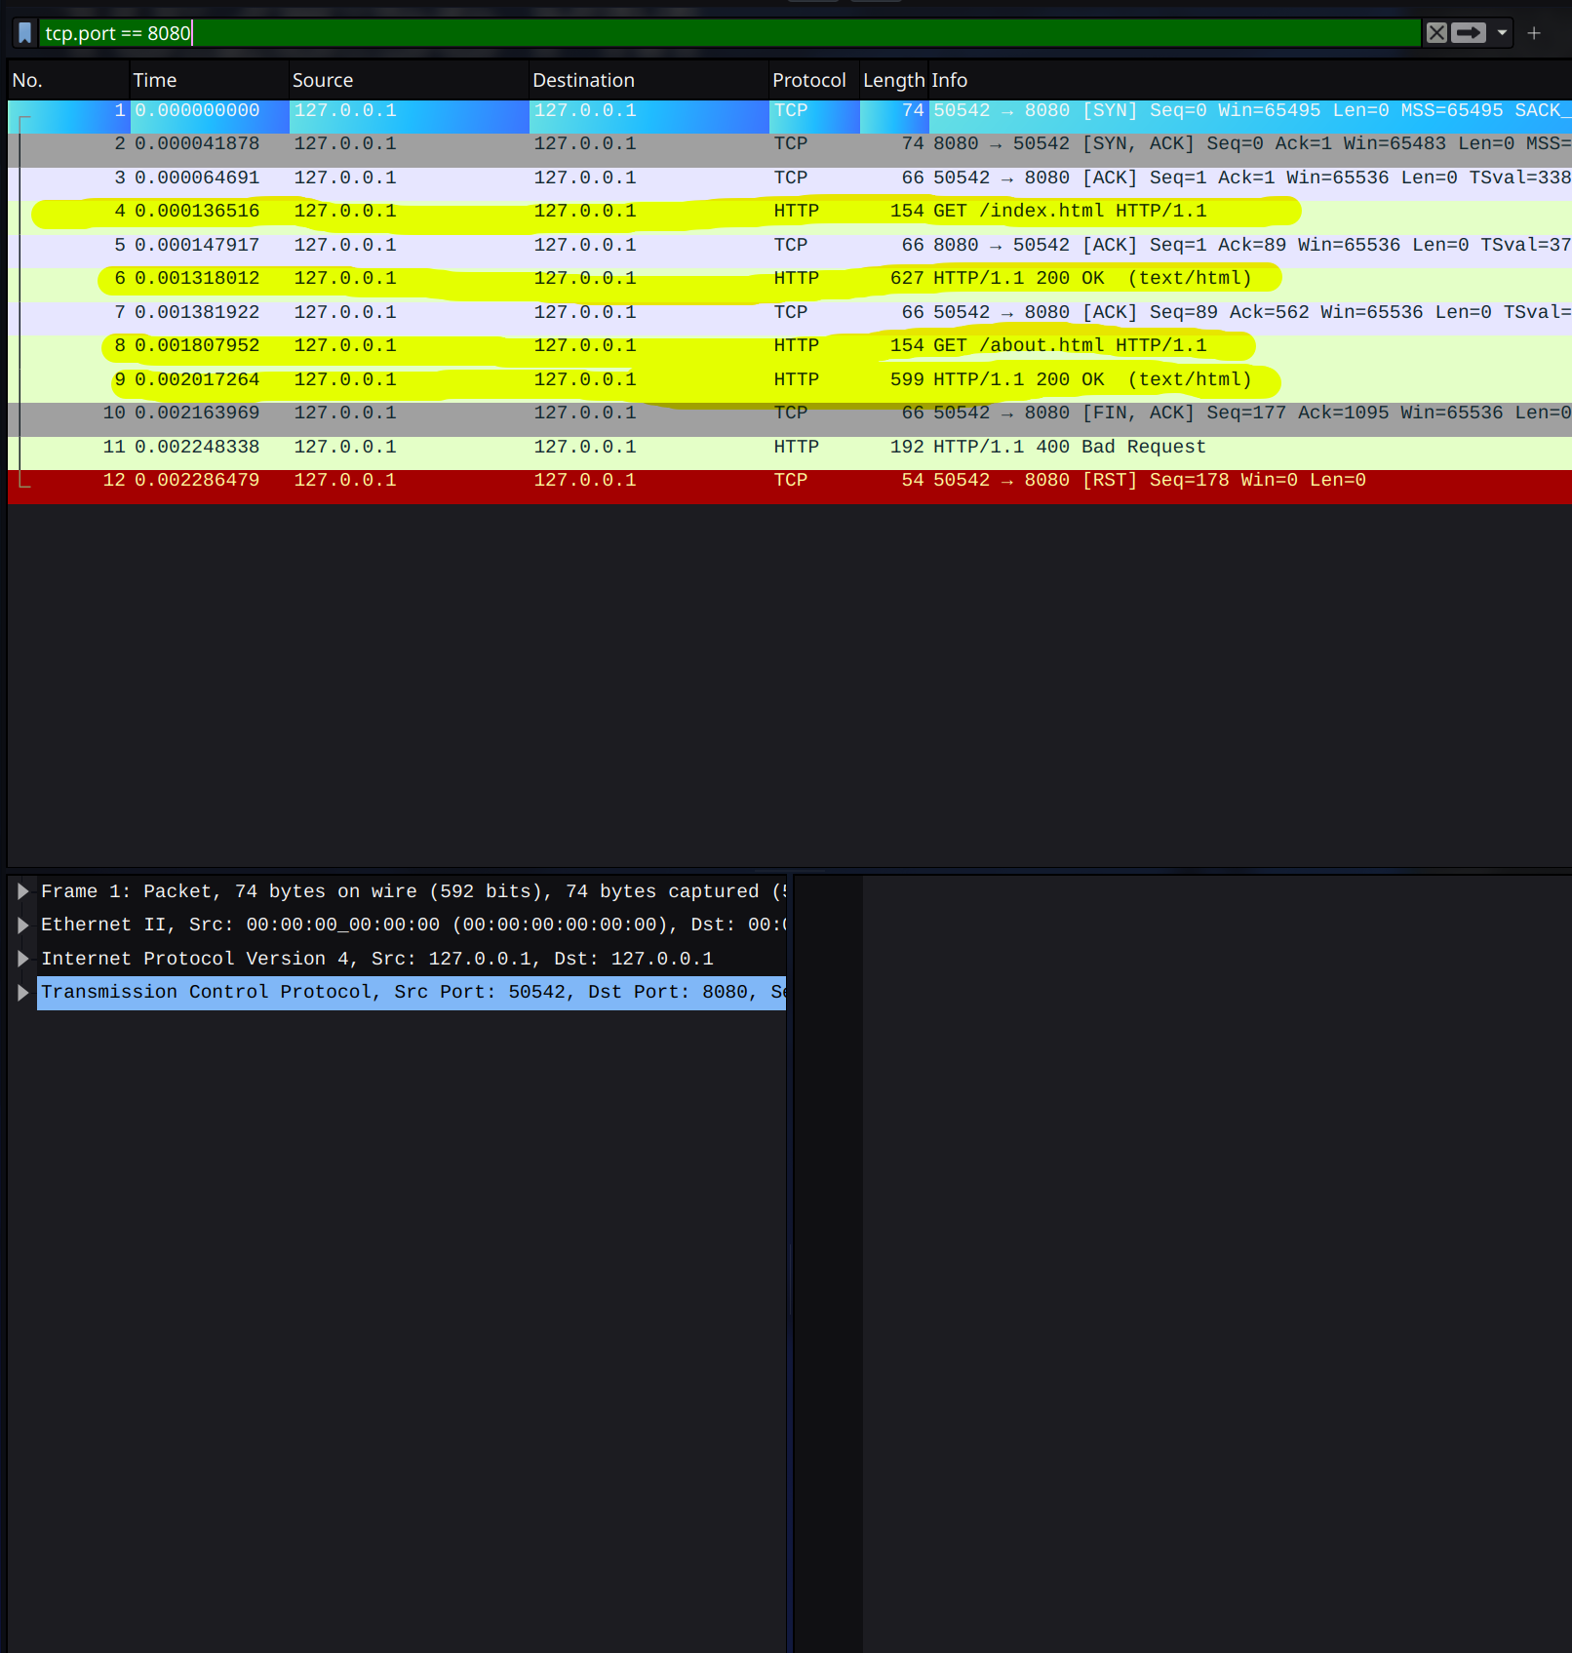Persistant server results in only 1 TCP handshake for the 2 sequential requests

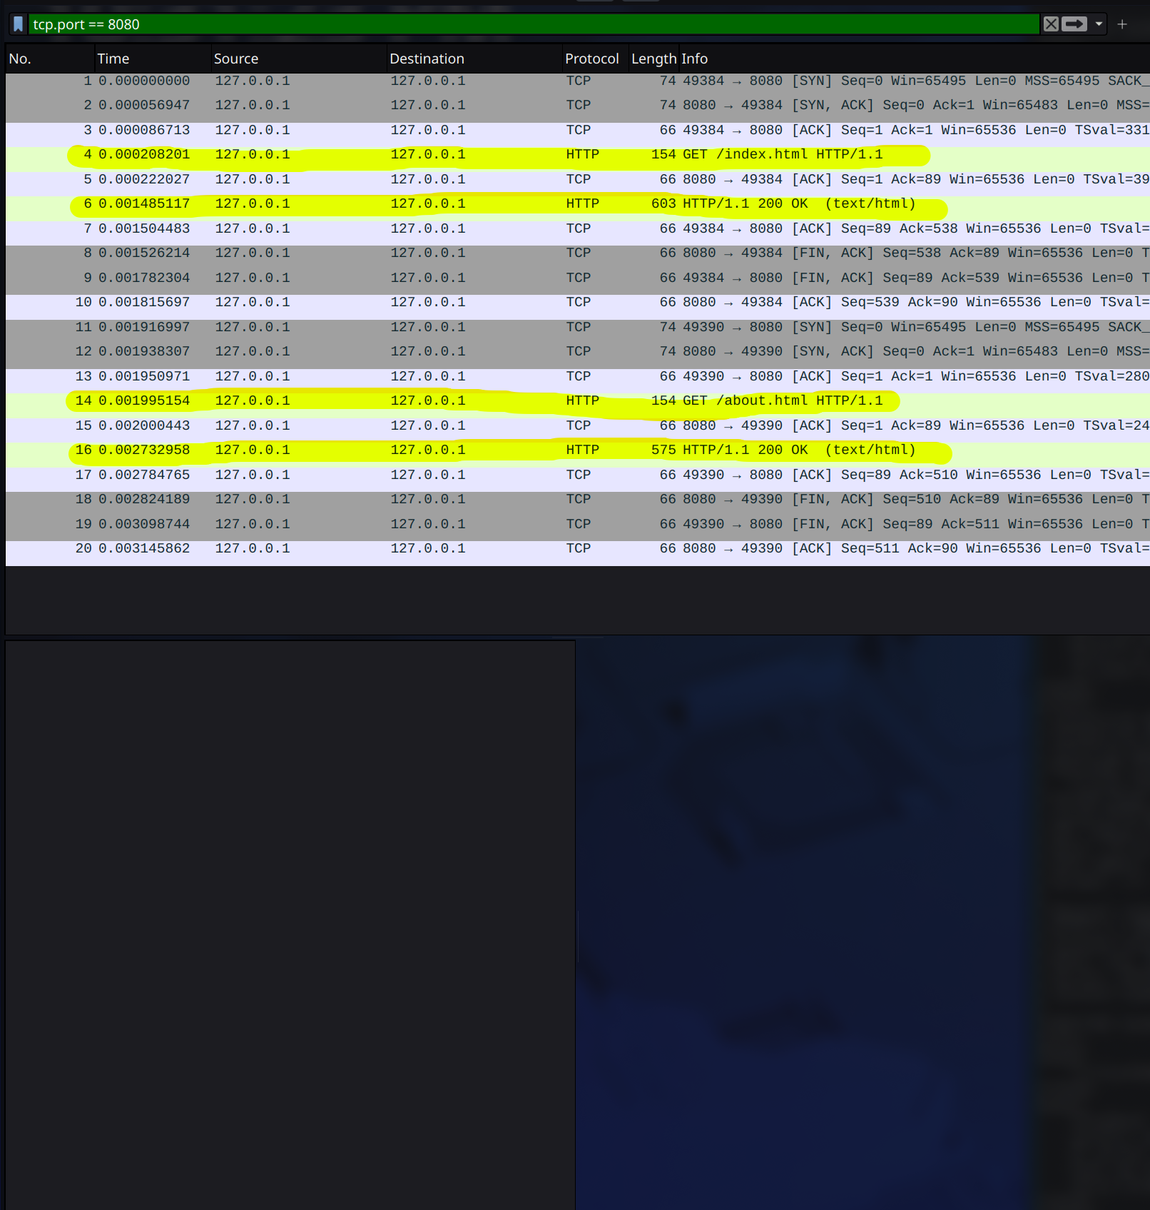Non-persistent mode results in 2 handshakes, one for each request

