Connor Petri
CS-158A Computer Networks
Lab 1

Checkpoint 1:
The request returned status code 200, which means the request was completed without issue
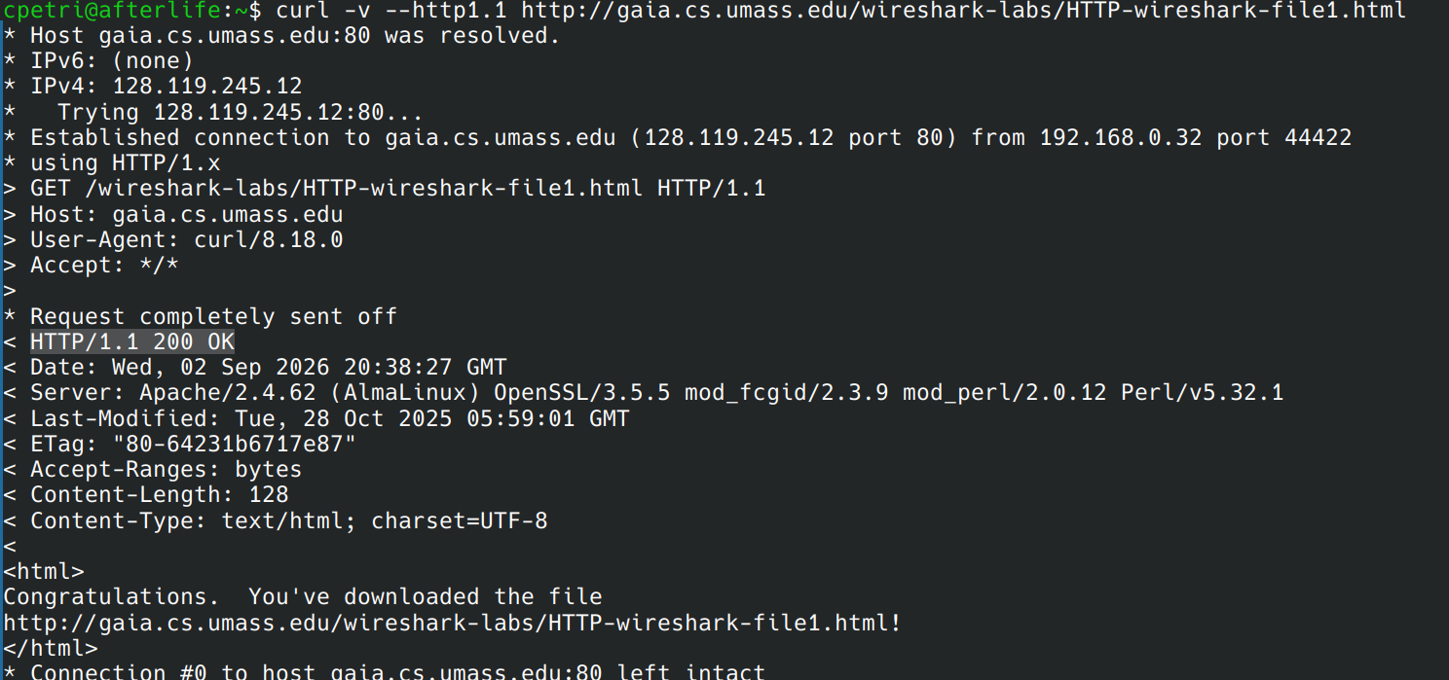Figure 1: Code 200 returned with descriptor OK following it

Checkpoint 2:
HTTP 1.0 has a full 3 way handshake for each request. 1.1 keeps the connection open for a time to minimize handshake overhead.
HTTP 1.0
HTTP 1.1
Figure 2: 2.707812413 - 2.621641011 = 0.086171402 s
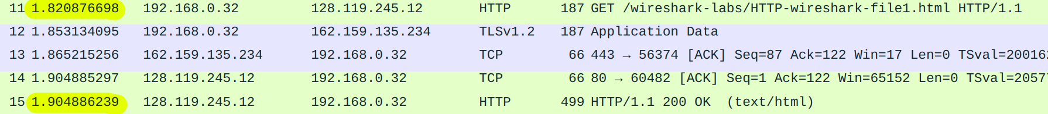Figure 3: 1.904886239 - 1.820876698 = 0.084009541 s

Checkpoint 3:
The IP address, URL, and a description of the client hello is still visible. The return code and contents are hidden from us when using HTTPS.

Figure 4: URL and IP address visible
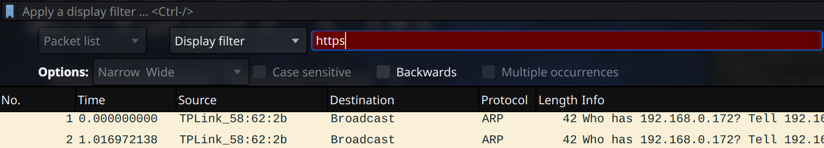Figure 5: No HTTP requests

