Connor Petri
Assignment 3
Design Patterns

Controller:
ActionListener (this is from a pop-up window which prompts the user for name and file path):
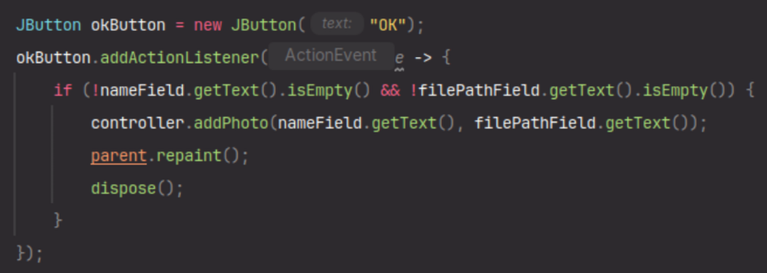
Controller Method:
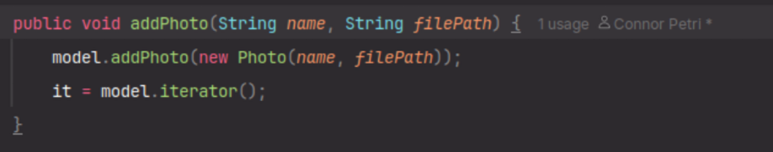
Model:
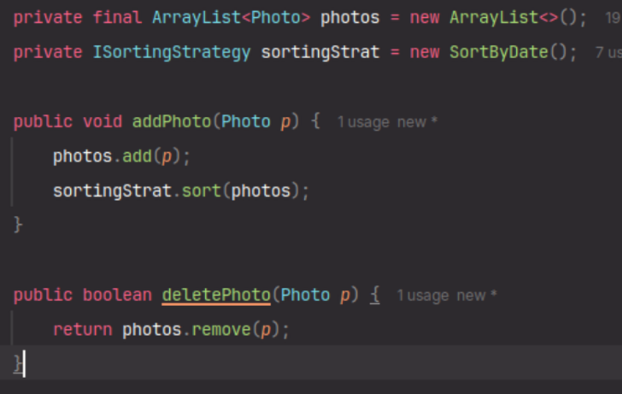

View:
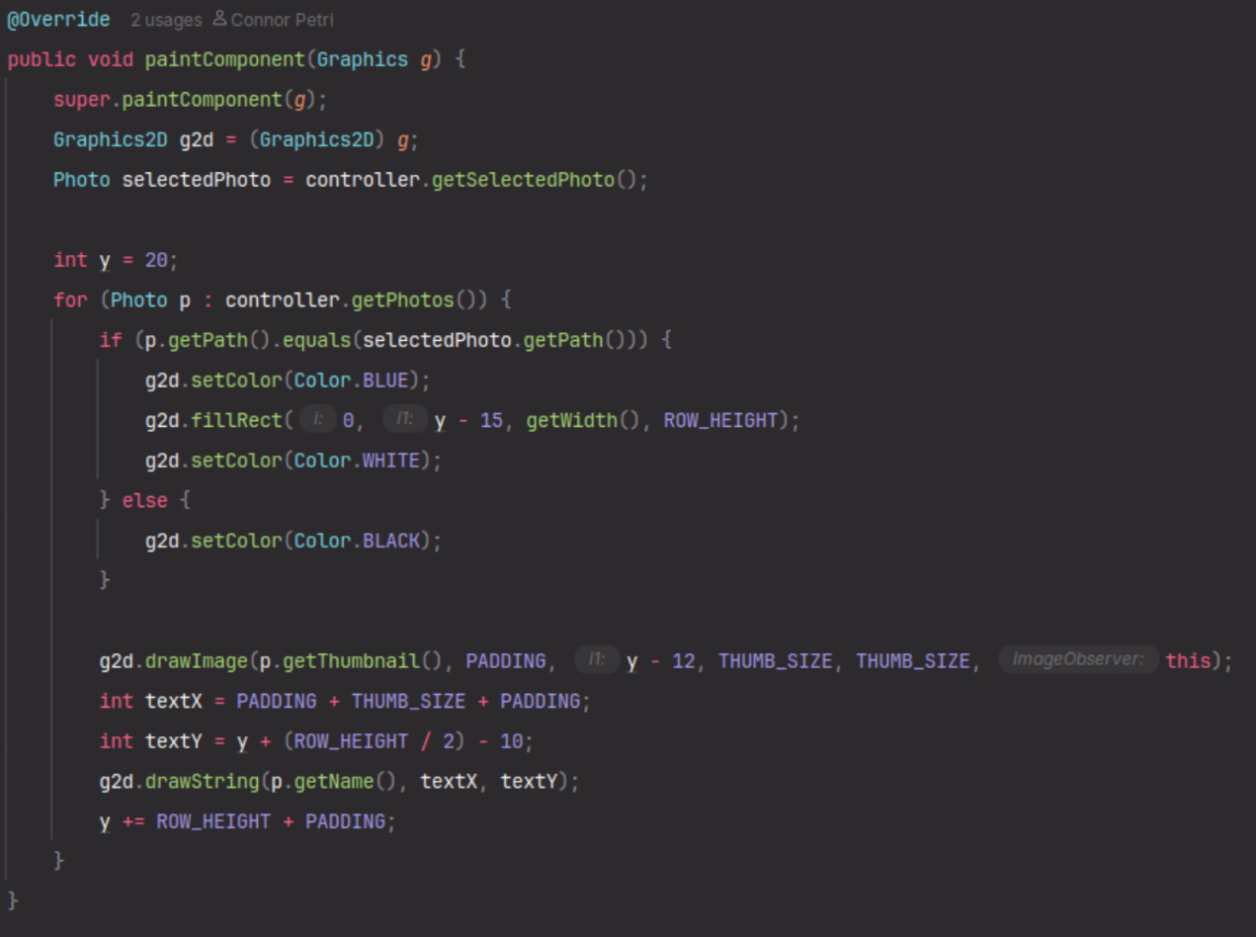

Strategy Pattern
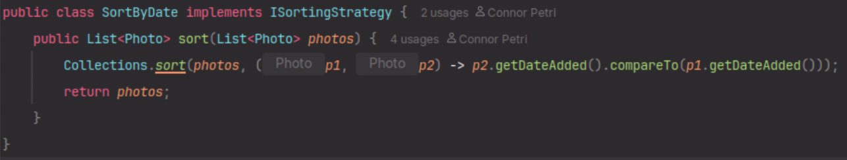
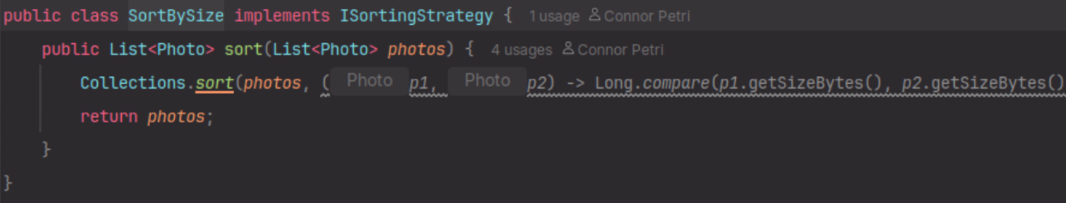
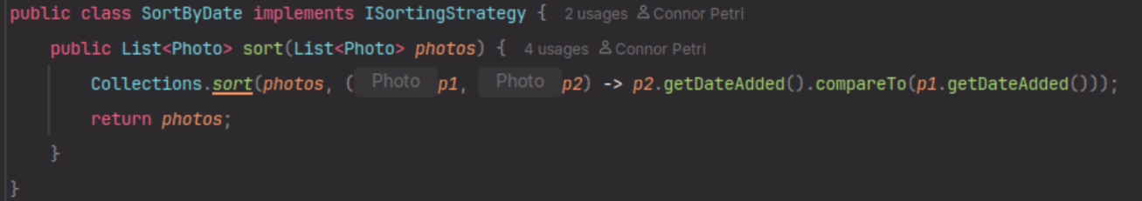

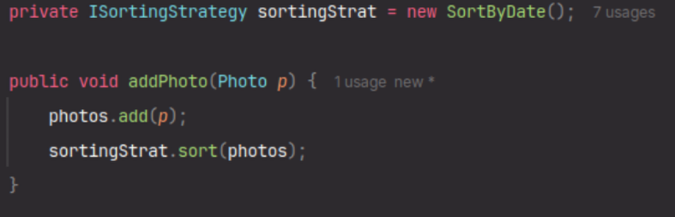
Iterator Pattern
