Connor Petri
CS-158A
Lab 3
Checkpoint 1
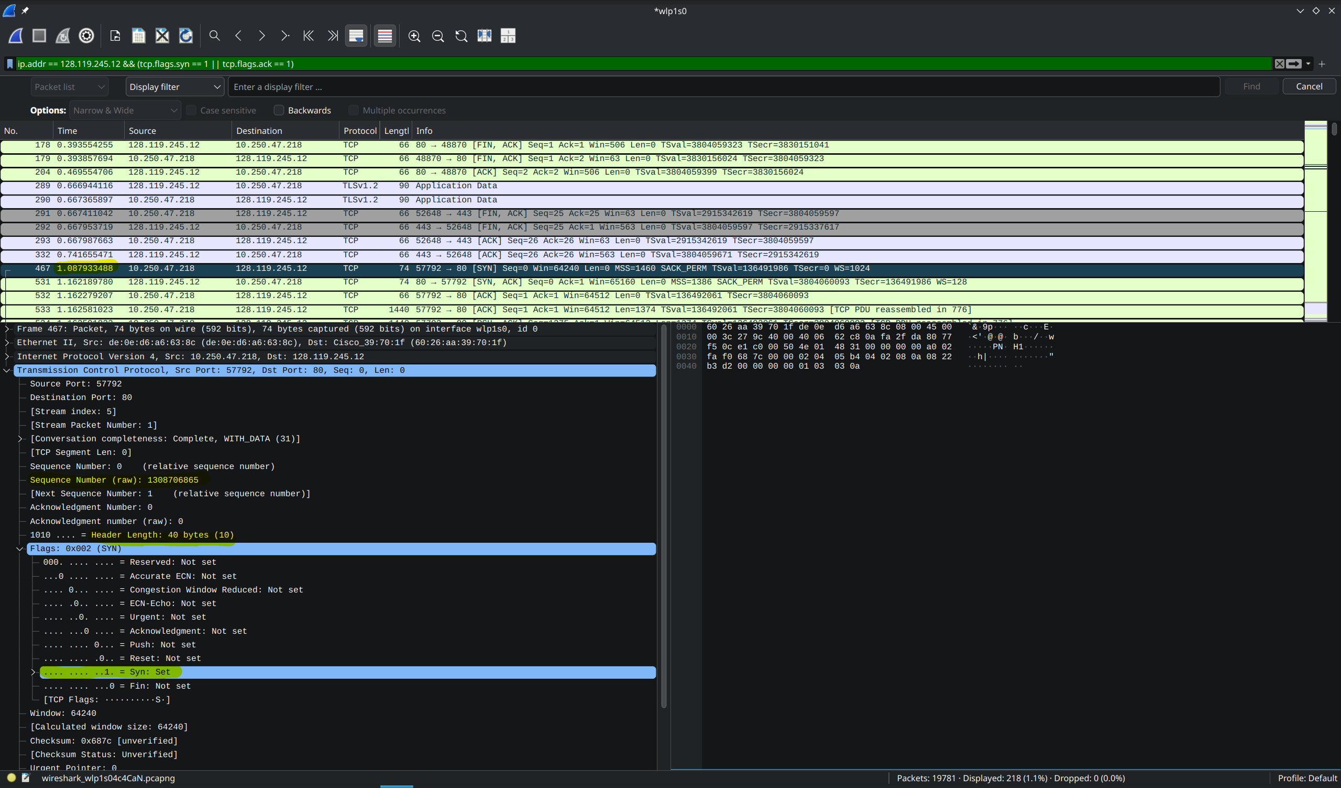SYN packet has SYN bit set only and ISN 1308706865
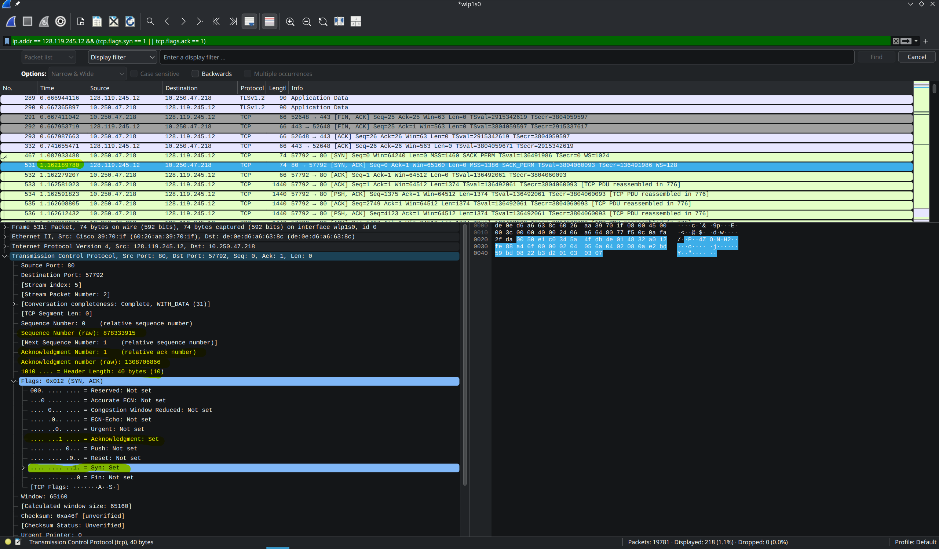SYN-ACK has both SYN and ACK bits set and ISN 878333915
Syn to Syn-Ack time 0.074256292 s
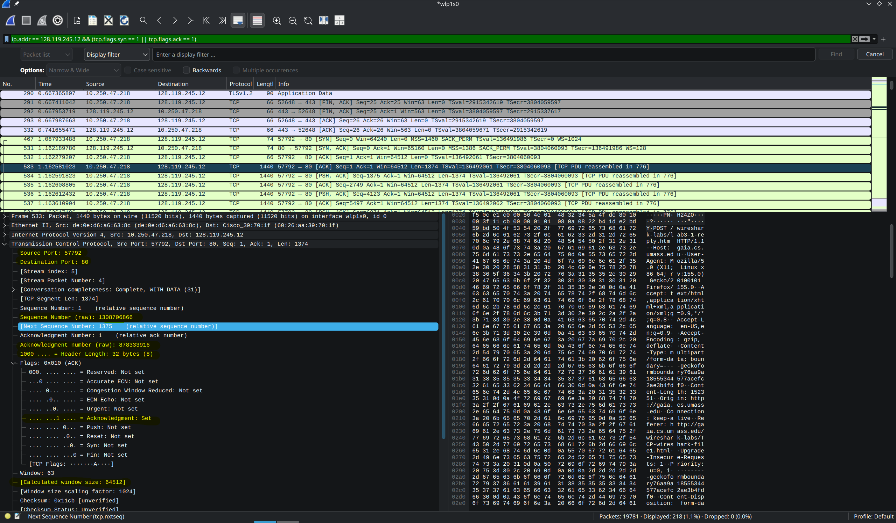Source port 57792, destination port 80, ISN 1308706866, ACK 878333916, ACK flag set, Window size 64512
Checkpoint 2
Segment | Seq (relative) | Length | Predict ACK

